Statistics for Business and Economics, 10e, Global Edition (Newbold)
Chapter 1 Describing Data: Graphical

1) Which of the following variables is an example of a categorical variable?
A) The amount of money you spend on eating out each month.
B) The time it takes you to write a test.
C) The geographic region of the country in which you live.
D) The weight of a cereal box.
Answer: C
Difficulty: Easy
Topic: Classification of Variables
AACSB: Reflective Thinking Skills
Course LO: Explain how data are acquired and distinguish among different types of data and levels of measurement

2) Which of the following is an example of a discrete random variable?
A) The monthly electric bill for a local business.
B) The number of people eating at a local café between noon and 2:00 p.m.
C) The amount of time it takes for a worker to complete a complex task.
D) The percentage of people living below the poverty level in Boston.
Answer: B
Difficulty: Easy
Topic: Classification of Variables
AACSB: Reflective Thinking Skills
Course LO: Explain how data are acquired and distinguish among different types of data and levels of measurement

3) What is the correct ranking of data from weakest or lowest level to strongest or highest level?
A) nominal, ordinal, interval and ratio
B) ordinal, nominal, interval and ratio
C) interval, nominal, ratio and ordinal
D) nominal, interval, ordinal, and ratio
Answer: A
Difficulty: Moderate
Topic: Classification of Variables
AACSB: Reflective Thinking Skills
Course LO: Explain how data are acquired and distinguish among different types of data and levels of measurement
4) Dr. Thomas graduated from West Virginia University with a code value = 1 while Professor Harrison graduated from the Marshall University with a code value = 2. The scale of measurement likely represented by this information is:
A) nominal.
B) ordinal.
C) interval.
D) ratio.
Answer: A
Difficulty: Moderate
Topic: Classification of Variables
AACSB: Analytic Skills
Course LO: Explain how data are acquired and distinguish among different types of data and levels of measurement

5) A measurement scale that rates product quality as either 1 = poor, 2 = average and 3 = good is known as:
A) nominal.
B) ordinal.
C) interval.
D) ratio.
Answer: B
Difficulty: Moderate
Topic: Classification of Variables
AACSB: Analytic Skills
Course LO: Explain how data are acquired and distinguish among different types of data and levels of measurement

6) Which of the following statements involve descriptive statistics as opposed to inferential statistics?
A) The Alcohol, Tobacco and Firearms Department reported that Seattle had 1,825 registered gun dealers in 2013.
B) Based on a survey of 380 magazine readers, the magazine reports that 30% of its readers prefer double column articles.
C) The FAA samples 425 traffic controllers in order to estimate the percent retiring due to job stress related illness.
D) Based on a sample of 350 professional baseball players, a baseball magazine reported that 23% of the parents of all professional baseball players did not play baseball.
Answer: A
Difficulty: Easy
Topic: Decision Making in an Uncertain Environment
AACSB: Analytic Skills
Course LO: Explain how data are acquired and distinguish among different types of data and levels of measurement
7) The width of each bar in a histogram corresponds to the:
A) midpoint of the class.
B) number of observations in the class.
C) boundaries of the class.
D) percentage of observations in the class.
Answer: C
Difficulty: Easy
Topic: Graphs to Describe Numerical Variables
AACSB: Reflective Thinking Skills
Course LO: Explain how data are acquired and distinguish among different types of data and levels of measurement

8) Which of the following statements is incorrect?
A) Ordinal data may be described as qualitative.
B) Nominal data may be described as quantitative.
C) A categorical variable may produce ordinal data.
D) A discrete numerical variable may produce ratio scale data.
Answer: B
Difficulty: Moderate
Topic: Classification of Variables
AACSB: Analytic Skills
Course LO: Explain how data are acquired and distinguish among different types of data and levels of measurement

9) The length of time it takes to assemble a particular electronic component varies from one employee to another. Management has collected the time (in minutes) it took 20 different employees to assemble the component. The information is summarized in the following frequency distribution generated by Excel:

Bin | Frequency | Cumulative %
10 | 1 | 5.00%
15 | 9 | 50.00%
20 | 1 | 55.00%
25 | 7 | 90.00%
More | 2 | 100.00%

Which of the following statements is true?
A) 50% of all the workers took exactly 15 minutes to assemble the component.
B) 100% of all the workers took longer than 25 minutes to assemble the component.
C) Eleven workers assembled the component in 20 minutes or less.
D) Seven workers took 25 minutes or longer to assemble the component.
Answer: C
Difficulty: Moderate
Topic: Graphs to Describe Numerical Variables
AACSB: Analytic Skills
Course LO: Use a modern software tool to perform statistical calculations
10) Consider the following frequency distributions generated by Excel. What is the missing cumulative % value identified by the asterisk?

Bin | Frequency | Cumulative %
12.8 | 1 | 5.00%
41.6 | 5 | 30.00%
70.4 | 6 | 60.00%
99.2 | 6 | *
More | 2 | 100.00%

A) 60.00%
B) 5.00%
C) 100%
D) 90%
Answer: D
Difficulty: Moderate
Topic: Graphs to Describe Numerical Variables
AACSB: Analytic Skills
Course LO: Use a modern software tool to perform statistical calculations

11) Consider the following frequency distribution generated by Excel. What is the missing frequency value identified by the asterisk?

Bin | Frequency | Cumulative %
584 | 1 | 4.00%
1774.4 | * | 64.00%
2964.8 | 4 | 80.00%
4155.2 | 3 | 92.00%
5345.6 | 1 | 96.00%
More | 1 | 100.00%

A) 3
B) 15
C) 16
D) 25
Answer: B
Difficulty: Moderate
Topic: Graphs to Describe Numerical Variables
AACSB: Analytic Skills
Course LO: Use a modern software tool to perform statistical calculations

12) When grouping data into classes it is recommended to have:
A) exactly 5 classes.
B) between 5 and 20 classes.
C) at least 5 classes.
D) at most 10 classes.
Answer: B
Difficulty: Moderate
Topic: Graphs to Describe Numerical Variables
AACSB: Reflective Thinking Skills
Course LO: Compare and contrast methods of summarizing and describing data

13) A researcher used a procedure to select a sample of n objects from a population in such a way that each member of the population is chosen strictly by chance, is equally likely to be chosen, and every possible sample of size n has the same chance of selection. The procedure used by the researcher is known as:
A) descriptive statistics.
B) inferential statistics.
C) simple random sampling.
D) None of the above
Answer: C
Difficulty: Moderate
Topic: Decision Making in an Uncertain Environment
AACSB: Reflective Thinking Skills
Course LO: Compare and contrast methods of summarizing and describing data

14) What type of graph does a stem-and-leaf resemble when turned vertically?
A) pie chart
B) scatter plot
C) histogram
D) line chart
Answer: C
Difficulty: Easy
Topic: Graphs to Describe Numerical Variables
AACSB: Analytic Skills
Course LO: Compare and contrast methods of summarizing and describing data

15) Consider the terms: information, data, and knowledge. From a statistical standpoint, list these terms in order of increasing usefulness in making decisions.
A) information, data, and knowledge
B) data, information, and knowledge
C) knowledge, information, and data
D) knowledge, data, and information
Answer: B
Difficulty: Easy
Topic: Decision Making in an Uncertain Environment
AACSB: Reflective Thinking Skills
Course LO: Explain how data are acquired and distinguish among different types of data and levels of measurement
16) A sample of 30 professional men was asked to estimate their yearly expenditures on clothes for work. The data are summarized in the following stem-and-leaf display.

Stem = 100 Leaf = 10
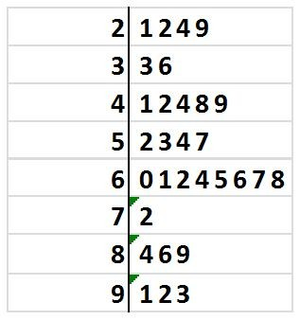

What percentage of these men spent more than $600 and less than $700 on professional attire? (Round to nearest tenth of a percent.)
A) 20.0%
B) 23.3%
C) 26.7%
D) 30.0%
Answer: C
Difficulty: Moderate
Topic: Graphs to Describe Numerical Variables
AACSB: Analytic Skills
Course LO: Compare and contrast methods of summarizing and describing data

17) Suppose a survey is taken of 300 high school seniors out of a total of 1,000 seniors. This group is probably a:
A) sample.
B) population.
C) system.
D) process.
Answer: A
Difficulty: Easy
Topic: Decision Making in an Uncertain Environment
AACSB: Reflective Thinking Skills
Course LO: Explain how data are acquired and distinguish among different types of data and levels of measurement
18) When data are collected in a statistical study for only a portion or subset of all elements of interest the researcher is using a:
A) parameter.
B) sample.
C) statistic.
D) population.
Answer: B
Difficulty: Easy
Topic: Decision Making in an Uncertain Environment
AACSB: Reflective Thinking Skills
Course LO: Explain how data are acquired and distinguish among different types of data and levels of measurement

19) Consider the following frequency distribution generated by Excel. What proportion of these values are less than 63?

Bin | Frequency | Cumulative %
26 | 0 | 0.00%
44.5 | 5 | 25.00%
63 | 7 | 60.00%
81.5 | 1 | 65.00%
More | 7 | 100.00%

A) 25%
B) 60%
C) 65%
D) 35%
Answer: A
Difficulty: Moderate
Topic: Graphs to Describe Numerical Variables
AACSB: Analytic Skills
Course LO: Use a modern software tool to perform statistical calculations

20) Which of the following is a quantitative variable?
A) the make of a washing machine
B) a person's gender
C) price of a car in thousands of dollars
D) whether a person is a college graduate or not
Answer: C
Difficulty: Easy
Topic: Classification of Variables
AACSB: Reflective Thinking Skills
Course LO: Explain how data are acquired and distinguish among different types of data and levels of measurement

21) Companies are often interested in knowing how customers learned about their products. They often solicit this information on mail-in warranty cards. The customers' responses for a particular product were gathered and the data are presented in the pie chart below.

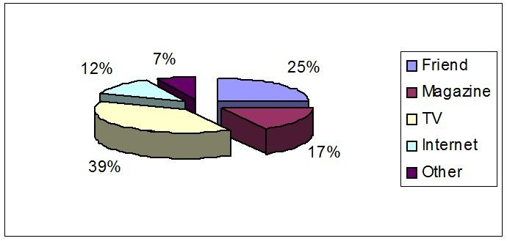

What percentage of respondents learned about the product through television or the Internet?
A) 12%
B) 39%
C) 51%
D) 100%
Answer: C
Difficulty: Easy
Topic: Graphs to Describe Categorical Variables
AACSB: Analytic Skills
Course LO: Compare and contrast methods of summarizing and describing data

22) A line graph that connects points that represent the cumulative percentage of observations below the upper limit of each class interval in a cumulative frequency distribution is known as a(n):
A) ogive.
B) frequency histogram.
C) frequency polygon.
D) scatter plot.
Answer: A
Difficulty: Easy
Topic: Graphs to Describe Numerical Variables
AACSB: Reflective Thinking Skills
Course LO: Compare and contrast methods of summarizing and describing data

23) Pareto's principle is applied to a wide variety of behavior over many systems. It is sometimes referred to as the:
A) "20-80" Rule.
B) "80-20" Rule.
C) "10-90" Rule.
D) "90-10" Rule.
Answer: B
Difficulty: Moderate
Topic: Graphs to Describe Categorical Variables
AACSB: Reflective Thinking Skills
Course LO: Compare and contrast methods of summarizing and describing data
24) Which of the following is most likely a continuous numerical variable?
A) the number of gallons of paint purchased
B) the number of reams of paper ordered
C) the population of Egypt in 2005
D) the number of miles of interstate highways
Answer: D
Difficulty: Moderate
Topic: Classification of Variables
AACSB: Reflective Thinking Skills
Course LO: Compare and contrast methods of summarizing and describing data

THE NEXT QUESTIONS ARE BASED ON THE FOLLOWING INFORMATION:
The Quality Assurance Department of a large restaurant is attempting to monitor and evaluate customer satisfaction with restaurant services. Prior to their departure, a random sample of customers is asked to fill out a short questionnaire to rate such services as quality of food, price, waiting time to be served, and cleanliness of the place. The Quality Assurance Department prepares weekly reports that are used to improve the services.

25) In this restaurant services study, the process of using sample information for predictions, forecasts, and estimates is called:
A) inferential statistics.
B) descriptive statistics.
C) statistical survey.
D) process.
Answer: A
Difficulty: Easy
Topic: Decision Making in an Uncertain Environment
AACSB: Reflective Thinking Skills
Course LO: Identify different business uses for statistics and the major statistical tools businesses use

26) In this restaurant services study, the process of using this information to predict future needs of customers in the restaurant is called:
A) statistical survey.
B) systemic sampling.
C) descriptive statistics.
D) forecasting.
Answer: D
Difficulty: Easy
Topic: Decision Making in an Uncertain Environment
AACSB: Reflective Thinking Skills
Course LO: Identify different business uses for statistics and the major statistical tools businesses use
27) In this restaurant services study, a listing of all customers in this restaurant over a particular week would constitute a:
A) sample.
B) population.
C) numerical variable.
D) process.
Answer: B
Difficulty: Easy
Topic: Decision Making in an Uncertain Environment
AACSB: Reflective Thinking Skills
Course LO: Identify different business uses for statistics and the major statistical tools businesses use

28) You asked ten of your classmates about their weight. On the basis of this information, you stated that the average weight of all students in your university or college is 142.6 pounds. This is an example of:
A) descriptive statistics.
B) inferential statistics.
C) parameter.
D) population.
Answer: B
Difficulty: Easy
Topic: Decision Making in an Uncertain Environment
AACSB: Analytic Skills
Course LO: Explain how data are acquired and distinguish among different types of data and levels of measurement

29) In rating the service provided by a restaurant server, the following responses are possible: excellent, above average, average, below average, and poor. The responses are coded from 1 to 5 with 5 being excellent. The level of measurement this scale represents is:
A) nominal.
B) ordinal.
C) interval.
D) ratio.
Answer: B
Difficulty: Easy
Topic: Classification of Variables
AACSB: Analytic Skills
Course LO: Explain how data are acquired and distinguish among different types of data and levels of measurement
30) Which of the following is a categorical variable?
A) tire pressure
B) bank account balance
C) daily sales in a store
D) eye color
Answer: D
Difficulty: Easy
Topic: Classification of Variables
AACSB: Reflective Thinking Skills
Course LO: Explain how data are acquired and distinguish among different types of data and levels of measurement

31) An automobile insurance agent believes that company A is more reliable than company B. Which level of measurement does this information represent?
A) nominal
B) ordinal
C) interval
D) ratio
Answer: B
Difficulty: Moderate
Topic: Classification of Variables
AACSB: Reflective Thinking Skills
Course LO: Explain how data are acquired and distinguish among different types of data and levels of measurement

32) Which of the following statements involve inferential statistics as opposed to descriptive statistics?
A) The FAA reported there were 180 near misses among commercial aircraft last year.
B) A class of fifty five statistics students earned an average grade of 72.5.
C) The city business office reported 50 building permits for new single-family housing units.
D) Based on a sample of 450 subscribers, a local satellite TV system estimates that 45 percent of its subscribers watch a premium channel at least once per day.
Answer: D
Difficulty: Moderate
Topic: Decision Making in an Uncertain Environment
AACSB: Analytic Skills
Course LO: Identify different business uses for statistics and the major statistical tools businesses use

33) Which of the following best describes the data: zip codes for students attending Glenville College?
A) qualitative
B) numerical
C) quantitative
D) time-series
Answer: A
Difficulty: Easy
Topic: Classification of Variables
AACSB: Reflective Thinking Skills
Course LO: Compare and contrast methods of summarizing and describing data
34) Which of the following best describes the data: grade point averages for athletes?
A) categorical
B) quantitative
C) qualitative
D) relative frequency
Answer: B
Difficulty: Easy
Topic: Classification of Variables
AACSB: Reflective Thinking Skills
Course LO: Compare and contrast methods of summarizing and describing data

35) A company has developed a new battery, but the average lifetime is unknown. In order to estimate this average, a sample of 110 batteries is tested and the average lifetime of this sample is found to be 200 hours. The 200 hours is the value of a:
A) parameter.
B) statistic.
C) sampling frame.
D) population.
Answer: B
Difficulty: Easy
Topic: Decision Making in an Uncertain Environment
AACSB: Reflective Thinking Skills
Course LO: Compare and contrast methods of summarizing and describing data

36) Consider the following data: like, no preference, or dislike. Which of the following best describes these data?
A) qualitative
B) numerical
C) quantitative
D) attitude
Answer: A
Difficulty: Easy
Topic: Classification of Variables
AACSB: Reflective Thinking Skills
Course LO: Compare and contrast methods of summarizing and describing data

37) A summary measure that is computed from a population is known as a(n):
A) parameter.
B) statistic.
C) sample.
D) inferential statistic.
Answer: A
Difficulty: Easy
Topic: Decision Making in an Uncertain Environment
AACSB: Reflective Thinking Skills
Course LO: Compare and contrast methods of summarizing and describing data
38) At a large company, the majority of the employees earn from $22,000 to $32,000 per year. Middle management employees earn between $32,000 and $52,000 per year while top management earn between $54,000 and $104,000 per year. A histogram of all salaries would have which of the following shapes?
A) symmetrical
B) uniform
C) skewed to right
D) skewed to left
Answer: C
Difficulty: Easy
Topic: Graphs to Describe Numerical Variables
AACSB: Analytic Skills
Course LO: Compare and contrast methods of summarizing and describing data

39) Which of the following is the graphical analog of a frequency table?
A) histogram
B) scatter plot
C) time series plot
D) contingency table
Answer: A
Difficulty: Easy
Topic: Graphs to Describe Numerical Variables
AACSB: Reflective Thinking Skills
Course LO: Compare and contrast methods of summarizing and describing data

40) Which of the following statements is false?
A) Relative frequencies are often useful in a presentation because nearly everybody understands fractional parts when expressed as percents.
B) Relative frequencies are particularly useful when comparing the frequency distributions of two different size sets of data.
C) The histogram of a normal sample should have a distribution shape that is skewed.
D) A stem-and-leaf display contains all the information needed to create a histogram.
Answer: C
Difficulty: Moderate
Topic: Graphs to Describe Numerical Variables
AACSB: Reflective Thinking Skills
Course LO: Compare and contrast methods of summarizing and describing data

41) Numerical variables can be subdivided into two types. What are they?
A) diverse and categorical
B) discrete and continuous
C) nominal and progressive
D) cross-sectional and discrete
Answer: B
Difficulty: Easy
Topic: Classification of Variables
AACSB: Reflective Thinking Skills
Course LO: Compare and contrast methods of summarizing and describing data
42) A summary measure that is computed from a sample to describe a characteristic of the population is known as a(n):
A) parameter.
B) statistic.
C) population.
D) inferential statistic.
Answer: B
Difficulty: Easy
Topic: Decision Making in an Uncertain Environment
AACSB: Reflective Thinking Skills
Course LO: Compare and contrast methods of summarizing and describing data

43) Gender and state of birth are examples of which type of data?
A) discrete
B) continuous
C) categorical
D) ordinal
Answer: C
Difficulty: Easy
Topic: Classification of Variables
AACSB: Reflective Thinking Skills
Course LO: Compare and contrast methods of summarizing and describing data

44) Which of the following statements is false?
A) A Pareto diagram is a bar graph with the bars arranged from the most numerous categories to the least numerous categories.
B) A Pareto diagram includes a line graph displaying the cumulative percentages and counts for the bars.
C) A Pareto diagram of types of defects will show the ones that have the greatest effect on the defective rate in order of effect. It is then easy to see which defects should be targeted in order to most effectively lower the defective rate.
D) A Pareto diagram shows the most frequent bars on the right.
Answer: D
Difficulty: Moderate
Topic: Graphs to Describe Categorical Variables
AACSB: Reflective Thinking Skills
Course LO: Compare and contrast methods of summarizing and describing data

45) A variable is classified as ordinal if:
A) there is a natural ordering of categories.
B) there is no natural ordering of categories.
C) the data arise from continuous measurements.
D) the variable is tracked over a period of time.
Answer: A
Difficulty: Easy
Topic: Classification of Variables
AACSB: Reflective Thinking Skills
Course LO: Compare and contrast methods of summarizing and describing data
46) A time-series plot is essentially a:
A) histogram.
B) scatter plot.
C) Pareto diagram.
D) pie chart.
Answer: B
Difficulty: Easy
Topic: Graphs to Describe Time-Series Data
AACSB: Reflective Thinking Skills
Course LO: Compare and contrast methods of summarizing and describing data

THE NEXT QUESTIONS ARE BASED ON THE FOLLOWING INFORMATION:
In a recent marketing experiment, consumers were given one of four different types of dishwashing detergent and asked to use it for a month. At the end of that time they were asked to rate the detergent in terms of overall quality. The results are presented below.

 | Poor | Average | Fair | Good | Total
Brand A | 5 | 17 | 11 | 10 | 43
Brand B | 14 | 26 | 8 | 18 | 66
Brand C | 10 | 23 | 11 | 17 | 61
Brand D | 11 | 19 | 7 | 5 | 42
Total | 40 | 85 | 37 | 50 | 212

47) What percentage of the consumers rated their detergent fair or good?
A) 49.0%
B) 41.0%
C) 17.5%
D) 23.6%
Answer: B
Difficulty: Moderate
Topic: Graphs to Describe Categorical Variables
AACSB: Analytic Skills
Course LO: Compare and contrast methods of summarizing and describing data

48) What percentage of the consumers evaluated Brand A?
A) 20.3%
B) 16.7%
C) 23.0%
D) 18.9%
Answer: A
Difficulty: Moderate
Topic: Graphs to Describe Categorical Variables
AACSB: Analytic Skills
Course LO: Compare and contrast methods of summarizing and describing data
49) What percentage of the consumers rated their detergent average or better?
A) 23.6%
B) 40.1%
C) 81.1%
D) 17.5%
Answer: C
Difficulty: Moderate
Topic: Graphs to Describe Categorical Variables
AACSB: Analytic Skills
Course LO: Compare and contrast methods of summarizing and describing data

50) What percentage of the consumers rated their detergent below average?
A) 41.0%
B) 59.0%
C) 17.5%
D) 18.9%
Answer: D
Difficulty: Moderate
Topic: Graphs to Describe Categorical Variables
AACSB: Analytic Skills
Course LO: Compare and contrast methods of summarizing and describing data

51) Of the customers who were given Brand A, what percentage rated it poor?
A) 12.5%
B) 2.40%
C) 11.6%
D) 18.9%
Answer: C
Difficulty: Moderate
Topic: Graphs to Describe Categorical Variables
AACSB: Analytic Skills
Course LO: Compare and contrast methods of summarizing and describing data

52) Of the customers who rated their detergent good, what percentage evaluated Brand C?
A) 23.6%
B) 34.0%
C) 8.0%
D) 28.8%
Answer: B
Difficulty: Moderate
Topic: Graphs to Describe Categorical Variables
AACSB: Analytic Skills
Course LO: Compare and contrast methods of summarizing and describing data
53) A professor needs to select a volunteer for a project. Which of the following would not be an example of a simple random sample?
A) He chooses a number between 00 and 99. The student whose phone number has the last two digits closest to the one the professor has chosen is selected.
B) He chooses that individual whose name is first in alphabetical order.
C) He puts all student names in a bowl, mixes them up, and selects one.
D) He has each student select a number between 0 and 99 and write it down. He then selects the student whose number is closest to the last two digits of his social security number.
Answer: B
Difficulty: Easy
Topic: Decision Making in an Uncertain Environment
AACSB: Reflective Thinking Skills
Course LO: Explain how data are acquired and distinguish among different types of data and levels of measurement

54) When data is collected using a qualitative, nominal variable, what is true about a frequency distribution that summarizes the data?
A) Lower and upper class limits can be computed.
B) Class midpoints can be computed.
C) Number of classes corresponds to number of the variable's categories.
D) None of the above
Answer: C
Difficulty: Easy
Topic: Classification of Variables
AACSB: Reflective Thinking Skills
Course LO: Compare and contrast methods of summarizing and describing data

55) An observed subset of the population that is usually selected for analysis is called:
A) knowledge.
B) a sample.
C) a statistic.
D) a process.
Answer: B
Difficulty: Easy
Topic: Decision Making in an Uncertain Environment
AACSB: Reflective Thinking Skills
Course LO: Explain how data are acquired and distinguish among different types of data and levels of measurement
56) Which analytical tool is often used to separate the "vital few" from the "trivial many"?
A) Pareto diagram
B) pie chart
C) line chart
D) histogram
Answer: A
Difficulty: Easy
Topic: Graphs to Describe Categorical Variables
AACSB: Reflective Thinking Skills
Course LO: Compare and contrast methods of summarizing and describing data
57) In a frequency distribution, what is the number of observations in a class called?
A) class midpoint
B) class frequency
C) class interval
D) none of the above
Answer: B
Difficulty: Easy
Topic: Graphs to Describe Numerical Variables
AACSB: Reflective Thinking Skills
Course LO: Compare and contrast methods of summarizing and describing data

58) If three possible values of a variable represent distinct categories of similar objects or events, the variable is referred to as a:
A) numerical variable.
B) categorical variable.
C) binary variable.
D) none of the above
Answer: B
Difficulty: Moderate
Topic: Classification of Variables
AACSB: Reflective Thinking Skills
Course LO: Compare and contrast methods of summarizing and describing data

59) A variable within a range of real numbers is referred to as a:
A) continuous variable.
B) categorical variable.
C) discrete variable.
D) parameter.
Answer: C
Difficulty: Moderate
Topic: Classification of Variables
AACSB: Reflective Thinking Skills
Course LO: Compare and contrast methods of summarizing and describing data
60) Dimensional characteristics, such as height, are an example of a:
A) continuous random variable.
B) discrete random variable.
C) categorical random variable.
D) any of the above
Answer: A
Difficulty: Easy
Topic: Classification of Variables
AACSB: Reflective Thinking Skills
Course LO: Explain how data are acquired and distinguish among different types of data and levels of measurement

61) Which of the following statements about a pie chart is false?
A) A pie chart is graphical representation of the proportion or percentage of frequency of each category of a categorical variable.
B) A pie chart is usually used to display the relative sizes of categories of a numerical variable.
C) A pie chart always has the shape of a circle.
D) The size of each slice of a pie chart is the proportion or percentage of frequency of the corresponding category of a categorical variable.
Answer: B
Difficulty: Moderate
Topic: Graphs to Describe Categorical Variables
AACSB: Reflective Thinking Skills
Course LO: Explain how data are acquired and distinguish among different types of data and levels of measurement

62) Anita collected a data set on the weights (to the nearest pounds) of all students at her university. The best graph to describe this data is a:
A) histogram
B) pie chart
C) bar chart
D) scatter plot
Answer: A
Difficulty: Easy
Topic: Graphs to Describe Numerical Variables
AACSB: Reflective Thinking Skills
Course LO: Explain how data are acquired and distinguish among different types of data and levels of measurement
63) What is the best type of chart for comparing two sets of categorical data?
A) Ogive
B) bar chart
C) pie chart
D) histogram
Answer: B
Difficulty: Easy
Topic: Graphs to Describe Categorical Variables
AACSB: Reflective Thinking Skills
Course LO: Explain how data are acquired and distinguish among different types of data and levels of measurement
64) The procedure used to select a sample of objects from a population in a way that each member of the population is chosen strictly by chance and is equally likely to be chosen is called:
A) sampled population.
B) systematic sampling.
C) simple random sampling.
D) self-selected sampling.
Answer: C
Difficulty: Easy
Topic: Decision Making in an Uncertain Environment
AACSB: Reflective Thinking Skills
Course LO: Explain how data are acquired and distinguish among different types of data and levels of measurement

65) A researcher randomly picks the first item or subject from a population, N then selects each jth subject where j is the ratio of the population size, N to the desired sample size, n. In this case, the researcher is using:
A) random sampling.
B) systematic random sampling.
C) population sampling.
D) parameter sampling.
Answer: B
Difficulty: Moderate
Topic: Decision Making in an Uncertain Environment
AACSB: Reflective Thinking Skills
Course LO: Explain how data are acquired and distinguish among different types of data and levels of measurement
66) Suppose a sample size of 50 is desired and the population consists of 2,500 names in alphabetical order. The jth, or systematic sampling number would be:
A) 50.
B) 100.
C) 250.
D) 500.
Answer: A
Difficulty: Moderate
Topic: Decision Making in an Uncertain Environment
AACSB: Analytic Skills
Course LO: Explain how data are acquired and distinguish among different types of data and levels of measurement

67) A source of error resulting from the fact that information is available only on a subset of the total population is referred to as a(n):
A) nonsampling error.
B) irrelevant error.
C) inaccurate error.
D) sampling error.
Answer: D
Difficulty: Moderate
Topic: Decision Making in an Uncertain Environment
AACSB: Reflective Thinking Skills
Course LO: Explain how data are acquired and distinguish among different types of data and levels of measurement

68) A more serious error resulting from errors in the kind of sampling procedure used is called a(n):
A) nonsampling error.
B) irrelevant error.
C) inaccurate error.
D) sampling error.
Answer: A
Difficulty: Moderate
Topic: Decision Making in an Uncertain Environment
AACSB: Reflective Thinking Skills
Course LO: Explain how data are acquired and distinguish among different types of data and levels of measurement
69) The type of variables which produce responses that belong to groups or categories, such as responses to yes or no questions, are called:
A) continuous numerical variables.
B) discrete numerical variables.
C) categorical variables.
D) inverse variables.
Answer: C
Difficulty: Moderate
Topic: Classification of Variables
AACSB: Reflective Thinking Skills
Course LO: Explain how data are acquired and distinguish among different types of data and levels of measurement

70) A baseball player is assigned the number 15 and another one the number 25. This is an example of ________ data.
A) quantitative
B) interval
C) ratio levels
D) qualitative
Answer: D
Difficulty: Easy
Topic: Classification of Variables
AACSB: Reflective Thinking Skills
Course LO: Explain how data are acquired and distinguish among different types of data and levels of measurement
71) A table used to organize data where the left column includes classes or groups and the right column includes the frequencies or observation for each class is called a:
A) crosstab.
B) frequency distribution.
C) relative frequency distribution.
D) class chart.
Answer: B
Difficulty: Moderate
Topic: Graphs to Describe Numerical Variables
AACSB: Reflective Thinking Skills
Course LO: Compare and contrast methods of summarizing and describing data
72) The table which lists the number of observations for every combination of values for two categorical or ordinal variables is called a:
A) frequency distribution.
B) relative frequency distribution.
C) cross table.
D) class chart.
Answer: C
Difficulty: Moderate
Topic: Graphs to Describe Categorical Variables
AACSB: Reflective Thinking Skills
Course LO: Compare and contrast methods of summarizing and describing data

73) One manner in which to bring attention to data summarized in a table showing relative frequencies is by the use of a:
A) bar chart.
B) pie chart.
C) scatter plot.
D) stem-and-leaf display.
Answer: B
Difficulty: Easy
Topic: Graphs to Describe Numerical Variables
AACSB: Reflective Thinking Skills
Course LO: Compare and contrast methods of summarizing and describing data
THE NEXT QUESTIONS ARE BASED ON THE FOLLOWING INFORMATION:

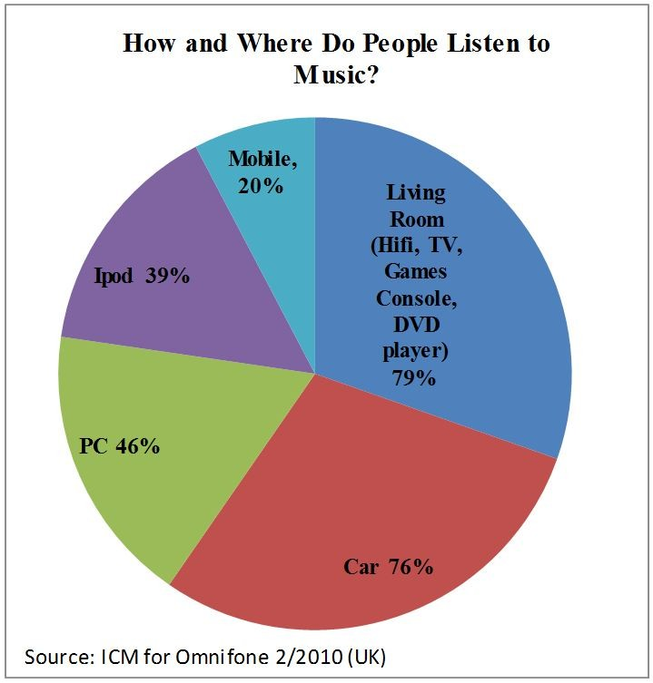

74) Where is most music listened to?
A) Car
B) Ipod
C) PC
D) Living Room
Answer: D
Difficulty: Easy
Topic: Graphs to Describe Categorical Variables
AACSB: Analytic Skills
Course LO: Compare and contrast methods of summarizing and describing data

75) What percentage of music is listened to on mobile devices?
A) 39%
B) 76%
C) 20%
D) 46%
Answer: C
Difficulty: Easy
Topic: Graphs to Describe Categorical Variables
AACSB: Analytic Skills
Course LO: Compare and contrast methods of summarizing and describing data
76) The bar chart that best identifies major causes of problems or defects by displaying the frequency of defect causes is called a:
A) pie chart.
B) scatter plot.
C) stem-and-leaf display.
D) Pareto diagram.
Answer: D
Difficulty: Easy
Topic: Graphs to Describe Categorical Variables
AACSB: Reflective Thinking Skills
Course LO: Compare and contrast methods of summarizing and describing data

77) Annual university enrollment, annual interest rates, daily stock closing prices for shares, and monthly products sales are examples of which type of data?
A) parameters
B) Pareto diagram
C) time-series data
D) pie charts
Answer: C
Difficulty: Moderate
Topic: Graphs to Describe Time-Series Data
AACSB: Reflective Thinking Skills
Course LO: Compare and contrast methods of summarizing and describing data

78) A frequency distribution of numerical data differs from a frequency distribution for categorical data in that a frequency distribution for numerical data:
A) focuses on number and width of classes.
B) does not contain classes.
C) lists the classes in the right column.
D) lists the observations in the left column.
Answer: A
Difficulty: Moderate
Topic: Graphs to Describe Numerical Variables
AACSB: Reflective Thinking Skills
Course LO: Compare and contrast methods of summarizing and describing data

79) We can describe graphically the shape of a distribution by a:
A) pie chart.
B) histogram.
C) scatter plot.
D) line chart.
Answer: B
Difficulty: Easy
Topic: Graphs to Describe Numerical Variables
AACSB: Reflective Thinking Skills
Course LO: Compare and contrast methods of summarizing and describing data
80) If the observations are not symmetrically distributed on either side of its center, the histogram is said to be:
A) leaning.
B) pointing.
C) skewed.
D) wide.
Answer: C
Difficulty: Easy
Topic: Graphs to Describe Numerical Variables
AACSB: Reflective Thinking Skills
Course LO: Compare and contrast methods of summarizing and describing data

81) If the distribution of a histogram has more lower values, it is said to be:
A) skewed right.
B) skewed left.
C) symmetrical.
D) wide.
Answer: A
Difficulty: Moderate
Topic: Graphs to Describe Numerical Variables
AACSB: Reflective Thinking Skills
Course LO: Compare and contrast methods of summarizing and describing data

82) A histogram which is skewed to the left has more:
A) lower values.
B) higher values.
C) even values.
D) odd values.
Answer: B
Difficulty: Moderate
Topic: Graphs to Describe Numerical Variables
AACSB: Reflective Thinking Skills
Course LO: Compare and contrast methods of summarizing and describing data

83) Procedures used to describe data in simple arithmetic terms with easy-to-draw pencil-and-paper pictures are called:
A) data exploration procedures (DEP).
B) cross table data.
C) exploratory data analysis (EDA).
D) inverted data.
Answer: C
Difficulty: Moderate
Topic: Graphs to Describe Numerical Variables
AACSB: Reflective Thinking Skills
Course LO: Compare and contrast methods of summarizing and describing data
84) Making the heights of the bars but not the areas in a histogram proportional to the frequencies provides for a(n):
A) balanced histogram
B) misleading histogram
C) symmetrical histogram
D) accurate histogram
Answer: B
Difficulty: Moderate
Topic: Data Presentation Errors
AACSB: Reflective Thinking Skills
Course LO: Compare and contrast methods of summarizing and describing data

85) The scatter plot can be used to detect whether a linear relationship exists in the data.
Answer: TRUE
Difficulty: Easy
Topic: Graphs to Describe Numerical Variables
AACSB: Reflective Thinking Skills
Course LO: Compare and contrast methods of summarizing and describing data

86) A histogram is the best graphical tool to display qualitative data.
Answer: FALSE
Difficulty: Easy
Topic: Graphs to Describe Numerical Variables
AACSB: Reflective Thinking Skills
Course LO: Compare and contrast methods of summarizing and describing data

87) Descriptive statistics are used to make a forecast regarding future trends.
Answer: FALSE
Difficulty: Easy
Topic: Graphs to Describe Time-Series Data
AACSB: Reflective Thinking Skills
Course LO: Compare and contrast methods of summarizing and describing data

88) Descriptive statistics transform data into information.
Answer: TRUE
Difficulty: Easy
Topic: Decision Making in an Uncertain Environment
AACSB: Reflective Thinking Skills
Course LO: Compare and contrast methods of summarizing and describing data

89) Discrete numerical variables necessarily have a finite number of values.
Answer: FALSE
Difficulty: Easy
Topic: Classification of Variables
AACSB: Reflective Thinking Skills
Course LO: Explain how data are acquired and distinguish among different types of data and levels of measurement
90) Ordinal data indicate the rank ordering of items, and similar to nominal data, the values are words that describe responses.
Answer: TRUE
Difficulty: Easy
Topic: Classification of Variables
AACSB: Reflective Thinking Skills
Course LO: Explain how data are acquired and distinguish among different types of data and levels of measurement

91) Descriptive statistics is the study of a sample that enables a researcher to make projections or estimates about the population from which the sample is drawn.
Answer: FALSE
Difficulty: Easy
Topic: Decision Making in an Uncertain Environment
AACSB: Reflective Thinking Skills
Course LO: Compare and contrast methods of summarizing and describing data

92) Statistics provides business functional areas with tools to make decisions under conditions of uncertainty.
Answer: TRUE
Difficulty: Easy
Topic: Decision Making in an Uncertain Environment
AACSB: Reflective Thinking Skills
Course LO: Identify different business uses for statistics and the major statistical tools businesses use

93) A time-series plot is considered a pie chart that displays the relative frequency of defect causes and is used to separate the "vital few" from the "trivial many"
Answer: FALSE
Difficulty: Easy
Topic: Graphs to Describe Time-Series Data
AACSB: Reflective Thinking Skills
Course LO: Compare and contrast methods of summarizing and describing data

94) An interval scale indicates rank and distance from a natural zero measured in unit intervals.
Answer: FALSE
Difficulty: Easy
Topic: Classification of Variables
AACSB: Reflective Thinking Skills
Course LO: Compare and contrast methods of summarizing and describing data

95) The role of inferential statistics is to help understand the characteristics of the sample.
Answer: FALSE
Difficulty: Easy
Topic: Decision Making in an Uncertain Environment
AACSB: Reflective Thinking Skills
Course LO: Compare and contrast methods of summarizing and describing data
96) A professor is looking for a volunteer for a project. She chooses a number between 00 and 99. The student whose phone number has the last two digits closest to the one the professor has chosen is selected. This is an example of a simple random sample.
Answer: TRUE
Difficulty: Easy
Topic: Decision Making in an Uncertain Environment
AACSB: Reflective Thinking Skills
Course LO: Explain how data are acquired and distinguish among different types of data and levels of measurement

97) A sample is the complete set of elements in which an investigator is interested.
Answer: FALSE
Difficulty: Easy
Topic: Decision Making in an Uncertain Environment
AACSB: Reflective Thinking Skills
Course LO: Explain how data are acquired and distinguish among different types of data and levels of measurement

98) Ratio data indicate both rank and distance from a natural zero, with ratios of two measures having meaning.
Answer: TRUE
Difficulty: Easy
Topic: Classification of Variables
AACSB: Reflective Thinking Skills
Course LO: Explain how data are acquired and distinguish among different types of data and levels of measurement

99) Inferential statistics transform data into information.
Answer: TRUE
Difficulty: Easy
Topic: Decision Making in an Uncertain Environment
AACSB: Reflective Thinking Skills
Course LO: Explain how data are acquired and distinguish among different types of data and levels of measurement

100) It is possible to use statistics to quantify the relationship between variables.
Answer: TRUE
Difficulty: Easy
Topic: Decision Making in an Uncertain Environment
AACSB: Reflective Thinking Skills
Course LO: Compare and contrast methods of summarizing and describing data

101) Cross tables can be used for summarizing both qualitative and quantitative data.
Answer: FALSE
Difficulty: Easy
Topic: Graphs to Describe Categorical Variables
AACSB: Reflective Thinking Skills
Course LO: Compare and contrast methods of summarizing and describing data
102) Bar charts and pie charts are commonly used to describe categorical data.
Answer: TRUE
Difficulty: Easy
Topic: Graphs to Describe Categorical Variables
AACSB: Reflective Thinking Skills
Course LO: Compare and contrast methods of summarizing and describing data

103) An audit of accounts receivable will generally be based on a population.
Answer: FALSE
Difficulty: Easy
Topic: Classification of Variables
AACSB: Reflective Thinking Skills
Course LO: Explain how data are acquired and distinguish among different types of data and levels of measurement

104) Inferential statistics transform information into knowledge.
Answer: TRUE
Difficulty: Easy
Topic: Decision Making in an Uncertain Environment
AACSB: Reflective Thinking Skills
Course LO: Explain how data are acquired and distinguish among different types of data and levels of measurement

105) In a simple random sample, every possible sample of size n is equally likely to be selected.
Answer: TRUE
Difficulty: Easy
Topic: Decision Making in an Uncertain Environment
AACSB: Reflective Thinking Skills
Course LO: Explain how data are acquired and distinguish among different types of data and levels of measurement

106) A time-series plot measures time along the vertical axis and the numerical values of the variable of interest along the horizontal axis.
Answer: FALSE
Difficulty: Easy
Topic: Graphs to Describe Time-Series Data
AACSB: Reflective Thinking Skills
Course LO: Compare and contrast methods of summarizing and describing data

107) An example of a quantitative variable is the make of a car.
Answer: FALSE
Difficulty: Easy
Topic: Classification of Variables
AACSB: Reflective Thinking Skills
Course LO: Compare and contrast methods of summarizing and describing data
108) Descriptive statistics is a process, not just a numerical result. This process might include estimation, hypothesis testing, analysis of relationships, or forecasting.
Answer: FALSE
Difficulty: Easy
Topic: Decision Making in an Uncertain Environment
AACSB: Reflective Thinking Skills
Course LO: Compare and contrast methods of summarizing and describing data

109) A line chart is also called a time-series plot.
Answer: TRUE
Difficulty: Easy
Topic: Graphs to Describe Time-Series Data
AACSB: Reflective Thinking Skills
Course LO: Compare and contrast methods of summarizing and describing data

110) A statistic is a descriptive measure computed from an entire population.
Answer: FALSE
Difficulty: Easy
Topic: Decision Making in an Uncertain Environment
AACSB: Reflective Thinking Skills
Course LO: Explain how data are acquired and distinguish among different types of data and levels of measurement

111) If we attempt to estimate the average age of a particular university's students using inferential statistics, we are analyzing relationships.
Answer: FALSE
Difficulty: Easy
Topic: Decision Making in an Uncertain Environment
AACSB: Reflective Thinking Skills
Course LO: Explain how data are acquired and distinguish among different types of data and levels of measurement

112) A parameter is a descriptive measure computed from an entire population.
Answer: TRUE
Difficulty: Easy
Topic: Decision Making in an Uncertain Environment
AACSB: Reflective Thinking Skills
Course LO: Explain how data are acquired and distinguish among different types of data and levels of measurement

113) Inferential statistics is the study and description of data that result from an experiment.
Answer: FALSE
Difficulty: Easy
Topic: Decision Making in an Uncertain Environment
AACSB: Reflective Thinking Skills
Course LO: Explain how data are acquired and distinguish among different types of data and levels of measurement
114) An ogive is also called a cumulative line graph.
Answer: TRUE
Difficulty: Easy
Topic: Graphs to Describe Numerical Variables
AACSB: Reflective Thinking Skills
Course LO: Compare and contrast methods of summarizing and describing data

115) The field of statistics can be roughly subdivided into two areas: descriptive statistics and probability.
Answer: FALSE
Difficulty: Easy
Topic: Decision Making in an Uncertain Environment
AACSB: Reflective Thinking Skills
Course LO: Compare and contrast methods of summarizing and describing data

116) A scatter plot usually doesn't indicate whether extreme values exist in the data.
Answer: FALSE
Difficulty: Easy
Topic: Graphs to Describe Numerical Variables
AACSB: Reflective Thinking Skills
Course LO: Compare and contrast methods of summarizing and describing data

117) A company employs 750 individuals. To ascertain how the employees feel regarding a pension plan, 75 of the employees are surveyed. The proportion of the 75 employees who favor the pension plan is a parameter.
Answer: FALSE
Difficulty: Easy
Topic: Decision Making in an Uncertain Environment
AACSB: Reflective Thinking Skills
Course LO: Explain how data are acquired and distinguish among different types of data and levels of measurement

118) Histograms may not be "mathematically correct" since they often cannot be scaled on the vertical axis.
Answer: TRUE
Difficulty: Easy
Topic: Graphs to Describe Numerical Variables
AACSB: Reflective Thinking Skills
Course LO: Compare and contrast methods of summarizing and describing data

119) A stem-and-leaf is an exploratory data analysis (EDA) graph that is an alternative to the line graph.
Answer: FALSE
Difficulty: Easy
Topic: Graphs to Describe Numerical Variables
AACSB: Reflective Thinking Skills
Course LO: Compare and contrast methods of summarizing and describing data
120) In real life, there aren't any situations in which we need to describe relationships between categorical or ordinal variables.
Answer: FALSE
Difficulty: Easy
Topic: Graphs to Describe Categorical Variables
AACSB: Reflective Thinking Skills
Course LO: Compare and contrast methods of summarizing and describing data

121) If we attempt to determine if weekend sales are higher than weekday sales using inferential statistics, we are testing a hypothesis.
Answer: TRUE
Difficulty: Moderate
Topic: Decision Making in an Uncertain Environment
AACSB: Reflective Thinking Skills
Course LO: Compare and contrast methods of summarizing and describing data

122) Decisions are often based on incomplete information in an uncertain environment.
Answer: TRUE
Difficulty: Moderate
Topic: Decision Making in an Uncertain Environment
AACSB: Reflective Thinking Skills
Course LO: Compare and contrast methods of summarizing and describing data

123) There are four levels of measurement within qualitative and quantitative data.
Answer: TRUE
Difficulty: Moderate
Topic: Classification of Variables
AACSB: Reflective Thinking Skills
Course LO: Explain how data are acquired and distinguish among different types of data and levels of measurement

124) The statement "The price of a Canon digital camera is likely to be lower in three months than it is now" is arrived at by the use of descriptive statistics.
Answer: FALSE
Difficulty: Moderate
Topic: Decision Making in an Uncertain Environment
AACSB: Reflective Thinking Skills
Course LO: Compare and contrast methods of summarizing and describing data

125) Your high school graduating class rank is an example of an ordinal scale.
Answer: FALSE
Difficulty: Easy
Topic: Classification of Variables
AACSB: Reflective Thinking Skills
Course LO: Compare and contrast methods of summarizing and describing data
126) All graphic representations of sets of data need to be completely self-explanatory. That includes a descriptive meaningful title and identification of the vertical and horizontal scales.
Answer: TRUE
Difficulty: Easy
Topic: Graphs to Describe Categorical Variables
AACSB: Reflective Thinking Skills
Course LO: Compare and contrast methods of summarizing and describing data

127) A professor is looking for a volunteer for a project. She chooses the individual whose name is first in alphabetical order. This is an example of a simple random sample.
Answer: FALSE
Difficulty: Moderate
Topic: Decision Making in an Uncertain Environment
AACSB: Reflective Thinking Skills
Course LO: Explain how data are acquired and distinguish among different types of data and levels of measurement

128) The stem-and-leaf display for summarizing numerical data is a combination of a graphic technique and a sorting technique.
Answer: TRUE
Difficulty: Easy
Topic: Graphs to Describe Numerical Variables
AACSB: Reflective Thinking Skills
Course LO: Compare and contrast methods of summarizing and describing data

129) The larger the number of observations in a numerical data set, the smaller the number of class intervals needed for constructing a grouped frequency distribution.
Answer: FALSE
Difficulty: Easy
Topic: Graphs to Describe Numerical Variables
AACSB: Reflective Thinking Skills
Course LO: Compare and contrast methods of summarizing and describing data

130) The ratio scale of measurement indicates both rank and distance from a natural zero.
Answer: TRUE
Difficulty: Easy
Topic: Classification of Variables
AACSB: Reflective Thinking Skills
Course LO: Explain how data are acquired and distinguish among different types of data and levels of measurement

131) The histogram of a sample should have a distribution shape very similar to that of the population from which the sample was drawn.
Answer: TRUE
Difficulty: Easy
Topic: Graphs to Describe Numerical Variables
AACSB: Reflective Thinking Skills
Course LO: Compare and contrast methods of summarizing and describing data
132) One important principle that must be followed in the sample selection process is randomness.
Answer: TRUE
Difficulty: Easy
Topic: Decision Making in an Uncertain Environment
AACSB: Reflective Thinking Skills
Course LO: Explain how data are acquired and distinguish among different types of data and levels of measurement

133) A student's IQ is an example of the ratio scale of measurement.
Answer: FALSE
Difficulty: Easy
Topic: Classification of Variables
AACSB: Reflective Thinking Skills
Course LO: Explain how data are acquired and distinguish among different types of data and levels of measurement

134) One possible error in constructing a histogram is to make the heights of the rectangles, and not the areas of the rectangles, proportional to the frequencies.
Answer: TRUE
Difficulty: Easy
Topic: Data Presentation Errors
AACSB: Reflective Thinking Skills
Course LO: Explain how data are acquired and distinguish among different types of data and levels of measurement

135) Descriptive statistics are used to transform information into data.
Answer: FALSE
Difficulty: Easy
Topic: Decision Making in an Uncertain Environment
AACSB: Reflective Thinking Skills
Course LO: Compare and contrast methods of summarizing and describing data

136) Jersey numbers of basketball players are an example of the ordinal scale data.
Answer: FALSE
Difficulty: Easy
Topic: Classification of Variables
AACSB: Reflective Thinking Skills
Course LO: Explain how data are acquired and distinguish among different types of data and levels of measurement

137) The nominal level of measurement indicates the rank ordering of items.
Answer: FALSE
Difficulty: Easy
Topic: Classification of Variables
AACSB: Reflective Thinking Skills
Course LO: Explain how data are acquired and distinguish among different types of data and levels of measurement
138) The relative frequency in a class is obtained by dividing the frequency in that class by the total number of observations.
Answer: TRUE
Difficulty: Easy
Topic: Graphs to Describe Numerical Variables
AACSB: Reflective Thinking Skills
Course LO: Compare and contrast methods of summarizing and describing data

139) By selecting a particular scale of measurement, the researcher can, in a time-series plot, create an impression either of relative stability or of substantial fluctuation over time.
Answer: TRUE
Difficulty: Easy
Topic: Graphs to Describe Time-Series Data
AACSB: Reflective Thinking Skills
Course LO: Compare and contrast methods of summarizing and describing data

140) Shoe size is an example of interval scale.
Answer: TRUE
Difficulty: Easy
Topic: Classification of Variables
AACSB: Reflective Thinking Skills
Course LO: Explain how data are acquired and distinguish among different types of data and levels of measurement

141) Quantitative variables usually represent membership in groups or categories.
Answer: FALSE
Difficulty: Easy
Topic: Classification of Variables
AACSB: Reflective Thinking Skills
Course LO: Explain how data are acquired and distinguish among different types of data and levels of measurement

142) When a variable is measured, a numerical value code is assigned to it, and the result will be in one of four levels of measurement — nominal, ordinal, interval, or ratio.
Answer: TRUE
Difficulty: Easy
Topic: Classification of Variables
AACSB: Reflective Thinking Skills
Course LO: Explain how data are acquired and distinguish among different types of data and levels of measurement
143) Every ogive starts on the left with a cumulative relative frequency of zero at the lower class boundary of the first class and ends on the right with a cumulative relative frequency of 100% at the upper class boundary of the last class.
Answer: TRUE
Difficulty: Easy
Topic: Graphs to Describe Numerical Variables
AACSB: Reflective Thinking Skills
Course LO: Compare and contrast methods of summarizing and describing data
144) A parameter is a numerical measure that describes a specific characteristic of a sample.
Answer: FALSE
Difficulty: Easy
Topic: Decision Making in an Uncertain Environment
AACSB: Reflective Thinking Skills
Course LO: Compare and contrast methods of summarizing and describing data

145) The interval scale is the highest measurement level.
Answer: FALSE
Difficulty: Easy
Topic: Classification of Variables
AACSB: Reflective Thinking Skills
Course LO: Explain how data are acquired and distinguish among different types of data and levels of measurement

146) Association of Tennis Professionals (ATP) singles rankings for tennis players is an example of an interval scale.
Answer: FALSE
Difficulty: Easy
Topic: Classification of Variables
AACSB: Reflective Thinking Skills
Course LO: Explain how data are acquired and distinguish among different types of data and levels of measurement

147) The scatter plot visually shows the relationship between two variables.
Answer: TRUE
Difficulty: Easy
Topic: Graphs to Describe Numerical Variables
AACSB: Reflective Thinking Skills
Course LO: Compare and contrast methods of summarizing and describing data

148) A pie chart is similar to a relative frequency distribution.
Answer: TRUE
Difficulty: Easy
Topic: Graphs to Describe Numerical Variables
AACSB: Reflective Thinking Skills
Course LO: Compare and contrast methods of summarizing and describing data
149) The calendar year is an example of an interval scale of measurement.
Answer: TRUE
Difficulty: Easy
Topic: Classification of Variables
AACSB: Reflective Thinking Skills
Course LO: Explain how data are acquired and distinguish among different types of data and levels of measurement

150) A pie chart typically depicts the proportion of frequencies in each category.
Answer: FALSE
Difficulty: Moderate
Topic: Graphs to Describe Categorical Variables
AACSB: Reflective Thinking Skills
Course LO: Compare and contrast methods of summarizing and describing data

151) Simple random sampling is a procedure used to select a sample of a population strictly by chance.
Answer: TRUE
Difficulty: Easy
Topic: Decision Making in an Uncertain Environment
AACSB: Reflective Thinking Skills
Course LO: Explain how data are acquired and distinguish among different types of data and levels of measurement

152) Systematic sampling is the random selection of an infinite number of samples from a population.
Answer: FALSE
Difficulty: Easy
Topic: Decision Making in an Uncertain Environment
AACSB: Reflective Thinking Skills
Course LO: Explain how data are acquired and distinguish among different types of data and levels of measurement

153) Sampling error results from the fact that information is available on only a subset of all the population members.
Answer: TRUE
Difficulty: Easy
Topic: Decision Making in an Uncertain Environment
AACSB: Reflective Thinking Skills
Course LO: Explain how data are acquired and distinguish among different types of data and levels of measurement

154) Errors which arise even if the entire population is used are called nonsampling errors.
Answer: TRUE
Difficulty: Easy
Topic: Decision Making in an Uncertain Environment
AACSB: Reflective Thinking Skills
Course LO: Explain how data are acquired and distinguish among different types of data and levels of measurement
155) We can describe graphically the shape of the distribution by a histogram, which can be symmetrical or asymmetrical.
Answer: TRUE
Difficulty: Easy
Topic: Graphs to Describe Numerical Variables
AACSB: Reflective Thinking Skills
Course LO: Explain how data are acquired and distinguish among different types of data and levels of measurement

156) Suppose you were interested in determining the average monthly expenditures of college students on DVDs. How would you define the population for this problem? How would you obtain sample data for this study? Why would you want to ensure that you survey a random sample of college students?
Answer: We might be interested in determining these expenditures for all students currently enrolled in a four-year institution of higher learning in the United States. We would want to collect a random sample such that each of the thousands of students in the population is equally likely to be selected. We would not just want to study the expenditures of students at a private college, as their expenditures may be quite different from those of students in public colleges.
Difficulty: Moderate
Topic: Decision Making in an Uncertain Environment
AACSB: Reflective Thinking Skills
Course LO: Explain how data are acquired and distinguish among different types of data and levels of measurement

157) Is it possible for a set of observations to be either a sample or a population? Give an illustrative example.
Answer: Yes, it is possible for a set of numbers to be either a sample or a population. Suppose we ask students in a business statistics class how many hours they studied for their mid-term exam. If we are just interested in this particular class's level of effort, then the data collected may be viewed as population data. However, if we intend on using this data to say something about the study habits of all business statistics students, then we would probably view this data as sample data.
Difficulty: Moderate
Topic: Decision Making in an Uncertain Environment
AACSB: Reflective Thinking Skills
Course LO: Explain how data are acquired and distinguish among different types of data and levels of measurement
THE NEXT QUESTIONS ARE BASED ON THE FOLLOWING INFORMATION:
A recent study examined the intended travel destinations for a sample of 100 residents from Grand Rapids, Michigan. The respondents indicated the likely destination of their next vacation. The results of this survey are as follows: 8% were contemplating an international trip, 16% were considering Florida, 30% said they would go to California, 36% thought they would go somewhere within Michigan, and the remaining 10% were looking at some other destination.

158) Construct a pie chart to show this information.
Answer:
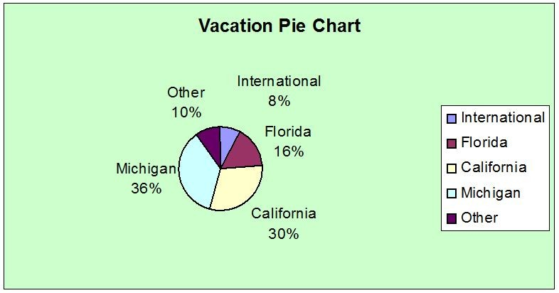
Difficulty: Moderate
Topic: Graphs to Describe Categorical Variables
AACSB: Analytic Skills
Course LO: Compare and contrast methods of summarizing and describing data

159) Construct a bar chart to show this information.
Answer:
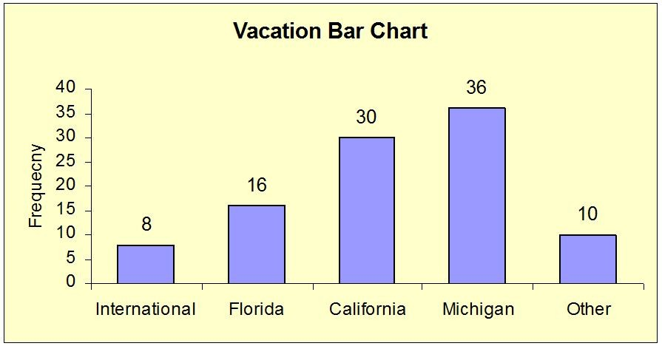
Difficulty: Moderate
Topic: Graphs to Describe Categorical Variables
AACSB: Analytic Skills
Course LO: Compare and contrast methods of summarizing and describing data
THE NEXT QUESTIONS ARE BASED ON THE FOLLOWING INFORMATION:
The data presented below were collected on the amount of time, in hours; it takes an employee, to process an order at a local plumbing wholesaler.

2.8 | 4.9 | 0.5 | 13.2 | 14.2 | 8.9 | 3.7 | 15.2 | 11.2 | 13.4
5.5 | 10.2 | 1.1 | 14.2 | 7.8 | 4.5 | 10.9 | 8.8 | 18.2 | 17.1

160) Construct a stem-and-leaf display of the data.
Answer:
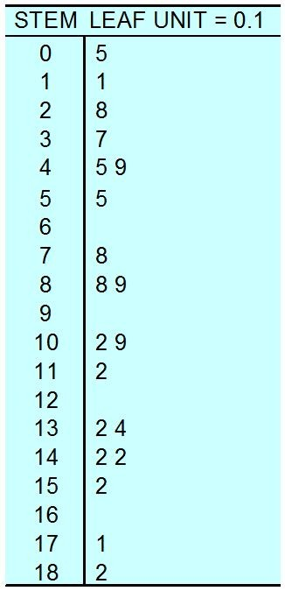
Difficulty: Moderate
Topic: Graphs to Describe Numerical Variables
AACSB: Analytic Skills
Course LO: Compare and contrast methods of summarizing and describing data

161) Construct a frequency distribution of the data.
Answer:
Time(in hours) | Frequency
0 but < 3.5 | 3
3.5 but < 6.5 | 4
6.5 but < 9.5 | 3
9.5 but < 12.5 | 3
12.5 but < 15.5 | 5
15.5 but < 18.5 | 2

Difficulty: Moderate
Topic: Graphs to Describe Numerical Variables
AACSB: Analytic Skills
Course LO: Compare and contrast methods of summarizing and describing data
162) Construct cumulative frequency and cumulative percent distributions of the data.
Answer:
Time (in hours) | Cumulative Frequency | Cumulative %
< 3.5 | 3 | 15%
< 6.5 | 7 | 35%
< 9.5 | 10 | 50%
< 12.5 | 13 | 65%
< 15.5 | 18 | 90%
< 18.5 | 20 | 100%

Difficulty: Moderate
Topic: Graphs to Describe Numerical Variables
AACSB: Analytic Skills
Course LO: Compare and contrast methods of summarizing and describing data

163) Construct a frequency histogram of the data.
Answer:
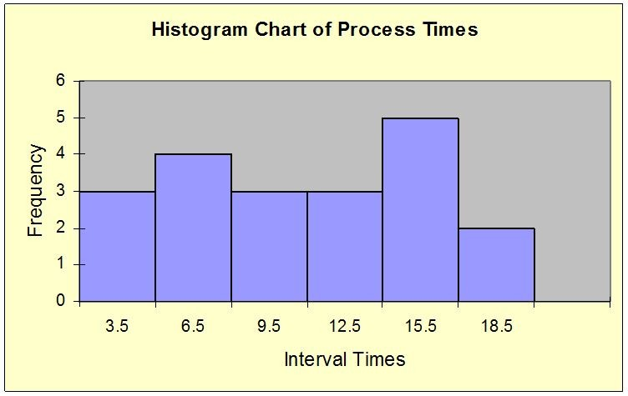
Difficulty: Moderate
Topic: Graphs to Describe Numerical Variables
AACSB: Analytic Skills
Course LO: Compare and contrast methods of summarizing and describing data

164) Determine the percentage of time it takes an employee at most 12.5 hours to process an order at the plumbing wholesaler.
Answer: 13/20 = 65%
Difficulty: Moderate
Topic: Graphs to Describe Numerical Variables
AACSB: Analytic Skills
Course LO: Compare and contrast methods of summarizing and describing data
165) Modify the following statement to reflect possible uncertainty: "The price of GM stock will be lower in six months than it is now."
Answer: The price of GM stock is likely to be lower in six months than it is now.
Difficulty: Easy
Topic: Graphs to Describe Numerical Variables
AACSB: Reflective Thinking Skills
Course LO: Compare and contrast tools for presenting and organizing data

166) Describe briefly what is meant by simple random sampling.
Answer: Simple random sampling is a procedure used to select a sample of n objects from a population in such a way that each member of the population is chosen strictly by chance, each member of the population is equally likely to be chosen, and every possible sample of a given size, n, has the same chance of selection. This method is so common that the adjective simple is generally dropped, and the resulting sample is called a random sample.
Difficulty: Moderate
Topic: Decision Making in an Uncertain Environment
AACSB: Reflective Thinking Skills
Course LO: Explain how data are acquired and distinguish among different types of data and levels of measurement

167) What is Statistics? Why do we need to study Statistics?
Answer: Statistics deals with the collection, analysis, and interpretation of numerical data, often using probability theory. It is used to predict or forecast sales of a new product, construction costs, customer-satisfaction levels, and many other variables that affect our daily lives.
We study Statistics relative to business and economics because Statistics provides the knowledge and information used to predict, forecast, or estimate sales of a new product, construction costs, customer satisfaction levels, interest rates, currency exchange rates, and many other variables that help us make better business decisions.
Difficulty: Moderate
Topic: Decision Making in an Uncertain Environment
AACSB: Reflective Thinking Skills
Course LO: Identify different business uses for statistics and the major statistical tools businesses use

168) Discuss briefly the difference between descriptive and inferential statistics.
Answer: The focus of descriptive statistics is on graphical and numerical procedures that are used to summarize and process data. Inferential statistics focuses on using the data to make predictions, forecasts and estimates to make better decisions.
Difficulty: Easy
Topic: Decision Making in an Uncertain Environment
AACSB: Reflective Thinking Skills
Course LO: Compare and contrast methods of summarizing and describing data
169) What is the difference between a frequency distribution and a relative frequency distribution?
Answer: The basic difference between the frequency and relative frequency distribution is that the relative frequency distribution tells us the proportions or percentages rather than the number of values in each class. This way the data is standardized making it much easier to compare it to other samples and populations.
Difficulty: Moderate
Topic: Graphs to Describe Numerical Variables
AACSB: Reflective Thinking Skills
Course LO: Compare and contrast methods of summarizing and describing data

170) Why is a cumulative relative frequency distribution so much more informative than just the relative frequency distribution?
Answer: Cumulative relative frequency distributions not only tell us the proportions or percentages in the sample or population less than a certain value, but we can take the differences and find the actual cumulative relative frequencies in each class from this distribution. Moreover, as long as we know the total sample or population size, you can get the actual frequencies as well.
Difficulty: Moderate
Topic: Graphs to Describe Numerical Variables
AACSB: Reflective Thinking Skills
Course LO: Compare and contrast methods of summarizing and describing data

171) A cable company, based on a survey of its customers, reports that 48% of all the television audience watch Larry King Live daily. Is this an example of descriptive or inferential statistics?
Answer: Inferential statistics
Difficulty: Easy
Topic: Decision Making in an Uncertain Environment
AACSB: Reflective Thinking Skills
Course LO: Compare and contrast methods of summarizing and describing data

172) A recent Wall Street Journal poll asked a group of American voters to rate economic conditions in the United States. 92% of the respondents rated economic conditions as "unfavorable." Identify the population, sample, sample statistic, and population parameter in this survey.
Answer: Population: All eligible voters in the U.S.
Sample: Voters selected to participate in the survey.
Sample statistic: 92% of the sample rated economic conditions as unfavorable.
Population parameter: The percentage of all voters who would rate economic conditions as unfavorable.
Difficulty: Easy
Topic: Decision Making in an Uncertain Environment
AACSB: Reflective Thinking Skills
Course LO: Explain how data are acquired and distinguish among different types of data and levels of measurement
THE NEXT QUESTIONS ARE BASED ON THE FOLLOWING INFORMATION:
An investment advisor recently reviewed the account activity of a sample of 10 of his clients and calculated the average number of stock trades per month over the past year for each client. He obtained the following data values: 10.2, 2.5, 11.4, 3.2, 1.1, 3.4, 8.4, 9.7, 11.2, and 2.4.

173) Construct a frequency distribution of the data.
Answer:
Average # Stock Trades | Frequency
1 but < 4 | 5
4 but < 7 | 0
7 but < 10 | 2
10 but < 13 | 3

Difficulty: Moderate
Topic: Graphs to Describe Numerical Variables
AACSB: Analytic Skills
Course LO: Compare and contrast methods of summarizing and describing data

174) Construct a relative frequency and percent distributions of the data.
Answer:
Average # Stock Trades | Relative Frequency | Percent
1 but < 4 | 0.5 | 50
4 but < 7 | 0.0 | 0
7 but < 10 | 0.2 | 20
10 but < 13 | 0.3 | 30

Difficulty: Moderate
Topic: Graphs to Describe Numerical Variables
AACSB: Analytic Skills
Course LO: Compare and contrast methods of summarizing and describing data

175) Construct a cumulative frequency distribution of the data.
Answer:
Average # Stock Trades | Cumulative Frequency
< 4 | 5
< 7 | 5
< 10 | 7
< 13 | 10

Difficulty: Moderate
Topic: Graphs to Describe Numerical Variables
AACSB: Analytic Skills
Course LO: Compare and contrast methods of summarizing and describing data
176) Construct a cumulative relative frequency and cumulative percent distributions of the data.
Answer:
Average # Stock Trades | Cumulative  Relative Frequency | Cumulative  Percent
< 4 | 0.5 | 50
< 7 | 0.5 | 50
< 10 | 0.7 | 70
< 13 | 1.0 | 100

Difficulty: Moderate
Topic: Graphs to Describe Numerical Variables
AACSB: Analytic Skills
Course LO: Compare and contrast methods of summarizing and describing data

177) Construct a frequency histogram of the data
Answer:
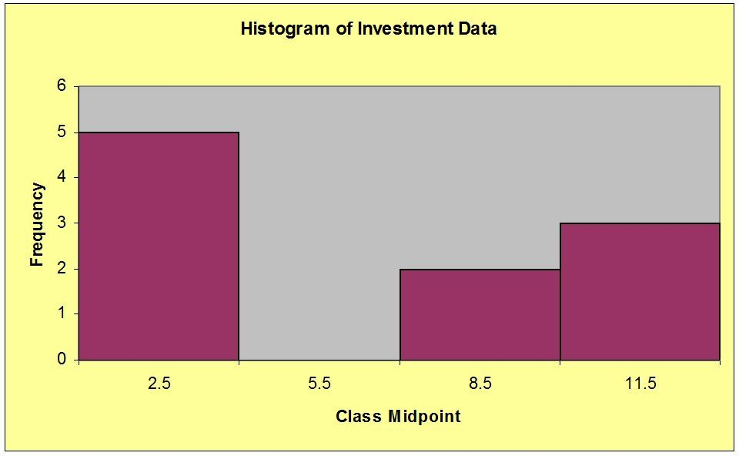
Difficulty: Moderate
Topic: Graphs to Describe Numerical Variables
AACSB: Analytic Skills
Course LO: Compare and contrast methods of summarizing and describing data

THE NEXT QUESTIONS ARE BASED ON THE FOLLOWING INFORMATION:
Suppose you own a DVD rental store.
178) Give an example of a question that could be answered using descriptive statistics.
Answer: How many new releases does the store order during the month of January 2014?
Difficulty: Easy
Topic: Decision Making in an Uncertain Environment
AACSB: Reflective Thinking Skills
Course LO: Compare and contrast methods of summarizing and describing data

179) Give an example of a question concerning a possible relationship between two variables of interest to your DVD business.
Answer: If the store manager increases the rental price of adult DVDs from $2 to $4 per DVD, what will be the effect on the rental of these DVDs?
Difficulty: Easy
Topic: Decision Making in an Uncertain Environment
AACSB: Analytic Skills
Course LO: Identify different business uses for statistics and the major statistical tools businesses use

180) Give an example of a question where estimating a parameter would be helpful.
Answer: What is the average age of the store's customers?
Difficulty: Easy
Topic: Decision Making in an Uncertain Environment
AACSB: Analytic Skills
Course LO: Identify different business uses for statistics and the major statistical tools businesses use

181) Give an example of a forecasting question.
Answer: Based on the store's rental sales from 2010 through 2013, what is the expected amount of sales in 2014?
Difficulty: Easy
Topic: Decision Making in an Uncertain Environment
AACSB: Analytic Skills
Course LO: Identify different business uses for statistics and the major statistical tools businesses use

182) Give an example of a question where testing a hypothesis about a parameter would be helpful.
Answer: Are weekend sales at least 25% higher than weekday sales?
Difficulty: Easy
Topic: Decision Making in an Uncertain Environment
AACSB: Analytic Skills
Course LO: Identify different business uses for statistics and the major statistical tools businesses use
183) A businessman who is running for the vacant Mayoral seat with 88,000 registered voters conducts a survey. In the survey, 54.6% of the 1,200 registered voters interviewed say they planned to vote for him. Identify the population of interest and the sample in this survey.
Answer: The population of interest is the political choices of the 88,000 registered voters. The sample is the political choices of the 1,200 registered voters interviewed.
Difficulty: Easy
Topic: Decision Making in an Uncertain Environment
AACSB: Analytic Skills
Course LO: Explain how data are acquired and distinguish among different types of data and levels of measurement

184) As a businessperson, in what ways may you find yourself involved with statistics?
Answer: As a businessperson one may be involved with statistics on a daily basis to gain information and knowledge useful in making good business decisions.
Interpretation of statistical data will aid in predicting, forecasting, and estimating matters of sales, financing, expansion, market conditions, etc.
Difficulty: Moderate
Topic: Decision Making in an Uncertain Environment
AACSB: Reflective Thinking Skills
Course LO: Identify different business uses for statistics and the major statistical tools businesses use

185) As part of the graduation paperwork, seniors at a particular college were asked to indicate their post-graduation plans. Results showed that 15% planned to start graduate school right after college graduation. Is this an example of descriptive or inferential statistics?
Answer: Descriptive statistics
Difficulty: Easy
Topic: Decision Making in an Uncertain Environment
AACSB: Reflective Thinking Skills
Course LO: Explain how data are acquired and distinguish among different types of data and levels of measurement

186) Briefly discuss the Pareto diagram.
Answer: A Pareto diagram, named after the Italian economist Vilfredo Pareto, is a bar chart that displays the frequency of defect causes. The bar at the left indicates the most frequent cause and bars to the right indicate causes with decreasing frequencies. A Pareto diagram is used to separate the "vital few" from the "trivial many."
Difficulty: Moderate
Topic: Graphs to Describe Categorical Variables
AACSB: Reflective Thinking Skills
Course LO: Compare and contrast methods of summarizing and describing data
187) The sales manager for a local commercial waste disposal company has tracked the yearly dollar value (in $1000) of contracts made by both internal sales people and external sales people. The data are presented below. Graph the data with a time plot. What possible conclusions or actions might the firm consider?

Year | 2003 | 2004 | 2005 | 2006 | 2007 | 2008
Internal Sales | $370 | 378 | 400 | 360 | 352 | 335
External Sales | $705 | 713 | 728 | 754 | 763 | 775

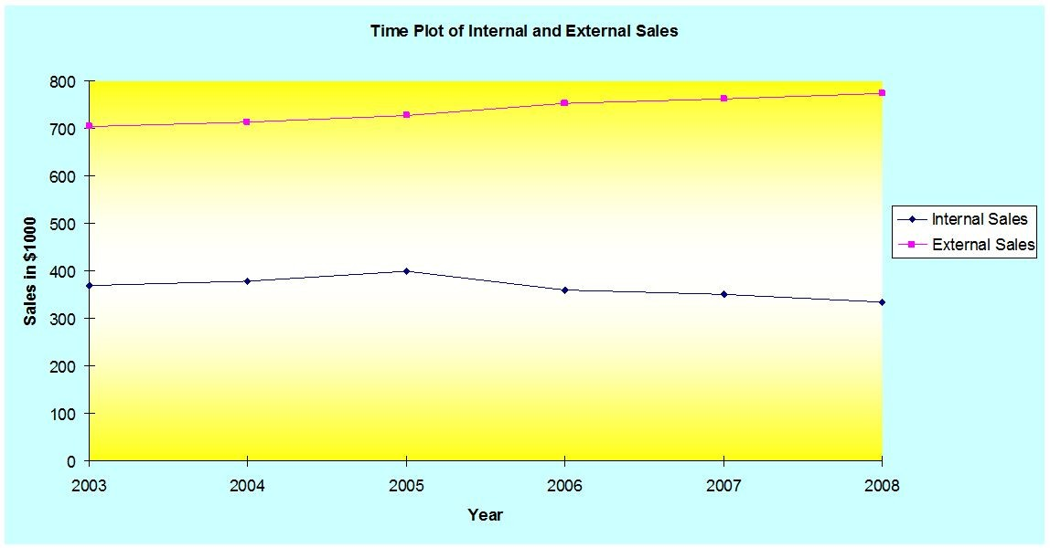
Answer: It appears that internal salespeople's contracts have been falling while external salespeople's have been increasing slowly over the period.
Difficulty: Moderate
Topic: Graphs to Describe Time-Series Data
AACSB: Analytic Skills
Course LO: Use a modern software tool to perform statistical calculations
THE NEXT QUESTIONS ARE BASED ON THE FOLLOWING INFORMATION:
Data were collected on the number of people entering an electronics store each hour. The data are presented below.

23 | 35 | 42 | 28 | 29 | 17 | 38 | 21 | 49 | 52
46 | 37 | 25 | 49 | 37 | 25 | 28 | 13 | 29 | 43

188) Construct a stem-and-leaf display of the data.
Answer:
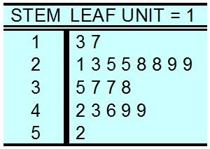
Difficulty: Easy
Topic: Graphs to Describe Numerical Variables
AACSB: Analytic Skills
Course LO: Compare and contrast methods of summarizing and describing data

189) Construct a frequency distribution of the data.
Answer:
Number of People | Frequency
10 but < 17 | 1
17 but < 24 | 3
24 but < 31 | 6
31 but < 38 | 3
38 but < 45 | 3
45 but < 52 | 3
52 but < 59 | 1

Difficulty: Moderate
Topic: Graphs to Describe Numerical Variables
AACSB: Analytic Skills
Course LO: Compare and contrast methods of summarizing and describing data
190) Construct cumulative frequency and cumulative percent distributions of the data.
Answer:
Number of people | Cumulative Frequency | Cumulative %
< 17 | 1 | 5%
< 24 | 4 | 20%
< 31 | 10 | 50%
< 38 | 13 | 65%
< 45 | 16 | 80%
< 52 | 19 | 95%
< 59 | 20 | 100%

Difficulty: Moderate
Topic: Graphs to Describe Numerical Variables
AACSB: Analytic Skills
Course LO: Compare and contrast methods of summarizing and describing data

THE NEXT QUESTIONS ARE BASED ON THE FOLLOWING INFORMATION:
The head of human resources at a corporation with 100 employees was curious about levels of employment by classification. She determined that 10% of all employees were classified as executive, 15% as professional, 25% as clerical and janitorial, 30% as administrative and 20% as technical workers:

191) Construct a pie chart to show this information.
Answer:
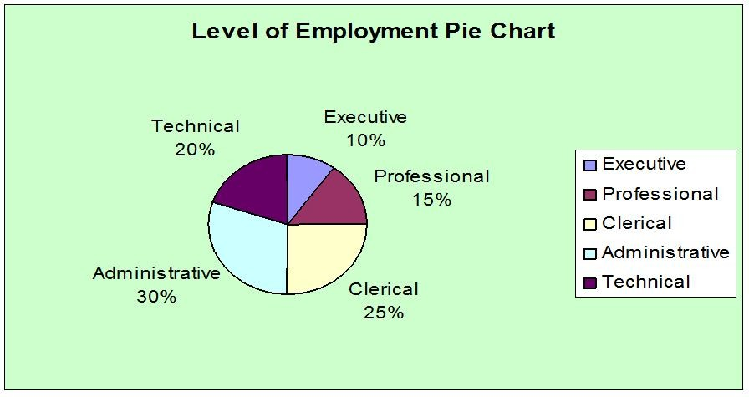
Difficulty: Moderate
Topic: Graphs to Describe Categorical Variables
AACSB: Analytic Skills
Course LO: Compare and contrast methods of summarizing and describing data
192) Construct a bar chart to show this information.
Answer:
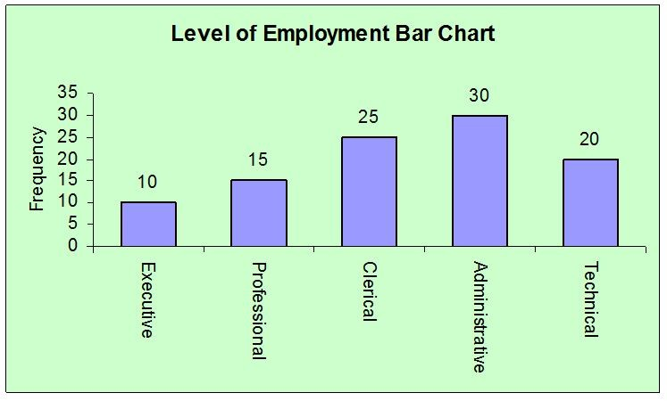
Difficulty: Moderate
Topic: Graphs to Describe Categorical Variables
AACSB: Analytic Skills
Course LO: Compare and contrast methods of summarizing and describing data

THE NEXT QUESTIONS ARE BASED ON THE FOLLOWING INFORMATION:
At New York State University, 800 students are randomly selected and asked the distance of their commute to campus. From this group a mean of 14.6 miles is computed.

193) What is the statistic?
Answer: The computed 14.6 miles
Difficulty: Moderate
Topic: Decision Making in an Uncertain Environment
AACSB: Analytic Skills
Course LO: Compare and contrast methods of summarizing and describing data

194) What is the variable of interest?
Answer: The commute distance for students to campus
Difficulty: Moderate
Topic: Decision Making in an Uncertain Environment
AACSB: Analytic Skills
Course LO: Compare and contrast methods of summarizing and describing data

195) What is the parameter?
Answer: The mean commute distance for all students at New York State University to the campus
Difficulty: Moderate
Topic: Decision Making in an Uncertain Environment
AACSB: Analytic Skills
Course LO: Compare and contrast methods of summarizing and describing data
196) What is the sample?
Answer: The 800 randomly selected students
Difficulty: Moderate
Topic: Decision Making in an Uncertain Environment
AACSB: Analytic Skills
Course LO: Compare and contrast methods of summarizing and describing data

197) What is the population?
Answer: All New York State University students
Difficulty: Moderate
Topic: Decision Making in an Uncertain Environment
AACSB: Analytic Skills
Course LO: Compare and contrast methods of summarizing and describing data

THE NEXT QUESTIONS ARE BASED ON THE FOLLOWING INFORMATION:
A paper company is interested in estimating the proportion of trees in a 600-acre forest with diameters exceeding 2 feet. The company selects 30 plots (100 feet by 100 feet) from the forest and utilizes the information from the 30 plots to help estimate the proportion for the whole forest.

198) What statistical term describes the 600-acre forest?
Answer: Population
Difficulty: Moderate
Topic: Decision Making in an Uncertain Environment
AACSB: Analytic Skills
Course LO: Compare and contrast methods of summarizing and describing data

199) What statistical term describes the 30 plots?
Answer: Sample
Difficulty: Moderate
Topic: Decision Making in an Uncertain Environment
AACSB: Analytic Skills
Course LO: Compare and contrast methods of summarizing and describing data
200) A company has determined that there are seven possible defects for one of its product lines. Construct a Pareto diagram for the following defect frequencies:

Defect Code | Frequency
A | 10
B | 70
C | 15
D | 90
E | 8
F | 4
G | 3

Answer:
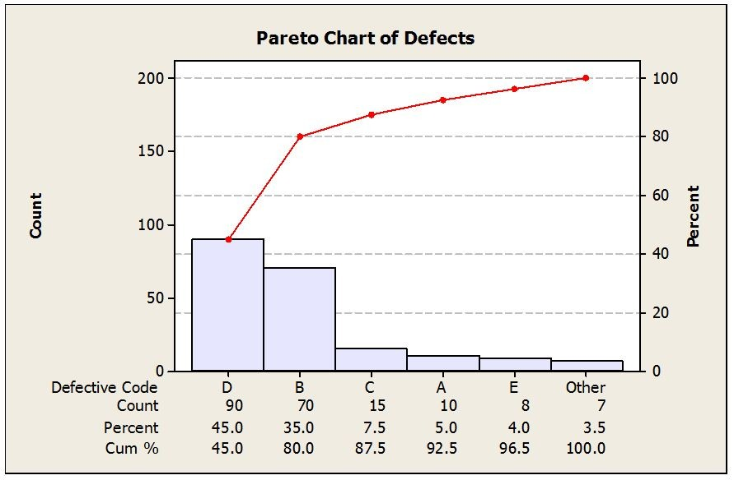
Difficulty: Moderate
Topic: Graphs to Describe Categorical Variables
AACSB: Analytic Skills
Course LO: Compare and contrast methods of summarizing and describing data
THE NEXT QUESTIONS ARE BASED ON THE FOLLOWING INFORMATION:
The data in the next table indicate the number of degrees awarded from 2002 to 2008 by degree type at a four-year university in Utah.

Year | Bachelor | Graduate | Law
2002 | 510 | 85 | 223
2003 | 498 | 85 | 263
2004 | 481 | 94 | 270
2005 | 472 | 110 | 270
2006 | 441 | 93 | 252
2007 | 441 | 119 | 282
2008 | 497 | 169 | 307

201) Graph the data with a time-series plot.
Answer:
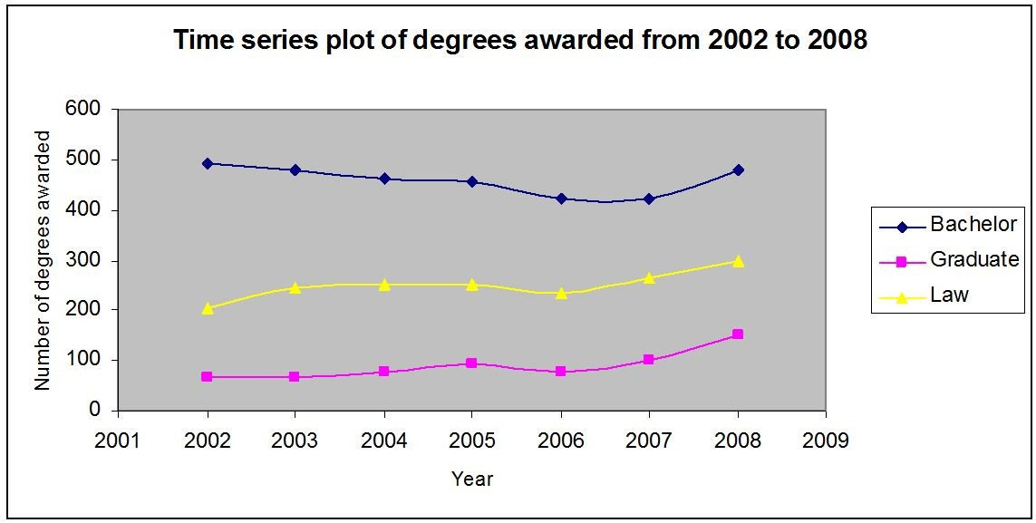
Difficulty: Moderate
Topic: Graphs to Describe Time-Series Data
AACSB: Analytic Skills
Course LO: Compare and contrast methods of summarizing and describing data

202) What possible conclusions or actions might the university consider?
Answer: The number of law and graduate degrees awarded is increasing. The number of bachelor degrees awarded declined from 2002 to 2007 with a slight increase in 2008. Enrollment restrictions may be in order if class sizes are becoming too large or if crowding conditions occur.
Difficulty: Moderate
Topic: Graphs to Describe Numerical Variables
AACSB: Reflective Thinking Skills
Course LO: Explain how data are acquired and distinguish among different types of data and levels of measurement
THE NEXT QUESTIONS ARE BASED ON THE FOLLOWING INFORMATION:
Percentage returns for the 25 largest U.S. common stock mutual funds for a particular day are displayed below.

24.3 | 13.6 | 19.7 | 25.0 | 31.0 | 21.8 | 24.9 | 31.5 | 20.2 | 25.9
33.2 | 28.3 | 20.6 | 39.8 | 30.6 | 19.0 | 20.6 | 37.1 | 24.8 | 29.9
31.1 | 32.6 | 49.9 | 31.1 | 38.3

203) Construct a histogram to describe the data.
Answer:
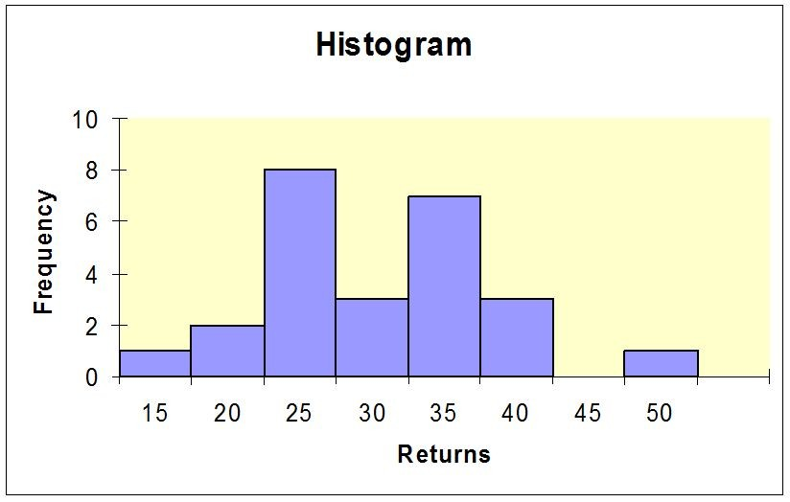
Difficulty: Moderate
Topic: Graphs to Describe Numerical Variables
AACSB: Analytic Skills
Course LO: Compare and contrast methods of summarizing and describing data
204) Construct an ogive to describe the data.
Answer:
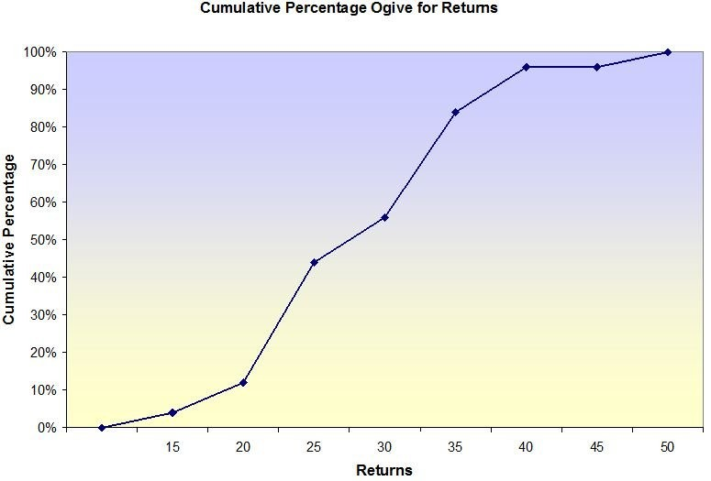
Difficulty: Moderate
Topic: Graphs to Describe Numerical Variables
AACSB: Analytic Skills
Course LO: Compare and contrast methods of summarizing and describing data

205) Draw a stem-and-leaf display to describe the data.
Answer: Observation values rounded to nearest whole number

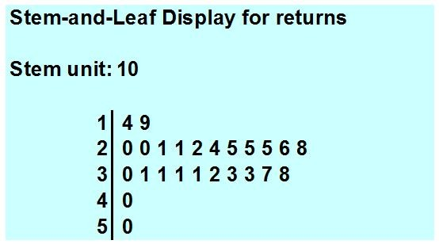
Difficulty: Moderate
Topic: Graphs to Describe Numerical Variables
AACSB: Analytic Skills
Course LO: Compare and contrast methods of summarizing and describing data
206) In completing a survey, respondents use the following code numbers to indicate marital status:
1 = Single (never married),
2 = Married,
3 = Divorced,
4 = WidowedIs this data qualitative or quantitative? Explain.
Answer: Even though marital status is coded by number, the data is qualitative as it categorizes each individual respondent. Also, the average of single and divorced is meaningless.
Difficulty: Moderate
Topic: Classification of Variables
AACSB: Reflective Thinking Skills
Course LO: Explain how data are acquired and distinguish among different types of data and levels of measurement

THE NEXT QUESTIONS ARE BASED ON THE FOLLOWING INFORMATION:
An office supply warehouse has boxes of pencils, 100 pencils to the box. Information about the entire warehouse as well as a sample of the boxes is shown below:

Number of defectives  per box | Number of boxes  (in warehouse)
0 | 1500
1 | 250
2 | 75
3 | 40
4 | 10

207) Describe the population.
Answer: All boxes of pencils in the warehouse
Difficulty: Easy
Topic: Decision Making in an Uncertain Environment
AACSB: Analytic Skills
Course LO: Compare and contrast methods of summarizing and describing data

208) What is the population size?
Answer: 1875 boxes
Difficulty: Easy
Topic: Decision Making in an Uncertain Environment
AACSB: Analytic Skills
Course LO: Compare and contrast methods of summarizing and describing data

209) Describe the sample.
Answer: The boxes of pencils sampled.
Difficulty: Easy
Topic: Decision Making in an Uncertain Environment
AACSB: Analytic Skills
Course LO: Compare and contrast methods of summarizing and describing data
210) A quality control inspector is interested in the number of boxes with more than two defectives. What is the value of the parameter?
Answer: 50
Difficulty: Easy
Topic: Decision Making in an Uncertain Environment
AACSB: Analytic Skills
Course LO: Compare and contrast methods of summarizing and describing data

211) A quality control inspector is interested in the proportion of boxes with no more than one defective pencil. What is the value of the parameter?
Answer: 1750 / 1875 = 0.933
Difficulty: Easy
Topic: Graphs to Describe Numerical Variables
AACSB: Analytic Skills
Course LO: Compare and contrast methods of summarizing and describing data

THE NEXT QUESTIONS ARE BASED ON THE FOLLOWING INFORMATION:
The time (in hours) that a sample of 20 students studied for a statistics test are shown below

6.5 | 5.8 | 4.5 | 6.2 | 4.8 | 7.3 | 4.6 | 3.9 | 4.4 | 5.5
5.2 | 6.7 | 3.0 | 2.4 | 5.0 | 3.6 | 2.9 | 4.0 | 2.8 | 3.6

212) Construct a stem-and-leaf display for the data
Answer:
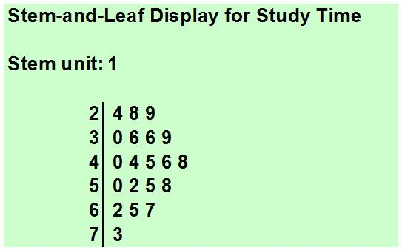
Difficulty: Easy
Topic: Graphs to Describe Numerical Variables
AACSB: Analytic Skills
Course LO: Compare and contrast methods of summarizing and describing data
213) Construct a frequency distribution of the data.
Answer:
Number of Hours | Frequency
2.0 but < 3.5 | 4
3.5 but < 5.0 | 8
5.0 but < 6.5 | 5
6.5 but < 8.0 | 3

Difficulty: Easy
Topic: Graphs to Describe Numerical Variables
AACSB: Analytic Skills
Course LO: Compare and contrast methods of summarizing and describing data

214) Construct a frequency histogram to describe graphically the time (in hours) that students studied for the test
Answer:
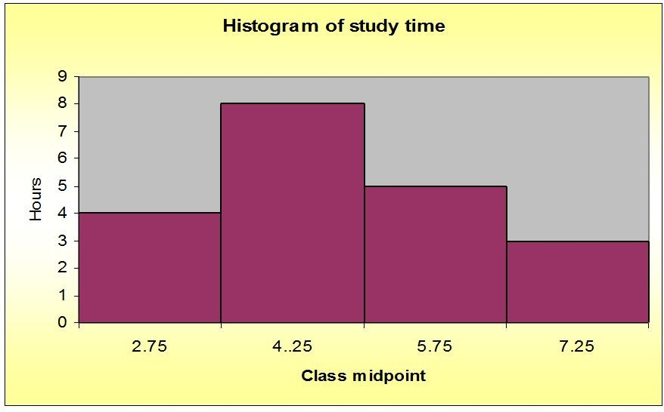
Difficulty: Easy
Topic: Graphs to Describe Numerical Variables
AACSB: Analytic Skills
Course LO: Compare and contrast methods of summarizing and describing data

215) Construct a relative frequency and percent distributions of the data.
Answer:
Number of Hours | Relative Frequency | Percent
2.0 but < 3.5 | 0.20 | 20
3.5 but < 5.0 | 0.40 | 40
5.0 but < 6.5 | 0.25 | 25
6.5 but < 8.0 | 0.15 | 15
Difficulty: Moderate
Topic: Graphs to Describe Numerical Variables
AACSB: Analytic Skills
Course LO: Compare and contrast methods of summarizing and describing data
216) Construct a cumulative frequency, cumulative relative frequency and cumulative percent distributions of the data.
Answer:
Number of Hours | Cumulative  Frequency | Cumulative Relative Frequency | Cumulative  Percent
< 3.5 | 4 | 0.20 | 20
< 5.0 | 12 | 0.60 | 60
< 6.5 | 17 | 0.85 | 85
< 8.0 | 20 | 1.0 | 100

Difficulty: Moderate
Topic: Graphs to Describe Numerical Variables
AACSB: Analytic Skills
Course LO: Compare and contrast methods of summarizing and describing data

217) Explain the difference between the terms "variable" and "data." Include an illustration that demonstrates this difference.
Answer: Variable: a characteristic of interest about each individual element of a population or a sample
Data: refer to the value or values of the variable of interest
Illustration: The age of a person when he/she first attends a professional sporting event would be the characteristic of interest about each person and is a variable. Jim was 17 when he first attended a professional sporting event; 17 is the value of the variable for Jim and is data.
Difficulty: Easy
Topic: Classification of Variables
AACSB: Reflective Thinking Skills
Course LO: Compare and contrast tools for presenting and organizing data

THE NEXT QUESTIONS ARE BASED ON THE FOLLOWING INFORMATION:
A statistics professor has developed the cross table presented below, that compares students' class standing with their final grades.

Year | A | B | C | D | F | Total
Freshman | ∗ | 17 | 28 | 8 | 3 | 69
Sophomore | 14 | 23 | 17 | 10 | 1 | ∗
Junior | 17 | 19 | 10 | 2 | 1 | 49
Senior | 5 | 8 | 4 | 0 | ∗ | 17
Total | ∗ | 67 | 59 | 20 | 5 | ∗

218) Calculate the missing values identified by asterisks. What patterns do you see in this table?
Answer:
Year | A | B | C | D | F | Total
Freshman | 13 | 17 | 28 | 8 | 3 | 69
Sophomore | 14 | 23 | 17 | 10 | 1 | 65
Junior | 17 | 19 | 10 | 2 | 1 | 49
Senior | 5 | 8 | 4 | 0 | 0 | 17
Total | 49 | 67 | 59 | 20 | 5 | 200

It appears that the earlier a student is in his or her college career, the worse they will do in class.
Difficulty: Moderate
Topic: Graphs to Describe Categorical Variables
AACSB: Analytic Skills
Course LO: Compare and contrast methods of summarizing and describing data

219) Convert the data to overall percentages. What patterns do you see in this table?
Answer:
Year | A | B | C | D | F | Total
Freshman | 6.5% | 8.5% | 14.0% | 4.0% | 1.5% | 34.5%
Sophomore | 7.0% | 11.5% | 8.5% | 5.0% | 0.5% | 32.5%
Junior | 8.5% | 9.5% | 5.0% | 1.0% | 0.5% | 24.5%
Senior | 2.5% | 4.0% | 2.0% | 0.0% | 0.0% | 8.5%
Total | 24.5% | 33.5% | 29.5% | 10% | 2.5% | 100%

The percentages of students failing the class for freshmen, sophomores, juniors, and seniors are 1.5%, 0.5%, 0.5% and 0.0%, respectively. It appears that the earlier a student is in his or her college career, the worse they will do in class.
Difficulty: Moderate
Topic: Graphs to Describe Categorical Variables
AACSB: Analytic Skills
Course LO: Compare and contrast methods of summarizing and describing data

220) In completing a survey, respondents use the following number codes to indicate ages.
1 = Age 19 years and under,
2 = 20 to 29 years of age
3 = 30 to 39 years of age,
4 = Age 40 years and older
Is this data qualitative or quantitative? Explain.
Answer: This is quantitative data; an age.
Difficulty: Moderate
Topic: Classification of Variables
AACSB: Reflective Thinking Skills
Course LO: Explain how data are acquired and distinguish among different types of data and levels of measurement
221) A department of mathematical sciences has majors in four areas.

Major | Number of Majors
Mathematics | 50
Computer Science | 22
Actuarial Science | 15
Statistics | 10

If a pie chart is constructed for these data, what would be the percentage of the graph for each major?
Answer:
Major | % of Majors
Mathematics | 51.5
Computer Science | 22.7
Actuarial Science | 15.5
Statistics | 10.3

Difficulty: Moderate
Topic: Graphs to Describe Categorical Variables
AACSB: Analytic Skills
Course LO: Compare and contrast methods of summarizing and describing data

222) A consumer goods company has been studying the effect of advertising on total profits. As part of this study, data on advertising expenditures ($1000s) and total sales ($1000s) were collected for a five-month period and are as follows: (15, 150), (22.5, 300), (10.5, 120), (18, 180), and (21, 225), where the first number is advertising expenditures and the second is total sales. Graphically display the data, and state an appropriate conclusion from the graph.
Answer:
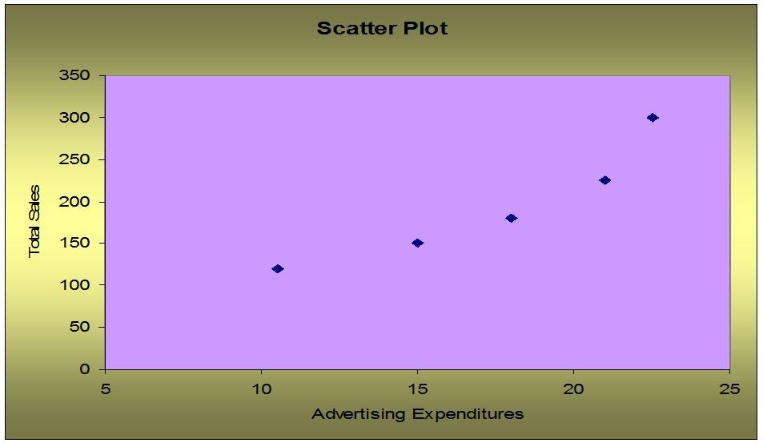

Clearly there is a positive relationship between advertising expenditures and total sales.
Difficulty: Moderate
Topic: Graphs to Describe Numerical Variables
AACSB: Analytic Skills
Course LO: Compare and contrast methods of summarizing and describing data
THE NEXT QUESTIONS ARE BASED ON THE FOLLOWING INFORMATION:
The final-inspection defect report for an assembly line is reported on the table and Pareto diagram as shown below:

Defect | Blemish | Scratch | Chip | Bend | Dent | Others
Count | 61 | 50 | 28 | 17 | 13 | 11

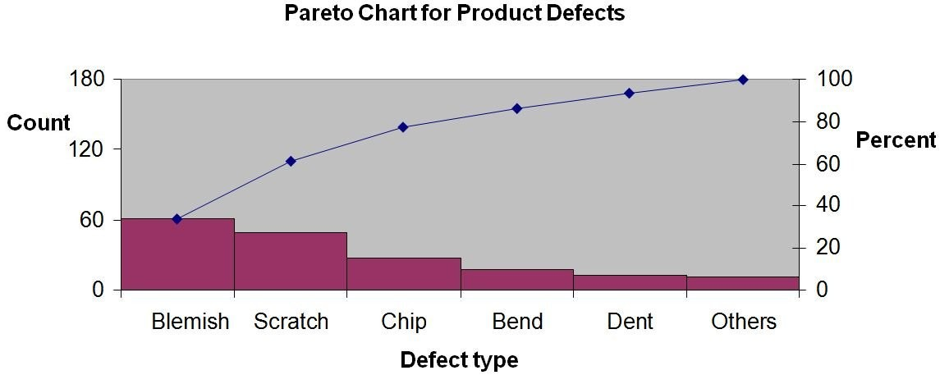

223) What is the total defect count in the report?
Answer: 180 defects
Difficulty: Moderate
Topic: Graphs to Describe Numerical Variables
AACSB: Analytic Skills
Course LO: Compare and contrast methods of summarizing and describing data

224) Find the percentage for "chip" defect items.
Answer: Percent of chip = (28/180) ∙ 100% = 15.56%
Difficulty: Moderate
Topic: Graphs to Describe Numerical Variables
AACSB: Analytic Skills
Course LO: Compare and contrast methods of summarizing and describing data

225) Find the cumulative % through Bend, and explain what that value means.
Answer: [(61 + 50 + 28 + 17)/180] ∙ 100% = (156/180) ∙ 100% = 86.67%. The value 86.67% is the sum of the percentages for all defects that occurred more often than Bend, as well as for Bend.
Difficulty: Moderate
Topic: Graphs to Describe Categorical Variables
AACSB: Analytic Skills
Course LO: Compare and contrast methods of summarizing and describing data

226) Management has given the production line the goal of reducing their defects by 50%. What two defects would you suggest they give special attention to in working toward this goal? Explain.
Answer: The two defects, Blemish and Scratch, total 61.67%. If they can control these two defects, the goal should be within reach.
Difficulty: Moderate
Topic: Data Presentation Errors
AACSB: Reflective Thinking Skills
Course LO: Compare and contrast methods of summarizing and describing data
THE NEXT QUESTIONS ARE BASED ON THE FOLLOWING INFORMATION:
What not to get them on Valentine's Day! A recent study among adults in the USA shows that adults prefer not to receive certain items as gifts on Valentine's Day; namely, Teddy bears: 45%; Chocolate: 25%; Jewelry: 15%; Flowers: 12%; Don't Know: 3%.

227) Draw a Pareto diagram picturing the "Unwanted Presents."
Answer:
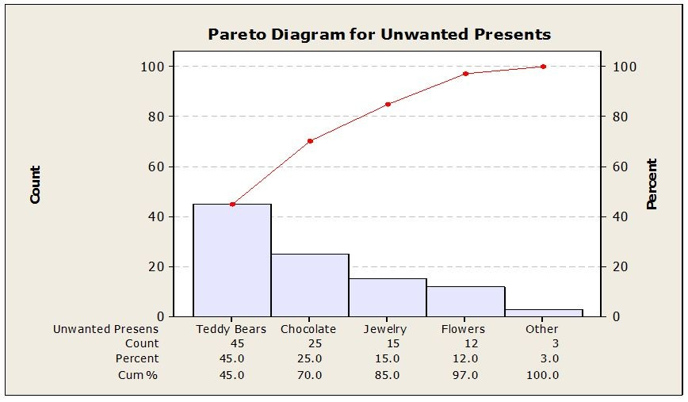
Difficulty: Moderate
Topic: Graphs to Describe Numerical Variables
AACSB: Analytic Skills
Course LO: Compare and contrast methods of summarizing and describing data

228) If you want to be 80% sure you did not get your valentine something unwanted, what should you avoid buying? How does the Pareto diagram show this?
Answer: Teddy bears, chocolates, jewelry; these are listed first in the Pareto diagram and account for 85%.
Difficulty: Moderate
Topic: Graphs to Describe Categorical Variables
AACSB: Analytic Skills
Course LO: Compare and contrast methods of summarizing and describing data
229) 400 adults are to be surveyed, what frequencies would you expect to occur for each unwanted item listed on the snapshot?
Answer: The frequencies are 180, 100, 60, 48, and 12 for teddy bears, chocolate, jewelry, flowers, and don't know, respectively.
Difficulty: Moderate
Topic: Graphs to Describe Numerical Variables
AACSB: Analytic Skills
Course LO: Compare and contrast methods of summarizing and describing data
THE NEXT QUESTIONS ARE BASED ON THE FOLLOWING INFORMATION:
A sample of 150 students at a State University was taken after the final business statistics exam to ask them whether they went partying the weekend before the final or spent the weekend studying, and whether they did well or poorly on the final. The following table contains the result.

 | Did Well in Exam | Did Poorly in Exam
Studying for Exam | 60 | 15
Went Partying | 22 | 53

230) Of those in the sample who went partying the weekend before the final exam, what percentage of them did well in the exam?
Answer: 22 out of 75, or 29.33%
Difficulty: Moderate
Topic: Graphs to Describe Categorical Variables
AACSB: Analytic Skills
Course LO: Compare and contrast methods of summarizing and describing data

231) Of those in the sample who did well on the final exam, what percentage of them went partying the weekend before the exam?
Answer: 22 out of 82, or 26.83%
Difficulty: Moderate
Topic: Graphs to Describe Categorical Variables
AACSB: Analytic Skills
Course LO: Compare and contrast methods of summarizing and describing data

232) What percentage of the students in the sample went partying the weekend before the final exam and did well in the exam?
Answer: 22 out of 150, or 14.67%
Difficulty: Moderate
Topic: Graphs to Describe Categorical Variables
AACSB: Analytic Skills
Course LO: Compare and contrast methods of summarizing and describing data
233) What percentage of the students in the sample spent the weekend studying and did well in the final exam?
Answer: 60 out of 150, or 40%
Difficulty: Moderate
Topic: Graphs to Describe Categorical Variables
AACSB: Analytic Skills
Course LO: Compare and contrast methods of summarizing and describing data

234) What percentage of the students in the sample went partying the weekend before the final exam and did poorly on the exam?
Answer: 53 out of 150, or 35.33%
Difficulty: Moderate
Topic: Graphs to Describe Categorical Variables
AACSB: Analytic Skills
Course LO: Compare and contrast methods of summarizing and describing data

235) If the sample is a good representation of the population, what percentage of the students in the population should we expect to spend the weekend studying and do poorly on the final exam?
Answer: 15 out of 150, or 10%
Difficulty: Moderate
Topic: Graphs to Describe Numerical Variables
AACSB: Analytic Skills
Course LO: Compare and contrast methods of summarizing and describing data

236) If the sample is a good representation of the population, what percentage of those who spent the weekend studying should we expect to do poorly on the final exam?
Answer: 15 out of 75, or 20%
Difficulty: Moderate
Topic: Graphs to Describe Numerical Variables
AACSB: Analytic Skills
Course LO: Compare and contrast methods of summarizing and describing data

237) If the sample is a good representation of the population, what percentage of those who did poorly on the final exam should we expect to have spent the weekend studying?
Answer: 15 out of 68, or 22.06%
Difficulty: Moderate
Topic: Graphs to Describe Numerical Variables
AACSB: Analytic Skills
Course LO: Compare and contrast methods of summarizing and describing data

238) Of those in the sample who went partying the weekend before the final exam, what percentage of them did poorly in the exam?
Answer: 53 out of 75, or 70.67%
Difficulty: Moderate
Topic: Graphs to Describe Numerical Variables
AACSB: Analytic Skills
Course LO: Compare and contrast methods of summarizing and describing data
239) Of those in the sample who did well in the final exam, what percentage of them spent the weekend before the exam studying?
Answer: 60 out of 82, or 73.17%
Difficulty: Moderate
Topic: Graphs to Describe Numerical Variables
AACSB: Analytic Skills
Course LO: Compare and contrast methods of summarizing and describing data
240) The students at a small community college in Iowa apply to study either English or Business. Some administrators at the college are concerned that women are being discriminated against in being allowed admittance, particularly in the business program. Below, you will find two contingency tables that show the percentage of students admitted by gender to the English program and the Business school. The data has also been presented graphically. What do the data and graphs indicate?

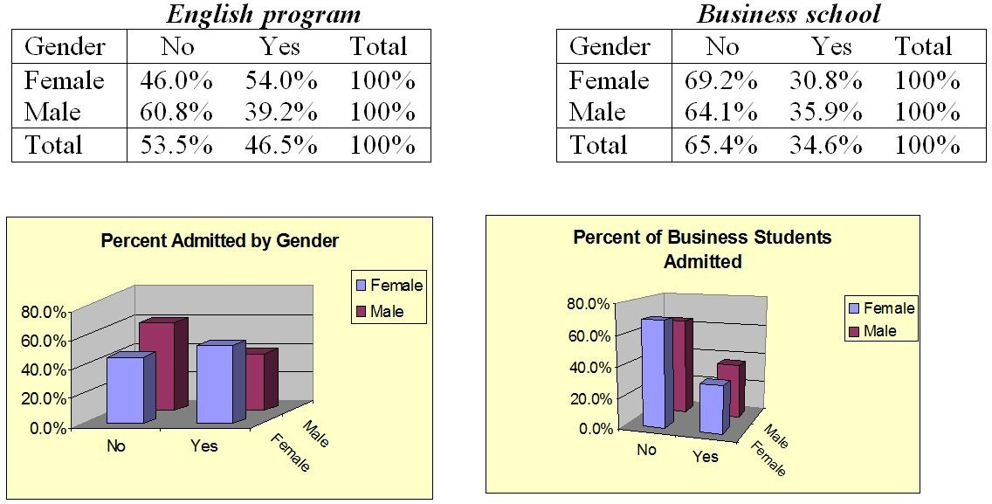
Answer: These data indicate that a smaller percentage of women are being admitted to the business program. Only 30.8% of women are being admitted to the business program compared to 35.9% for men. However, it is also important to note that only 34.6% of all applicants (women and men) are admitted to the business program compared to 46.5% for the English program. Maybe the males should say something about being discriminated against in being admitted to the English program.
Difficulty: Moderate
Topic: Graphs to Describe Numerical Variables
AACSB: Analytic Skills
Course LO: Explain how data are acquired and distinguish among different types of data and levels of measurement
241) The 2005 mobile phone manufacturers' global market shares were as follows: Nokia 26.9%, Motorola 16.9%, Ericson 10.5%, Samsung 6.2%, Panasonic 5.5%, others (Siemens, Alcatel, Mitsubishi, Philips, NEC, and more) 34.0%. Present this information in a pie chart.
Answer:
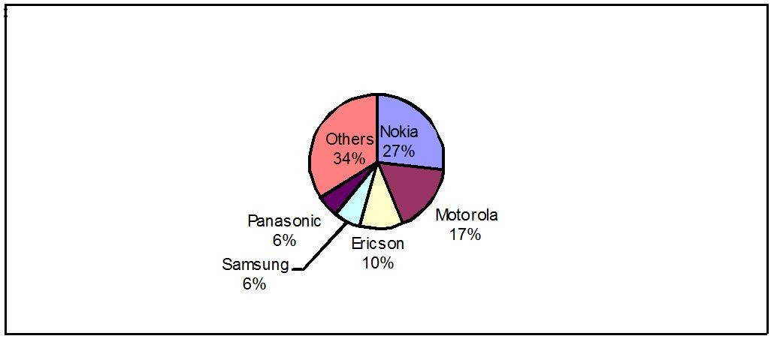

Difficulty: Moderate
Topic: Graphs to Describe Categorical Variables
AACSB: Analytic Skills
Course LO: Explain how data are acquired and distinguish among different types of data and levels of measurement

242) The data in the time-series plot below represents monthly sales for two years of beanbag animals at a local retail store (Month 1 represents January and Month 12 represents December). Do you see any obvious patterns in the data? Explain.
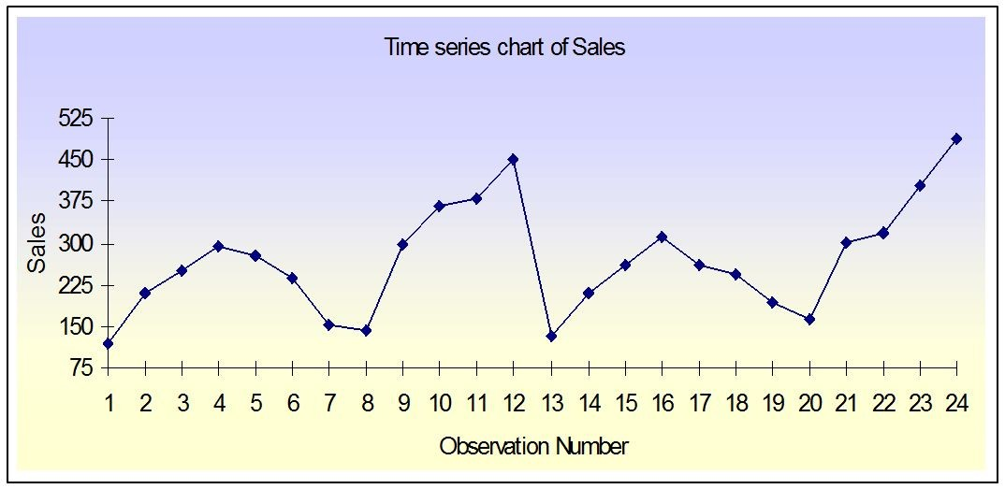
Answer: This is a representation of seasonal data. There seems to be a small increase in months 3, 4, and 5 and a large increase at the end of the year. The sales of this item seem to peak in December and have a significant drop off in January.
Difficulty: Moderate
Topic: Graphs to Describe Time-Series Data
AACSB: Analytic Skills
Course LO: Explain how data are acquired and distinguish among different types of data and levels of measurement
243) Describe systematic sampling. Use a sample size of 50 and a population of 500 names in alphabetical order.
Answer: Systematic sampling involves the selection of every jth item in the population, where j is the ratio of the population size N to the desired sample size n; so that j = 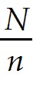. A random number from 1 to j is selected to be the first item in the systematic sample, then every j = = 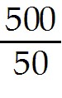 = 50th name is selected
Difficulty: Challenging
Topic: Decision Making in an Uncertain Environment
AACSB: Reflective Thinking Skills; Analytic Skills
Course LO: Explain how data are acquired and distinguish among different types of data and levels of measurement; Compare and contrast methods of summarizing and describing data

244) Briefly describe sampling and nonsampling errors.
Answer: A sampling error is a source of error which results from the fact that information is available on only a subset of all the population members.
Nonsampling errors are errors unconnected with the kind of sampling procedures used, in other words, such errors could happen whether you use the total population or just a sample of it. Examples of nonsampling errors are: the population sampled is not the relevant one; survey subjects may give inaccurate or dishonest answers; or, there may be no response to survey questions.
Difficulty: Challenging
Topic: Decision Making in an Uncertain Environment
AACSB: Reflective Thinking Skills
Course LO: Explain how data are acquired and distinguish among different types of data and levels of measurement; Compare and contrast methods of summarizing and describing data
245) Using the Cross Table below, construct a Component Bar Chart and a Cluster Bar Chart for the number of 6-String and 12-String guitars sold in 2013.

Number of 6-string and 12-string guitars sold in 2013
 | 6-Strings | 12-Strings | Total
Acoustic-Electric | 10000 | 8000 | 18000
Hollow-Body Electric | 16000 | 7000 | 23000
Solid-Body Electric | 20000 | 10000 | 30000
Total | 46000 | 25000 | 71000
Answer:
Component Bar Chart:
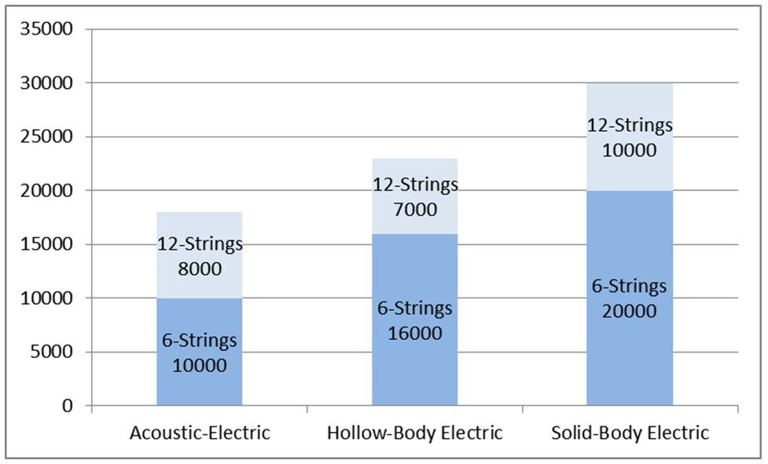
Cluster Bar Chart:
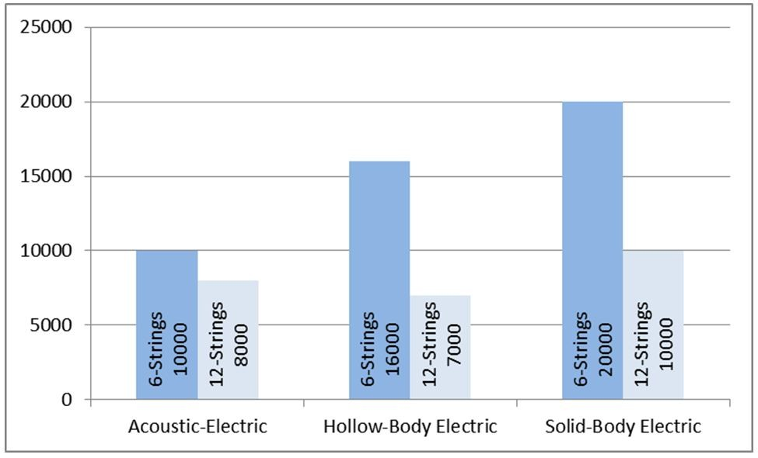
Difficulty: Challenging
Topic: Graphs to Describe Categorical Variables
AACSB: Analytic Skills
Course LO: Explain how data are acquired and distinguish among different types of data and levels of measurement; Compare and contrast methods of summarizing and describing data

246) Identify the shape of the distribution of the following histograms as:

Symmetric distribution; Skewed-right distribution; or Skewed-left distribution

A.
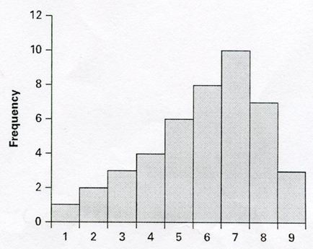

B.
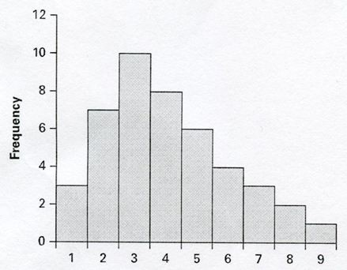

C.
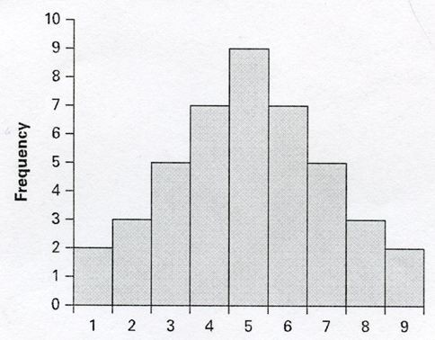
Answer: A. Skewed-left distribution
B. Skewed-right distribution
C. Symmetric distribution
Difficulty: Moderate
Topic: Graphs to Describe Numerical Variables
AACSB: Analytic Skills
Course LO: Explain how data are acquired and distinguish among different types of data and levels of measurement; Compare and contrast methods of summarizing and describing data

247) Discuss how a histogram can be constructed to give mistaken impressions and how this error can be corrected.
Answer: One possible error in constructing a histogram is to make the heights of the rectangles, and not the area of the rectangles, proportional to the frequencies. This frequently occurs when the widths of the intervals are not equal.
To remedy this, one must adjust the areas to be proportional to the frequencies. For example, if the intervals have widths of 10 and then jumps to a width of 20, the height of the frequencies for the greater width interval should be halved.
Difficulty: Challenging
Topic: Graphs to Describe Numerical Variables
AACSB: Reflective Thinking Skills
Course LO: Explain how data are acquired and distinguish among different types of data and levels of measurement; Compare and contrast methods of summarizing and describing data

