Statistics for Psychology, 5e (Aron/Aron/Coups)

Chapter 1

Displaying the Order in a Group of Numbers Using Tables and Graphs

1)

A psychologist who constructs a frequency table to summarize data collected on the amount of stress people have experienced in the last 2-1/2 weeks is using

A)

a measure of central tendency.

B)

a descriptive statistical method.

C)

an intuitive statistical method.

D)

an inferential statistical method.

Answer:

B

2)

Students who have read the first chapter of the textbook and theorize that performance on statistics exams will be related to the number of hours spent studying statistics know that to test their theory, they will need to use

A)

common sense.

B)

reasoning by analogy.

C)

inferential statistics.

D)

intuition.

Answer:

C

3)

The two branches of statistical methods are

A)

theoretical and inferential.

B)

intuitive and observational.

C)

descriptive and intuitive.

D)

descriptive and inferential.

Answer:

D

4)

If a psychologist studying aggressive tendencies in people develops an inventory to measure aggression, the psychologist is using scores on the inventory as a(n)

A)

abstract concept.

B)

variable.

C)

descriptive statistic.

D)

invariable construct.

Answer:

B

5)

Each of several patients is rated for their degree of depression, and if a particular patient's depression is rated 8 on a 20-point scale, 8 represents that patient's

A)

frequency.

B)

variable.

C)

score.

D)

mean.

Answer:

C

6)

If an intelligence test includes 12 items so that a person can answer any number of items between 0 and 12 correctly, each of these numbers between 0 and 12 is called a

A)

value.

B)

variable.

C)

rating.

D)

mean.

Answer:

A

7)

If a difference between scores of 3 and 4 is about the same as a difference between scores of 15 and 16, the variable being measured is

A)

equal-interval.

B)

differential.

C)

non-differential.

D)

rank-order.

Answer:

A

8)

The number of times a person exercises in a week is an example of a

A)

nominal variable.

B)

rank-order variable.

C)

ratio variable.

D)

categorical variable.

Answer:

C

9)

The number of problems correct on a test is an example of a

A)

continuous variable.

B)

discrete variable.

C)

log-linear variable.

D)

quadratic variable.

Answer:

B

10)

The length of time a person talks in a group discussion is an example of a(n)

A)

continuous variable.

B)

categorical variable.

C)

transformed variable.

D)

extraneous variable.

Answer:

A

11)

If the exact degree of difference between two scores has no meaning beyond the fact that one is
higher than the other, the level of measurement is

A)

nominal.

B)

ratio.

C)

rank-order.

D)

equal-interval.

Answer:

C

12)

Which of the following student characteristics is an example of a nominal variable?

A)

grade point average (3.2, 2.5, etc.)

B)

number of friends (0, 1, etc.)

C)

birth position in the family (first, second, etc.)

D)

nationality (U.S., Japanese, etc.)

Answer:

D

13)

Which of the following student characteristics is an example of a rank-order variable?

A)

grade point average (3.2, 2.5, etc.)

B)

number of friends (0, 1, etc.)

C)

birth position in the family (first, second, etc.)

D)

nationality (U.S., Japanese, etc.)

Answer:

C

14)

The value of putting numbers into a frequency table is that

A)

it makes the pattern of numbers clear at a glance.

B)

it is easier to draw inferences from tables.

C)

they are required by many journals.

D)

none of the above

Answer:

A

15)

A frequency table lists

A)

the times per second variations occur in various wave bands.

B)

the number of scores at each value.

C)

the intensity of a variable over all the participants studied.

D)

the average value of each variable.

Answer:

B

16)

The word "frequency" in a frequency table refers to

A)

cycles per second.

B)

how many scores there are for each value.

C)

the times per unit change of each score.

D)

the lags between values.

Answer:

B

17)

Consider the scores 1, 3, 3, 5, 6, 6, 6, 7, 7, and 8. Which of the following would be the correct top line of a frequency table?

A)

3 2 20%

B)

10 10 100%

C)

0 2 25%

D)

8 1 10%

Answer:

D

18)

Consider the scores 2, 6, 7, 1, 7, 8, 5, and 4. Which of the following would be the correct second line of a frequency table?

A)

2 7 25%

B)

7 2 25%

C)

6 1 6%

D)

1 1 12.5%

Answer:

B

19)

Which of the following is most likely to be possible?

A)

making a normal curve from a bimodal distribution

B)

making a bimodal distribution from a normal curve

C)

making an ordinary frequency table from a grouped frequency table

D)

making a grouped frequency table from an ordinary frequency table

Answer:

D

20)

If a psychologist summarizes data for a variable in a frequency table, but finds that there are so many values for the variable that the table is too cumbersome to be useful, the next step would be to make a

A)

histogram.

B)

frequency polygon.

C)

grouped frequency table.

D)

bar chart.

Answer:

C

21)

A psychologist plans to measure the eye movements of 50 participants as they read ambiguous words embedded in sentences. Since participants' eye movements are measured in milliseconds and there are likely to be many different measured times, the psychologist reasons that the best way to present the data is a

A)

frequency polygon.

B)

histogram.

C)

grouped frequency table.

D)

bar chart.

Answer:

C

22)

If a student sees 5.0-9.9 in a table in an article in a psychology journal, the student is seeing

A)

an interval.

B)

a cumulative percent.

C)

a value.

D)

an ordinal rank.

Answer:

A

23)

A histogram looks most like

A)

a city skyline.

B)

a large wave.

C)

a silhouette of mountains.

D)

a pattern of iron filings.

Answer:

A

24)

The graph a histogram most resembles is a

A)

pie graph.

B)

line graph.

C)

tree graph.

D)

bar graph.

Answer:

D

25)

In a histogram, the vertical dimension shows

A)

the possible values the variable can have.

B)

the intensity of the variable.

C)

the mean score.

D)

the frequency.

Answer:

D

26)

In a histogram, the horizontal dimension shows

A)

the possible values the variable can have.

B)

the intensity of the variable.

C)

the mean score.

D)

the frequency.

Answer:

A

27)

Making a histogram is easiest if one begins with

A)

a list of all the scores in order.

B)

a frequency table.

C)

a list of all the percentages in order.

D)

a normal curve table.

Answer:

B

28)

A difference between a histogram and a frequency polygon is that the frequency polygon

A)

is for grouped values.

B)

is for individual values.

C)

covers the full range of values.

D)

begins and ends with a frequency of zero.

Answer:

D

29)

A frequency polygon looks most like

A)

a city skyline.

B)

a large wave.

C)

a silhouette of mountains.

D)

a pattern of iron filings.

Answer:

C

30)

The graph a frequency polygon most resembles is a

A)

pie graph.

B)

line graph.

C)

tree graph.

D)

bar graph.

Answer:

B

31)

Psychologists use frequency tables, histograms, or frequency polygons to show

A)

the relation between two variables.

B)

the reasoning behind experiments.

C)

the hypotheses they plan to test.

D)

the way numbers they collect are distributed.

Answer:

D

32)

The distribution of the scores in most psychological research studies are

A)

unimodal.

B)

bimodal.

C)

multimodal.

D)

rectangular.

Answer:

A

33)

If a psychologist rating empathic responses to strangers' distress on a scale of 1 to 20 finds that most participants have ratings of either 8 or 16, the distribution of ratings is

A)

bimodal.

B)

unimodal.

C)

rectangular.

D)

normal.

Answer:

A

34)

If a psychologist rating empathic responses to strangers' distress on a scale of 1 to 20 finds that most participants have ratings of 8, 12 or 16, the distribution of ratings is

A)

rectangular.

B)

unimodal.

C)

multimodal.

D)

normal.

Answer:

C

35)

If a state law sets the maximum number of students in each classroom, a psychologist graphing the numbers of students in fifth grade classes in a school system would expect the graph to be

A)

normal.

B)

unimodal.

C)

multimodal.

D)

rectangular.

Answer:

D

36)

If most students earned average scores on a statistics test with about the same number of students earning above average scores and below average scores, the distribution of test scores would be

A)

symmetrical.

B)

negatively skewed.

C)

rectangular.

D)

positively skewed.

Answer:

A

37)

If most students did very well on a statistics test and only a few did poorly, including a few who did very poorly, the distribution of test scores would be

A)

symmetrical.

B)

negatively skewed.

C)

rectangular.

D)

positively skewed.

Answer:

B

38)

If most students did very poorly on a statistics test and only a few did well, including a few who did very well, the distribution of test scores would be

A)

symmetrical.

B)

negatively skewed.

C)

rectangular.

D)

positively skewed.

Answer:

D

39)

When a distribution is skewed to the right it means that

A)

more scores piled up at the high end of the range.

B)

the scores are evenly distributed.

C)

more scores piled up at the low end of the range.

D)

there is a ceiling effect.

Answer:

C

40)

When a distribution is skewed to the left, it is likely that

A)

there is a floor effect.

B)

more scores piled up at the low end of the range.

C)

the distribution is approximately normal.

D)

there is a ceiling effect.

Answer:

D

41)

If most students earned perfect scores on a statistics test, the distribution would

A)

be symmetrical.

B)

be rectangular.

C)

reflect a ceiling effect.

D)

reflect a floor effect.

Answer:

C

42)

A normal curve is typically

A)

kurtotic.

B)

bimodal.

C)

slightly skewed.

D)

none of the above

Answer:

D

43)

When a distribution is heavy-tailed, it is

A)

flatter than a normal curve.

B)

skewed to the right.

C)

skewed to the left.

D)

more peaked than a normal curve.

Answer:

A

44)

When a distribution is light-tailed, it is

A)

flatter than a normal curve.

B)

skewed to the right.

C)

skewed to the left.

D)

more peaked than a normal curve.

Answer:

D

45)

The proportions of the axes in a graphic display should usually be

A)

square (1 up to 1 across).

B)

rectangular wide (about 1-1/2 across to 1 up).

C)

rectangular tall (about 1-1/2 up to 1 across).

D)

rectangular long (about 1 up to the number of intervals across).

Answer:

B

46)

A frequency table is most likely to be included in a research article when

A)

the variable involves categories.

B)

there are a very small number of scores.

C)

a correlation is being reported.

D)

there are only two values for the variable.

Answer:

A

47)

Historically, an early use of statistics was to tabulate information to determine

A)

taxes.

B)

randomization.

C)

poverty rates.

D)

access to medical care.

Answer:

A

48)

Statistics means "state arithmetic" because it originally

A)

focused on the state of a variable at a given point.

B)

involved computations using state-trait mathematics.

C)

involved the tabulation of information about nations.

D)

required the stating aloud of taxation figures in Roman times.

Answer:

C

49)

If you suffer from test anxiety, some useful advice is to

A)

over prepare for tests (at least at first).

B)

do everything you can to increase your motivation to do well.

C)

use stimulants (such as coffee) just before the exam.

D)

wait until the night before the test to study.

Answer:

A

50)

Research about the math performance of women indicates that women generally do

A)

worse in statistics classes because they have lower expectations for themselves.

B)

worse in statistics classes because others have lower expectations of them.

C)

worse in statistics classes because instructors tend to call on them less often.

D)

as well as men in statistics classes.

Answer:

D

51)

If psychologists want to summarize a group of numbers collected in a research study and make them more understandable, they will use __________.

Answer:

descriptive statistics

52)

If psychologists want to draw statistical conclusions that go beyond the numbers actually collected in a research study, they will use __________.

Answer:

inferential statistics

53)

A listing that shows how many times each value of a variable occurs among a particular group of scores is called a(n) __________.

Answer:

frequency table

54)

If a student answers 20 of 25 multiple choice items on a statistics test correctly, 20 is the student's __________.

Answer:

score

55)

If a statistics test is designed to test student knowledge of the shapes of distributions, knowledge of the shapes of distributions is a(n) __________.

Answer:

variable

56)

If the difference between scores of 3 and 4 has the same meaning as the difference between 25 and 26 on a particular measure, the measure is said to be __________.

Answer:

equal-interval

57)

A variable that has specific values and cannot have values between those specific values is a(n) __________.

Answer:

discrete variable

58)

Since a person can fail to recognize any unfamiliar words embedded in longer words, word recognition is measured as a(n) __________.

Answer:

ratio variable

59)

The length of a therapy session is a numeric ratio variable, and more specifically a(n) __________.

Answer:

continuous variable

60)

The number of therapy sessions a person has attended is a numeric ratio variable, and more specifically a(n) __________.

Answer:

discrete variable.

61)

Another name for an ordinal measurement is a(n) __________.

Answer:

rank-order measurement

62)

Equal-interval and rank-order variables, but not nominal variables, are examples of __________

Answer:

numeric variables, quantitative variables

63)

Which country in which a person lives is an example of a(n) __________.

Answer:

nominal variable, categorical variable

64)

A psychologist making a frequency table will list the values in the first column and the __________ for each value in the second column.

Answer:

frequency, number of scores

65)

Usually, the heading for the third column of a frequency table is __________.

Answer:

percentage, %

66)

The type of table created when a psychologist lists the number of employees at each level of earnings from $80,000 to $99,999 going down to $20,000 to $29,999 is a(n) __________.

Answer:

grouped frequency table

67)

A way to simplify a frequency table when there are a large number of possible values is to group the scores into __________.

Answer:

intervals

68)

A graph of frequencies in which the bars are adjacent to each other is a(n) __________.

Answer:

histogram

69)

A psychologist who makes a histogram, puts a dot at the top of each bar and dots on the base line just below and just above the intervals where the histogram begins and ends, and then connects the dots is making a(n) __________.

Answer:

frequency polygon

70)

A frequency table, histogram, or frequency polygon describes a(n) __________.

Answer:

frequency distribution, distribution of scores, distribution

71)

If one of the bars of a histogram is higher than all the others, the distribution is __________.

Answer:

unimodal

72)

If a psychologist studying exercise behavior found that one group of people exercised less than 1 hour per week, while another group all exercised more than 10 hours per week, the distribution would be __________.

Answer:

bimodal, multimodal

73)

The frequency distribution that would reflect the number of times the various numbers on a roulette wheel are used, in the long run, will be __________.

Answer:

rectangular, symmetrical

74)

If each half of a distribution is a mirror image of the other, the distribution is __________.

Answer:

symmetrical

75)

A distribution in which the scores pile up at one end is said to be __________.

Answer:

skewed

76)

If most adults are good readers, but a small number of people are nearly illiterate, scores on a test of reading ability on which high scores indicate high reading ability, the distribution of adults will be skewed to the __________.

Answer:

left

77)

Since no environment can be more quiet than no noise at all, a survey of noise in various study environments found that noise scores tended to pile up at the low end, reflecting a(n) __________.

Answer:

floor effect

78)

A psychologist would include difficult questions on an intelligence test to reduce the number of perfect scores in order to avoid a(n) __________.

Answer:

ceiling effect

79)

The distributions of scores collected in psychology research studies often approximate a(n) __________.

Answer:

normal curve

80)

A rectangular distribution, in addition to being symmetrical, would be an example of a(n) __________.

Answer:

heavy-tailed distribution

81)

Graphs can be deceiving when the width to height proportion differs from __________.

Answer:

1.5 width to 1.0 height

82)

Explain the difference between descriptive statistics and inferential statistics.

83)

Explain why a grouped frequency table can sometimes be more useful than an ordinary frequency table in describing a group of numbers.

84)

Explain what it means to have a ceiling effect in a distribution of scores. Give an example.

85)

Draw (a) a normal distribution, (b) a bimodal distribution, (c) a positively skewed distribution, and (d) a heavy tailed distribution.

86)

Make up a study that would result in a bimodal distribution.

87)

Make up a study that would result in a distribution that is skewed to the left.

88)

Make up a set of scores and graphically display these data in a way that is misleading. Explain what you have done.

89)

A developmental psychologist surveyed 16 single senior citizens living in private apartments. Each participant completed a questionnaire on the number of telephone conversations he or she had in the last day. Their answers were as follows: 5, 0, 2, 1, 1, 9, 0, 1, 0, 3, 1, 1, 4, 3, 4, and 7.
a. Make a frequency table.
b. Make a histogram based on the frequency table.
c. Describe in words the shape of the histogram.

Answer:

See the graph.

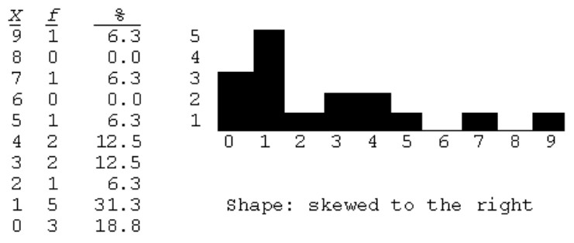

90)

A prison psychologist recorded the number of rule infractions for 12 prison inmates over a six-month period to be 1, 3, 0, 1, 0, 6, 8, 2, 0, 1, 0, and 2.
a. Make a frequency table.
b. Make a histogram based on the frequency table.
c. Describe in words the shape of the histogram.

Answer:

See the graph.

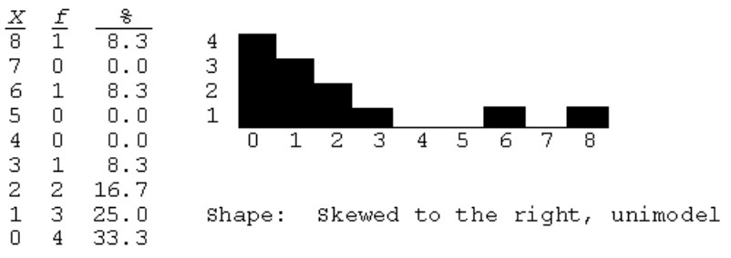

91)

An industrial psychologist recorded the number of units produced per hour by 15 factory workers. The results were as follows: 8, 10, 4, 9, 9, 10, 1, 9, 8, 5, 9, 9, 8, 7, and 8.
a. Make a frequency table.
b. Make a frequency polygon based on the frequency table.
c. Describe in words the shape of the frequency polygon.

Answer:

See the graph.

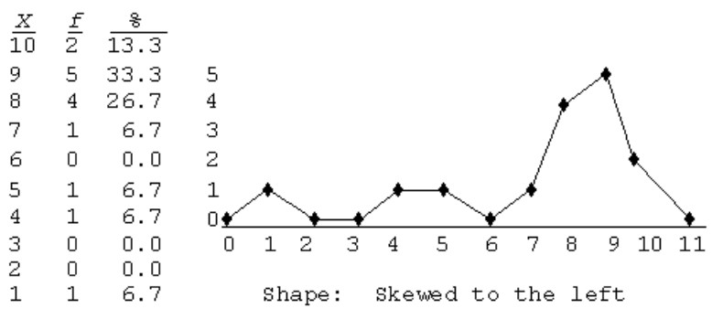

92)

A social psychologist gave a survey to 20 active members of a small political action group about how many hours they put into the group's activities each week. The results were as follows: 24, 41, 1, 41, 14, 2, 40, 58, 2, 1, 41, 2, 41, 30, 0, 41, 3, 3, 41, and 49.
a. Make a grouped frequency table using the intervals 0-9, 10-19, 20-29, etc.
b. Make a histogram based on the grouped frequency table.
c. Describe in words the shape of the histogram.

Answer:

See the graph.

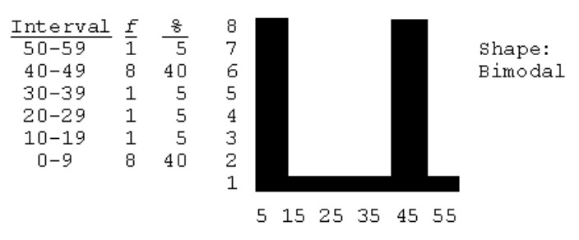

93)

A developmental psychologist studies how long it took toddlers to pick up a particular attractive new toy. Fifty toddlers were studiedall of whom eventually picked up the toy. In the research article, she provided the following table for the approximate numbers of minutes it took.

Minutes f %
10 7 14
9 0 0
8 3 6
7 5 10
6 7 14
5 8 16
4 9 18
3 7 14
2 2 4
1 1 2

(a) Using this table as an example, explain the idea of a frequency table to a person who has never had a course in statistics. (b) Explain the general meaning of the pattern of results.

94)

An anthropologist examined the average number of children in a particular group of 84 hunter-gatherer societies. The anthropologist reported that the distribution was bimodal. Explain what this means to a person who has never had a course in statistics.

