# Tansey Test Bank, Chapter 2: Nucleic Acids

**MULTIPLE CHOICE**

1.Nucleotides play a central role in living organisms because ______.

A) they mediate transport of energy within the cell

B) they are involved in oxidation-reduction reactions

C) they are involved in intracellular signaling

D) they function as building blocks for nucleic acids

E) all of the above

Answer: E

Difficulty: Easy

Section: 2.1

Learning Objective: Analyze the structures of nucleic acids at the chemical level.

**MULTIPLE CHOICE**

2.What group is attached to the pyrimidine ring in thymine and is not present in uracil?

A) ribose

B) –CH3

C) –NH2

D) deoxyribose

E) none of the above

Answer: B

Difficulty: Moderate

Section: 2.1

Learning Objective: Analyze the structures of nucleic acids at the chemical level.

**MULTIPLE CHOICE**

3.Nucleotides contain one or more phosphate groups that are usually attached to the ______.

A) C-3ꞌ or C-5ꞌ atoms

B) C-3 or C-3ꞌ atoms

C) C-5 or N-3 atoms

D) C-1ꞌ or N-3 atoms

E) none of the above

Answer: A

Difficulty: Moderate

Section: 2.1

Learning Objective: Analyze the structures of nucleic acids at the chemical level.

**MULTIPLE CHOICE**

4.Inside our cells, free nucleotides are almost always associated with ______.

A) proteins

B) cholesterol

C) Cl− counterions

D) fatty acids

E) Mg2+ counterions

Answer: E

Difficulty: Moderate

Section: 2.1

Learning Objective: Analyze the structures of nucleic acids at the chemical level.

**MULTIPLE CHOICE**

5.Nucleoside triphosphates are useful for energy transfer because the phosphoanhydride bonds are relatively ______.

A) stable

B) high energy

C) biocompatible

D) large

E) low energy

Answer: B

Difficulty: Easy

Section: 2.1

Learning Objective: Analyze the structures of nucleic acids at the chemical level.

**MULTIPLE CHOICE**

6.Nucleoside triphosphates carry energy in the form of ______.

A) glycosidic bonds

B) phosphoester bonds

C) phosphoanhydride bonds

D) hydrogen bonds

E) amide linkages

Answer: C

Difficulty: Moderate

Section: 2.1

Learning Objective: Analyze the structures of nucleic acids at the chemical level.

**MULTIPLE CHOICE**

7.Which of the following nucleotides contain energy rich bonds?

A) ATP

B) TTP

C) GTP

D) CTP

E) all of the above

Answer: E

Difficulty: Easy

Section: 2.1

Learning Objective: Analyze the structures of nucleic acids at the chemical level.

**MULTIPLE CHOICE**

8.Which of the following molecules does *not* contain an energy-rich phosphoanhydride bond?

A) ADP

B) GDP

C) AMP

D) CDP

E) all of the above

Answer: C

Difficulty: Easy

Section: 2.1

Learning Objective: Analyze the structures of nucleic acids at the chemical level.

**SHORT ANSWER**

9.Which of the following bases pairs with guanine?

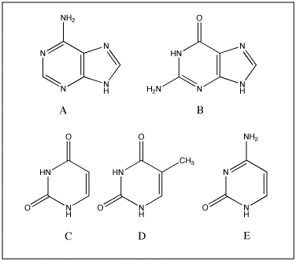

Answer: E

Difficulty: Easy

Section: 2.1

Learning Objective: Analyze the structures of nucleic acids at the chemical level.

**MULTIPLE CHOICE**

10.Knowledge about the tautomeric forms of the bases of nucleic acids is needed ______.

A) to understand H-bonding between the complementary bases

B) to understand how the bases are linked to ribose

C) to understand how bases are linked to deoxyribose

D) to understand the ability of nucleotides to act as energy carriers

E) to distinguish the 5ꞌ end of a DNA strand from the 3ꞌ end

Answer: A

Difficulty: Easy

Section: 2.1

Learning Objective: Analyze the structures of nucleic acids at the chemical level.

**MULTIPLE CHOICE**

11.RNA occurs primarily as single-stranded molecules that can give rise to _______ structures.

A) diploid

B) stem-loop

C) parallel

D) tautomeric

E) haploid

Answer: B

Difficulty: Easy

Section: 2.1

Learning Objective:Analyze the structures of nucleic acids at the chemical level.

**SHORT ANSWER**

12.Which of the following bases is *not* present in RNA?



Answer: D

Difficulty: Easy

Section: 2.1

Learning Objective: Analyze the structures of nucleic acids at the chemical level.

**SHORT ANSWER**

13. This is the structure of adenine.

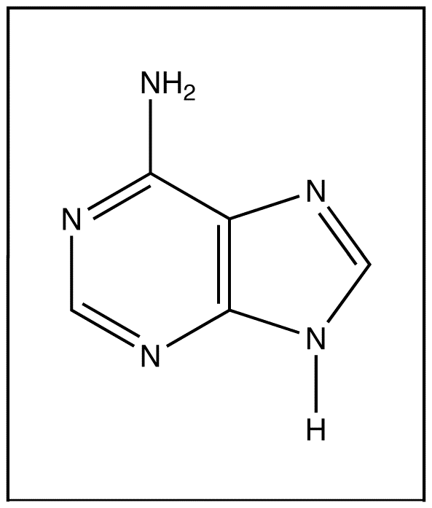

a. Is adenine a purine or a pyrimidine?

b. Which base does adenine base-pair (H-bond) with in DNA?

c. What is the name of the molecule that is composed of adenine linked to the C-1ꞌ of ribose?

d. Indicate on the drawing through which atom adenine is connected to ribose or deoxyribose.

e. Indicate on the drawing which groups on adenine are involved in base-pairing or H-bonding with its complementary base.

Answer: a. purine

b. thymine

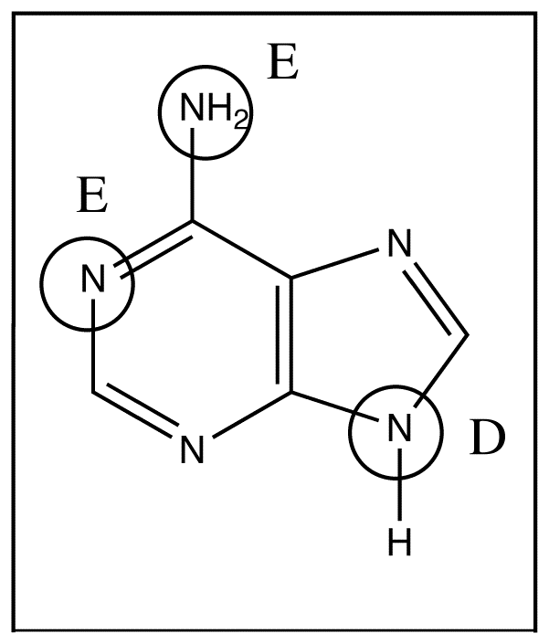c. adenosine

d. see diagram

e. see diagram

Difficulty: Difficult

Section: 2.1

Learning objective: Analyze the structures of nucleic acids at the chemical level.

**SHORT ANSWER**

14.Describe the structure of a DNA molecule by listing six characteristics.

Answer: 1. DNA forms a double helix.

2. The two strands run antiparallel.

3. The sugar is deoxyribose.

4. The sugar-phosphate groups are on the outside of the helix.

5. The bases are in the center of the helix.

6. The bases are planar, and their plane is orientated perpendicular to the axis of the helix.

6. There are four bases: adenine, guanine, cytosine, and thymine.

7. The strands are held together by H-bonding between complementary bases: adenine- thymine and guanine-cytosine.

8. The helix has a minor and a major groove on its surface.

Difficulty: Difficult

Section: 2.1

Learning objective: Analyze the structures of nucleic acids at the chemical level.

**SHORT ANSWER**

15.This is the structure of cytosine.

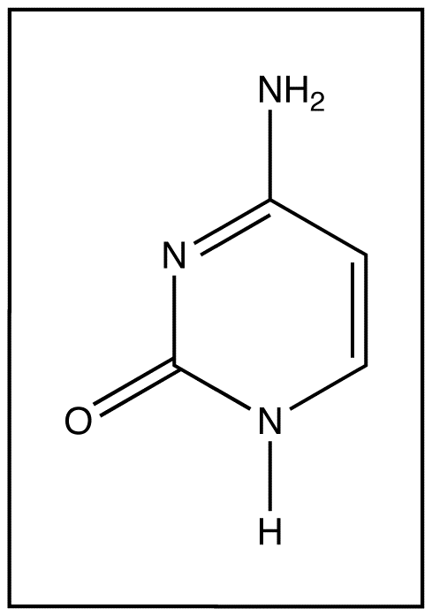

a. What are the names of the other three bases that are found in DNA?

b. Is cytosine a purine or a pyrimidine?

c. Give the name and the one letter abbreviation of the base cytosine base-pairs (H-bonds) with in DNA.

d. What is the name of the molecule composed of cytosine linked to ribose?

e. Indicate on the drawing through which atom cytosine is connected to ribose or deoxyribose

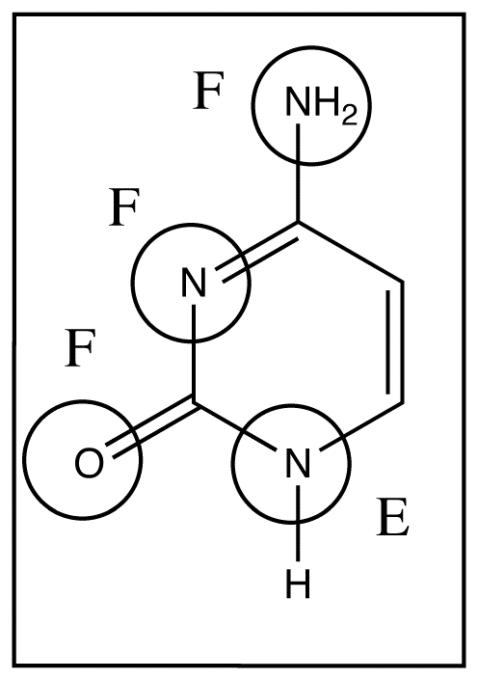f. Indicate on the drawing which groups on cytosine are involved in base-pairing (H-bonding) with its complementary base.

Answer: a. adenine, guanine, and thymine

b. pyrimidine

c. guanine, G

d. cytidine

e. see diagram

f. see diagram

Difficulty: Difficult

Section: 2.1

Learning objective: Analyze the structures of nucleic acids at the chemical level.

**TEXT ENTRY**

16.The pyrimidine found in both DNA and RNA is _____. The pyrimidine found only in DNA is _____, and the pyrimidine found only in RNA is _____.

Answer 1: cytosine

Answer 2: thymine

Answer 3: uracil

Difficulty: Moderate

Section: 2.1

Learning Objective: Analyze the structures of nucleic acids at the chemical level.

**DROPDOWN**

17. The link between a purine and ribose is made from the ____ of the purine ring to the ____ of the ribose.

Dropdown 1: N-1, N-3, N-7, **N-9**

Dropdown 2: **C-1ꞌ**, C-2ꞌ, C-3ꞌ, C-4ꞌ, C-5ꞌ

Difficulty: Moderate

Section: 2.1

Learning Objective: Analyze the structures of nucleic acids at the chemical level.

**DROPDOWN**

18.The link between a pyrimidine and ribose is made from the ___ of the pyrimidine ring to the ___ of the ribose.

Dropdown 1: **N-1**, N-3

Dropdown 2: **C-1ꞌ**, C-2ꞌ, C-3ꞌ, C-4ꞌ, C-5ꞌ

Difficulty: Moderate

Section: 2.1

Learning Objective: Analyze the structures of nucleic acids at the chemical level.

**MULTIPLE CHOICE**

19.In DNA, the ribose derivative lacks an _____ on C-_____.

A) alcohol; 2

B) alcohol; 3

C) amine; 2

D) amine; 3

E) none of the above

Answer: A

Difficulty: Moderate

Section: 2.1

Learning Objective: Analyze the structures of nucleic acids at the chemical level.

**MULTIPLE CHOICE**

20.What type of bond is made between nucleotides?

A) ester

B) phosphoester

C) phosphodiester

D) glycosidic

E) none of the above

Answer: C

Difficulty: Easy

Section: 2.1

Learning Objective: Analyze the structures of nucleic acids at the chemical level.

**MULTIPLE CHOICE**

21.The most common base pairs in DNA are _____ and _____.

A) A-T; A-G

B) G-C; C-A

C) T-A; A-U

D) C-G; T-A

E) G-U; A-T

Answer: D

Difficulty: Moderate

Section: 2.1

Learning Objective: Analyze the structures of nucleic acids at the chemical level.

**MULTIPLE CHOICE**

22.An A-T base pair consists of _____ H-bond(s); a C-G base pair consists of _____ H-bond(s).

A) 1; 2

B) 2; 1

C) 2; 2

D) 3; 2

E) 2; 3

Answer: E

Difficulty: Easy

Section: 2.1

Learning Objective: Analyze the structures of nucleic acids at the chemical level.

**MULTIPLE CHOICE**

23.Which of the following correctly describes the B-DNA double helix?

A) antiparallel strands

B) right-handed helix

C) base pairs are located in the center of the helix

D) one helical rotation has a rise of 3.4 nm

E) all of the above

Answer: E

Difficulty: Difficult

Section: 2.1

Learning Objective: Analyze the structures of nucleic acids at the chemical level.

**MULTIPLE CHOICE**

24.The DNA strand that serves as the template for the synthesis of RNA is often called the _____.

A) coding strand

B) noncoding strand

C) messenger strand

D) transfer strand

E) transcription strand

Answer: B

Difficulty: Easy

Section: 2.2

Learning Objective: Illustrate when and how nucleic acids function in replication of DNA, transcription of DNA into RNA, regulation of transcription, and translation of RNA into proteins.

**MULTIPLE CHOICE**

25.The replication of DNA is made possible by the presence of _____ strands in the double helix of DNA.

A) antiparallel

B) hydrogen-bonded

C) complementary

D) genomic

E) none of the above

Answer: C

Difficulty: Easy

Section: 2.2

Learning Objective: Illustrate when and how nucleic acids function in replication of DNA, transcription of DNA into RNA, regulation of transcription, and translation of RNA into proteins.

**MULTIPLE CHOICE**

26.In living organisms, genetic information is most often stored in the form of ______.

A) ribonucleic acid

B) deoxyribonucleic acid

C) proteins

D) enzymes

E) deoxynucleotides

Answer: B

Difficulty: Easy

Section: 2.2

Learning Objective: Illustrate when and how nucleic acids function in replication of DNA, transcription of DNA into RNA, regulation of transcription, and translation of RNA into proteins**.**

**MULTIPLE CHOICE**

27.Genomic DNA is _____, resulting in the production of _____.

A) transcribed; mRNA

B) translated; tRNA

C) transcribed; protein

D) translated; protein

E) translated; rRNA

Answer: A

Difficulty: Moderate

Section: 2.2

Learning Objective: Illustrate when and how nucleic acids function in replication of DNA, transcription of DNA into RNA, regulation of transcription, and translation of RNA into proteins.

**MULTIPLE CHOICE**

28.An *E. coli* has _____ replication fork(s) on its single chromosome; humans have _____ replication fork(s) on each chromosome.

A) 1; 1

B) 1; 2

C) 2; 2

D) 2; many

E) many; many

Answer: D

Difficulty: Easy

Section: 2.2

Learning Objective: Illustrate when and how nucleic acids function in replication of DNA, transcription of DNA into RNA, regulation of transcription, and translation of RNA into proteins.

**MULTIPLE CHOICE**

29.Which strand of DNA is replicated exclusively in a discontinuous fashion?

A) forward strand

B) reverse strand

C) leading strand

D) lagging strand

E) the strand that is read in a 5ꞌ to 3ꞌ direction

Answer: D

Difficulty: Easy

Section: 2.2

Learning Objective: Illustrate when and how nucleic acids function in replication of DNA, transcription of DNA into RNA, regulation of transcription, and translation of RNA into proteins.

**MULTIPLE CHOICE**

30.Which of the following best describes a new strand of DNA relative to the template strand used to synthesize it?

A) an exact duplicate of the template

B) a negative copy of the template

C) a palindromic copy of the template

D) an exact copy of the template but with the 3ꞌ and 5ꞌ ends reversed

E) none of the above

Answer: B

Difficulty: Moderate

Section: 2.2

Learning Objective: Illustrate when and how nucleic acids function in replication of DNA, transcription of DNA into RNA, regulation of transcription, and translation of RNA into proteins.

**MULTIPLE CHOICE**

31.In most organisms, replication proceeds in a _____ manner from the _____.

A) bidirectional; replication origin

B) bidirectional; theta site

C) bidirectional; lagging strand

D) unidirectional; chromosome ends

E) none of the above

Answer: A

Difficulty: Easy

Section: 2.2

Learning Objective: Illustrate when and how nucleic acids function in replication of DNA, transcription of DNA into RNA, regulation of transcription, and translation of RNA into proteins.

**MULTIPLE CHOICE**

32**.** Genomic DNA that encodes proteins undergoes the process of _____ to produce _____.

A) transcription; mRNA

B) transcription; tRNA

C) translation; rRNA

D) translation; proteins

E) transcription; proteins

Answer: A

Difficulty: Moderate

Section: 2.2

Learning Objective: Illustrate when and how nucleic acids function in replication of DNA, transcription of DNA into RNA, regulation of transcription, and translation of RNA into proteins.

**TEXT ENTRY**

33.Prokaryotes contain nucleotide sequences known as _____ that contain related genes with related functions.

Answer: operons

Difficulty: Easy

Section: 2.2

Learning Objective: Illustrate when and how nucleic acids function in replication of DNA, transcription of DNA into RNA, regulation of transcription, and translation of RNA into proteins.

**MULTIPLE CHOICE**

34.All cellular RNAs are transcribed from ______.

A) DNA templates

B) RNA templates

C) either DNA or RNA templates, but not both in the same organism

D) a combination of DNA and RNA templates

E) none of the above

Answer: A

Difficulty: Easy

Section: 2.2

Learning Objective: Illustrate when and how nucleic acids function in replication of DNA, transcription of DNA into RNA, regulation of transcription, and translation of RNA into proteins.

**MULTIPLE CHOICE**

35.The term rRNA refers to ______ RNA.

A) ribosomal

B) retroviral

C) recombinant

D) rho factor

Answer: A

Difficulty: Easy

Section: 2.2

Learning Objective: Illustrate when and how nucleic acids function in replication of DNA, transcription of DNA into RNA, regulation of transcription, and translation of RNA into proteins.

**MULTIPLE CHOICE**

36.Polypeptide synthesis proceeds from the _____ to the _____.

A) entrance site; exit site

B) 50S subunit; 30S subunit

C) C-terminus; N-terminus

D) N-terminus; C-terminus

E) peptidyl site; aminoacyl site

Answer: D

Difficulty: Moderate

Section: 2.2

Learning Objective: Illustrate when and how nucleic acids function in replication of DNA, transcription of DNA into RNA, regulation of transcription, and translation of RNA into proteins.

**MULTIPLE CHOICE**

37.Which of the following is a function of the ribosome?

I. bind mRNA and allow codon recognition

II. mediate the binding of proteins necessary for initiation, elongation, and termination

III. catalyze synthesis of peptide bonds

IV. translocate such that multiple codons can be read

A) I only

B) I, II

C) I, IV

D) II only

E) I, II, III, IV

Answer: E

Difficulty: Moderate

Section: 2.2

Learning Objective: Illustrate when and how nucleic acids function in replication of DNA, transcription of DNA into RNA, regulation of transcription, and translation of RNA into proteins.

**MULTIPLE CHOICE**

38.Which diagram correctly depicts a ribosome engaged in translation?

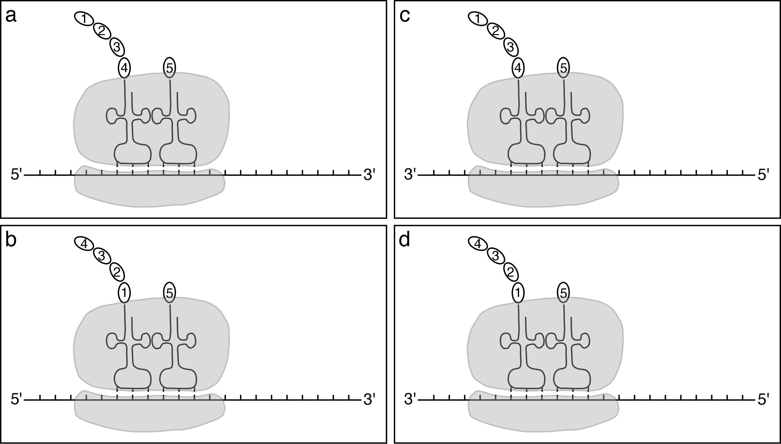

A) a

B) b

C) c

D) d

Answer: A

Difficulty: Difficult

Section: 2.2

Learning Objective: Illustrate when and how nucleic acids function in replication of DNA, transcription of DNA into RNA, regulation of transcription, and translation of RNA into proteins.

**MULTIPLE CHOICE**

39.Transfer RNA molecules are involved in ______.

A) transcription

B) translation

C) replication

D) reverse transcription

E) post-translational processing

Answer: B

Difficulty: Easy

Section: 2.2

Learning Objective: Illustrate when and how nucleic acids function in replication of DNA, transcription of DNA into RNA, regulation of transcription, and translation of RNA into proteins.

**SHORT ANSWER**

40.There are three types of RNA that are directly involved in translation.

a. Name these three types of RNA

b. Briefly describe the function of each of these types of RNA.

Answer: a. mRNA, tRNA, rRNA

b. mRNA moves genetic information from the nucleus to the ribosomes in the cytoplasm. tRNA decodes the genetic message; it matches sequences of three nucleotides to amino acids. rRNA is involved in the catalysis of amide bond formation.

Difficulty: Difficult

Section: 2.2

Learning objective: Illustrate when and how nucleic acids function in replication of DNA, transcription of DNA into RNA, regulation of transcription, and translation of RNA into proteins.

**TEXT ENTRY**

41.In bacteria, riboflavin can inhibit its own synthesis by binding to an mRNA element termed a ______.

Answer: riboswitch

Difficulty: Moderate

Section: 2.2

Learning Objective: Illustrate when and how nucleic acids function in replication of DNA, transcription of DNA into RNA, regulation of transcription, and translation of RNA into proteins.

**MULTIPLE CHOICE**

42.RNA interference is a mechanism of post-transcriptional RNA-dependent ______.

A) chromatin-remodeling

B) gene silencing

C) histone methylation

D) coactivation

E) apoptosis

Answer: B

Difficulty: Easy

Section: 2.2

Learning Objective: Illustrate when and how nucleic acids function in replication of DNA, transcription of DNA into RNA, regulation of transcription, and translation of RNA into proteins.

**MULTIPLE CHOICE**

43.Which of the following would likely result in the formation of RNAi?

A) injection of antisense RNA from a human into human cells

B) injection of sense RNA into *C. elegans*

C) injection of antisense RNA from yeast into a human

D) all of the above

E) none of the above

Answer: E

Difficulty: Difficult

Section: 2.2

Learning Objective: Illustrate when and how nucleic acids function in replication of DNA, transcription of DNA into RNA, regulation of transcription, and translation of RNA into proteins.

**MULTIPLE CHOICE**

44.Incorporation of which of the following would result in chain termination during sequencing of DNA?

A) dATP

B) dCTP

C) ddTTP

D) dGTP

E) none of the above

Answer: C

Difficulty: Easy

Section: 2.3

Learning Objective: Describe how alterations to nucleic acids in the cell can facilitate biochemical studies.

**MULTIPLE CHOICE**

45.The results of DNA sequencing are obtained by first separating different-sized pieces of DNA using _____ followed by detection of the particular dideoxynucleotide using _____.

A) HPLC; NMR

B) HPLC; absorbance spectroscopy

C) electrophoresis; fluorescence spectroscopy

D) electrophoresis; X-ray crystallography

E) none of the above

Answer: C

Difficulty: Moderate

Section: 2.3

Learning Objective: Describe how alterations to nucleic acids in the cell can facilitate biochemical studies.

**MULTIPLE CHOICE**

46.The most commonly used technique for making large numbers of copies of DNA is _____.

A) polymerase chain reaction

B) dideoxy sequencing

C) restriction digestion

D) genetic engineering

E) site-directed mutagenesis

Answer: A

Difficulty: Easy

Section: 2.3

Learning Objective: Describe how alterations to nucleic acids in the cell can facilitate biochemical studies.

**MULTIPLE CHOICE**

47.Because of the high temperature _____ step during a PCR reaction, the DNA polymerase from _____ is used.

A) primer extension; *E. coli*

B) strand separation; *Thermus aquaticus*

C) primer annealing; *Thermus aquaticus*

D) primer extension; bacteriophage λ

E) strand separation; *E. coli*

Answer: B

Difficulty: Moderate

Section: 2.3

Learning Objective: Describe how alterations to nucleic acids in the cell can facilitate biochemical studies.

**MULTIPLE CHOICE**

48.What reagents are required to perform PCR?

A) DNA fragment, primers flanking the region of interest, dNTPs, DNA polymerase

B) DNA fragment, primers flanking the region of interest, dNTPs, ddNTPs, DNA polymerase

C) DNA fragment, one primer, dNTPs, DNA polymerase, DNA ligase

D) DNA fragment, one primer, dNTPs, DNA polymerase, DNA endonuclease

E) DNA fragment, primers flanking the region of interest, dNTPs, DNA endonuclease

Answer: A

Difficulty: Moderate

Section: 2.3

Learning Objective: Describe how alterations to nucleic acids in the cell can facilitate biochemical studies.

**MULTIPLE CHOICE**

49.Which of the following represents the correct order of steps in a PCR reaction beginning with double-stranded DNA?

A) primer annealing, strand separation, primer extension

B) strand separation, primer extension, primer annealing

C) strand separation, primer annealing, primer extension

D) primer extension, primer annealing, strand separation

E) primer annealing, primer extension, strand separation

Answer: C

Difficulty: Moderate

Section: 2.3

Learning Objective: Describe how alterations to nucleic acids in the cell can facilitate biochemical studies.

**MULTIPLE CHOICE**

50.EcoRI recognizes the sequence 5ꞌ-G↓AATTC-3ꞌ (the arrow indicates the point of cleavage). Treatment of the following oligonucleotide with EcoRI would produce two oligonucleotides with sizes of _____ nucleotides containing _____ ends.

5ꞌ–AAGTCGATACAGAATTCGTACCTAG–3ꞌ

A) 12 and 13; blunt

B) 12 and 8; blunt

C) 11 and 8; sticky

D) 12 and 13; sticky

E) 9 and 13; sticky

Answer: D

Difficulty: Difficult

Section: 2.3

Learning Objective: Describe how alterations to nucleic acids in the cell can facilitate biochemical studies.

**MULTIPLE CHOICE**

51.What term describes a small, circular molecule of DNA that can be used to transfer genetic material from one organism to another?

A) plasmid

B) bacteriophage

C) clone

D) tRNA

E) splice

Answer: A

Difficulty: Easy

Section: 2.3

Learning Objective: Describe how alterations to nucleic acids in the cell can facilitate biochemical studies.

**MULTIPLE CHOICE**

52.What term describes the production of multiple identical organisms from a single ancestor?

A) transcription

B) cloning

C) sequencing

D) phenotyping

E) ligation

Answer: B

Difficulty: Easy

Section: 2.3

Learning Objective: Describe how alterations to nucleic acids in the cell can facilitate biochemical studies.

**MULTIPLE CHOICE**

53.What enzyme is required to form a new phosphodiester bond when inserting DNA into a plasmid?

A) DNA polymerase

B) endonuclease

C) exonuclease

D) ligase

E) clonase

Answer: D

Difficulty: Easy

Section: 2.3

Learning Objective: Describe how alterations to nucleic acids in the cell can facilitate biochemical studies.

**MULTIPLE CHOICE**

54.What technique involves addition of primers that do not exactly match the sequence of a gene, thus allowing for introduction of a mutation?

A) cloning

B) transformation

C) site-directed mutagenesis

D) selection

E) none of the above

Answer: C

Difficulty: Easy

Section: 2.3

Learning Objective: Describe how alterations to nucleic acids in the cell can facilitate biochemical studies.

**MULTIPLE CHOICE**

55.Double-stranded DNA molecules can be cleaved at specific recognition sites by _____.

A) RNA polymerase

B) DNA ligase

C) DNA polymerase

D) reverse transcriptase

E) Type II restriction endonucleases

Answer: E

Difficulty: Moderate

Section: 2.3

Learning Objective: Describe how alterations to nucleic acids in the cell can facilitate biochemical studies.

**MULTIPLE CHOICE**

56.DNA sequencing using the Sanger method requires _____.

A) template, primer, DNA polymerase, mRNA, dNTPs, ddNTPs

B) template, primer, DNA polymerase, dNTPs, ddNTPs

C) template, primer, DNA polymerase, rRNA, dNTPs, ddNTPs

D) template, primer, DNA polymerase, mRNA, dNTPs

E) none of the above

Answer: B

Difficulty: Moderate

Section: 2.3

Learning Objective: Describe how alterations to nucleic acids in the cell can facilitate biochemical studies.

**MULTIPLE CHOICE**

57.In Sanger dideoxy DNA sequencing, DNA polymerase I is used to add nucleotides to the _____ end of the growing polynucleotide chain.

A) sticky

B) blunt

C) 3ꞌ

D) 5ꞌ

E) dideoxy-nucleotide-containing

Answer: C

Difficulty: Moderate

Section: 2.3

Learning Objective: Describe how alterations to nucleic acids in the cell can facilitate biochemical studies.

**MULTIPLE CHOICE**

58.DNA sequencing by the chain-termination method uses DNA polymerase I to make a complementary copy of the target or template DNA molecule. A reaction with a 20 bp template and dideoxyadenosine nucleotides as terminators results in the production of a 5 bp fragment. Based on this result, we can conclude that the template contains _____.

A) a cytosine at position 5

B) a thymine at position 5

C) a cytosine at position 16

D) a thymine at position 16

E) a uracil at position 5

Answer: D

Difficulty: Difficult

Section: 2.3

Learning Objective: Describe how alterations to nucleic acids in the cell can facilitate biochemical studies.

**MULTIPLE CHOICE**

59.Mutations leading to changes that can be inherited by the next generation have to be introduced at the ______ level.

A) DNA

B) rRNA

C) protein

D) mRNA

E) tRNA

Answer: A

Difficulty: Moderate

Section: 2.3

Learning Objective: Describe how alterations to nucleic acids in the cell can facilitate biochemical studies.

**MULTIPLE CHOICE**

60.In molecular cloning, transformed organisms must be identified. One common method for accomplishing this involves the inclusion of ______ in the plasmid.

A) a restriction site

B) a nuclease gene

C) a deletion

D) an origin of replication

E) an antibiotic resistance gene

Answer: E

Difficulty: Moderate

Section: 2.3

Learning Objective: Describe how alterations to nucleic acids in the cell can facilitate biochemical studies.

**MULTIPLE CHOICE**

61.To perform PCR, which of the following describes the reagents that must be included in the reaction mixture?

A) DNA fragment, primers flanking the region of interest, dNTPs, DNA polymerase

B) DNA fragment, primers flanking the region of interest, dNTPs, ddNTPS, DNA polymerase

C) DNA fragment, one primer, dNTPs, DNA polymerase, DNA ligase

D) DNA fragment, primers flanking the region of interest, dNTPs, DNA ligase

E) none of the above

Answer: A

Difficulty: Moderate

Section: 2.3

Learning Objective: Describe how alterations to nucleic acids in the cell can facilitate biochemical studies.

**MULTIPLE CHOICE**

62.Which of the following statements about PCR is (are) true?

A) Small amounts of DNA can be easily amplified to millions of copies.

B) PCR is often used in forensics laboratories.

C) PCR reaction products can be used in molecular cloning.

D) PCR is used in clinical laboratories.

E) All of the above

Answer: E

Difficulty: Difficult

Section: 2.3

Learning Objective: Describe how alterations to nucleic acids in the cell can facilitate biochemical studies.

**MULTIPLE CHOICE**

63.DNA polymerase from *Thermus aquaticus* is used in PCR because _____.

A) it is a soluble protein

B) the genes from *Thermus aquaticus* are readily distinguished from those of “normal” organisms

C) the enzyme is readily deactivated by heat, effectively halting the reaction

D) it is stable at high temperatures

E) it is not infectious

Answer: D

Difficulty: Easy

Section: 2.3

Learning Objective: Describe how alterations to nucleic acids in the cell can facilitate biochemical studies.

**MULTIPLE CHOICE**

64.A gene knockout is _____.

A) a gene that has been inactivated or removed from an organism

B) a dominant gene that knocks out expression of other genes

C) a gene inserted in place of another gene

D) a gene present on a YAC

E) none of the above

Answer: A

Difficulty: Moderate

Section: 2.3

Learning Objective: Describe how alterations to nucleic acids in the cell can facilitate biochemical studies.

**MULTIPLE CHOICE**

65.Recombinant DNA technology can be used for ______.

A) constructing mutant proteins

B) the industrial production of useful proteins

C) producing transgenic organisms

D) correcting genetic defects

E) all of the above

Answer: E

Difficulty: Easy

Section: 2.3

Learning Objective: Describe how alterations to nucleic acids in the cell can facilitate biochemical studies.