|  |  |
| --- | --- |
|  | Question Bank accompanying Business Data Communications  By Manish Agrawal |

Chapter 2 – Physical Layer

* 1. Signaling is _____.
     1. the transmission path over which information propagates
     2. wiring cables between locations
     3. combining multiple signals for transmission over one medium
     4. converting data to signals for transmission over physical media

Answer: (d)

* 1. A signal is _____.
     1. information added to data to remove errors
     2. cables connecting networked locations
     3. detectable transmitted energy that can be used to carry information
     4. converting data to signals for transmission over physical media

Answer: (c)

* 1. The only layer in the TCP/ IP stack that deals with the limitations of nature is _____.
     1. the data link layer
     2. the physical layer
     3. the network layer
     4. the transport layer

Answer: (b)

* 1. Signals in copper wire are transmitted as _____.
     1. sound signals
     2. light signals
     3. electrical signals.
     4. smoke signals

Answer: (c)

* 1. A physical medium is _____.
     1. the transmission path over which a signal propagates
     2. the method of combining multiple signals for transmission over one medium
     3. used to convert data to signals for transmission
     4. detectable transmitted energy that can be used to carry information

Answer: (a)

* 1. As a physical medium, copper possesses all of the following properties except _____.
     1. copper is relatively abundant
     2. copper is a good conductor of electricity
     3. copper is relatively inexpensive
     4. copper can transmit information over very long distances

Answer: (d)

* 1. The term UTP stands for _____.
     1. unshielded telephone pair
     2. unshielded twisted pair
     3. uncovered twisted pair
     4. uncovered telephone pair

Answer: (b)

* 1. A CAT 5 cable has _____ wires.
     1. 4
     2. 6
     3. 8
     4. 10

Answer: (c)

* 1. A CAT 5 cable is terminated using connectors called _____.
     1. RJ 11 connectors
     2. RJ 19 connectors
     3. RJ 45 connectors
     4. RJ 54 connectors

Answer: (c)

* 1. As a physical medium, optical fiber possesses all of the following properties except _____.
     1. it is relatively light in weight
     2. it can carry signals for long distances without the need for repeaters
     3. it is relatively inexpensive
     4. it is as robust as copper in withstanding abuse

Answer: (d)

* 1. Single mode fiber is preferred over multi-mode fiber for short distances.
     1. True
     2. False

Answer: (b)

* 1. Data is converted to signals for transmission because _____.
     1. data is expensive to transport over physical media
     2. there is no known method to transport data over physical media
     3. signals are inexpensive to transport over physical media
     4. network carriers prefer to transport signals

Answer: (b)

* 1. Good signals have all the following properties except _____.
     1. good signals do not need to be multiplexed
     2. good signals are efficient at using bandwidth
     3. good signals are resistant to noise
     4. good signals are easy to detect at the receiver’s end

Answer: (a)

* 1. The figure shows an example of _____.

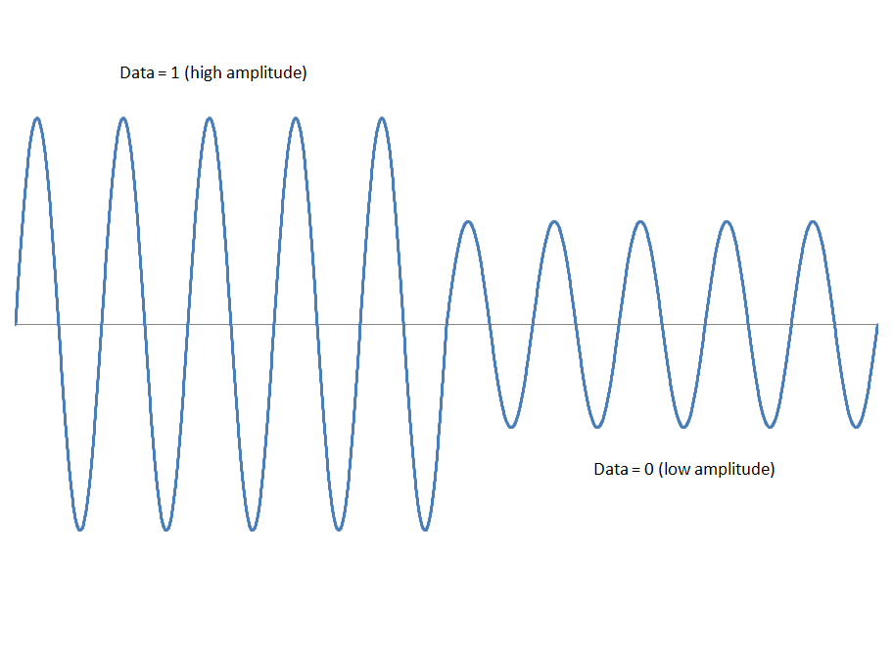

* + 1. digital data transmitted using a digital signal
    2. digital data transmitted using an analog signal
    3. analog data transmitted using a digital signal
    4. analog data transmitted using an analog signal

Answer: (b)

* 1. Amplitude is a measure of _____.
     1. the height of a sine wave
     2. the number of cycles made by a sine wave in one second
     3. the position of a sine wave at the start time
     4. None of the above

Answer: (a)

* 1. Modulation is the process of _____.
     1. spinning a wheel to generate a sine wave
     2. increasing the amplitude of a sine wave
     3. increasing the frequency of a sine wave
     4. changing one or more properties of a sine wave in response to data

Answer: (d)

* 1. Quadrature amplitude modulation _____.
     1. is another name for amplitude modulation
     2. combines amplitude modulation with phase modulation
     3. combines amplitude modulation with frequency modulation
     4. None of the above

Answer: (b)

* 1. Binary signals are preferred over other forms of signals (ternary, decimal etc) because _____.
     1. binary signals are the easiest to detect reliably by the receiver
     2. binary signals can carry the most amount of information in a given time period
     3. binary signals are the fastest known means of transmitting data
     4. binary signals are the easiest to generate for the sender

Answer: (a)

* 1. A bit _____.
     1. transforms elements from one set of elements to another set
     2. generates sine waves for transmission over a medium
     3. is the unit of information that designates one of two possible states
     4. changes one or more properties of a sine wave in response to data

Answer: (c)

* 1. Coding is _____.
     1. the unit of information
     2. the transformation of elements from one set of elements to another set
     3. the generation of sine waves for transmission over a medium
     4. changing one or more properties of a sine wave in response to data

Answer: (b)

* 1. Noise is _____.
     1. the transformation of elements from one set of elements to another set
     2. the generation of sine waves for transmission over a medium
     3. changing one or more properties of a sine wave in response to data
     4. any disturbance that interferes with the normal operation of a device

Answer: (d)

* 1. The ASCII code is used to encode _____.
     1. characters in the English alphabet
     2. characters in the Chinese language
     3. characters in all languages
     4. characters in most languages spoken around the world

Answer: (a)

* 1. Unicode is used to encode _____.
     1. characters in the English alphabet only
     2. characters in the Chinese language only
     3. characters in most languages
     4. characters in the 5 most common languages spoken around the world

Answer: (c)

* 1. In FDM _____.
     1. signals from each channel are sent at a specified frequency
     2. signals from each channel are sent at a specified amplitude
     3. signals from each channel are sent at a specified phase
     4. signals from each channel are sent at a specified time

Answer: (a)

* 1. In TDM _____.
     1. signals from each channel are sent at a specified frequency
     2. signals from each channel are sent at a specified amplitude
     3. signals from each channel are sent at a specified phase
     4. signals from each channel are sent at a specified time

Answer: (d)