Fundamentals of Corporate Finance, 4Ce (Berk et al.)
Chapter 1 Corporate Finance and the Financial Manager

1.1 Why Study Finance

1) The Valuation Principle shows how to make the costs and benefits of a decision comparable so that we can evaluate them properly.
Answer: TRUE
Diff: 1 Type: TF
Skill: Conceptual
Objective: 1.1 Grasp the importance of financial information in both your personal and business lives

2) Which of the following best describes why the Valuation Principle is a key concept in making financial decisions?
A) It shows how to assign monetary value to intangibles such as good health and well-being.
B) It allows fixed assets and liquid assets to be valued correctly.
C) It gives a good indication of the net worth of a person, item, or company and can be used to estimate any changes in that net worth.
D) It shows how to make the costs and benefits of a decision comparable so that we can weigh them properly.
E) It allows us to produce accurate financial statements.
Answer: D
Diff: 1 Type: MC
Skill: Conceptual
Objective: 1.1 Grasp the importance of financial information in both your personal and business lives

3) Both personal financial decisions and business financial decisions can best be made by applying the:
A) Internal Ranking Criteria.
B) Best Alternatives Matrix.
C) Valuation Principle.
D) Financial Comparison Analysis.
E) Law of One Price.
Answer: C
Diff: 1 Type: MC
Skill: Conceptual
Objective: 1.1 Grasp the importance of financial information in both your personal and business lives

1.2 The Three Types of Firms

1) Partnerships are the most common type of business firm in the world.
Answer: FALSE
Diff: 1 Type: TF
Skill: Conceptual
Objective: 1.2 Understand the important features of the three main types of firms and see why the advantages of the corporate form have led it to dominate economic activity

2) Corporations have come to dominate the business world through their ability to raise large amounts of capital by sale of ownership shares to anonymous outside investors.
Answer: TRUE
Diff: 1 Type: TF
Skill: Conceptual
Objective: 1.2 Understand the important features of the three main types of firms and see why the advantages of the corporate form have led it to dominate economic activity

3) Which of the following types of firms do NOT have limited liability?
A) sole proprietorships
B) limited partnerships
C) private corporations
D) public corporations
E) limited liability partnerships
Answer: A
Diff: 1 Type: MC
Skill: Conceptual
Objective: 1.2 Understand the important features of the three main types of firms and see why the advantages of the corporate form have led it to dominate economic activity

4) Over 60% of all Canadian business profit is generated by which type of firm?
A) sole proprietorships
B) partnerships
C) limited partnerships
D) corporations
E) limited liability partnerships
Answer: D
Diff: 1 Type: MC
Skill: Conceptual
Objective: 1.2 Understand the important features of the three main types of firms and see why the advantages of the corporate form have led it to dominate economic activity

5) What is the most common type of firm in Canada and the world?
A) sole proprietorships
B) partnerships
C) limited partnerships
D) corporations
E) limited liability partnerships
Answer: A
Diff: 1 Type: MC
Skill: Conceptual
Objective: 1.2 Understand the important features of the three main types of firms and see why the advantages of the corporate form have led it to dominate economic activity

6) Which of the following is typically the major factor in limiting the growth of a sole proprietorship?
A) The organization of such firms tends to become extremely complicated over time.
B) It is extremely difficult to transfer control of such a firm to a new owner if the present owner dies or wishes to sell the firm.
C) The amount of money that can be raised by the firm is limited by the fact that the single owner must make good on all debts.
D) Investors have a great deal of control over the day-to-day running of the firm, leading to confusion when conflicts in direction arise.
E) The owner's personal reputation is the basis for the business.
Answer: C
Diff: 1 Type: MC
Skill: Conceptual
Objective: 1.2 Understand the important features of the three main types of firms and see why the advantages of the corporate form have led it to dominate economic activity

7) Joe is a general partner in a limited partnership firm, while Jane is a limited partner in that same firm. Which of the following statements regarding their respective relationships to the firm is correct?
A) Joe has no management authority within the partnership.
B) Jane is legally involved in the managerial decision making of the firm.
C) Jane's liability for the firm's debts consists solely of her investment in the firm.
D) Withdrawal of Jane from the partnership will dissolve that partnership.
E) Jane's liability consists of all the firm's outstanding debts.
Answer: C
Diff: 1 Type: MC
Skill: Conceptual
Objective: 1.2 Understand the important features of the three main types of firms and see why the advantages of the corporate form have led it to dominate economic activity

8) What is the major way in which the roles and obligations of the owners of a limited liability partnership differ from the roles and obligations of limited partners in a limited partnership?
A) The owners of a limited liability partnership have personal obligation for debts incurred by the company.
B) There is no separation between the company and its owners in a limited liability partnership.
C) The owners of a limited liability partnership can withdraw from the company without the company being dissolved.
D) The owners of a limited liability partnership can take an active role in running the company.
E) The owners of a limited liability partnership are responsible for the negligence of other partners.
Answer: D
Diff: 1 Type: MC
Skill: Conceptual
Objective: 1.2 Understand the important features of the three main types of firms and see why the advantages of the corporate form have led it to dominate economic activity

9) In which of the following ways is a limited liability partnership like a corporation?
A) Both types of firm were created and developed first in Canada.
B) Both can choose to be considered a partnership for tax purposes.
C) All of its owners' liability is restricted to their investment in the firm.
D) It is directly managed by the owners of the firm.
E) Owners have unlimited personal liability for the negligence of those whom they supervise.
Answer: C
Diff: 1 Type: MC
Skill: Conceptual
Objective: 1.2 Understand the important features of the three main types of firms and see why the advantages of the corporate form have led it to dominate economic activity

10) Why is it possible for a corporation to enter into contracts, acquire assets, incur obligations, and enjoy protection against the seizure of its property?
A) The number of owners, and hence the spread of risk among these owners, is not limited.
B) Its owners are liable for any obligations it enters into.
C) The province in which the corporation is incorporated provides safeguards against any wrongdoing by the corporation.
D) It is a legally defined, artificial entity that is separate from its owners.
E) Corporations represent their owners, who have all of those rights.
Answer: D
Diff: 1 Type: MC
Skill: Conceptual
Objective: 1.2 Understand the important features of the three main types of firms and see why the advantages of the corporate form have led it to dominate economic activity

11) To calculate the taxes owing on dividends received from Canadian corporations, investors must undertake the following calculations:
A) Gross up the dividend received; apply this amount to their marginal tax rate; and received the federal and provincial dividend tax credit.
B) Gross up the dividend received; apply this amount to their marginal tax rate; and received the federal tax credit.
C) Gross up the dividend received; apply this amount to their average tax rate; and received the federal and provincial dividend tax credit.
D) Apply the amount of the dividend received to their marginal tax rate and received the federal and provincial dividend tax credit.
E) Apply the amount of the dividend received to their average tax rate and received the federal and provincial dividend tax credit.
Answer: A
Diff: 1 Type: MC
Skill: Definition
Objective: 1.2 Understand the important features of the three main types of firms and see why the advantages of the corporate form have led it to dominate economic activity

12) What is one of the major advantages corporations have over other business entities?
A) It is harder for a corporation to raise capital than other forms of businesses.
B) The owners of the corporation are personally liable for its obligations.
C) Corporations are the only organizational structures not subject to double taxation.
D) There is no limitation on who can own its stock.
E) It is less costly to set up a corporation.
Answer: D
Diff: 1 Type: MC
Skill: Conceptual
Objective: 1.2 Understand the important features of the three main types of firms and see why the advantages of the corporate form have led it to dominate economic activity

13) A flow-through entity that holds all the debt and equity securities of a corporation is called:
A) an energy trust.
B) a real estate investment trust.
C) a business income trust.
D) a parent corporation.
E) an ownership trust.
Answer: C
Diff: 1 Type: MC
Skill: Definition
Objective: 1.2 Understand the important features of the three main types of firms and see why the advantages of the corporate form have led it to dominate economic activity

14) The collection of all the outstanding shares of a corporation is known as the:
A) Debt.
B) Assets.
C) Liabilities.
D) Equity.
E) Ownership.
Answer: D
Diff: 1 Type: MC
Skill: Definition
Objective: 1.2 Understand the important features of the three main types of firms and see why the advantages of the corporate form have led it to dominate economic activity

15) Katie owns 12.5% of the stock of the Gimli Corporation. The tax rate on dividend income is 24%. If Gimli makes a dividend payment of $25,000,000 paid proportionally to its shareholders, how much of this amount would Katie receive after taxes?
A) $750,000
B) $2,375,000
C) $3,125,000
D) $6,000,000
E) $19,000,000
Answer: B
Explanation: Katie will receive 12.5% of the dividend payment proportional to her ownership:
0.125 × 25,000,000 = $3,125,000. She pays taxes at 24%, and receives (3,125,000)(1 - 0.24) = 2,375,000 after taxes.
Diff: 2 Type: MC
Skill: Analytical
Objective: 1.2 Understand the important features of the three main types of firms and see why the advantages of the corporate form have led it to dominate economic activity

16) Kuljeet owns 20% of the stock of the Flin Flon Corporation. The tax rate on dividend income is 15%. If Flin Flon makes a dividend payment of $2,000,000 paid proportionally to its shareholders, how much of this amount would Kuljeet receive after taxes?
A) $450,000
B) $300,000
C) $60,000
D) $340,000
E) $400,000
Answer: D
Explanation: Kuljeet will receive 20% of the dividend payment proportional to her ownership:
0.20 × 2,000,000 = $400,000. She pays taxes at 15%, and receives (400,000)(1 - 0.15) = $340,000 after taxes.
Diff: 2 Type: MC
Skill: Analytical
Objective: 1.2 Understand the important features of the three main types of firms and see why the advantages of the corporate form have led it to dominate economic activity

17) Saskatoon Smelting is a corporation that earned $4 per share before it paid any taxes. The firm retained $2 of after-tax earnings for reinvestment, and distributed what remained in dividend payments. If the corporate tax rate was 25% and dividend earnings were taxed at 15%, what was the value of the dividend earnings received after tax by a holder of 10,000 shares of Saskatoon Smelting?
A) $7,500
B) $17,000
C) $8,500
D) $10,000
E) $20,000
Answer: C
Explanation: Corporate tax paid on $4 earnings = $4 × 0.25 = $1; earnings after tax =4 - 1 = $3; earnings distributed as dividends = $3 - $2 = $1; taxes paid on dividends by a shareholder = 1 × 0.15 = 0.15; after-tax dividends per share = 1 - 0.15 = $0.85; hence a holder of 10,000 shares receives 0.85 × 100,000 = $8,500
Diff: 2 Type: MC
Skill: Analytical
Objective: 1.2 Understand the important features of the three main types of firms and see why the advantages of the corporate form have led it to dominate economic activity

18) Moncton Meats is a corporation that earned $3 per share before it paid any taxes. The firm retained $1 of after-tax earnings for reinvestment, and distributed what remained in dividend payments. You hold 20,000 shares of Moncton Meats in a tax-free savings account. If the corporate tax rate was 30% and dividend earnings were taxed at 20%, what was the value of your dividend earnings received after all taxes are paid?
A) $40,000
B) $16,000
C) $20,000
D) $17,600
E) $22,000
Answer: E
Explanation: Corporate tax paid on $3 earnings = $3 × 0.3 = 0.9; earnings after tax = 3 - 0.9 = $2.1; earnings distributed as dividends = $2.1 - $1 = $1.1; hence a holder of 20,000 shares in a TFSA receives 1.1 × 20,000 = $$22,000
Diff: 2 Type: MC
Skill: Analytical
Objective: 1.2 Understand the important features of the three main types of firms and see why the advantages of the corporate form have led it to dominate economic activity

19) Tofino Toffee is a corporation that earned $5 per share before it paid any taxes. The firm retained $2.50 of after-tax earnings for reinvestment, and distributed what remained in dividend payments. You hold 6,000 shares of Tofino Toffee in a tax-free savings account, and 4,000 shares outside of a tax-free savings account. If the corporate tax rate was 25% and dividend earnings were taxed at 15%, what was the value of your dividend earnings received after all taxes are paid?
A) $12,500
B) $11,750
C) $10,625
D) $23,500
E) $13,175
Answer: B
Explanation: Corporate tax paid on $5 earnings = $5 × 0.25 =1.25; earnings after tax = 5 - 1.25 = $3.75; earnings distributed as dividends = $3.75 - $2.50 = $1.25;
after-tax dividends = 1.25 × (1 - 0.15) = $1.0625;
Inside TFSA: 1.25 × 6,000 = $7,500
Outside TFSA: 1.0625 × 4,000 = $4,250; Total earnings =7,500 + 4,250 = $11,750
Diff: 2 Type: MC
Skill: Analytical
Objective: 1.2 Understand the important features of the three main types of firms and see why the advantages of the corporate form have led it to dominate economic activity

20) You are a unit holder in Pembina Properties, a real estate investment trust (REIT). The REIT announces a profit of $8 per share, of which it retains $3 for reinvestment and distributes the rest as dividend payments. Given your personal tax rate of 30%, and the tax rate on dividends is 15%, how much tax must you pay per unit?
A) $0.90
B) $1.20
C) $0.75
D) $0.45
E) $0
Answer: B
Explanation: Tax paid by unit holder of a REIT = 5 × 0.3 = $1.50
Diff: 2 Type: MC
Skill: Analytical
Objective: 1.2 Understand the important features of the three main types of firms and see why the advantages of the corporate form have led it to dominate economic activity

21) You hold 1,000 units of Calgary Commercial Property, a real estate investment trust (REIT). The REIT announces a profit of $10 per share, of which it retains $4 for reinvestment and distributes the rest as dividend payments. Given your personal tax rate of 40%, and the tax rate on dividends is 15%, how much tax must you pay on your holdings?
A) $900
B) $4,000
C) $2,400
D) $1,500
E) $1,600
Answer: C
Explanation: Tax paid by unit holder of a REIT = 6 × 0.4 × 1,000 units = $2,400
Diff: 2 Type: MC
Skill: Analytical
Objective: 1.2 Understand the important features of the three main types of firms and see why the advantages of the corporate form have led it to dominate economic activity

22) You hold 1,000 units of Calgary Commercial Property, a real estate investment trust (REIT). 500 of those units are held inside a tax-free savings account, the other 500 are outside the tax-free savings account. The REIT announces a profit of $10 per share, of which it retains $4 for reinvestment and distributes the rest as dividend payments. Given your personal tax rate of 30%, and the tax rate on dividends is 15%, how much tax must you pay on your holdings?
A) $900
B) $450
C) $1,800
D) $1,500
E) $1,600
Answer: A
Explanation: Tax paid by unit holder of a REIT = 6 × 0.3 × 500 units = $900
Diff: 2 Type: MC
Skill: Analytical
Objective: 1.2 Understand the important features of the three main types of firms and see why the advantages of the corporate form have led it to dominate economic activity

23) You hold 1,000 units of Calgary Commercial Property, a real estate investment trust (REIT). 500 of those units are held inside a tax-free savings account, the other 500 are outside the tax-free savings account. The REIT announces a profit of $10 per share, of which it retains $4 for reinvestment and distributes the rest as dividend payments. Given your personal tax rate of 30%, and the tax rate on dividends is 15%, what is your total after-tax income?
A) $6,000
B) $5,100
C) $5,550
D) $4,200
E) $5,000
Answer: B
Explanation: Tax paid by unit holder of a REIT = 6 × 0.3 × 500 units = $900
Total dividends = 6 × 1,000 = $6,000. After-tax income = 6,000 - 900 = $5,100
Diff: 2 Type: MC
Skill: Analytical
Objective: 1.2 Understand the important features of the three main types of firms and see why the advantages of the corporate form have led it to dominate economic activity

24) Red Deer Plumbing Supply Co. earns $4.50 per share before taxes. The corporate tax rate is 30%, the personal tax rate on dividends is 15%, and the personal tax rate on non-dividend income is 40%. What is the total amount of taxes paid per share if the company pays a $2.00 dividend?
A) $0.30
B) $2.15
C) $1.35
D) $1.65
E) $0.80
Answer: D
Explanation: Corporate tax = $4.50 × 30% = $1.35, Personal tax = $2.00 × 15% = $0.30.
Total = $1.35 + $0.30 = $1.65
Diff: 2 Type: MC
Skill: Analytical
Objective: 1.2 Understand the important features of the three main types of firms and see why the advantages of the corporate form have led it to dominate economic activity

25) Windsor Windows earns $4.50 per share before taxes. The corporate tax rate is 30%, the personal tax rate on dividends is 15%, and the personal tax rate on non-dividend income is 40%. What is the total amount of taxes paid per share if the company pays a $2.00 dividend but all of the shares are held in a tax-free savings account?
A) $0.30
B) $2.15
C) $1.35
D) $1.65
E) $0.80
Answer: C
Explanation: Corporate tax = $4.50 × 30% = $1.35, no personal tax.
Diff: 2 Type: MC
Skill: Analytical
Objective: 1.2 Understand the important features of the three main types of firms and see why the advantages of the corporate form have led it to dominate economic activity

26) Windsor Windows earns $4.50 per share before taxes and pays a dividend of $2.00 per share. The corporate tax rate is 30%, the personal tax rate on dividends is 15%, and the personal tax rate on non-dividend income is 40%. What is the after-tax amount an individual would receive per share from the dividend?
A) $2.68
B) $2.15
C) $1.35
D) $1.65
E) $1.70
Answer: E
Explanation: Personal tax = $2.00 × 0.15 = $0.30. After-tax income = $2.00 - $0.30 = $1.70.
Diff: 2 Type: MC
Skill: Analytical
Objective: 1.2 Understand the important features of the three main types of firms and see why the advantages of the corporate form have led it to dominate economic activity

27) You own shares in two different companies, Ace Holdings, and Beta Inc. Ace Holdings earns $6.00 per share before taxes, has a corporate tax rate of 25%, and pays out 50% of its after-tax earnings as dividends. Beta Inc. earns $4.00 per share before taxes, has a corporate tax rate of 15%, and pays out 100% of its after-tax earnings as dividends. Which company pays you a higher dividend, and by how much?
A) Beta Inc., by $1.15
B) Beta Inc., by $1.75
C) Ace Holdings, by $0.15
D) Ace Holdings, by $1.10
E) Ace Holdings, by $2.25
Answer: A
Explanation: Ace Holdings dividend = $6.00(1 - 0.25)(0.5) = $2.25. Beta Inc. dividend = $4.00(1 - 0.15) = $3.40. $3.40 - 2.25 = $1.15.
Diff: 2 Type: MC
Skill: Analytical
Objective: 1.2 Understand the important features of the three main types of firms and see why the advantages of the corporate form have led it to dominate economic activity

28) You own 100 shares in each of two different companies, Ace Holdings, and Beta Inc. Ace Holdings earns $6.00 per share before taxes, has a corporate tax rate of 25%, and pays out 50% of its after-tax earnings as dividends. Beta Inc. earns $4.00 per share before taxes, has a corporate tax rate of 15%, and pays out 100% of its after-tax earnings as dividends. The tax rate on dividend income is 15%. If all of your shares are held outside a TFSA, what is the total after-tax income you receive from your dividends?
A) $191.25
B) $289.00
C) $480.25
D) $565.00
E) $739.00
Answer: C
Explanation: Ace Holdings dividend = $6.00(1 - 0.25)(0.5) = $2.25. After dividend tax: $2.25(1 - 0.15) = $1.9125. $1.9125 × 100 shares = $191.25. Beta Inc. dividend = $4.00(1 - 0.15) = $3.40. After dividend tax: $3.40(1 - 0.15) = $2.89. $2.89 × 100 shares = $289. Total received = $191.25 + $289 = $480.25.
Diff: 2 Type: MC
Skill: Analytical
Objective: 1.2 Understand the important features of the three main types of firms and see why the advantages of the corporate form have led it to dominate economic activity

29) You own 100 shares in each of two different companies, Ace Holdings, and Beta Inc. Ace Holdings earns $6.00 per share before taxes, has a corporate tax rate of 25%, and pays out 50% of its after-tax earnings as dividends. Beta Inc. earns $4.00 per share before taxes, has a corporate tax rate of 15%, and pays out 100% of its after-tax earnings as dividends. The tax rate on dividend income is 15%. If your shares of Ace Holdings are held outside of a TFSA, and your shares of Beta Inc. are held inside a TFSA, what is the total after-tax income you receive from your dividends?
A) $191.25
B) $289.00
C) $480.25
D) $531.25
E) $565.00
Answer: D
Explanation: Ace Holdings dividend = $6.00(1 - 0.25)(0.5) = $2.25. After dividend tax: $2.25(1 - 0.15) = $1.9125. $1.9125 × 100 shares = $191.25. Beta Inc. dividend = $4.00(1 - 0.15) = $3.40. $3.40 × 100 shares = $340. Total received = $191.25 + $289 = $531.25.
Diff: 2 Type: MC
Skill: Analytical
Objective: 1.2 Understand the important features of the three main types of firms and see why the advantages of the corporate form have led it to dominate economic activity

30) You own 50 units of a real estate investment trust (REIT) and 50 shares of a public corporation. The REIT earns $6.00 per unit. The corporation earns $4.00 per share before taxes. The corporate tax rate is 25%, your personal tax rate is 35%, and the tax rate on dividend income is 15%. What is the total after-tax income you receive, if everything is held outside a TFSA?
A) $273.75
B) $318.75
C) $322.50
D) $382.50
E) $450.00
Answer: C
Explanation: REIT distribution: $6.00 × 50 = $300.00. After tax: $300.00(1 - 0.35) = $195.00. Dividends after corporate taxes: ($4.00 × 50)(1 - 0.25) = $150. After dividend tax: $150(1 - 0.15) = $127.50. Total income = $195.00 + 127.50 = $322.50
Diff: 2 Type: MC
Skill: Analytical
Objective: 1.2 Understand the important features of the three main types of firms and see why the advantages of the corporate form have led it to dominate economic activity

31) You own 50 units of a real estate investment trust (REIT) and 50 shares of a public corporation. The REIT earns $6.00 per unit. The corporation earns $4.00 per share before taxes. The corporate tax rate is 25%, your personal tax rate is 35%, and the tax rate on dividend income is 15%. What is the total after-tax income you receive, if your REIT holdings are outside of a TFSA, and your corporation shares are held inside a TFSA?
A) $273.75
B) $318.75
C) $322.50
D) $345.00
E) $450.00
Answer: D
Explanation: REIT distribution: $6.00 × 50 = $300.00. After tax: $300.00(1 - 0.35) = $195.00. Dividends after corporate taxes: ($4.00 × 50)(1 - 0.25) = $150. Total income = $195.00 + 150.00 = $345.00
Diff: 2 Type: MC
Skill: Analytical
Objective: 1.2 Understand the important features of the three main types of firms and see why the advantages of the corporate form have led it to dominate economic activity

32) What is the process of double taxation for the stockholders in a corporation?
A) Their shares are taxed when they are both bought and sold.
B) The corporation is taxed on the profits it makes, and the owners are taxed when this profit is distributed to them.
C) The owners of a corporation are taxed when they receive dividend payments and when they make a profit from the sale of shares.
D) The corporation must pay taxes on any profits it makes, and the capital raised by the sale of shares is also subject to taxation.
E) The corporation is taxed on any profits it makes, and owners are taxed when they sell their shares.
Answer: B
Diff: 1 Type: MC
Skill: Conceptual
Objective: 1.2 Understand the important features of the three main types of firms and see why the advantages of the corporate form have led it to dominate economic activity

33) Which of the following is an advantage of a sole proprietorship?
A) double taxation
B) ease of setup
C) limited liability
D) separation of ownership and control
E) the ability to raise substantial amounts of capital
Answer: B
Diff: 1 Type: MC
Skill: Conceptual
Objective: 1.2 Understand the important features of the three main types of firms and see why the advantages of the corporate form have led it to dominate economic activity

34) What are the main differences between a partnership and sole proprietorship?
Answer: While a sole proprietor has the same identity as its single owner, a partnership of general partners has the same identity as its partners. Each general partner is responsible for the decisions taken by that partner as well as any other general partner.
Diff: 1 Type: SA
Skill: Conceptual
Objective: 1.2 Understand the important features of the three main types of firms and see why the advantages of the corporate form have led it to dominate economic activity

35) What are the main differences between a limited partnership and limited liability partnership?
Answer: A limited partnership is required to have at least one general partner. A limited liability partnership can only be used in the legal and accounting professions. The limitation on a partner's liability is only in cases related to actions of negligence of other partners or those supervised by other partners.
Diff: 2 Type: SA
Skill: Conceptual
Objective: 1.2 Understand the important features of the three main types of firms and see why the advantages of the corporate form have led it to dominate economic activity

36) How is a corporation different from most of the other forms of business organizations?
Answer: A corporation has a separate legal identity from those of its owners. This separation gives the owners limited liability for the actions of the corporation. The down side is the process of double taxation for each dollar earned by the corporation, once when it is earned by the corporation and subsequently when it is passed on to the owners as a dividend.
Diff: 2 Type: SA
Skill: Conceptual
Objective: 1.2 Understand the important features of the three main types of firms and see why the advantages of the corporate form have led it to dominate economic activity

1.3 The Financial Manager

1) The principal goal of the financial manager is to maximize the wealth of the shareholders.
Answer: TRUE
Diff: 1 Type: TF
Skill: Conceptual
Objective: 1.3 Explain the goal of the financial manager and the reasoning behind that goal, as well as understand the three main types of decisions a financial manager makes

2) It is generally not the duty of financial managers to ensure that a firm has the cash it needs for day-to-day transactions.
Answer: FALSE
Diff: 1 Type: TF
Skill: Conceptual
Objective: 1.3 Explain the goal of the financial manager and the reasoning behind that goal, as well as understand the three main types of decisions a financial manager makes

3) Which of the following are major duties of a financial manager?
I. To make investment decisions
II. To make financing decisions
III. To manage cash flow from operating activities
A) I only
B) I and II only
C) I and III only
D) II and III only
E) I, II and III
Answer: E
Diff: 3 Type: MC
Skill: Conceptual
Objective: 1.3 Explain the goal of the financial manager and the reasoning behind that goal, as well as understand the three main types of decisions a financial manager makes

4) Why in general do financial managers make financial decisions in a corporation, rather than the owners making these decisions themselves?
A) It is best for the control of the finances of a corporation to be in the hands of a disinterested third party.
B) The interests of the various owners may conflict with each other.
C) The owners may not be Canadian citizens or residents.
D) There are often many owners, and they can often change as they buy and sell stock.
E) The owners will make decisions for their own self-interest rather than the corporation's interests.
Answer: D
Diff: 2 Type: MC
Skill: Conceptual
Objective: 1.3 Explain the goal of the financial manager and the reasoning behind that goal, as well as understand the three main types of decisions a financial manager makes

5) What is the most important duty of a financial manager?
A) to ensure that the firm has enough cash on hand to meet its commitments at any given time
B) to decide how to pay for investments
C) to manage working capital
D) to make investment decisions
E) to minimize taxes
Answer: D
Diff: 2 Type: MC
Skill: Conceptual
Objective: 1.3 Explain the goal of the financial manager and the reasoning behind that goal, as well as understand the three main types of decisions a financial manager makes

6) The financial manager of a well-regarded book publishing firm wishes to buy a small Internet publishing company to provide an avenue for sale of its materials online. In order to raise the funds to make this purchase, the financial manager decides to sell more stock in the company. How is the financial manager raising funds in this case?
A) by increasing the debt burden carried by the company
B) by raising the company's equity by encouraging new owners to take a stake in the company
C) by decreasing the ratio of equity to debt held by the company
D) by increasing the value of shares held by the existing owners of the company
E) by adding a new revenue stream from the Internet publishing company
Answer: B
Diff: 1 Type: MC
Skill: Conceptual
Objective: 1.3 Explain the goal of the financial manager and the reasoning behind that goal, as well as understand the three main types of decisions a financial manager makes

7) A company that produces racing motorbikes has several models that sell well within the motorcycle racing community and that are very profitable for the company. Despite having a profitable product, why must this company take care to ensure that it has sufficient cash on hand to meet its obligations?
A) Profits from the sales of popular models will be lost when returned to the shareholders in the form of dividends.
B) New models will require a lot of money to develop and bring to market before they generate any revenue.
C) The company will have built up debts which must be repaid in order to bring the current models to market.
D) Equity must be raised to finance the development of new models to replace the existing models.
E) This will enable the company to maintain a high share price for its stock.
Answer: B
Diff: 1 Type: MC
Skill: Conceptual
Objective: 1.3 Explain the goal of the financial manager and the reasoning behind that goal, as well as understand the three main types of decisions a financial manager makes

8) A typical company has many types of shareholders, from individuals holding a few shares, to large institutions that hold very large numbers of shares. How does a financial manager ensure that the priorities and concerns of such disparate stockholders are met?
A) The financial manager should seek to make investments that do not harm the interests of the stockholders.
B) The decisions taken by the financial manager should be solely influenced by the benefit to the company since, by maximizing its fitness, he or she will also maximize the benefits of that company to the shareholders.
C) The financial manager should consider the interests and concerns of large shareholders a priority, so the needs of those who hold a controlling interest in the company are met.
D) In general, all shareholders will agree that they are better off if the financial manager works to maximize the value of their investment.
E) The financial manager will consider the priorities of all the shareholders at the annual shareholders' meeting.
Answer: D
Diff: 1 Type: MC
Skill: Conceptual
Objective: 1.3 Explain the goal of the financial manager and the reasoning behind that goal, as well as understand the three main types of decisions a financial manager makes

9) Whose interests should a financial manager consider paramount when making a decision?
A) the stockholders who have risked their money to become owners of the company
B) the employees and associated stakeholders who are employed by the company
C) the public who consume the company's goods and services
D) the senior management and associated colleagues at the executive level within the company
E) the financial manager's own interests
Answer: A
Diff: 1 Type: MC
Skill: Conceptual
Objective: 1.3 Explain the goal of the financial manager and the reasoning behind that goal, as well as understand the three main types of decisions a financial manager makes

10) What is the principal guiding factor for the financial manager?
Answer: Maximizing shareholder wealth is the paramount guiding factor for the financial manager.
Diff: 1 Type: SA
Skill: Conceptual
Objective: 1.3 Explain the goal of the financial manager and the reasoning behind that goal, as well as understand the three main types of decisions a financial manager makes

1.4 The Financial Manager's Place in the Corporation

1) In most corporations the owners exercise direct control of the corporation.
Answer: FALSE
Diff: 1 Type: TF
Skill: Conceptual
Objective: 1.4 Know how a corporation is managed and controlled, the financial manager's place in it, and some of the ethical issues financial managers face

2) How do the shareholders of most corporations exercise their control of that corporation?
A) by voting on issues that concern them
B) by electing members of a board of directors
C) by vetting the decisions of the board of directors
D) by providing oversight of the day-to-day running of the corporation
E) by hiring other shareholders to run the corporation
Answer: B
Diff: 1 Type: MC
Skill: Conceptual
Objective: 1.4 Know how a corporation is managed and controlled, the financial manager's place in it, and some of the ethical issues financial managers face

3) Who is typically responsible for the day-to-day running of a corporation?
A) the shareholders
B) the board of directors
C) the management team
D) the sole proprietor
E) the limited partner
Answer: C
Diff: 1 Type: MC
Skill: Conceptual
Objective: 1.4 Know how a corporation is managed and controlled, the financial manager's place in it, and some of the ethical issues financial managers face

4) What are the responsibilities of the board of directors?
A) make rules on how the corporation is run, set policy, and monitor the performance of the company
B) oversee the day-to-day running of the corporation.
C) making investment decisions
D) risk management
E) implementing the rules and policies set by the CEO
Answer: A
Diff: 1 Type: MC
Skill: Conceptual
Objective: 1.4 Know how a corporation is managed and controlled, the financial manager's place in it, and some of the ethical issues financial managers face

5) Which of the following would be more typically the responsibility of a controller rather than a treasurer?
A) overseeing accounting and tax functions
B) capital budgeting
C) managing credit
D) making investment decisions
E) managing risk
Answer: A
Diff: 1 Type: MC
Skill: Conceptual
Objective: 1.4 Know how a corporation is managed and controlled, the financial manager's place in it, and some of the ethical issues financial managers face

6) Which of the following would be best considered to be a principal-agent problem in the behaviour of the following financial managers?
A) Bill chooses to pursue a risky investment for the company's funds, because his compensation will substantially rise if it succeeds.
B) Sue instructs her staff to skip safety inspections in one of the company's factories, knowing that it will likely fail the inspection and incur significant costs to fix.
C) James ignores an opportunity for his company to invest in a new drug to fight Alzheimer's disease, judging the drug's chances of succeeding as low.
D) Michael chooses to enhance his firm's reputation at some cost to its shareholders by sponsoring a team of athletes for the Special Olympics.
E) Tara treats her staff to a free lunch at the company's expense to increase morale.
Answer: A
Diff: 3 Type: MC
Skill: Conceptual
Objective: 1.4 Know how a corporation is managed and controlled, the financial manager's place in it, and some of the ethical issues financial managers face

7) A factory owner wants his workers to produce as many widgets as they can, so he pays his workers based on how many widgets they produce. However, in order to make sure that the workers do not rush and produce a large number of poorly made widgets, he checks the widgets at random at various stages of their manufacture. If a defect is found in a widget, the pay of the entire section of the factory responsible for that defect is docked. How is this factory owner seeking to solve the principal-agent problem in this case?
A) by supplying incentives so the agents act in the way principal desires
B) by ensuring that all workers co-operate to maximize the gains of their section
C) by making the agents into principals themselves
D) by maximizing the information that the principal obtains about the behaviour of the agents
E) by using quality control techniques
Answer: A
Diff: 1 Type: MC
Skill: Conceptual
Objective: 1.4 Know how a corporation is managed and controlled, the financial manager's place in it, and some of the ethical issues financial managers face

8) What is the most common way that principal-agent problems are addressed in most corporations?
A) by minimizing the number of decisions that a manager makes where there is a conflict between the managers interests and those of the shareholders
B) by terminating the employment of employees who are found to have put their own interests above those of the company
C) by using disinterested outside bodies to adjudicate between managers and shareholders when such conflicts arise
D) by prosecuting managers who have been found to have illegally used company moneys for their own benefit
E) by paying the managers high salaries to encourage them to act in the company's interests.
Answer: A
Diff: 1 Type: MC
Skill: Conceptual
Objective: 1.4 Know how a corporation is managed and controlled, the financial manager's place in it, and some of the ethical issues financial managers face

9) A company's board of directors chooses to provide a comprehensive health care plan for the families of all employees, despite the large cost. They argue that this will not only increase the number of employees who stay with the firm, and thus reduce some costs involved in employee turnover, but also increase the employees' diligence and industry. What general principle is being argued by the board of directors?
A) In a conflict between stakeholders in a company, the most important stakeholder is not always the stockholders.
B) Some activities that decrease shareholders' wealth may have intangible benefits which increase the strength of the company overall.
C) When a conflict of interest arises between shareholders and other stakeholders, in general, the correct solution is the one that creates the greatest good for the greatest number of stakeholders.
D) Ethical decisions should be assessed on their moral value, not on their value in dollars and cents.
E) Decisions involving employees must take fairness into account.
Answer: B
Diff: 1 Type: MC
Skill: Conceptual
Objective: 1.4 Know how a corporation is managed and controlled, the financial manager's place in it, and some of the ethical issues financial managers face

10) Why is the stock price of a company an indication of the performance of that company's senior managers?
A) Well-run companies are invariably highly profitable, which leads to a higher share price.
B) In general, people want to invest in a well-managed corporation, which will drive up the price of shares.
C) Investors who can see that a company is well-run will hold on to their shares, even if the company faces temporary setbacks, since they know that the stock price will likely rise again.
D) Larger companies tend to be better run and so have higher stock prices.
E) Managers who perform well get paid well, and can afford to buy more shares of their own company, driving up the share price.
Answer: B
Diff: 1 Type: MC
Skill: Conceptual
Objective: 1.4 Know how a corporation is managed and controlled, the financial manager's place in it, and some of the ethical issues financial managers face

11) A corporate raider gains a controlling fraction of the shares of a poorly managed company and replaces the board of directors. How does the corporate raider hope to make a profit in this case?
A) by the sale of the assets held by the company that hold most of its value
B) by the rise in the value of the stock held by the raider when the new board of directors is judged to be superior to the ousted board of directors
C) by motivating the board of directors and other stakeholders in the company to make difficult short-term decisions that will increase the long-term viability of the company
D) by removing the employees' expectations of the continued poor performance of the company
E) by paying itself a large portion of the firm's cash flows
Answer: B
Diff: 1 Type: MC
Skill: Conceptual
Objective: 1.4 Know how a corporation is managed and controlled, the financial manager's place in it, and some of the ethical issues financial managers face

12) A ________ is when a rich individual or organization purchases a large fraction of the stock of a poorly performing firm and in doing so gets enough votes to replace the board of directors and the CEO.
A) shareholder proposal
B) leveraged buyout
C) shareholder action
D) hostile takeover
E) merger
Answer: D
Diff: 2 Type: MC
Skill: Definition
Objective: 1.4 Know how a corporation is managed and controlled, the financial manager's place in it, and some of the ethical issues financial managers face

13) Briefly discuss the issues in the principal-agent problem.
Answer: The principal-agent problem arises out of the principal-agent relationship existing between the shareholders and managers of a corporation. Although managers are required to put the shareholders interest ahead of their own, in practice they tend to put their own interest ahead of the shareholders' interests.
Diff: 2 Type: SA
Skill: Conceptual
Objective: 1.4 Know how a corporation is managed and controlled, the financial manager's place in it, and some of the ethical issues financial managers face

14) Explain some of the measures taken to reduce the principal-agent problem.
Answer: The principal-agent problem can be reduced by taking measures that align the managers' interests with those of the shareholders. For example, incentive-based compensation such as employee stock options help align the interests of these two constituents.
Diff: 2 Type: SA
Skill: Analytical
Objective: 1.4 Know how a corporation is managed and controlled, the financial manager's place in it, and some of the ethical issues financial managers face

1.5 The Stock Market

1) The shares of private corporations are traded on a stock market.
Answer: FALSE
Diff: 1 Type: TF
Skill: Conceptual
Objective: 1.5 Understand the importance of financial markets, such as stock markets, to a corporation and the financial manager's role as liaison to those markets

2) Stock markets provide liquidity for a firm's shares.
Answer: TRUE
Diff: 1 Type: TF
Skill: Conceptual
Objective: 1.5 Understand the importance of financial markets, such as stock markets, to a corporation and the financial manager's role as liaison to those markets

3) If a broker will buy a share of stock from you at $3.85 and sell it to you at $3.87, the ask price would be $3.85.
Answer: FALSE
Diff: 1 Type: TF
Skill: Conceptual
Objective: 1.5 Understand the importance of financial markets, such as stock markets, to a corporation and the financial manager's role as liaison to those markets

4) Which of the following need be TRUE for an asset to be considered liquid?
A) It pays regular dividends.
B) It can be bought and sold at an organized stock market or bourse.
C) It is offered for sale on both primary and secondary markets.
D) It can be easily bought and sold and the selling price is very close to the buying price at a given point in time.
E) Buyers and sellers are anonymous.
Answer: D
Diff: 1 Type: MC
Skill: Conceptual
Objective: 1.5 Understand the importance of financial markets, such as stock markets, to a corporation and the financial manager's role as liaison to those markets

5) Why is it in general difficult to determine the market price of a private corporation's shares at any point in time?
A) It is difficult to obtain enough information to accurately value such a company.
B) The price of its shares is fixed by the owners.
C) It has a limited number of owners.
D) There is no organized market for its shares.
E) Buyers do not wish to reveal their bid price.
Answer: D
Diff: 1 Type: MC
Skill: Conceptual
Objective: 1.5 Understand the importance of financial markets, such as stock markets, to a corporation and the financial manager's role as liaison to those markets

6) Which of the stock markets listed below is the smallest, as judged by trading volume?
A) Japan Exchange Group
B) London Stock Exchange
C) NASDAQ
D) NYSE Euronext (US)
E) TMX Group
Answer: E
Diff: 1 Type: MC
Skill: Conceptual
Objective: 1.5 Understand the importance of financial markets, such as stock markets, to a corporation and the financial manager's role as liaison to those markets

7) Why is a stock exchange like NASDAQ considered a secondary market?
A) It trades the second-largest volume of shares in the world.
B) Shares sold on it are exchanged between investors without any involvement of the issuing corporation.
C) The exchange has rules that attempt to ensure that bid and ask prices do not get too far apart.
D) NASDAQ is called a secondary market because NYSE is considered a primary market.
E) Smaller companies are listed on the NASDAQ.
Answer: B
Diff: 1 Type: MC
Skill: Conceptual
Objective: 1.5 Understand the importance of financial markets, such as stock markets, to a corporation and the financial manager's role as liaison to those markets

8) In a Dark Pool trading venue:
A) The size and price of the order is not disclosed to the participant and the price is between the best bid and asked price.
B) The size of the order is disclosed to the participant and the price is between the best bid and asked price.
C) Traders can assume that the order will be filled.
D) Traders should not expect prices better than what could be quoted in a conventional market.
E) Dark Pools do not constitute a large portion of total transactions compared to activity in conventional markets.
Answer: A
Diff: 1 Type: MC
Skill: Conceptual
Objective: 1.5 Understand the importance of financial markets, such as stock markets, to a corporation and the financial manager's role as liaison to those markets

9) On August 19, 2004, Google IPO offered 19,605,052 shares at a price of U.S. $85 per share, which were sold in an online auction in a bid to make the shares more widely available. Which of the following statements best describes why these are considered a primary market transaction?
A) The transaction was between the corporation and investors.
B) Shares of Google from this time onward could be traded between investors on a stock exchange.
C) The shares were the first to be publicly issued by Google.
D) Google was at the time a recently founded company seeking capital with which to expand.
E) The share price was above the threshold required to be known as a primary market transaction.
Answer: A
Diff: 1 Type: MC
Skill: Conceptual
Objective: 1.5 Understand the importance of financial markets, such as stock markets, to a corporation and the financial manager's role as liaison to those markets

10) What is the bid-ask spread?
A) the difference between the lowest price being quoted to sell a stock and the highest price being quoted to buy that stock
B) all of the costs and fees that a stock exchange charges in order to process a transaction
C) the rise or fall in the value of a stock between the time it is acquired by an investor and sold by that investor
D) the difference in the selling price of a stock between different exchanges
E) the change in the price of a stock from the market's open to the market's close
Answer: A
Diff: 1 Type: MC
Skill: Conceptual
Objective: 1.5 Understand the importance of financial markets, such as stock markets, to a corporation and the financial manager's role as liaison to those markets

11) Stella places a market order with her broker to buy 1000 shares of OneWorld Corp. The broker buys 1000 shares at $15.40 each, and sells them to Stella at $15.55 each. He also charges a commission of $12.00. What is bid-ask spread in this case?
A) $15,400
B) $15,562
C) $172
D) $150
E) $162
Answer: D
Explanation: (15.55 - 15.40) × 1000 = $150
Diff: 2 Type: MC
Skill: Analytical
Objective: 1.5 Understand the importance of financial markets, such as stock markets, to a corporation and the financial manager's role as liaison to those markets

12) Why do many Canadian companies list on the NYSE in addition to the TSX?
A) To raise funds in $US.
B) As a signal of their higher quality.
C) To avoid Canadian taxes.
D) They have grown too big for the TSX.
E) It is the first step in moving their operations to the US.
Answer: B
Diff: 1 Type: MC
Skill: Conceptual
Objective: 1.5 Understand the importance of financial markets, such as stock markets, to a corporation and the financial manager's role as liaison to those markets

Use the figure for the question(s) below.

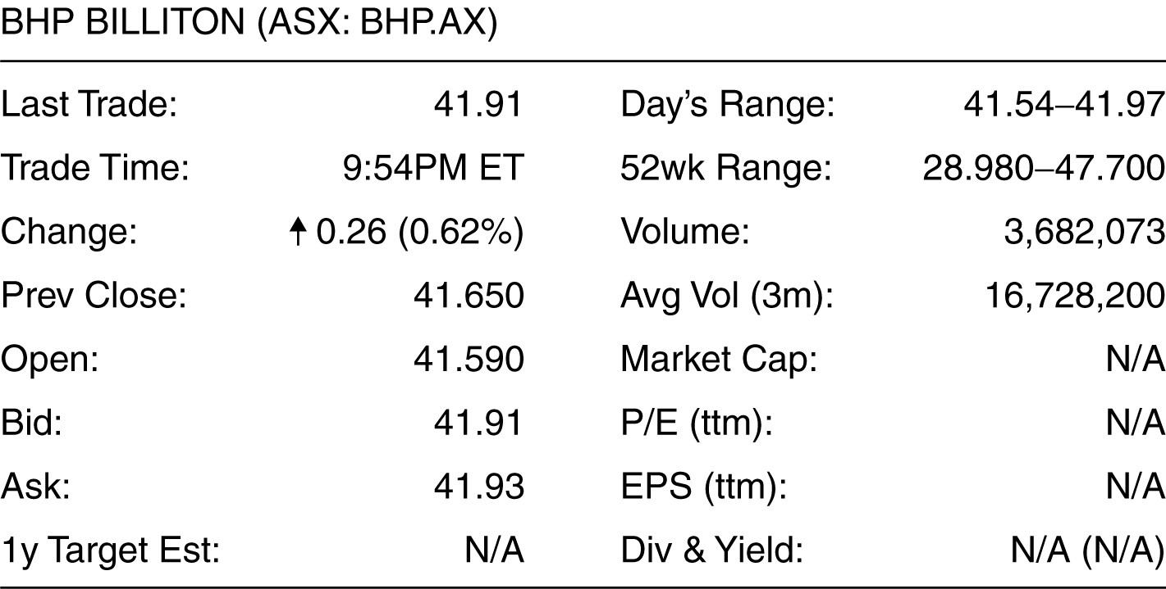

13) Using the above information, how much would you pay for a share of BHP Billiton stock?
A) $41.91
B) $41.93
C) $41.65
D) $41.59
E) $41.54
Answer: B
Diff: 1 Type: MC
Skill: Analytical
Objective: 1.5 Understand the importance of financial markets, such as stock markets, to a corporation and the financial manager's role as liaison to those markets

Use the figure for the question(s) below.

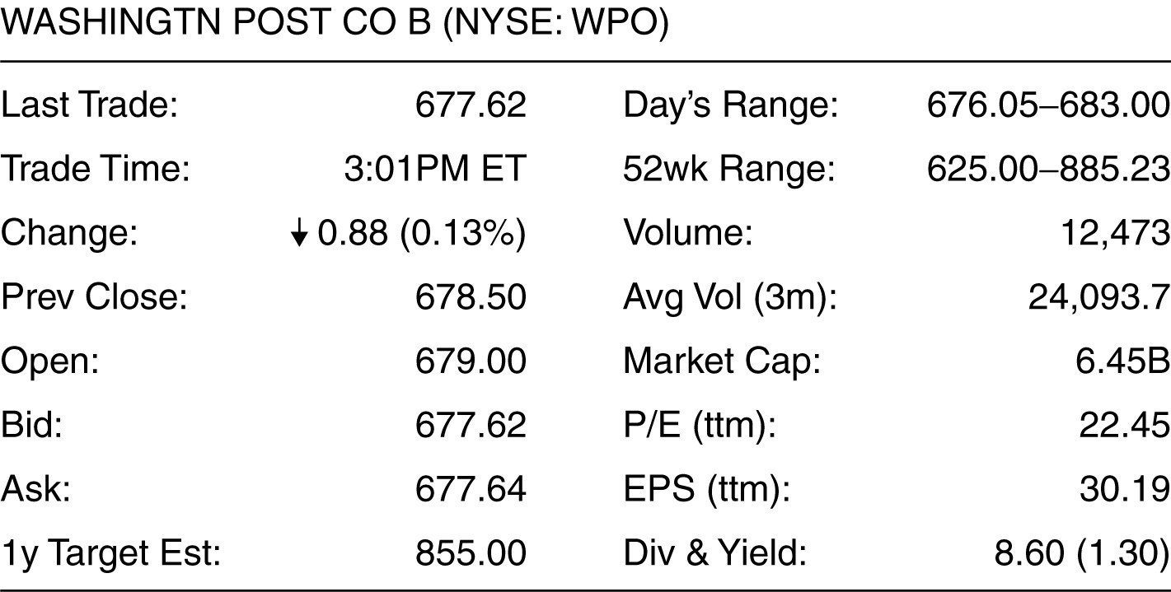

14) Using the above information, how much would you receive if you sold a share of Washington Post stock?
A) $683.00
B) $677.62
C) $678.50
D) $677.64
E) $679.00
Answer: B
Diff: 1 Type: MC
Skill: Analytical
Objective: 1.5 Understand the importance of financial markets, such as stock markets, to a corporation and the financial manager's role as liaison to those markets

Use the figure for the question(s) below.

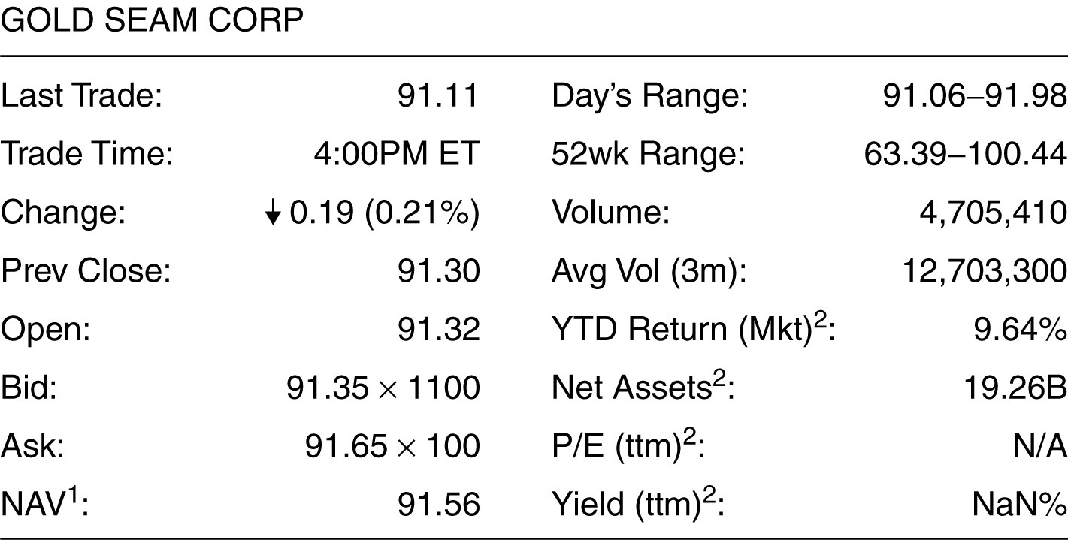

15) Based on the information shown above, what would it cost to buy 1000 shares of the above stock?
A) $91,110
B) $91,300
C) $91,320
D) $91,650
E) $91,350
Answer: D
Diff: 1 Type: MC
Skill: Analytical
Objective: 1.5 Understand the importance of financial markets, such as stock markets, to a corporation and the financial manager's role as liaison to those markets

Use the figure for the question(s) below.

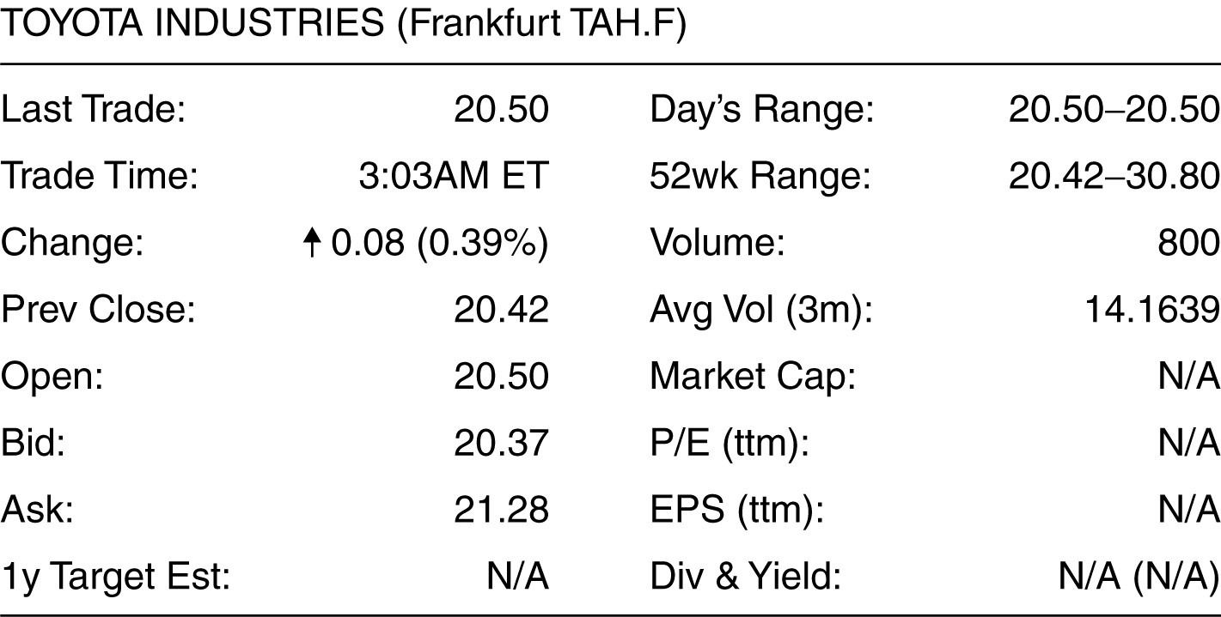

16) Based on the information shown above, how much would you receive from selling 2000 shares of the above stock?
A) €40,840
B) €40,740
C) €41,000
D) €42,560
E) €41,650
Answer: B
Explanation: 2000 shares × €20.37 = 40,740
Diff: 1 Type: MC
Skill: Analytical
Objective: 1.5 Understand the importance of financial markets, such as stock markets, to a corporation and the financial manager's role as liaison to those markets

Use the figure for the question(s) below.

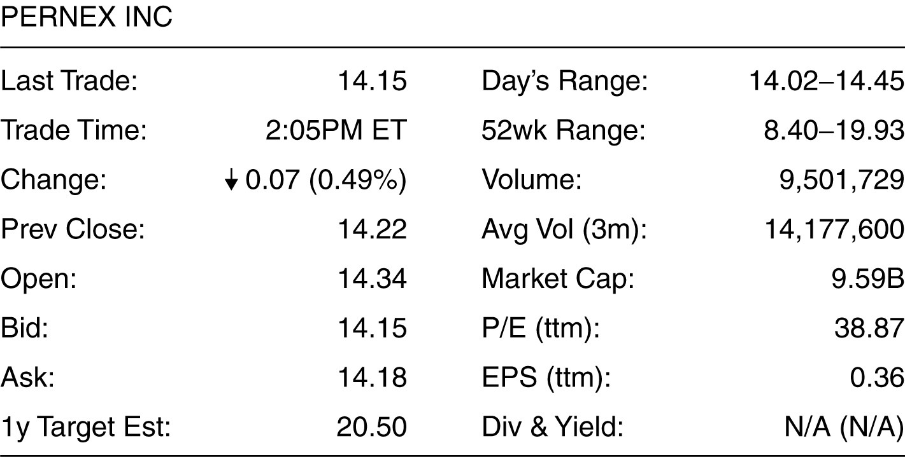

17) What is the bid-ask spread on the stock shown above?
A) 1 cent
B) 3 cents
C) 6 cents
D) 12 cents
E) 4 cents
Answer: B
Diff: 1 Type: MC
Skill: Analytical
Objective: 1.5 Understand the importance of financial markets, such as stock markets, to a corporation and the financial manager's role as liaison to those markets

Use the figure for the question(s) below.

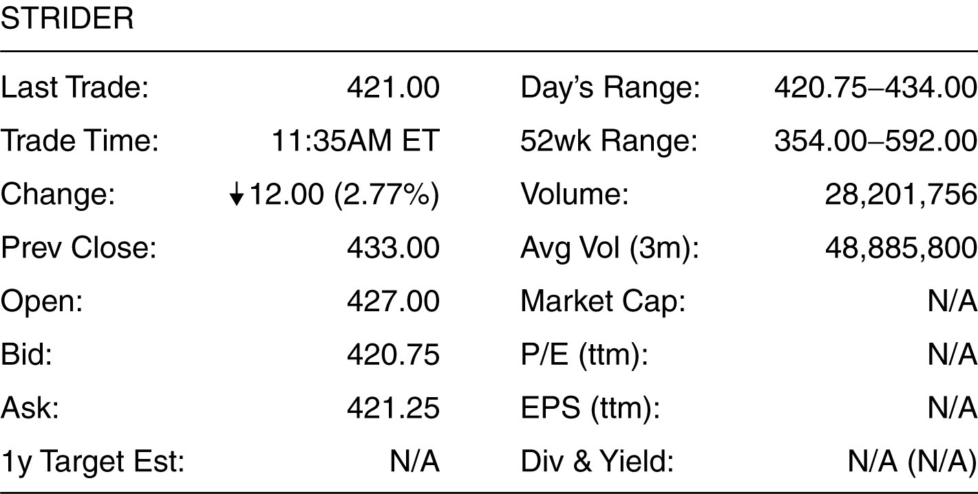

18) How much money would a stock exchange make from buying and selling 500 shares of the stock under the conditions shown above?
A) $250
B) $3,000
C) $5,875
D) $210,375
E) $210,625
Answer: A
Explanation: (421.25 - 420.75) × 500 = $250
Diff: 2 Type: MC
Skill: Analytical
Objective: 1.5 Understand the importance of financial markets, such as stock markets, to a corporation and the financial manager's role as liaison to those markets

19) Companies that attract the interest of just a few investors are said to be:
A) thinly traded.
B) penny stocks.
C) liquid.
D) unpopular.
E) bad investments.
Answer: A
Diff: 2 Type: MC
Skill: Definition
Objective: 1.5 Understand the importance of financial markets, such as stock markets, to a corporation and the financial manager's role as liaison to those markets

20) What are the terms for the two types of prices quoted for a stock on an exchange?
Answer: The two quotes associated with a stock quoted on the exchange are bid price and ask price.
Diff: 2 Type: SA
Skill: Conceptual
Objective: 1.5 Understand the importance of financial markets, such as stock markets, to a corporation and the financial manager's role as liaison to those markets

21) What is the general relation of the two types of prices quoted for a stock on a exchange?
Answer: The two prices are bid price and ask price. The ask price is higher than the bid price to deter a buyer from buying a stock and selling it back immediately, assuming everything else remains unchanged.
Diff: 2 Type: SA
Skill: Conceptual
Objective: 1.5 Understand the importance of financial markets, such as stock markets, to a corporation and the financial manager's role as liaison to those markets

22) What is the term for the applicable price that I will pay, if I have to buy a stock?
Answer: The buyer of a stock pays the ask price when he buys the stock.
Diff: 2 Type: SA
Skill: Conceptual
Objective: 1.5 Understand the importance of financial markets, such as stock markets, to a corporation and the financial manager's role as liaison to those markets

23) What is the term for the applicable price that the seller gets when he sells a stock on the exchange?
Answer: The seller gets the bid price when he sells a stock on the exchange.
Diff: 2 Type: SA
Skill: Conceptual
Objective: 1.5 Understand the importance of financial markets, such as stock markets, to a corporation and the financial manager's role as liaison to those markets

24) What are the main differences between the TSX and the TSX Venture Exchange?
Answer: The TSX has more stringent listing standards than the TSX Venture Exchange, and bid-ask spreads tend to be lower. The TSX Venture Exchange is an exchange for relatively small company stocks.
Diff: 2 Type: SA
Skill: Conceptual
Objective: 1.5 Understand the importance of financial markets, such as stock markets, to a corporation and the financial manager's role as liaison to those markets

1.6 Financial Institutions

1) Raising new capital by issuing bonds is an example of a commercial banking activity.
Answer: FALSE
Diff: 1 Type: TF
Skill: Conceptual
Objective: 1.6 Recognize the role that financial institutions play in the financial cycle of the economy

2) Put the following steps of the financial cycle in the correct order:
I. Money flows to companies who use it to fund growth through new products.
II. People invest and save their money.
III. Money flows back to savers and investors.
A) I, II, III
B) II, I, III
C) III, II, I
D) II, III, I
E) I, III, II
Answer: B
Diff: 1 Type: MC
Skill: Conceptual
Objective: 1.6 Recognize the role that financial institutions play in the financial cycle of the economy

3) Which type of financial institution receives money in the form of deposits and loans it out to people and businesses?
A) Banks and credit unions
B) Insurance companies
C) Mutual funds
D) Pension funds
E) Hedge funds
Answer: A
Diff: 1 Type: MC
Skill: Definition
Objective: 1.6 Recognize the role that financial institutions play in the financial cycle of the economy

4) Which type of financial institution receives money in the form of investments by wealthy individuals and endowments and invests in any kind of investment with an attempt to maximize returns for relatively low risk?
A) Mutual funds
B) Pension funds
C) Hedge funds
D) Venture capital funds
E) Private equity funds
Answer: C
Diff: 1 Type: MC
Skill: Definition
Objective: 1.6 Recognize the role that financial institutions play in the financial cycle of the economy

5) Which type of financial institution receives money in the form of investments by wealthy individuals and endowments and purchases whole companies by using a small amount of equity and borrowing the rest?
A) Mutual funds
B) Pension funds
C) Hedge funds
D) Venture capital funds
E) Private equity funds
Answer: E
Diff: 1 Type: MC
Skill: Definition
Objective: 1.6 Recognize the role that financial institutions play in the financial cycle of the economy

6) Which type of financial institution is involved in many different aspects of the financial cycle, brokering many of the transactions that take place between institutions?
A) Banks and credit unions
B) Mutual funds
C) Investment banks
D) Hedge funds
E) Private equity funds
Answer: C
Diff: 1 Type: MC
Skill: Definition
Objective: 1.6 Recognize the role that financial institutions play in the financial cycle of the economy

7) What is Fintech? Given an example of Fintech, and name some of the subareas of Fintech.
Answer: Fintech refers to technology replacing a traditional financial function—the term is relatively new, but the concept has been around for decades. For instance, in 1977, the Toronto Stock Exchange introduced the first fully automated trading system, called CATS (Computer Assisted Trading System). This eliminated the need for floor trading, made public the central limit order book for each stock, and fully automated the trading of each security.

There are many subareas of fintech: lending, payments, personal finance/wealth management, money transfer/remittance, blockchain/digital currency, insurance, crowdfunding, capital markets, and others.
Diff: 1 Type: SA
Skill: Definition
Objective: 1.6 Recognize the role that financial institutions play in the financial cycle of the economy

8) Fintech has made financial industry more competitive.
Answer: TRUE
Explanation: The use of technology and innovation have reduced the cost of providing financial services, making the financial industry increasingly competitive over time. As fintech companies test their approaches in the market and incumbents respond, we will undoubtedly see a shakeout as some new approaches thrive and others fall short.
Diff: 1 Type: TF
Skill: Conceptual
Objective: 1.6 Recognize the role that financial institutions play in the financial cycle of the economy

