Microeconomics, 3e (Hubbard/O'Brien) - TB2
Chapter 1 Economics: Foundations and Models

1.1 Three Key Economic Ideas

1) As the number of jobs in the United States that require technical education and training continues to increase, many U.S. firms, particularly those involved with information technology
A) are unable to hire any foreign workers due to the H-1B visa program.
B) have found it unnecessary to look to foreign workers to get these jobs, as there are more than enough qualified U.S. workers in the labor force.
C) have had difficulty filling all their available job openings with U.S. citizens.
D) are now able to hire an unlimited number of foreign workers to fill these jobs under the H-1B visa program.
Answer: C
Diff: 2 Page Ref: 3/3
Topic: Scarcity
Objective: LO1: Explain these three key economic ideas: People are rational. People respond to incentives. Optimal decisions are made at the margin.
AACSB: Reflective Thinking
Special Feature: Chapter Opener: Microsoft Versus the U.S. Congress on Worker Visas

2) The study of economics arises due to
A) money.
B) scarcity.
C) greed.
D) resources.
Answer: B
Comment: Recurring
Diff: 1 Page Ref: 4/4
Topic: Scarcity
Objective: LO1: Explain these three key economic ideas: People are rational. People respond to incentives. Optimal decisions are made at the margin.
AACSB: Reflective Thinking
Special Feature: None

3) Scarcity refers to the situation in which
A) unlimited wants exceed limited resources.
B) unlimited resources exceed limited wants.
C) a country's population is larger than its resource base.
D) a nation's poverty level increases faster than its population.
Answer: A
Comment: Recurring
Diff: 1 Page Ref: 4/4
Topic: Scarcity
Objective: LO1: Explain these three key economic ideas: People are rational. People respond to incentives. Optimal decisions are made at the margin.
AACSB: Reflective Thinking
Special Feature: None
4) The basic economic problem of scarcity
A) has always existed and will continue to exist.
B) will eventually disappear as technology continues to advance.
C) is a problem only in developing economies.
D) does not apply to the wealthy in society.
Answer: A
Comment: Recurring
Diff: 1 Page Ref: 4/4
Topic: Scarcity
Objective: LO1: Explain these three key economic ideas: People are rational. People respond to incentives. Optimal decisions are made at the margin.
AACSB: Reflective Thinking
Special Feature: None

5) Economics is the study of the ________ people make to attain their goals, given their ________ resources.
A) purchases; unlimited
B) choices; scarce
C) income; available
D) decisions; household
Answer: B
Comment: Recurring
Diff: 1 Page Ref: 4/4
Topic: Scarcity
Objective: LO1: Explain these three key economic ideas: People are rational. People respond to incentives. Optimal decisions are made at the margin.
AACSB: Reflective Thinking
Special Feature: None

6) What is an economic model?
A) It is a description of an economic issue that includes all possible related information.
B) It is a description of an economic issue based on official government information.
C) It is a detailed version of some aspect of economic life used to analyze an economic issue.
D) It is a simplified version of some aspect of economic life used to analyze an economic issue.
Answer: D
Comment: Recurring
Diff: 1 Page Ref: 4/4
Topic: Economic Models
Objective: LO1: Explain these three key economic ideas: People are rational. People respond to incentives. Optimal decisions are made at the margin.
AACSB: Reflective Thinking
Special Feature: None
7) The term "market" in economics refers to
A) a place where money changes hands.
B) a legal institution where exchange can take place.
C) a group of buyers and sellers of a product and the arrangement by which they come together to trade.
D) an organization which sells goods and services.
Answer: C
Comment: Recurring
Diff: 1 Page Ref: 4/4
Topic: Markets
Objective: LO1: Explain these three key economic ideas: People are rational. People respond to incentives. Optimal decisions are made at the margin.
AACSB: Reflective Thinking
Special Feature: None

8) Economists assume that
A) individuals behave in unpredictable ways.
B) consumer behavior is explained by the existence of unlimited resources.
C) people put other people's interests ahead of their own.
D) optimal decisions are made at the margin.
Answer: D
Comment: Recurring
Diff: 1 Page Ref: 5/5
Topic: Optimal Decisions Are Made at the Margin
Objective: LO1: Explain these three key economic ideas: People are rational. People respond to incentives. Optimal decisions are made at the margin.
AACSB: Reflective Thinking
Special Feature: None

9) Which of the following best describes an assumption economists make about human behavior?
A) They assume that individuals act rationally all the time in all circumstances.
B) They assume that rational behavior is useful in explaining choices people make even though people may not behave rationally all the time.
C) They assume that people take into account the question of fairness in all decisions they make.
D) They assume that individuals act randomly.
Answer: B
Comment: Recurring
Diff: 2 Page Ref: 5/5
Topic: People Are Rational
Objective: LO1: Explain these three key economic ideas: People are rational. People respond to incentives. Optimal decisions are made at the margin.
AACSB: Reflective Thinking
Special Feature: None
10) Economists assume that rational people
A) never use all available information as they act to achieve their goals.
B) undertake activities that benefit others and hurt themselves.
C) only weigh the benefits and costs of the most desirable alternative actions.
D) respond to economic incentives.
Answer: D
Comment: Recurring
Diff: 2 Page Ref: 5/5
Topic: People Are Rational
Objective: LO1: Explain these three key economic ideas: People are rational. People respond to incentives. Optimal decisions are made at the margin.
AACSB: Reflective Thinking
Special Feature: None

11) Your roommate, Serafina, a psychology major, said, "The problem with economics is that it assumes that consumers and firms always make the correct decision. But we know that everyone's human, and we all make mistakes." Do you agree with her comment?
A) Yes, I agree with her. One cannot make predictions about economic behavior because in reality people make incorrect choices in many situations.
B) I disagree with her. Economics does not study correct or incorrect behaviors but rather it assumes that economic agents behave rationally, meaning they make the best decisions given their knowledge of the costs and benefits.
C) Yes, I agree with her. Economic theory should allow for irrational behavior so that we can have more reliable predictions.
D) I disagree with her. If we cannot assume that decisions are correct, then we will not be able to examine the moral implications of these decisions.
Answer: B
Comment: Recurring
Diff: 2 Page Ref: 5/5
Topic: People Are Rational
Objective: LO1: Explain these three key economic ideas: People are rational. People respond to incentives. Optimal decisions are made at the margin.
AACSB: Analytic Skills
Special Feature: None
12) Consider the following statements:
a. Consumers rent more DVDs from a video store that rents DVDs at a lower price than other rival video stores in the area.
b. Department stores take steps to increase security since they believe it is more costly to allow shoplifting than to install expensive security monitoring equipment.
c. Farmers produce more cotton when its selling price falls.

Which of the above statements demonstrates that economic agents respond to incentives?
A) a only.
B) b only.
C) c only.
D) a and b.
E) a, b, and c.
Answer: D
Comment: Recurring
Diff: 3 Page Ref: 5/5
Topic: People Respond to Economic Incentives
Objective: LO1: Explain these three key economic ideas: People are rational. People respond to incentives. Optimal decisions are made at the margin.
AACSB: Analytic Skills
Special Feature: None

13) In the first six months of 2003, branches of Commerce Bank in New York City were robbed 14 times. The New York City Police recommended steps the bank could take to deter robberies, including the installation of plastic barriers called "bandit barriers." The police were surprised the bank did not take their advice. According to a deputy commissioner of police, "Commerce does very little of what we recommend. They've told our detectives they have no interest in ever putting in the barriers."

It would seem that Commerce bank would have a strong incentive to install "bandit barriers" to deter robberies. Why wouldn't they do it?
A) The banks would rather delay installation of any theft deterring equipment in anticipation of new lower cost innovations in the security devices market.
B) The banks must have weighed the cost of installing bandit barriers against the benefits and decided that they have "no interest in ever putting in the barriers".
C) The banks are concerned that "bandit barriers" would send the wrong message to customers -- that the bank is unsafe.
D) The banks probably resent any interference from the police department.
Answer: B
Diff: 2 Page Ref: 5/5
Topic: People Respond to Economic Incentives
Objective: LO1: Explain these three key economic ideas: People are rational. People respond to incentives. Optimal decisions are made at the margin.
AACSB: Reflective Thinking
Special Feature: None
14) In Austria, per child, an Austrian woman can get up to 48 months of pension benefits and is guaranteed a maternity allowance two months before and after she gives birth. Further, the Austrian government gives monthly payouts ranging from $132 to $547, depending on the age of offspring and offers generous tax benefits for families with children. How will these benefits affect a woman's decision to have children?
A) These incentives will have no effect on having children; the decision to have children is a social and psychological decision, not an economic decision.
B) These incentives will encourage only less educated women to have more children.
C) These incentives will encourage only women with high opportunity costs to have more children.
D) These incentives will encourage women to have children and increase the birth rate.
Answer: D
Diff: 2 Page Ref: 5/5
Topic: People Respond to Economic Incentives
Objective: LO1: Explain these three key economic ideas: People are rational. People respond to incentives. Optimal decisions are made at the margin.
AACSB: Analytic Skills
Special Feature: Making the Connection: Will Women Have More Babies if the Government Pays Them To?

15) In the United States and in most European countries, aging populations and declining birthrates threaten public finances. As the population ages, there are fewer workers paying taxes relative to the number of retired people receiving government benefits. Which of the following government policies would help reduce the pressure on public finances?
A) offer financial incentives to increase the birthrate
B) reduce taxes paid by current workers so that they can save for their future
C) increase retiree benefit payments
D) lower the retirement age
Answer: A
Diff: 2 Page Ref: 5/5
Topic: People Respond to Economic Incentives
Objective: LO1: Explain these three key economic ideas: People are rational. People respond to incentives. Optimal decisions are made at the margin.
AACSB: Analytic Skills
Special Feature: Making the Connection: Will Women Have More Babies if the Government Pays Them To?

16) What does the term "marginal" mean in economics?
A) the edge of a market
B) an additional or extra
C) illegal
D) secondary
E) trivial
Answer: B
Comment: Recurring
Diff: 1 Page Ref: 6/6
Topic: Optimal Decisions Are Made at the Margin
Objective: LO1: Explain these three key economic ideas: People are rational. People respond to incentives. Optimal decisions are made at the margin.
AACSB: Reflective Thinking
Special Feature: None
17) An office supply store sells a ream of printer paper at a fixed price of $4.50. Which of the following is a term used by economists to describe the money received from the sale of an additional ream of paper?
A) marginal revenue
B) gross earnings
C) pure profit
D) marginal costs
E) net benefit
Answer: A
Comment: Recurring
Diff: 1 Page Ref: 7/7
Topic: Optimal Decisions Are Made at the Margin
Objective: LO1: Explain these three key economic ideas: People are rational. People respond to incentives. Optimal decisions are made at the margin.
AACSB: Reflective Thinking
Special Feature: None

18) Economics promotes which of the following as the way to make the best decision?
A) Continue an enjoyable activity as long as you do not have to pay for it.
B) Continue an enjoyable activity until it is no longer enjoyable.
C) Continue an enjoyable activity until you cannot afford to pursue it.
D) Continue an enjoyable activity up to the point where its marginal benefit equals its marginal cost.
Answer: D
Comment: Recurring
Diff: 2 Page Ref: 7/7
Topic: Optimal Decisions Are Made at the Margin
Objective: LO1: Explain these three key economic ideas: People are rational. People respond to incentives. Optimal decisions are made at the margin.
AACSB: Reflective Thinking
Special Feature: None

19) ________ involves undertaking an activity until its marginal benefits equal marginal costs.
A) Scarcity reduction
B) Central planning
C) Marginal analysis
D) Market intervention
Answer: C
Comment: Recurring
Diff: 1 Page Ref: 7/7
Topic: Optimal Decisions Are Made at the Margin
Objective: LO1: Explain these three key economic ideas: People are rational. People respond to incentives. Optimal decisions are made at the margin.
AACSB: Reflective Thinking
Special Feature: None
20) The revenue received from the sale of an additional unit of a product
A) is a marginal benefit to the firm.
B) is called profit.
C) is called gross sales.
D) is called a net gain.
Answer: A
Comment: Recurring
Diff: 2 Page Ref: 7/7
Topic: Optimal Decisions Are Made at the Margin
Objective: LO1: Explain these three key economic ideas: People are rational. People respond to incentives. Optimal decisions are made at the margin.
AACSB: Reflective Thinking
Special Feature: None

21) The cost incurred from the production of an additional unit of a product
A) is a marginal cost to the firm.
B) is called a loss.
C) is called opportunity cost.
D) must be zero for a firm to be efficient.
Answer: A
Comment: Recurring
Diff: 2 Page Ref: 7/7
Topic: Optimal Decisions Are Made at the Margin
Objective: LO1: Explain these three key economic ideas: People are rational. People respond to incentives. Optimal decisions are made at the margin.
AACSB: Reflective Thinking
Special Feature: None

22) Before Apple decides to produce 1 million more iPhones, it should
A) make sure that its marginal cost will exceed its marginal benefit.
B) only consider its increase in total profit.
C) weigh the costs and benefits of producing 1 million more iPhones before deciding if the additional production should be undertaken.
D) only look at its marginal benefit, because marginal cost will not change.
Answer: C
Diff: 1 Page Ref: 7/7
Topic: Optimal Decisions Are Made at the Margin
Objective: LO1: Explain these three key economic ideas: People are rational. People respond to incentives. Optimal decisions are made at the margin.
AACSB: Reflective Thinking
Special Feature: Solved Problem: Apple Computer Makes a Decision at the Margin
23) If the marginal cost of producing a television is constant at $200, then a firm should produce this item
A) only if the marginal benefit it receives is greater than $200 plus an acceptable profit margin.
B) as long as the marginal benefit it receives is just equal to or greater than $200.
C) as long as its marginal cost does not rise.
D) until the marginal benefit it receives reaches zero.
Answer: B
Comment: Recurring
Diff: 2 Page Ref: 7/7
Topic: Optimal Decisions Are Made at the Margin
Objective: LO1: Explain these three key economic ideas: People are rational. People respond to incentives. Optimal decisions are made at the margin.
AACSB: Reflective Thinking
Special Feature: None

24) Which of the following is an example of a "how much" decision?
A) The Pleasantville movie theatre is open only in the evenings. The theatre's manager is debating whether to add daily matinee shows.
B) The Zhous have demolished their old home and are debating whether to build a ranch-style house or a Craftsman home.
C) You're planning to hold a graduation party and must decide between having your party catered or having a pot-luck.
D) Chelsea has withdrawn from the swim team to take up a full-time job.
Answer: A
Comment: Recurring
Diff: 2 Page Ref: 6/6
Topic: Optimal Decisions Are Made at the Margin
Objective: LO1: Explain these three key economic ideas: People are rational. People respond to incentives. Optimal decisions are made at the margin.
AACSB: Reflective Thinking
Special Feature: None

25) Marginal cost is the ________ associated with undertaking an activity.
A) total cost
B) extra cost.
C) opportunity cost.
D) foregone cost.
Answer: B
Comment: Recurring
Diff: 1 Page Ref: 7/7
Topic: Optimal Decisions Are Made at the Margin
Objective: LO1: Explain these three key economic ideas: People are rational. People respond to incentives. Optimal decisions are made at the margin.
AACSB: Reflective Thinking
Special Feature: None
26) Cassie's Quilts alters, reconstructs and restores heirloom quilts. Cassie has just spent $800 purchasing, cleaning and reconstructing an antique quilt which she expects to sell for $1,500 once she is finished. After having spent $800, Cassie discovers that she would need some special period fabric that would cost her $200 in material and time in order to complete the task. Alternatively, she can sell the quilt "as is" now for $900. What is her marginal benefit if she sells the quilt "as is" now?
A) $100
B) $900
C) She makes a marginal loss of $600, not a marginal benefit.
D) The marginal benefit cannot be determined.
Answer: B
Comment: Recurring
Diff: 2 Page Ref: 7/7
Topic: Optimal Decisions Are Made at the Margin
Objective: LO1: Explain these three key economic ideas: People are rational. People respond to incentives. Optimal decisions are made at the margin.
AACSB: Analytic Skills
Special Feature: None

27) Cassie's Quilts alters, reconstructs and restores heirloom quilts. Cassie has just spent $800 purchasing, cleaning and reconstructing an antique quilt which she expects to sell for $1,500 once she is finished. After having spent $800, Cassie discovers that she would need some special period fabric that would cost her $200 in material and time in order to complete the task. Alternatively, she can sell the quilt "as is" now for $900. What is the marginal cost of completing the task?
A) $200
B) $500
C) $1,000
D) $1,000 plus the value of her time
Answer: A
Comment: Recurring
Diff: 2 Page Ref: 7/7
Topic: Optimal Decisions Are Made at the Margin
Objective: LO1: Explain these three key economic ideas: People are rational. People respond to incentives. Optimal decisions are made at the margin.
AACSB: Analytic Skills
Special Feature: None
28) Cassie's Quilts alters, reconstructs and restores heirloom quilts. Cassie has just spent $800 purchasing, cleaning and reconstructing an antique quilt which she expects to sell for $1,500 once she is finished. After having spent $800, Cassie discovers that she would need some special period fabric that would cost her $200 in material and time in order to complete the task. Alternatively, she can sell the quilt "as is" now for $900. What should she do?
A) She should cut her losses and sell the quilt now.
B) It does not matter what she does; she is going to take a loss on her project.
C) She should purchase the period fabric, complete the task and then sell the quilt.
D) She should not do anymore work on the quilt because she has already spent too much time on it and has not been paid for that time.
Answer: C
Comment: Recurring
Diff: 3 Page Ref: 7/7
Topic: Optimal Decisions Are Made at the Margin
Objective: LO1: Explain these three key economic ideas: People are rational. People respond to incentives. Optimal decisions are made at the margin.
AACSB: Analytic Skills
Special Feature: None

Scenario 1-1

Suppose a t-shirt manufacturer currently sells 5,000 t-shirts per week and makes a profit of $10,000 per week. A manager at the plant observes, "Although the last 400 t-shirts we produced and sold increased our revenue by $4,000 and our costs by $4,800, we are still making an overall profit of $10,000 per week so I think we're on the right track. We are producing the optimal number of t-shirts."

29) Refer to Scenario 1-1. Using marginal analysis terminology, what is another economic term for the incremental revenue received from the sale of the last 400 t-shirts?
A) gross earnings
B) marginal revenue
C) sales revenue
D) gross profit
Answer: B
Comment: Recurring
Diff: 1 Page Ref: 7/7
Topic: Optimal Decisions Are Made at the Margin
Objective: LO1: Explain these three key economic ideas: People are rational. People respond to incentives. Optimal decisions are made at the margin.
AACSB: Reflective Thinking
Special Feature: None
30) Refer to Scenario 1-1. Using marginal analysis terminology, what is another economic term for the incremental cost of producing the last 400 t-shirts?
A) marginal cost
B) operating cost
C) explicit cost
D) Any of the above terms are correct.
Answer: A
Comment: Recurring
Diff: 1 Page Ref: 7/7
Topic: Optimal Decisions Are Made at the Margin
Objective: LO1: Explain these three key economic ideas: People are rational. People respond to incentives. Optimal decisions are made at the margin.
AACSB: Reflective Thinking
Special Feature: None

31) Refer to Scenario 1-1. Had the firm not produced and sold the last 400 t-shirts, would its profit be higher or lower, and if so by how much?
A) Its profit will be $4,800 higher.
B) Its profit will be $800 higher.
C) Its profit will be $800 lower.
D) Its profit will be $4,000 lower.
Answer: B
Comment: Recurring
Diff: 2 Page Ref: 7/7
Topic: Optimal Decisions Are Made at the Margin
Objective: LO1: Explain these three key economic ideas: People are rational. People respond to incentives. Optimal decisions are made at the margin.
AACSB: Analytic Skills
Special Feature: None
Table 1-1

Hours  Open | Total  Revenue  (dollars)
1 | $35
2 | 60
3 | 80
4 | 92
5 | 100
6 | 105

Eva runs a small bakery in the village of Roggerli. She is debating whether she should extend her hours of operation. Eva figures that her sales revenue will depend on the number of hours the bakery is open as shown in the table above. She would have to hire a worker for those hours at a wage rate of $12 per hour.

32) Refer to Table 1-1. Using marginal analysis, determine how many hours should Eva extend
her bakery's hours of operations?
A) 2 hours
B) 3 hours
C) 4 hours
D) 5 hours
E) 6 hours
Answer: C
Comment: Recurring
Diff: 3 Page Ref: 7/7
Topic: Optimal Decisions Are Made at the Margin
Objective: LO1: Explain these three key economic ideas: People are rational. People respond to incentives. Optimal decisions are made at the margin.
AACSB: Analytic Skills
Special Feature: None

33) Refer to Table 1-1. What is Eva's marginal benefit if she decides to stay open for two hours instead of one hour?
A) $25
B) $36
C) $60
D) $95
Answer: A
Comment: Recurring
Diff: 2 Page Ref: 7/7
Topic: Optimal Decisions Are Made at the Margin
Objective: LO1: Explain these three key economic ideas: People are rational. People respond to incentives. Optimal decisions are made at the margin.
AACSB: Analytic Skills
Special Feature: None
34) Refer to Table 1-1. What is Eva's marginal cost if she decides to stay open for two hours instead of one hour?
A) $12
B) $24
C) $36
D) $71
Answer: A
Comment: Recurring
Diff: 2 Page Ref: 7/7
Topic: Optimal Decisions Are Made at the Margin
Objective: LO1: Explain these three key economic ideas: People are rational. People respond to incentives. Optimal decisions are made at the margin.
AACSB: Analytic Skills
Special Feature: None

35) Tabitha shares a flea market booth with her sister. Her share of the rent is $150 per month. She is considering moving to her own, larger booth which she will not have to share with anyone. The larger booth rents for $450 per month. Recently, you ran into Tabitha in the grocery store and she tells you that she has rented the larger booth. Tabitha is as rational as any other person. As an economics major, you rightly conclude that
A) Tabitha did not have a choice; her sister was overcharging her.
B) Tabitha figures that the additional benefit of having her own booth (as opposed to sharing) is at least $300.
C) Tabitha figures that the benefit of having her own booth (as opposed to sharing) is at least $450.
D) the cost of having one's own booth outweighs the benefits.
Answer: B
Comment: Recurring
Diff: 2 Page Ref: 7/7
Topic: Optimal Decisions Are Made at the Margin
Objective: LO1: Explain these three key economic ideas: People are rational. People respond to incentives. Optimal decisions are made at the margin.
AACSB: Analytic Skills
Special Feature: None

36) All economic questions arise from the fact that resources are scarce.
Answer: TRUE
Comment: Recurring
Diff: 1 Page Ref: 4/4
Topic: Scarcity
Objective: LO1: Explain these three key economic ideas: People are rational. People respond to incentives. Optimal decisions are made at the margin.
AACSB: Reflective Thinking
Special Feature: None

37) As population declines, scarcity eventually disappears.
Answer: FALSE
Comment: Recurring
Diff: 1 Page Ref: 4/4
Topic: Scarcity
Objective: LO1: Explain these three key economic ideas: People are rational. People respond to incentives. Optimal decisions are made at the margin.
AACSB: Reflective Thinking
Special Feature: None
38) The term "market" refers only to trading arrangements that have been approved by the government.
Answer: FALSE
Comment: Recurring
Diff: 1 Page Ref: 4/4
Topic: Markets
Objective: LO1: Explain these three key economic ideas: People are rational. People respond to incentives. Optimal decisions are made at the margin.
AACSB: Reflective Thinking
Special Feature: None

39) The sales revenue a seller receives from the sale of an additional unit of goods is called the marginal cost.
Answer: FALSE
Comment: Recurring
Diff: 1 Page Ref: 7/7
Topic: Optimal Decisions Are Made at the Margin
Objective: LO1: Explain these three key economic ideas: People are rational. People respond to incentives. Optimal decisions are made at the margin.
AACSB: Reflective Thinking
Special Feature: None

40) Marginal benefit is the benefit that your activity provides to someone else.
Answer: FALSE
Comment: Recurring
Diff: 1 Page Ref: 7/7
Topic: Optimal Decisions Are Made at the Margin
Objective: LO1: Explain these three key economic ideas: People are rational. People respond to incentives. Optimal decisions are made at the margin.
AACSB: Reflective Thinking
Special Feature: None

41) If it costs Vijay $150 to design 5 websites and $175 to design 6 websites, then $175 is the marginal cost of producing the 6th Websites.
Answer: FALSE
Comment: Recurring
Diff: 1 Page Ref: 7/7
Topic: Optimal Decisions Are Made at the Margin
Objective: LO1: Explain these three key economic ideas: People are rational. People respond to incentives. Optimal decisions are made at the margin.
AACSB: Reflective Thinking
Special Feature: None

42) Suppose the extra cost to Apple Computer of producing another iPhone is $270. Then, Apple should not produce this unit if it can only sell it for $270.
Answer: FALSE
Diff: 2 Page Ref: 7/7
Topic: Optimal Decisions Are Made at the Margin
Objective: LO1: Explain these three key economic ideas: People are rational. People respond to incentives. Optimal decisions are made at the margin.
AACSB: Analytic Skills
Special Feature: Solved Problem: Apple Computer Makes a Decision at the Margin
43) What is scarcity, and why is it a fundamental concept in economics?
Answer: Scarcity refers to a situation in which unlimited wants exceed the limited resources available to fulfill those wants. Scarcity is a fundamental concept in economics, because economics is the study of the choices people make to attain their goals, given their scarce resources.
Comment: Recurring
Diff: 1 Page Ref: 4/4
Topic: Scarcity
Objective: LO1: Explain these three key economic ideas: People are rational. People respond to incentives. Optimal decisions are made at the margin.
AACSB: Reflective Thinking
Special Feature: None

44) What is an economic market?
Answer: An economic ic market refers to a group of buyers and sellers of a good or service and the institution or arrangement by which they come together to trade.
Comment: Recurring
Diff: 1 Page Ref: 4/4
Topic: Markets
Objective: LO1: Explain these three key economic ideas: People are rational. People respond to incentives. Optimal decisions are made at the margin.
AACSB: Reflective Thinking
Special Feature: None

45) What does the word "marginal" mean in economics? What is a marginal benefit? What is a marginal cost? What is marginal analysis?
Answer: In economics, the word "marginal" means "extra" or "additional". Marginal benefit is the additional benefit received from continuing with an activity. Marginal cost is the additional cost associated with continuing with an activity. Marginal analysis involves comparing marginal benefits and marginal costs.
Comment: Recurring
Diff: 1 Page Ref: 4/4
Topic: Optimal Decisions Are Made at the Margin
Objective: LO1: Explain these three key economic ideas: People are rational. People respond to incentives. Optimal decisions are made at the margin.
AACSB: Reflective Thinking
Special Feature: None

46) Assume that Apple computer can earn an additional $65 million of revenue from making 150,000 more iPhones. What must the additional cost of producing these 150,000 be to make the additional output economically rational?
Answer: The additional cost of the 150,000 extra iPhones must be no more than $65 million to make the production of these extra units economically rational.
Diff: 2 Page Ref: 7/7
Topic: Optimal Decisions Are Made at the Margin
Objective: LO1: Explain these three key economic ideas: People are rational. People respond to incentives. Optimal decisions are made at the margin.
AACSB: Analytic Skills
Special Feature: Solved Problem: Apple Computer Makes a Decision at the Margin
1.2 The Economic Problem That Every Society Must Solve

1) Trade-offs force society to make choices when answering what three fundamental questions?
A) What will be the prices of goods and services; how will these goods and services be produced; and who will receive them?
B) What goods and services to produce; how will these goods and services be produced; and who receives them?
C) Who gets jobs; what wages do workers earn; and who owns what property?
D) How much will be saved; what will be produced; and how can these goods and services be fairly distributed?
Answer: B
Comment: Recurring
Diff: 1 Page Ref: 8/8
Topic: Trade-offs
Objective: LO2: Discuss how an economy answers these questions: What goods and services will be produced? How will the goods and services be produced? Who will receive the goods and services?
AACSB: Reflective Thinking
Special Feature: None

2) Every society faces economic trade-offs. This means
A) some people live better than others do.
B) not everyone can have enough goods to survive.
C) producing more of one good means less of another good can be produced.
D) society's output cannot be made available to all.
Answer: C
Comment: Recurring
Diff: 1 Page Ref: 8/8
Topic: Trade-offs
Objective: LO2: Discuss how an economy answers these questions: What goods and services will be produced? How will the goods and services be produced? Who will receive the goods and services?
AACSB: Reflective Thinking
Special Feature: None

3) Which of the following statements is false?
A) Anytime you have to decide which action to take you are facing an economic trade-off.
B) Trade-offs do not apply when the consumers purchase a product for which there is excess supply, such as a stock clearance sale.
C) Every individual, no matter how rich or poor, is faced with making trade-offs.
D) Economics is a social science that studies the trade-offs we are forced to make because of scarcity.
Answer: B
Comment: Recurring
Diff: 2 Page Ref: 8/8
Topic: Trade-offs
Objective: LO2: Discuss how an economy answers these questions: What goods and services will be produced? How will the goods and services be produced? Who will receive the goods and services?
AACSB: Reflective Thinking
Special Feature: None
4) Which of the following is an example of an economic trade-off that a firm has to make?
A) whether it is cheaper to produce with more machines or with more workers
B) deciding why consumers want its products
C) whether or not consumers will buy its products
D) deciding what profit margin it desires for its products
Answer: A
Comment: Recurring
Diff: 1 Page Ref: 8/8
Topic: Trade-offs
Objective: LO2: Discuss how an economy answers these questions: What goods and services will be produced? How will the goods and services be produced? Who will receive the goods and services?
AACSB: Reflective Thinking
Special Feature: None

5) Opportunity cost is defined as
A) the benefit of an activity.
B) the monetary expense associated with an activity.
C) the highest valued alternative that must be given up to engage in an activity.
D) the total value of all alternatives that must be given up to engage in an activity.
Answer: C
Comment: Recurring
Diff: 1 Page Ref: 8/8
Topic: Opportunity Cost
Objective: LO2: Discuss how an economy answers these questions: What goods and services will be produced? How will the goods and services be produced? Who will receive the goods and services?
AACSB: Reflective Thinking
Special Feature: None

6) The Stogie Shop, a cigar store in the mall, sells hand-rolled cigars for $10.00 and machine-made cigars for $2.50 each. What is the opportunity cost of buying a hand-rolled cigar?
A) 4 machine-made cigars
B) 1/4 of a machine-made cigar
C) $10.00
D) $2.50
Answer: A
Comment: Recurring
Diff: 1 Page Ref: 8/8
Topic: Opportunity Cost
Objective: LO2: Discuss how an economy answers these questions: What goods and services will be produced? How will the goods and services be produced? Who will receive the goods and services?
AACSB: Analytic Skills
Special Feature: None
7) Ted quits his $60,000-a-year job to be a stay-at-home dad. What is the opportunity cost of his decision?
A) 0 since he will no longer be earning a salary
B) depends on the "going rate" for stay-at-home dads
C) at least $60,000
D) the value he attributes to the joy of parenting
Answer: C
Comment: Recurring
Diff: 1 Page Ref: 8/8
Topic: Opportunity Cost
Objective: LO2: Discuss how an economy answers these questions: What goods and services will be produced? How will the goods and services be produced? Who will receive the goods and services?
AACSB: Analytic Skills
Special Feature: None

8) Who receives the goods and services produced in the United States depends largely on
A) how income is distributed.
B) how the goods and services are produced.
C) what goods and services are produced.
D) government redistribution.
Answer: A
Comment: Recurring
Diff: 2 Page Ref: 8/8
Topic: Who Will Receive the Goods and Services Produced?
Objective: LO2: Discuss how an economy answers these questions: What goods and services will be produced? How will the goods and services be produced? Who will receive the goods and services?
AACSB: Reflective Thinking
Special Feature: None

9) Fast food restaurants produce a range of menu items such as hamburgers, chicken sandwiches, salads, and french fries. What fundamental economic question are they addressing by offering this range of items?
A) How to produce goods that consumers want?
B) Why produce a variety of menu items?
C) What to produce?
D) Who to produce the menu items for?
Answer: C
Comment: Recurring
Diff: 1 Page Ref: 8/8
Topic: What Goods and Services Will Be Produced?
Objective: LO2: Discuss how an economy answers these questions: What goods and services will be produced? How will the goods and services be produced? Who will receive the goods and services?
AACSB: Reflective Thinking
Special Feature: None
10) Consider the following economic agents:
a. the government
b. consumers
c. producers

Who, in a modern mixed economy, decides what goods and services will be produced with the scarce resources available in that economy?
A) the government
B) producers
C) consumers
D) consumers and producers
E) the government, consumers and producers
Answer: E
Comment: Recurring
Diff: 1 Page Ref: 9/9
Topic: What Goods and Services Will Be Produced?
Objective: LO2: Discuss how an economy answers these questions: What goods and services will be produced? How will the goods and services be produced? Who will receive the goods and services?
AACSB: Reflective Thinking
Special Feature: None

11) In a market economy, who decides what goods and services will be produced?
A) only the producers
B) only consumers
C) consumers and producers
D) the government
Answer: C
Comment: Recurring
Diff: 1 Page Ref: 9/9
Topic: What Goods and Services Will Be Produced?
Objective: LO2: Discuss how an economy answers these questions: What goods and services will be produced? How will the goods and services be produced? Who will receive the goods and services?
AACSB: Reflective Thinking
Special Feature: None

12) Which of the following is correct about the economic decisions consumers, firms, and the government have to make?
A) Governments may face the problem of shortages but not scarcity in making economic decisions.
B) Only individuals face scarcity; firms and the government do not.
C) Firms and the government face scarcity, individuals only face shortages.
D) Each faces the problem of scarcity which necessitates trade-offs in making economic decisions.
Answer: D
Comment: Recurring
Diff: 1 Page Ref: 9/9
Topic: Efficiency
Objective: LO2: Discuss how an economy answers these questions: What goods and services will be produced? How will the goods and services be produced? Who will receive the goods and services?
AACSB: Reflective Thinking
Special Feature: None
13) It is necessary for all economic systems to provide people with goods and services and also restrict them from getting as much of these goods and services as they wish, because failure to do this could ________ the efficiency of the system by producing some goods and services that are ________.
A) reduce; not as highly valued as others
B) increase; not as highly valued as others
C) reduce; valued more than others
D) increase; valued more than others
Answer: A
Comment: Recurring
Diff: 3 Page Ref: 10/10
Topic: Efficiency
Objective: LO2: Discuss how an economy answers these questions: What goods and services will be produced? How will the goods and services be produced? Who will receive the goods and services?
AACSB: Analytic Skills
Special Feature: None

14) How does a market system prevent people from getting as many goods and services as they wish?
A) Governments interfere with the market mechanism to influence the allocation of goods and services.
B) In a market system, firms can charge any price they want, thus preventing poor people from getting as many goods and services as they wish.
C) The market system allocates goods and services to those who are able to pay for those products and therefore income is a limiting factor.
D) The government imposes taxes on those who earn beyond a certain amount of income.
Answer: C
Comment: Recurring
Diff: 2 Page Ref: 9/9
Topic: Market Economies
Objective: LO2: Discuss how an economy answers these questions: What goods and services will be produced? How will the goods and services be produced? Who will receive the goods and services?
AACSB: Reflective Thinking
Special Feature: None

15) In a market economy, those who are willing and able to buy what is produced
A) receives what the government allows them to receive.
B) receive the most of what is produced.
C) receive no more than everyone else in the market.
D) solely determine what is produced.
Answer: B
Comment: Recurring
Diff: 1 Page Ref: 9/9
Topic: Market Economies
Objective: LO2: Discuss how an economy answers these questions: What goods and services will be produced? How will the goods and services be produced? Who will receive the goods and services?
AACSB: Reflective Thinking
Special Feature: None
16) How are the fundamental economic decisions determined in Cuba?
A) Individuals, firms, and the government interact in a market to make these economic decisions.
B) These decisions are made by the country's elders who have had much experience in answering these questions.
C) The government decides because Cuba is a centrally planned economy.
D) The United Nations decides because Cuba is a developing economy.
Answer: C
Comment: Recurring
Diff: 1 Page Ref: 9/9
Topic: Centrally Planned Economies
Objective: LO2: Discuss how an economy answers these questions: What goods and services will be produced? How will the goods and services be produced? Who will receive the goods and services?
AACSB: Reflective Thinking
Special Feature: None

17) In a market economy, ________ interact in markets to decide the answers to the fundamental economic questions.
A) state and local governments
B) large corporations
C) households and firms
D) the judicial and legislative branches of the federal government
Answer: C
Comment: Recurring
Diff: 2 Page Ref: 9/9
Topic: Market Economies
Objective: LO2: Discuss how an economy answers these questions: What goods and services will be produced? How will the goods and services be produced? Who will receive the goods and services?
AACSB: Reflective Thinking
Special Feature: None

18) Which of the following is a problem inherent in centrally planned economies?
A) There are no problems and everyone, including consumers, is satisfied.
B) There is too much production of low-cost, high-quality goods and services.
C) Production managers are more concerned with satisfying government's orders than with satisfying consumer wants.
D) Unemployment is too high.
Answer: C
Comment: Recurring
Diff: 2 Page Ref: 9/9
Topic: Centrally Planned Economies
Objective: LO2: Discuss how an economy answers these questions: What goods and services will be produced? How will the goods and services be produced? Who will receive the goods and services?
AACSB: Reflective Thinking
Special Feature: None
19) Which of the following contributed to the downfall of the Soviet Union in 1991?
A) public dissatisfaction with low living standards and political repression
B) producing higher-quality goods than were desired by consumers
C) the rapidly increasing standard of living
D) the lack of a strong dictator who can coordinate economic activities
Answer: A
Comment: Recurring
Diff: 2 Page Ref: 9/9
Topic: Centrally Planned Economies
Objective: LO2: Discuss how an economy answers these questions: What goods and services will be produced? How will the goods and services be produced? Who will receive the goods and services?
AACSB: Reflective Thinking
Special Feature: None

20) When goods and services are produced at the lowest possible cost, ________ occurs.
A) allocative efficiency
B) productive efficiency
C) equity
D) efficient central planning
Answer: B
Comment: Recurring
Diff: 1 Page Ref: 10/10
Topic: Efficiency
Objective: LO2: Discuss how an economy answers these questions: What goods and services will be produced? How will the goods and services be produced? Who will receive the goods and services?
AACSB: Reflective Thinking
Special Feature: None

21) Productive efficiency is achieved when firms produce goods and services
A) most desired by society.
B) at the highest profit margin.
C) at the lowest cost.
D) of the highest quality.
Answer: C
Comment: Recurring
Diff: 1 Page Ref: 10/10
Topic: Efficiency
Objective: LO2: Discuss how an economy answers these questions: What goods and services will be produced? How will the goods and services be produced? Who will receive the goods and services?
AACSB: Reflective Thinking
Special Feature: None
22) When every good or service is produced up to the point where the last unit provides a marginal benefit to society equal to the marginal cost of producing it, ________ occurs.
A) allocative efficiency
B) productive efficiency
C) equity
D) efficient central planning
Answer: A
Comment: Recurring
Diff: 1 Page Ref: 10/10
Topic: Efficiency
Objective: LO2: Discuss how an economy answers these questions: What goods and services will be produced? How will the goods and services be produced? Who will receive the goods and services?
AACSB: Reflective Thinking
Special Feature: None

23) Allocative efficiency is achieved when
A) goods and services are fairly distributed among consumers in an economy.
B) firms produce the goods and services that consumers value most.
C) firms produce goods and services at the lowest cost.
D) there are no shortages or surpluses in the market.
Answer: B
Comment: Recurring
Diff: 1 Page Ref: 10/10
Topic: Efficiency
Objective: LO2: Discuss how an economy answers these questions: What goods and services will be produced? How will the goods and services be produced? Who will receive the goods and services?
AACSB: Reflective Thinking
Special Feature: None

24) Which of the following contributes to the efficiency of markets?
A) Governments play an active role in the day-to-day operations of markets.
B) Markets are able to bring about an equitable distribution of goods and services.
C) Markets promote equal standards of living.
D) Markets promote competition and voluntary exchange.
Answer: D
Comment: Recurring
Diff: 2 Page Ref: 10/10
Topic: Efficiency
Objective: LO2: Discuss how an economy answers these questions: What goods and services will be produced? How will the goods and services be produced? Who will receive the goods and services?
AACSB: Reflective Thinking
Special Feature: None
25) Competition forces firms to produce and sell products as long as the ________ to consumers exceeds the ________ of production.
A) marginal benefit; marginal cost
B) marginal benefit; marginal benefit
C) marginal cost; marginal cost
D) marginal cost; marginal benefit
Answer: A
Comment: Recurring
Diff: 2 Page Ref: 10/10
Topic: Efficiency
Objective: LO2: Discuss how an economy answers these questions: What goods and services will be produced? How will the goods and services be produced? Who will receive the goods and services?
AACSB: Reflective Thinking
Special Feature: None

26) Voluntary exchange increases economic efficiency
A) because neither the buyer nor the seller would agree to a trade unless they both benefit.
B) because voluntary exchange only takes place with government permission.
C) because it is free and consequently does not cost anything.
D) because it allows wealthy individuals to act altruistically and give to the poor.
Answer: A
Comment: Recurring
Diff: 1 Page Ref: 10/10
Topic: Efficiency
Objective: LO2: Discuss how an economy answers these questions: What goods and services will be produced? How will the goods and services be produced? Who will receive the goods and services?
AACSB: Reflective Thinking
Special Feature: None

27) All ________ economies have been political dictatorships.
A) centrally planned
B) mixed
C) market
D) mixed and market
Answer: A
Comment: Recurring
Diff: 1 Page Ref: 9/9
Topic: Centrally Planned Economies
Objective: LO2: Discuss how an economy answers these questions: What goods and services will be produced? How will the goods and services be produced? Who will receive the goods and services?
AACSB: Reflective Thinking
Special Feature: None
28) Which of the following generates allocative efficiency in a market economy?
A) national government intervention
B) voluntary exchange between buyers and sellers
C) United Nations rules for competition
D) equity
Answer: B
Comment: Recurring
Diff: 1 Page Ref: 10/10
Topic: Efficiency
Objective: LO2: Discuss how an economy answers these questions: What goods and services will be produced? How will the goods and services be produced? Who will receive the goods and services?
AACSB: Reflective Thinking
Special Feature: None

29) Competition among sellers generates
A) productive efficiency.
B) allocative efficiency.
C) equity.
D) scarcity.
Answer: A
Comment: Recurring
Diff: 1 Page Ref: 10/10
Topic: Efficiency
Objective: LO2: Discuss how an economy answers these questions: What goods and services will be produced? How will the goods and services be produced? Who will receive the goods and services?
AACSB: Reflective Thinking
Special Feature: None
Article Summary

Chrysalis Ventures, a venture-capital firm in Louisville, Kentucky, invests in health care start-up companies that make health care information more cost-effective and accessible to patients. "Whatever form health care reform takes, we believe companies that can improve the productivity and efficiency of improvement of health care services and avoidance of medical problems are going to prosper, and we're putting our money behind that belief," said David Jones, the company's chairman and managing director. Among the companies in which Chrysalis has invested are a company which make medical services more affordable to consumers, one that produces early detection devices for premature births, and another which provides information and coaching over the Internet. While most venture firms are cutting investments this year, Chrysalis is increasing their investments, basing their decision on the notion that these cost-saving technologies will be in more demand than ever.

Source: Claire Cain Miller, "Betting on Health Care Start-Ups That Cut Costs," New York Times, July 21, 2009.

30) Refer to the Article Summary above. Chrysalis Ventures invests in companies which it believes can "improve the productivity and efficiency" of health care services. How can Chrysalis Ventures strive to achieve this productive efficiency?
A) by investing in companies that produce goods and services based on consumer preferences
B) by investing in companies that produce goods and services at the lowest possible cost
C) by investing in companies that fairly distribute their products and services
D) by investing in companies that produce up to the point where the marginal benefit of the last unit produced is equal to the marginal cost of producing it.
Answer: B
Diff: 1 Page Ref: 10/10
Topic: Efficiency
Objective: LO2: Discuss how an economy answers these questions: What goods and services will be produced? How will the goods and services be produced? Who will receive the goods and services?
AACSB: Reflective Thinking
Special Feature: Making the Connection: Betting on Health Care Start-Ups That Cut Costs

31) Refer to the Article Summary above. Chrysalis Ventures invests in companies which it believes can "improve the productivity and efficiency" of health care services. What would Chrysalis Ventures need to do to try to achieve allocative efficiency?
A) invest in companies that produce goods and services based on consumer preferences
B) invest in companies that produce goods and services at the lowest possible cost
C) invest in companies that fairly distribute their products and services
D) invest in companies that produce up to the point where the marginal cost of the last unit produced is zero.
Answer: A
Diff: 1 Page Ref: 10/10
Topic: Efficiency
Objective: LO2: Discuss how an economy answers these questions: What goods and services will be produced? How will the goods and services be produced? Who will receive the goods and services?
AACSB: Reflective Thinking
Special Feature: Making the Connection: Betting on Health Care Start-Ups That Cut Costs
32) Selling tickets to graduation ceremonies has long been a tradition among students at institutions that limit the number of guests. Suppose your classmate, Heidi purchased two tickets for $40 each. Is this transaction economically efficient?
A) No, people should never be allowed to sell items they received for free.
B) Yes, it was a voluntary exchange that benefited both parties.
C) No, Heidi paid too much for the tickets.
D) Yes, it is efficient only from the perspective of the seller and not from the perspective of the buyer.
Answer: B
Comment: Recurring
Diff: 2 Page Ref: 9/9
Topic: Market Economies
Objective: LO2: Discuss how an economy answers these questions: What goods and services will be produced? How will the goods and services be produced? Who will receive the goods and services?
AACSB: Analytic Skills
Special Feature: None

33) ________ occurs when economic benefits are distributed fairly.
A) Productive efficiency
B) Allocative efficiency
C) Equality
D) Equity
Answer: D
Comment: Recurring
Diff: 1 Page Ref: 10/10
Topic: Equity
Objective: LO2: Discuss how an economy answers these questions: What goods and services will be produced? How will the goods and services be produced? Who will receive the goods and services?
AACSB: Reflective Thinking
Special Feature: None

34) Which of the following is motivated by an equity concern?
A) Some U.S. colleges have cut back on merit scholarships since these programs siphon money from need-based programs, thus harming lower-income students with greater financial need.
B) Following the removal of subsidies in urban water use, household demand for water decreased quite significantly in Bogor, Indonesia.
C) In November 2003, the Federal Communications Commission implemented the "local number portability" rule which gives cell phone customers the option of keeping their number when they switch carriers within the same geographic region.
D) The United States protects intellectual property rights, allowing inventors to prevent others from using their inventions without payment.
Answer: A
Comment: Recurring
Diff: 3 Page Ref: 10/10
Topic: Equity
Objective: LO2: Discuss how an economy answers these questions: What goods and services will be produced? How will the goods and services be produced? Who will receive the goods and services?
AACSB: Reflective Thinking, Ethical Reasoning
Special Feature: None
35) Which of the following is motivated by an efficiency concern?
A) In 2009, the Obama administration increased unemployment benefits.
B) As part of an economic stimulus package, each taxpayer received a $3,000 tax rebate check.
C) Following a six-month drought, a city banned homeowners from watering their lawns in an effort to conserve water.
D) Some U.S. colleges have cut back on merit scholarships since these programs siphon money from need-based programs, thus harming lower-income students with greater financial need.
Answer: C
Diff: 3 Page Ref: 10/10
Topic: Efficiency
Objective: LO2: Discuss how an economy answers these questions: What goods and services will be produced? How will the goods and services be produced? Who will receive the goods and services?
AACSB: Reflective Thinking, Ethical Reasoning
Special Feature: None

36) Which of the following is not an example of an efficiency-equity trade-off faced by economic agents?
A) According to an article by in the American Journal of Public Health by Edward Kaplan and Michael Merson of Yale University School of Medicine, the federal government's current method of allocating HIV-prevention resources is not cost-effective. Instead of allocating resources to states in proportion to reported AIDS cases, resources should flow first to those activities that prevent more infections per dollar and then to less and less effective combinations of programs and populations until funds are exhausted, even if it means that some populations would be left without any prevention services.
B) Concerned about the falling birth rate, the French government has pledged more money for families with three children, in an effort to encourage working women to have more babies.
C) The growing demand for corn by ethanol producers has led to a surge in the price of tortillas, a staple in the Mexican diet. To quell public outcry over rising tortilla prices, the Mexican government released government corn stocks at prices well below the market, and pressured states to impose price ceilings on tortillas.
D) Some US colleges cut back on merit scholarships since these programs siphon money from need-based programs, thus harming lower-income students with greater financial need.
Answer: B
Comment: Recurring
Diff: 3 Page Ref: 10/10
Topic: Efficiency
Objective: LO2: Discuss how an economy answers these questions: What goods and services will be produced? How will the goods and services be produced? Who will receive the goods and services?
AACSB: Analytic Skills, Ethical Reasoning
Special Feature: None
37) There is often a trade-off between
A) productive efficiency and allocative efficiency.
B) limited and unlimited resources.
C) voluntary and involuntary exchanges.
D) economic efficiency and economic equity.
Answer: D
Comment: Recurring
Diff: 2 Page Ref: 10/10
Topic: Efficiency
Objective: LO2: Discuss how an economy answers these questions: What goods and services will be produced? How will the goods and services be produced? Who will receive the goods and services?
AACSB: Reflective Thinking
Special Feature: None

38) The government makes all economic decisions in a centrally planned economy.
Answer: TRUE
Comment: Recurring
Diff: 1 Page Ref: 9/9
Topic: Centrally Planned Economies
Objective: LO2: Discuss how an economy answers these questions: What goods and services will be produced? How will the goods and services be produced? Who will receive the goods and services?
AACSB: Reflective Thinking
Special Feature: None

39) When voluntary exchange takes place, only one party gains from the exchange.
Answer: FALSE
Comment: Recurring
Diff: 1 Page Ref: 9/9
Topic: Market Economies
Objective: LO2: Discuss how an economy answers these questions: What goods and services will be produced? How will the goods and services be produced? Who will receive the goods and services?
AACSB: Reflective Thinking
Special Feature: None

40) A college must decide if it wants to offer more evening and weekend classes. This decision involves answering the economic question of "for whom to produce."
Answer: FALSE
Comment: Recurring
Diff: 1 Page Ref: 9/9
Topic: What Goods and Services Will Be Produced?
Objective: LO2: Discuss how an economy answers these questions: What goods and services will be produced? How will the goods and services be produced? Who will receive the goods and services?
AACSB: Reflective Thinking
Special Feature: None
41) In a centrally planned economy, the government decides how economic resources will be allocated.
Answer: TRUE
Comment: Recurring
Diff: 1 Page Ref: 9/9
Topic: Centrally Planned Economies
Objective: LO2: Discuss how an economy answers these questions: What goods and services will be produced? How will the goods and services be produced? Who will receive the goods and services?
AACSB: Reflective Thinking
Special Feature: None

42) Trade-offs force society to make choices when answering what three fundamental questions?
Answer: 1. What goods and services will be produced?
2. How will the goods and services be produced?
3. Who will receive the goods and services produced?
Comment: Recurring
Diff: 2 Page Ref: 8/8
Topic: Trade-offs
Objective: LO2: Discuss how an economy answers these questions: What goods and services will be produced? How will the goods and services be produced? Who will receive the goods and services?
AACSB: Reflective Thinking
Special Feature: None

43) What is the difference between economic efficiency and equity?
Answer: Economic efficiency is concerned with maximizing the value of output that can be generated by a given resource base while equity deals with the distribution of society's total output among the sectors and individuals of society.
Comment: Recurring
Diff: 2 Page Ref: 10/10
Topic: Efficiency
Objective: LO2: Discuss how an economy answers these questions: What goods and services will be produced? How will the goods and services be produced? Who will receive the goods and services?
AACSB: Reflective Thinking
Special Feature: None

44) What is a market economy?
Answer: A market economy is an economy in which the decisions of households and firms interacting in markets allocate economic resources.
Comment: Recurring
Diff: 3 Page Ref: 9/9
Topic: Market Economies
Objective: LO2: Discuss how an economy answers these questions: What goods and services will be produced? How will the goods and services be produced? Who will receive the goods and services?
AACSB: Analytic Skills
Special Feature: None
45) Define allocative efficiency. Explain the significance of this concept in economics?
Answer: Allocative efficiency is an efficiency criterion that describes a situation where the marginal benefit (or marginal valuation) of the last unit purchased is equal to the marginal cost of producing that unit. In other words, allocative efficiency occurs when production reflects consumer preferences. This is a significant concept in that all societies face scarcity which necessitates that societies make choices about what goods and services to produce. To maximize society's wealth, resources must flow to their highest valued use. This value is determined by consumers.
Comment: Recurring
Diff: 3 Page Ref: 10/10
Topic: Efficiency
Objective: LO2: Discuss how an economy answers these questions: What goods and services will be produced? How will the goods and services be produced? Who will receive the goods and services?
AACSB: Reflective Thinking
Special Feature: None

1.3 Economic Models

1) Economic models
A) make no assumptions in order to remain as accurate as possible.
B) are simplified versions of reality.
C) can not be used to analyze real-world issues.
D) magnify the complexity of economic issues in order to provide useful data.
Answer: B
Comment: Recurring
Diff: 1 Page Ref: 11/11
Topic: Economic Models
Objective: LO3: Understand the role of models in economic analysis.
AACSB: Reflective Thinking
Special Feature: None

2) Which of the following is part of an economic model?
A) assumptions
B) norms
C) opinions
D) preferences of economic agents
Answer: A
Comment: Recurring
Diff: 1 Page Ref: 11/11
Topic: Economic Models
Objective: LO3: Understand the role of models in economic analysis.
AACSB: Reflective Thinking
Special Feature: None
3) Which of the following statements about positive economic analysis is true ?
A) Positive analysis uses an economic model to estimate the costs and benefits of different course of actions.
B) There is much less disagreement among economists over normative economic analysis than over positive economic analysis.
C) There is much more disagreement among economists over positive economic analysis than over normative economic analysis.
D) Unlike positive economic analysis, normative economic analysis can be tested.
Answer: A
Comment: Recurring
Diff: 2 Page Ref: 14/14
Topic: Normative and Positive Analysis
Objective: LO3: Understand the role of models in economic analysis.
AACSB: Reflective Thinking
Special Feature: None

4) Which of the following is a positive economic statement?
A) Everyone should live at the same standard of living.
B) If the price of gasoline rises, a smaller quantity of it will be bought.
C) The government should close income tax loopholes.
D) U.S. firms should not be allowed to outsource production of goods and services.
Answer: B
Comment: Recurring
Diff: 2 Page Ref: 14/14
Topic: Normative and Positive Analysis
Objective: LO3: Understand the role of models in economic analysis.
AACSB: Reflective Thinking
Special Feature: None

5) Which of the following is a positive economic statement?
A) People should not buy imported fruits and vegetables.
B) The government should subsidize solar power for homeowners.
C) The minimum wage law causes unemployment.
D) The number of work visas should not be limited by the government.
Answer: C
Comment: Recurring
Diff: 2 Page Ref: 14/14
Topic: Normative and Positive Analysis
Objective: LO3: Understand the role of models in economic analysis.
AACSB: Reflective Thinking
Special Feature: None
6) Which of the following is a normative economic statement?
A) Rising global demand for diesel and heating oil has led to increases in the price of crude oil.
B) With falling home prices and rising mortgage interest rates, the amount of foreclosures has increased.
C) The federal government is considering raising the gasoline tax to promote the use of public transportation.
D) Fashion designers should be allowed to copyright designs to promote innovation.
Answer: D
Comment: Recurring
Diff: 2 Page Ref: 14/14
Topic: Normative and Positive Analysis
Objective: LO3: Understand the role of models in economic analysis.
AACSB: Ethical Reasoning
Special Feature: None

7) Which of the following is a normative economic statement?
A) The price of milk is too high.
B) The current high price of milk is the result of reduced worldwide supply.
C) When the price of milk rises, the quantity of milk purchased falls.
D) When the price of milk rises, the cost of milk-based products rises.
Answer: A
Comment: Recurring
Diff: 2 Page Ref: 14/14
Topic: Normative and Positive Analysis
Objective: LO3: Understand the role of models in economic analysis.
AACSB: Reflective Thinking
Special Feature: None

8) What is an argument used by proponents of limits to H-1B visas?
A) Firms were hiring workers for jobs no U.S. workers would take.
B) Firms were hiring foreign workers because their wages were lower than those of domestic workers with the same skills.
C) Only firms receiving government subsidies were allowed to hire workers with H-1B visas.
D) The government did not receive enough revenue from the sales of H-1B visas.
Answer: B
Diff: 2 Page Ref: 13/13
Topic: Normative and Positive Analysis
Objective: LO3: Understand the role of models in economic analysis.
AACSB: Analytic Skills
Special Feature: Making the Connection: Should the Federal Government Have Increased Restrictions on the Immigration of Skilled Workers?
9) The economic analysis of minimum wage involves both normative and positive analysis. Consider the following consequences of a minimum wage:
a. The minimum wage law causes unemployment.
b. Unemployment would be lower without a minimum wage law.
c. Minimum wage laws benefit some workers and harm others.
d. The minimum wage should be more than $7.25 per hour.

Which of the consequences above are positive statements and which are normative statements?
A) a, b, and c are positive statements and d is a normative statement.
B) a and b are positive statements, c and d are normative statement.
C) Only a is a positive statement, b, c and d are normative statements.
D) a and c are positive statements, b and d are normative statements
Answer: A
Diff: 2 Page Ref: 13/13
Topic: Normative and Positive Analysis
Objective: LO3: Understand the role of models in economic analysis.
AACSB: Analytic Skills
Special Feature: Don't Let This Happen to YOU!: Don't Confuse Positive Analysis with Normative Analysis

10) "A decrease in the price of digital cameras will decrease the demand for camera film." This statement is an example of a positive economic statement.
Answer: TRUE
Comment: Recurring
Diff: 1 Page Ref: 14/14
Topic: Normative and Positive Analysis
Objective: LO3: Understand the role of models in economic analysis.
AACSB: Reflective Thinking
Special Feature: None

11) "The distribution of income should be determined by the government" is an example of a normative economic statement.
Answer: TRUE
Comment: Recurring
Diff: 1 Page Ref: 14/14
Topic: Normative and Positive Analysis
Objective: LO3: Understand the role of models in economic analysis.
AACSB: Reflective Thinking
Special Feature: None

12) Policies based on normative economic ideas tend to increase economic efficiency and improve equity.
Answer: FALSE
Comment: Recurring
Diff: 2 Page Ref: 14/14
Topic: Normative and Positive Analysis
Objective: LO3: Understand the role of models in economic analysis.
AACSB: Reflective Thinking
Special Feature: None
13) What is an economic variable? Give an example of an economic variable.
Answer: An economic variable is something measurable that can have different values, such as the wages of software programmers. (Students will give many different examples).
Comment: Recurring
Diff: 1 Page Ref: 11/11
Topic: Economic Models
Objective: LO3: Understand the role of models in economic analysis.
AACSB: Reflective Thinking
Special Feature: None

14) Which of the following are positive economic statements and which are normative economic statements?

a. An increase in the minimum wage causes unemployment.
b. The government should raise the minimum wage above $7.25 per hour.
c. The prolonged recession has caused the unemployment rate to reach a 30-year high.
d. Interest rates need to be lower for the economy to emerge from the recession.
e. Inflation has decreased since the onset of the recession.
f. Once the recession has ended, interest rates should increased to assure that inflation does not go up.
Answer: Statements a, c, and e are positive economic statements. Statements b, d, and f are normative economic statements.
Diff: 2 Page Ref: 12/12
Topic: Normative and Positive Analysis
Objective: LO3: Understand the role of models in economic analysis.
AACSB: Reflective Thinking
Special Feature: None

1.4 Microeconomics and Macroeconomics

1) Which of the following is a microeconomics question?
A) Why do economies experience periods of recession?
B) Will government intervention lower the unemployment rate?
C) Why has growth in the economy slowed down over the past decade?
D) How will Apple decide on a selling price for the iPhone?
Answer: D
Comment: Recurring
Diff: 1 Page Ref: 14/14
Topic: Microeconomics
Objective: LO4: Distinguish between microeconomics and macroeconomics.
AACSB: Reflective Thinking
Special Feature: None
2) The branch of economics which studies how households and firms make choices, interact in markets and how government attempts to influence their choices is called
A) macroeconomics.
B) microeconomics.
C) positive economics.
D) normative economics.
Answer: B
Comment: Recurring
Diff: 1 Page Ref: 14/14
Topic: Microeconomics
Objective: LO4: Distinguish between microeconomics and macroeconomics.
AACSB: Reflective Thinking
Special Feature: None

3) Which of the following is a macroeconomics question?
A) What determines the unemployment rate?
B) How is the production quantity of digital cameras determined?
C) What factors determine the price of iPhones?
D) What determines the wages and benefits of flight attendants?
Answer: A
Comment: Recurring
Diff: 1 Page Ref: 14/14
Topic: Macroeconomics
Objective: LO4: Distinguish between microeconomics and macroeconomics.
AACSB: Reflective Thinking
Special Feature: None

4) The branch of economics which studies the behavior of entire economies and policies that affect the economy as a whole is called
A) public economics.
B) microeconomics.
C) macroeconomics.
D) normative economics.
Answer: C
Comment: Recurring
Diff: 1 Page Ref: 14/14
Topic: Macroeconomics
Objective: LO4: Distinguish between microeconomics and macroeconomics.
AACSB: Reflective Thinking
Special Feature: None
Article Summary

Chrysalis Ventures, a venture-capital firm in Louisville, Kentucky, invests in health care start-up companies that make health care information more cost-effective and accessible to patients. "Whatever form health care reform takes, we believe companies that can improve the productivity and efficiency of improvement of health care services and avoidance of medical problems are going to prosper, and we're putting our money behind that belief," said David Jones, the company's chairman and managing director. Among the companies in which Chrysalis has invested are a company which make medical services more affordable to consumers, one that produces early detection devices for premature births, and another which provides information and coaching over the Internet. While most venture firms are cutting investments this year, Chrysalis is increasing their investments, basing their decision on the notion that these cost-saving technologies will be in more demand than ever.

Source: Claire Cain Miller, "Betting on Health Care Start-Ups That Cut Costs," New York Times, July 21, 2009.

5) When Chrysalis Ventures decides on the companies in which it will invest, a ________ issue is being addressed.
A) microeconomic
B) macroeconomic
C) positive economic
D) normative economic
Answer: A
Diff: 1 Page Ref: 14/14
Topic: Microeconomics
Objective: LO4: Distinguish between microeconomics and macroeconomics.
AACSB: Reflective Thinking
Special Feature: Making the Connection: Betting on Health Care Start-Ups That Cut Costs

6) Examining the conditions that could lead to inflation in an economy is an example of microeconomics topic.
Answer: FALSE
Comment: Recurring
Diff: 1 Page Ref: 14/14
Topic: Macroeconomics
Objective: LO4: Distinguish between microeconomics and macroeconomics.
AACSB: Reflective Thinking
Special Feature: None

7) According to a Wall Street Journal article, there are nearly 75,000 patients in the U.S. awaiting kidney transplants. To move more people off the wait list, economists along with computer experts and surgeons are developing a market for kidney swapping. This is an example of a macroeconomics topic.
Source: Laura Meckler, "Kidney Swaps Seen as a Way to Ease Donor Shortage", Wall Street Journal, page A1, Oct 15, 2007.
Answer: FALSE
Diff: 1 Page Ref: 14/14
Topic: Microeconomics
Objective: LO4: Distinguish between microeconomics and macroeconomics.
AACSB: Reflective Thinking
Special Feature: None
8) How does the study of microeconomics differ from that of macroeconomics? Give one example each of an issue studied in microeconomics and in macroeconomics.
Answer: Microeconomics is the study of how household and businesses make choices, how they interact in markets, and how the government attempts to influence their choices while macroeconomics is the study of the economy as a whole including topics like unemployment, inflation and economic growth. (Students will give many different examples.)
Comment: Recurring
Diff: 2 Page Ref: 14/14
Topic: Microeconomics
Objective: LO4: Distinguish between microeconomics and macroeconomics.
AACSB: Reflective Thinking
Special Feature: None

1.5 A Preview of Important Economic Terms

1) Which of the following statements is true about revenue?
A) Revenue is the total amount received for selling a good or service.
B) Revenue is calculated by dividing the price per unit by the number of units sold.
C) The terms "revenue" and "profit" can be used interchangeably.
D) A firm's revenue will increase as its costs increase.
Answer: A
Comment: Recurring
Diff: 1 Page Ref: 15/15
Topic: Revenue
Objective: LO5: Become familiar with important economic terms.
AACSB: Reflective Thinking
Special Feature: None

2) Human capital refers to
A) the money people have.
B) the machines workers have to work with.
C) the accumulated skills and training workers have.
D) the wealth people have.
Answer: C
Comment: Recurring
Diff: 1 Page Ref: 16/16
Topic: Human Capital
Objective: LO5: Become familiar with important economic terms.
AACSB: Reflective Thinking
Special Feature: None
3) Which of the following is an example of an activity undertaken by an entrepreneur?
A) choosing the color scheme for your renovated kitchen
B) being promoted to the position of Chief of Police
C) being appointed to the U.S. Supreme Court
D) starting your own snow cone business
Answer: D
Comment: Recurring
Diff: 1 Page Ref: 15/15
Topic: Entrepreneur
Objective: LO5: Become familiar with important economic terms.
AACSB: Reflective Thinking
Special Feature: None

4) Which of the following is counted as "capital" in economics?
A) the money people have
B) the machines workers have to work with
C) the accumulated skills and training workers have
D) the wealth people have
Answer: B
Comment: Recurring
Diff: 2 Page Ref: 16/16
Topic: Capital
Objective: LO5: Become familiar with important economic terms.
AACSB: Reflective Thinking
Special Feature: None

5) The processes used to produce goods and services describes
A) innovation.
B) entrepreneurship.
C) technology.
D) capital.
Answer: C
Comment: Recurring
Diff: 1 Page Ref: 15/15
Topic: Technology
Objective: LO5: Become familiar with important economic terms.
AACSB: Reflective Thinking
Special Feature: None

6) Which of the following statements about economic resources is false?
A) Economic resources include financial capital and money.
B) Economic resources are also called factors of production.
C) Economic resources are used to produce goods and services.
D) Some economic resources are human-made while others are found in nature.
Answer: A
Comment: Recurring
Diff: 1 Page Ref: 16/16
Topic: Resources
Objective: LO5: Become familiar with important economic terms.
AACSB: Reflective Thinking
Special Feature: None
7) Supporters of restrictions on H-1B visas for highly-skilled workers argue that reducing the ability of firms to hire foreign workers would
A) increase the jobs and wages available to U.S. workers.
B) increase the productivity of U.S. firms.
C) force the government to subsidize technical training for U.S. workers.
D) finally prevent U.S. firms from outsourcing critical jobs to countries like China and India.
Answer: A
Diff: 1 Page Ref: 16/16
Topic: Human Capital
Objective: LO5: Become familiar with important economic terms.
AACSB: Reflective Thinking
Special Feature: Economics in YOUR LIFE!: Will You be Competing with Immigrant Workers for Your Next Job?

8) The study conducted by William Kerr and William Lincoln regarding patents issued to immigrant workers provides evidence that
A) immigrant scientists appear to be complementing domestic workers.
B) immigrant scientists appear to be displacing domestic workers.
C) domestic scientists would be more productive if the number of immigrants was restricted by the current H-1B visa limitations.
D) no correlation appears to exist between the increase in the number of immigrant scientists to the United States since the late 1970s and the number of patents issued to these scientists.
Answer: A
Diff: 2 Page Ref: 18/18
Topic: Human Capital
Objective: LO5: Become familiar with important economic terms.
AACSB: Reflective Thinking
Special Feature: An Inside LOOK at Policy: Do Immigrants Displace or Complement Domestic Workers?

9) In the market for factors of production, households earn income by supplying factors of production to firms.
Answer: TRUE
Comment: Recurring
Diff: 1 Page Ref: 16/16
Topic: Resources
Objective: LO5: Become familiar with important economic terms.
AACSB: Reflective Thinking
Special Feature: None

10) One example of human capital is the amount of savings that you have.
Answer: FALSE
Comment: Recurring
Diff: 1 Page Ref: 16/16
Topic: Human Capital
Objective: LO5: Become familiar with important economic terms.
AACSB: Reflective Thinking
Special Feature: None
11) What is the difference between physical capital and human capital?
Answer: Physical capital includes manufactured goods which are used to produce other goods and services. Human capital refers to the accumulated education, training and skills that workers possess.
Diff: 1 Page Ref: 15/15
Topic: Capital
Objective: LO5: Become familiar with important economic terms.
AACSB: Reflective Thinking
Special Feature: None

12) What is the difference between accounting profit and economic profit?
Answer: Profit is the difference between revenue and cost. Accounting profit excludes the cost of some economic resources that the firm does not pay for explicitly. Economic profit includes the opportunity cost of all resources used by the firm.
Comment: Recurring
Diff: 1 Page Ref: 15/15
Topic: Profit
Objective: LO5: Become familiar with important economic terms.
AACSB: Reflective Thinking
Special Feature: None

13) What is a household? How do households interact with firms in a market?
Answer: A household consists of all persons occupying a home. Households supply factors of production used by firms to produce goods and services. Households also demand goods and services produced by firms.
Comment: Recurring
Diff: 1 Page Ref: 15/15
Topic: Resources
Objective: LO5: Become familiar with important economic terms.
AACSB: Reflective Thinking
Special Feature: None

14) President Obama has stated that part of the solution to the economic problems in the country should come from America's universities and research laboratories. How does this "solution" conflict with the limitations on immigration of skilled foreign workers set by the H-1B visa program?
Answer: Universities and research laboratories in the United States are heavily manned by immigrants. According to the 2000 U.S. census, 47 percent of scientists and engineers in the United States with PhDs were immigrants, and between 1995 and 2006 immigrants accounted for two-thirds of the net addition to the stock of these workers in the United States. Based on these numbers, limiting the immigration of skilled workers could have a significant impact on the amount of research and innovation generated by American universities and research labs.
Diff: 2 Page Ref: 18/18
Topic: Human Capital
Objective: LO5: Become familiar with important economic terms.
AACSB: Reflective Thinking
Special Feature: An Inside LOOK at Policy: Do Immigrants Displace or Complement Domestic Workers?
1.6 Appendix: Using Graphs and Formulas

1) If a graph has a line that shows the quantity of flat-screen televisions sold in the last five years, it is known as
A) a pie chart.
B) a time-series graph.
C) a demand curve for outsourcing.
D) a supply curve of outsourcing.
Answer: B
Comment: Recurring
Diff: 1 Page Ref: 26/26
Topic: Graphs
Skill: Graphing
Objective: Appendix: Review the use of graphs and formulas
AACSB: Reflective Thinking
Special Feature: None

2) Two-dimensional graphs have a horizontal and a vertical axis and are used in economics to illustrate
A) relationships between two economic variables.
B) one variable.
C) a flow chart.
D) a pie chart.
Answer: A
Comment: Recurring
Diff: 1 Page Ref: 26/26
Topic: Graphs
Skill: Graphing
Objective: Appendix: Review the use of graphs and formulas
AACSB: Reflective Thinking
Special Feature: None

3) How can the influence of a third variable be shown on a two-dimensional graph?
A) by allowing the relationship to be nonlinear
B) by allowing the position of the relationship line or curve to shift on the graph
C) by drawing a third axis coming out of the two axes
D) by super-imposing the third variable on the two-dimensional graph
Answer: B
Comment: Recurring
Diff: 3 Page Ref: 28/28
Topic: Graphs
Skill: Graphing
Objective: Appendix: Review the use of graphs and formulas
AACSB: Analytic Skills
Special Feature: None
4) Which of the following statements is true?
A) An inverse relationship has a positive slope value.
B) A direct relationship has a negative slope value.
C) A curved line has slope values that change at every point.
D) A straight line has a slope of one.
Answer: C
Comment: Recurring
Diff: 2 Page Ref: 31/31
Topic: Slope
Objective: Appendix: Review the use of graphs and formulas
AACSB: Reflective Thinking
Special Feature: None

5) The relationship between sales and revenue is
A) an inverse relationship.
B) a direct relationship.
C) a negative relationship.
D) independent.
Answer: B
Comment: Recurring
Diff: 1 Page Ref: 29/29
Topic: Positive and Negative Relationships
Objective: Appendix: Review the use of graphs and formulas
AACSB: Reflective Thinking
Special Feature: None

6) Suppose when the price of hybrid automobiles rises, consumers buy fewer hybrid automobiles. This implies that
A) there is a positive relationship between hybrid automobile prices and quantities purchased by consumers.
B) there is a negative relationship between hybrid automobile prices and quantities purchased by consumers.
C) there is a direct relationship between hybrid automobile prices and quantities purchased by consumers.
D) there is a one-to-one relationship between hybrid automobile prices and quantities purchased by consumers.
Answer: B
Comment: Recurring
Diff: 1 Page Ref: 29/29
Topic: Positive and Negative Relationships
Objective: Appendix: Review the use of graphs and formulas
AACSB: Reflective Thinking
Special Feature: None
7) In 2008, Smileytown consumed 50,000 tubes of toothpaste. In 2009, toothpaste consumption rose to 62,000 tubes. Calculate the percentage change in toothpaste consumption.
A) 12%
B) 16.42%
C) 19.35%
D) 24%
Answer: D
Diff: 1 Page Ref: 32/32
Topic: Formulas
Objective: Appendix: Review the use of graphs and formulas
AACSB: Analytic Skills
Special Feature: None

8) If a straight line passes through the point x = 12 and y = 4 and also through the point x = 4 and y = 8, the slope of this line is
A) negative 8 divided by 4.
B) seven tenths.
C) negative one half.
D) one and one half.
Answer: C
Comment: Recurring
Diff: 2 Page Ref: 27/27
Topic: Slope
Skill: Graphing
Objective: Appendix: Review the use of graphs and formulas
AACSB: Analytic Skills
Special Feature: None

9) If the price of gasoline was $1.25 a gallon and it is now $2.25 a gallon, what is the percentage change in price?
A) 4.4 percent
B) 8 percent
C) 44 percent
D) 80 percent
Answer: D
Diff: 1 Page Ref: 32/32
Topic: Formulas
Objective: Appendix: Review the use of graphs and formulas
AACSB: Analytic Skills
Special Feature: None
10) At a recent company meeting, Geraldine Erwin, sales manager of Dastoria, a flavored beverage producer announced, "We have increased our sales by 8 percent in just six months." Suppose six months ago, its sales amounted to $452,000, what is the value of its sales today?
A) $36,160
B) $415,840
C) $488,160
D) $565,000
Answer: C
Comment: Recurring
Diff: 1 Page Ref: 32/32
Topic: Formulas
Objective: Appendix: Review the use of graphs and formulas
AACSB: Analytic Skills
Special Feature: None

Figure 1-1

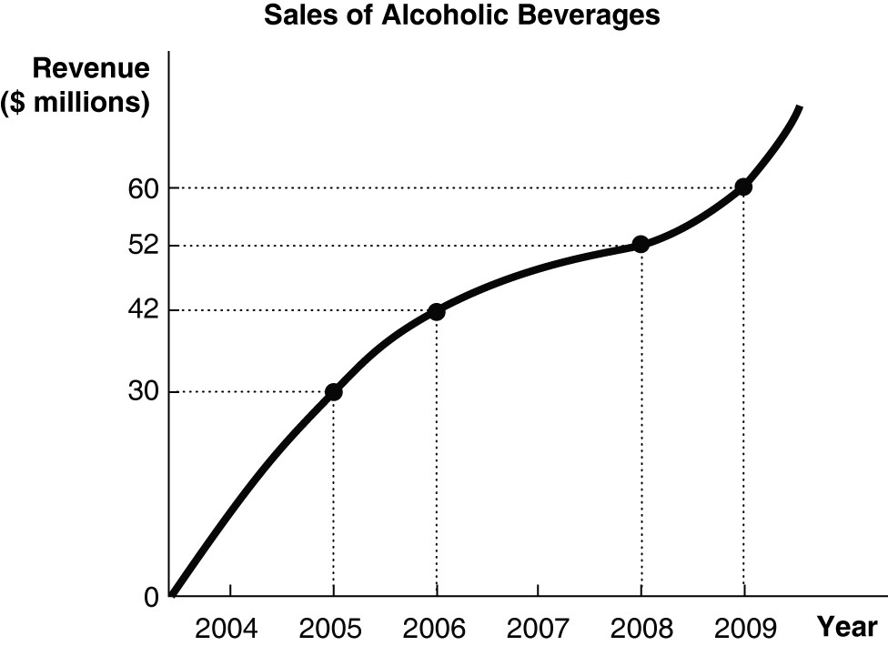

11) Refer to Figure 1-1. Using the information in the figure above, calculate the percentage change in sales of alcoholic beverages between 2006 and 2008.
A) 23.8%
B) 40%
C) 42.9%
D) 73.3%
Answer: A
Diff: 1 Page Ref: 32/32
Topic: Formulas
Skill: Graphing
Objective: Appendix: Review the use of graphs and formulas
AACSB: Analytic Skills
Special Feature: None
Figure 1-2
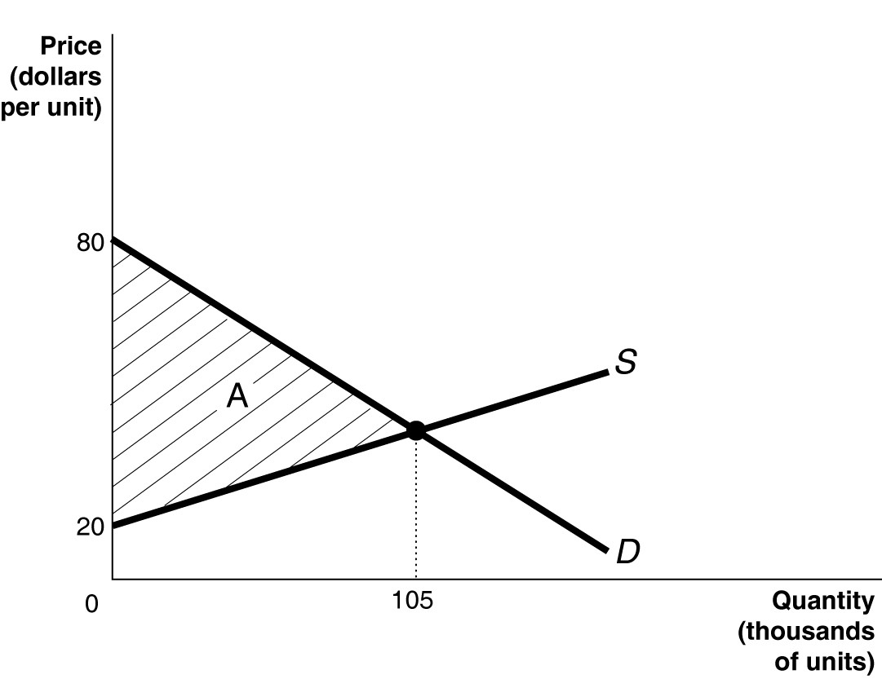

12) Refer to Figure 1-2. Calculate the area of the triangle A.
A) $8.4 million
B) $6.3 million
C) $3.15 million
D) $2.1 million
Answer: C
Comment: Recurring
Diff: 1 Page Ref: 33/33
Topic: Formulas
Skill: Graphing
Objective: Appendix: Review the use of graphs and formulas
AACSB: Analytic Skills
Special Feature: None
Figure 1-3

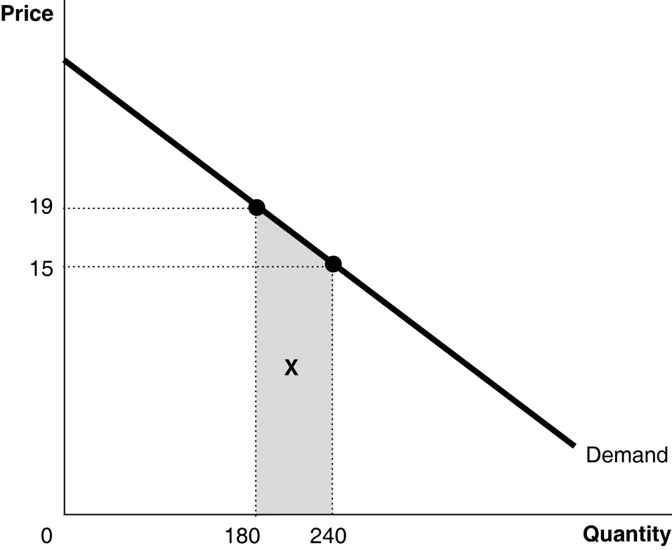

13) Refer to Figure 1-3. Calculate the area of the trapezoid X.
A) $361
B) $450
C) $1,020
D) $1,140
Answer: C
Comment: Recurring
Diff: 2 Page Ref: 33/33
Topic: Formulas
Skill: Graphing
Objective: Appendix: Review the use of graphs and formulas
AACSB: Analytic Skills
Special Feature: None
Figure 1-4

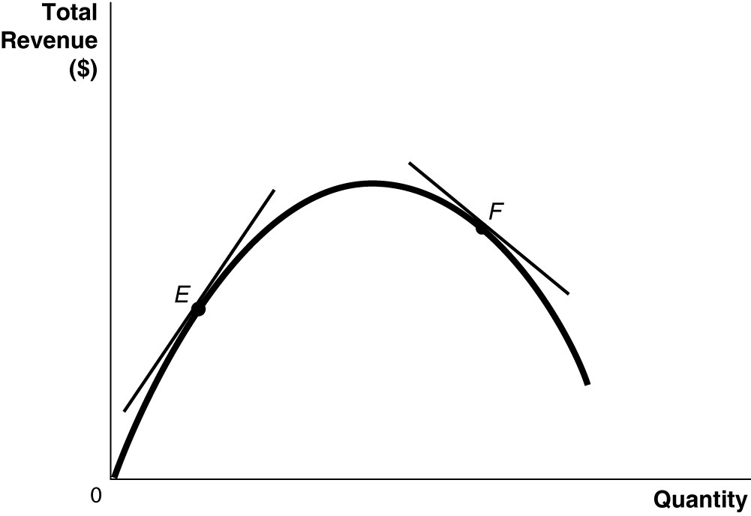

14) Refer to Figure 1-4. Which of the following statements is true?
A) The slope of the tangent at E is positive and the slope of the tangent at F is negative.
B) The slope of the tangent at E is negative and the slope of the tangent at F is positive.
C) The slope of the tangent at E and the slope of the tangent at F are negative.
D) The slope of the tangent at E and the slope of the tangent at F are positive.
Answer: A
Comment: Recurring
Diff: 1 Page Ref: 31/31
Topic: Slope
Skill: Graphing
Objective: Appendix: Review the use of graphs and formulas
AACSB: Analytic Skills
Special Feature: None

15) An "omitted variable" is
A) a variable which is purposely omitted from an economic analysis.
B) a variable which is inadvertently omitted from an economic analysis.
C) a variable that has no impact on other variables in an economic analysis.
D) a variable that affects other variables and its omission from economic analysis can lead to false conclusions about cause and effect.
Answer: D
Comment: Recurring
Diff: 1 Page Ref: 30/30
Topic: Cause and Effect
Objective: Appendix: Review the use of graphs and formulas
AACSB: Reflective Thinking
Special Feature: None
16) What is the "reverse causality" problem in determining cause and effect?
A) It is a problem that occurs when one concludes that a change in variable X caused a change in variable Y when in actual fact, it is a change in variable Z that caused a change in variable Y.
B) It is a problem that occurs when one observes that a change in variable X caused a change in variable Y which caused a change in variable Z and concludes that a change in variable X caused a change in variable Z.
C) It is a problem that occurs when one concludes that a change in variable X caused a change in variable Y when in actual fact, it is a change in variable Y that caused a change in variable X.
D) It is a problem that arises when two variables are inter-connected so that a change in variable X causes a change in variable Y, and a change in variable Y causes a change in variable X.
Answer: C
Comment: Recurring
Diff: 2 Page Ref: 30/30
Topic: Cause and Effect
Objective: Appendix: Review the use of graphs and formulas
AACSB: Reflective Thinking
Special Feature: None

17) The number of people who have gray hair is very high among residents living in Florida. A student concludes that living in Florida causes hair to turn gray. What is the flaw in this student's reasoning?
A) The student is drawing a false conclusion by making the mistake of omitting critical variables such as the age and gender of the residents.
B) The student is using an inadequate sample size.
C) The student is drawing a false conclusion; he is confusing cause and effect.
D) The student has failed to take into account other causes of gray hair.
Answer: C
Comment: Recurring
Diff: 2 Page Ref: 30/30
Topic: Cause and Effect
Objective: Appendix: Review the use of graphs and formulas
AACSB: Analytic Skills
Special Feature: None
18) You explain to your friend Haslina, who runs a catering service called "Meals in a Zip", about an economic theory which asserts that consumers will purchase less of a product at higher prices than they will at lower prices. She contends that the theory is incorrect because over the past two years she has raised the price of her catered meals and yet has seen a brisk increase in sales. How would you respond to Haslina?
A) Haslina is right; she has evidence to back her claim. The theory must be erroneous.
B) I will explain to her that she is making the error of reverse causality: it is the increase in demand that has enabled her to raise her prices
C) I will explain to her that there are some omitted variables that have contributed to an increase in her sales such as changes in income.
D) Haslina is making the mistake of assuming that correlation implies causation.
Answer: C
Comment: Recurring
Diff: 2 Page Ref: 30/30
Topic: Cause and Effect
Objective: Appendix: Review the use of graphs and formulas
AACSB: Reflective Thinking
Special Feature: None
Table 1-2

Year | Flat-Panel TV Sets (millions)
2003 | 1.0
2004 | 1.5
2005 | 7.3
2006 | 12.7
2007 | 20.0

19) Refer to Table 1-2. The table above shows the sales of flat-panel television sets in North America. Present the information using a bar graph.
Answer:
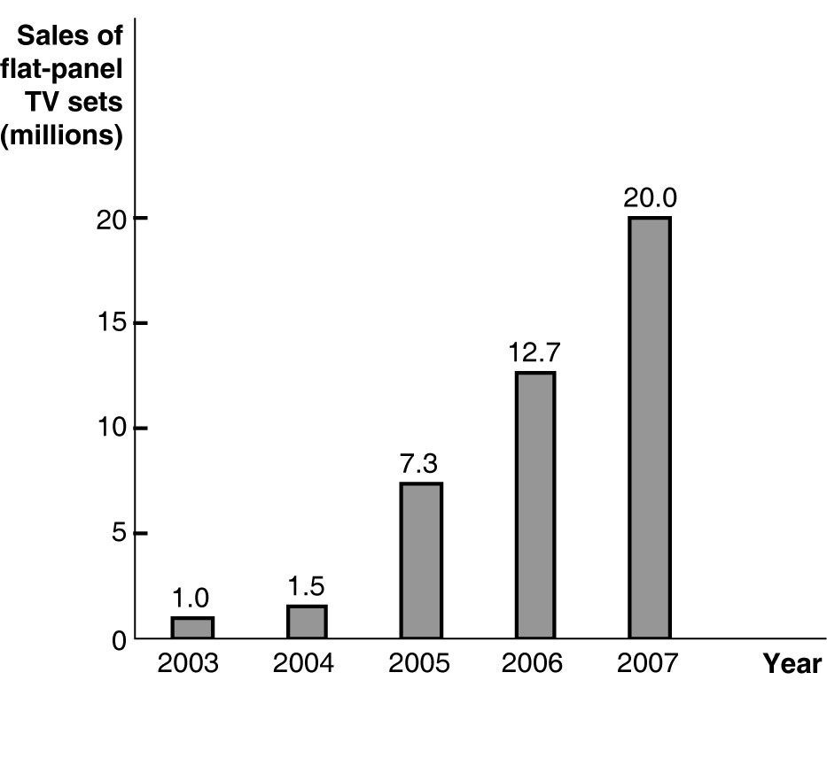
Diff: 1 Page Ref: 25/25
Topic: Graphs
Skill: Graphing
Objective: Appendix: Review the use of graphs and formulas
AACSB: Analytic Skills
Special Feature: None

