Chapter 1—The Where, Why, and How of Data Collection

The more difficult problems in this chapter are:
For Section 1.1
1.8, 1.9, 1.15, 1.16

For Section 1.2
1.28, 1.29, 1.30, 1.31

For Section 1.3
1.40, 1.46, 1.47, 1.48

For Section 1.4
1.57, 1.58

For End of Chapter
1.62, 1.63, 1.68

Section 1.1
1.1 This application is primarily descriptive in nature. The owner wishes to develop a presentation. She will most likely use charts, graphs, tables and numerical measures to describe her data.

1.2 The graph is a bar chart. A bar chart displays values associated with categories. In this case the categories are the departments at the food store. The values are the total monthly sales (in dollars) in each department. A bar chart also typically has gaps between the bars. A histogram has no gaps and the horizontal axis represents the possible values for a numerical variable.

1.3 A bar chart is used whenever you want to display data that has already been categorized while a histogram is used to display data over a range of values for the factor under consideration. Another fundamental difference is that there typically are gaps between the bars on a bar chart but there are no gaps between the bars of a histogram.

1.4 Businesses often make claims about their products that can be tested using hypothesis testing. For example, it is not enough for a pharmaceutical company to claim that its new drug is effective in treating a disease. In order for the drug to be approved by the Food and Drug Administration the company must present sufficient evidence that the drug first does no harm and that it also provides an effective treatment against the disease. The claims that the drug does no harm and is an effective treatment can be tested using hypothesis testing.

1.5 Hypothesis testing uses statistical techniques to validate a claim. With hypothesis testing, sample data is used to make an inference about the larger population from which the sample was drawn. Student-provided examples will differ depending on their experiences.

1.6 Statistical inference procedures are useful in situations where a decision maker needs to reach an estimate about a population based on a subset of data taken from the population. For example, a decision maker might want to know the starting annual salary of all attorneys in the United States. If it is not feasible or possible to look at the salary data for all attorneys, the decision maker could look at a subset of attorneys and use statistical inference to reach a conclusion about the population of all attorneys.

1.7 Hypothesis testing is used whenever one is interested in testing claims that concern a population. Using information taken from samples, hypothesis testing evaluates the claim and makes a conclusion about the population from which the sample was taken. Estimation is used when we are interested in knowing something about all the data, but the population is too large, or the data set is too big for us to work with all the data. In estimation, no claim is being made or tested.

1.8 The major advantage of a graph is it allows a more complete representation of information in the data. Not only can a decision maker visualize the center of the data but also how spread out the data is. An average, for instance, nicely represents the center of a data set, but contains no information of how spread out the data is.

1.9 By its nature, a single measure is just one value and therefore is simpler than a table. It allows an easy method of comparison between two or more data sets, something that is more difficult if the data sets are represented in tabular form. In addition, although not mentioned in this chapter, additional statistical techniques, such as hypothesis testing and estimation, involve calculations based on a single measure from a subset of population data.

1.10 The company could use statistical inference to determine if its parts last longer. Because it is not possible to examine every part that could be produced the company could examine a randomly chosen subset of its parts and compare the average life of the subset to the average life of a randomly chosen subset of the competitor’s parts. By using statistical inference procedures the company could reach a conclusion about whether its parts last longer or not.

1.11 Student answers will vary depending on the periodical selected and the periodical's issue date, but should all address the three parts of the question.

1.12 The appropriate chart in this case is a histogram where the horizontal axis contains the number of missed days and the area of the bars represent the number of employees who missed each number of days.
Note, there are no gaps between the bars.

1.13 Because it would be too costly, too time consuming, or practically impossible to contact every subscriber to ascertain the desired information, the decision makers at Fortune might decide to use statistical inference, particularly estimation, to answer its questions. By looking at a subset of the data and using the procedures of estimation it would be possible for the decision makers to arrive at values for average age and average income that are within tolerable limits of the actual values..

1.14 Student answers will vary depending on the business periodical or newspaper selected and the article referenced. Some representative examples might include estimates of the number of CEO's who will vote for a particular candidate, estimates of the percentage increase in wages for factory workers, estimates of the average dollar advertising expenditures for pharmaceutical companies in a specific year, and the expected increase in R&D expenditures for the coming quarter.

1.15. Student answers will vary. However, the examples should illustrate how statistics has been used and should clearly indicate the type of statistical analysis employed.

1.16
  - A commonly used measure of the center of the data is the mean or average. The executive could calculate the average age of the people in the market area and use the average as the center value.
  - To determine a value for the percentage of people in the market area that are senior citizens, the executives would rely on estimation--a set of statistical techniques that allow one to know something about a data set by using a subset of the data whenever the data set is too large to work with all the data.
  - The executives might want to test the hypothesis that the percentage of senior citizens in the market area is greater than the percentage of senior citizens nationwide. The executives could also test the hypothesis that the percentage of senior citizens is greater than or less than a specific value, say 27%.

Section 1.2
1.17 As discussed in this section, the pet store would most likely use a written survey or a telephone survey to collect the customer satisfaction data.

1.18 A leading question is one that is designed to elicit a specific response, or one that might influence the respondent’s answer by its wording. The question is posed so that the respondent believes the researcher has a specific answer in mind when the question is asked, or worded in such a way that the respondent feels obliged to provide an answer consistent with the question. For example, a question such as “Do you agree with the experts who recommend that more tax dollars be given to clean up dangerous and unhealthy pollution?” could cause respondents to provide the answer that they think will be consistent with the “experts” with whom they do not want to disagree. Leading question should be avoided in surveys because they may introduce bias.

1.19 An experiment is any process that generates data as its outcome. The plan for performing the experiment in which the variable of interest is defined is referred to as an experimental design. In the experimental design one or more factors are identified to be changed so that the impact on the variable of interest can be observed or measured.

1.20 In a survey, poorly worded and leading questions can produce different results. Major organizations usually do a good job of conducting surveys. However, sometimes even seemingly subtle differences in wording can lead to different outcomes. Here the noticeable difference in the three surveys is that one mentions tax payers and the other two the government or government agencies. While this may seem a minor difference, it could be significant enough to cause the difference in response.

1.21. There will likely by a high rate of nonresponse bias since many people who work days will not be home during the 9-11 AM time slot. Also, the data collectors need to be careful where they get the phone number list as some people do not have listed phones in phone books and others have no phone or only a cell phone. This may result in selection bias.

1.22
- Observation would be the most likely method. Observers could be located at various bike routes and observe the number of riders with and without helmets. This would likely be better than asking people if they wear a helmet since the popular response might be to say yes even when they don’t always do so.
- A telephone survey to gas stations in the state. This could be a cost effective way of getting data from across the state. The respondent would have the information and be able to provide the correct price.
- A written survey of passengers. This could be given out on the plane before the plane lands and passengers could drop the surveys in a box as they de-plane. This method would likely garner higher response rates compared to sending the survey to passengers’ mailing address and asking them to return the completed survey by mail.

1.23 The two types of validity mentioned in the section are internal validity and external validity. For this problem external validity is easiest to address. It simply means the sampling method chosen will be sufficient to insure the results based on the sample will be able to be generalized to the population of all students. Internal validity would involve making sure the data gathering method, for instance a questionnaire, accurately determines the respondent’s attitude toward the registration process.

1.24 This data could have been collected through observation or experiment. Employees of the USDA could provide periodic reports of fire ant activity in their region. Likewise, scientists studying the spread of fire ants may have conducted experiments that indicate the rate of spread under certain conditions.

1.25 There are many potential sources of bias associated with data collection. If data is to be collected using personal interviews it will be important that the interviewer be trained so that interviewer bias, arising from the way survey questions are asked, is not injected into the survey. If the survey is conducted using either a mail survey or a telephone survey then it is important to be aware of nonresponse bias from those who do not respond to the mailing or refuse to answer your calls. You must also be careful when selecting your survey subjects so that selection bias is not a problem. In order to have useful, reliable data that is representative of the true student opinions regarding campus food service, it is necessary that the data collection process be conducted in a manner that reduces or eliminates the potential for these and other sources of potential bias.

1.26 For retailers technology that scans the product UPC code at checkout makes the collection of data fast and accurate. Retailers that use such technology can automatically update their inventory records and develop an extensive collection of customer buying habits. By applying advanced statistical techniques to the data the retailer can identify relationships among purchases that might otherwise go unnoticed. Such information could enable retailers to target their advertising or even rearrange the placement of products in the store to increase sales. Manufacturing firms use bar code scanning to collect information concerning product availability and product quality. Credit card purchases are automatically tracked by the retailer and the bankcard company. In this way the credit card company is able to track your purchases and even alert you to potential fraud if purchases on your card appear to be unusual. Finally, some companies are using radio frequency identification (RFID) to track products through their supply chain, so that product delays and inventory problems can be minimized.

1.27 One advantage of this form of data gathering is the same as for mail questionnaires. That is low cost. Additional factors being speed of delivery and, with current software, with closed- ended questions, instant updating of data analysis. Disadvantages are also similar, in particular low response and potential confusion about questions. An additional factor might be the ability of competitors to “hack” into the database and analysis program.

1.28. Student answers will vary. Look for clarity of questions and to see that the issue questions are designed to gather useful data. Look for appropriate demographic questions.

1.29 Students should select some form of personal observation as the data-gathering technique. In addition, there should be a discussion of a sampling procedure with an effort made to ensure the sample randomly selected both days of the week unless daily observations are made, and randomly selected times of the day since 24 hour observation would likely be impossible. A complete answer would also address efforts to reduce the potential bias of having an observer standing in an obvious manner by the displays.

1.30 Student answers will vary. However, the issue questions should be designed to gather the desired data regarding customers’ preferences for the use of the space. Demographic questions should provide data so that the responses can be broken down appropriately so that United Fitness Center managers can determine which subset of customers have what opinion about this issue. Regarding questionnaire layout, look at neatness and answer location space. Make sure questions are properly worded, used reasonable vocabulary, and are not leading questions.

1.31 The results of the survey are based on telephone interviews with 1,025 national adults, aged 18 and older. Students may also answer that the survey could have been conducted using personal interviews. Because telephone interviews were used to collect the survey data nonresponse biases associated with sampled adults who are not at home when phoned, or adults who refuse to participate in the survey. There is also the problem that some adults do not have a phone. If personal interviews are used to collect the data then it is important to guard against nonresponse bias from those sampled adults who refuse to be interviewed. There is also the problem of selection bias. In phone interviews we may miss the people who work evenings and nights. If personal interviews are used we must be careful to select a representative sample of the adult population, not just those who appear willing or interested in participating.

Section 1.3
1.32.
- Because the population is spread over a large geographical area, a cluster random sample could be selected to reduce travel costs.
- A stratified random sample would probably be used to keep sample size as small as possible.
- Most likely a convenience sample would be used since doing a statistical sample would be too difficult.

1.33 To determine the range of employee numbers for the first employee selected in a systematic random sample use the following:
Part range =
Thus, the first person selected will come from employees 1-180. Once that person is randomly selected, the second person will be the one numbered 100 higher than the first, and so on.

1.34 Whenever a descriptive numerical measure such as an average is calculated from the entire population it is a parameter. The corresponding measure calculated from a subset of the population, that is to say a sample, is a statistic.

1.35 Statistical sampling techniques consist of those sampling methods that select samples based on chance. Nonstatistical sampling techniques consist of those methods of selecting samples using convenience, judgment, or other nonchance processes. In convenience sampling, samples are chosen because they are easy or convenient to sample. There is no attempt to randomize the selection of the selected items. In convenience sampling not every item in the population has a random chance of being selected. Rather, items are sampled based on their convenience alone. Thus, convenience sampling is not a statistical sampling method.

1.36 From a numbered list of all customers who own a certificate of deposit the bank would need to randomly determine a starting point between 1 and k, where k would be equal to 25000/1000 = 25. This could be done using a random number table or by having a statistical package or a spreadsheet generate a random number between 1 and 25. Once this value is determined the bank would select that numbered customer as the first sampled customer and then select every 25th customer after that until 100 customers are sampled.

1.37 A census is an enumeration of the entire set of measurements taken from the population as a whole. While in some cases, the items of interest are obtained from people such as through a survey, in many instances the items of interest come from a product or other inanimate object. For example, a study could be conducted to determine the defect rate for items made on a production line. The census would consist of all items produced on the line in a defined period of time.

1.38 Values computed from a sample are always considered statistics. In order for a value, such as an average, to be considered a parameter it must be computed from all items in the population.

1.39 In stratified random sampling, the population is divided into homogeneous groups called strata. The idea is to make all items in a stratum as much alike as possible with respect to the variable of interest thereby reducing the number of items that will need to be sampled from each stratum. In cluster sampling, the idea is to break the population into heterogeneous groups called clusters (usually on a geographical basis) such that each cluster looks as much like the original population as possible. Then clusters are randomly selected and from the cluster, individual items are selected using a statistical sampling method.

1.40 Using Excel, choose the Data tab, select Data Analysis from the Analysis Group , then Random Number Generation – shown as follows:
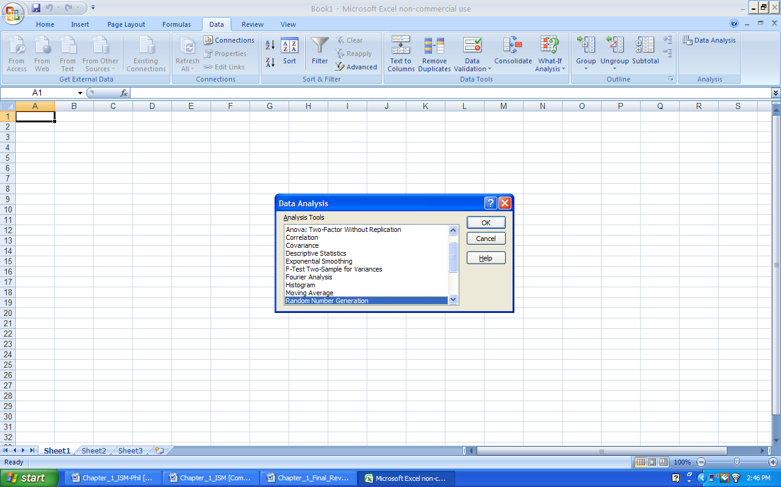

The next step is to complete the random number generation dialog as follows:
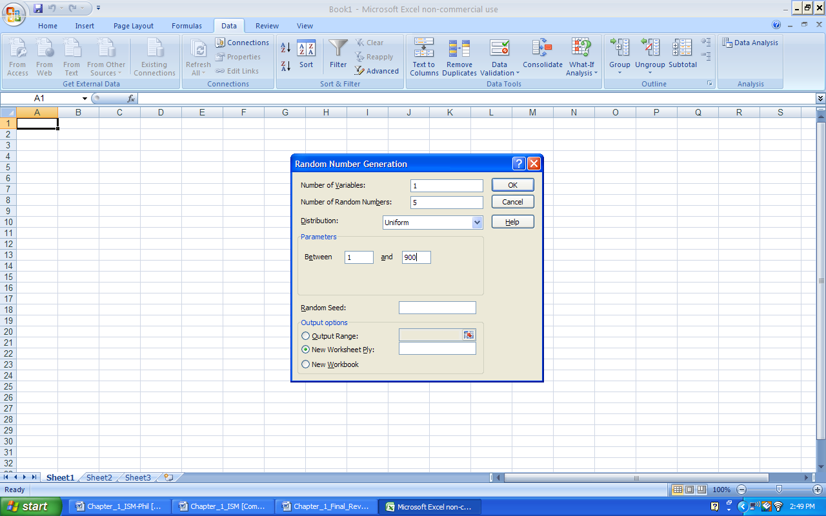

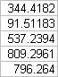
The resulting random numbers generated are:

Note, the students’ answers may differ since Excel generates different streams of random numbers each time it is used. Also, if the application requires integer numbers, the Decrease Decimal option can be used.

1.41 If these percentages were based on all students attending college in those years they would would be parameters, if the percentages were based on a sample they would be statistics.

1.42 This is a statistic. A poll would be a sample of eligible voters rather than all eligible voters.

1.43 Solution
a. Stratified random sampling
b. Simple random sampling or possibly cluster random sampling
c. Systematic random sampling
d. Stratified random sampling

1.44 This is a statistical sample. Every employee has an equal chance of being selected using this method. In fact, this is an example of a simple random sample because every possible sample of size 50 has an equal chance of being selected.

1.45
  - Student answers will vary
  - Cluster sampling could be used to ensure that you get all types of cereal. Make each cluster the area where certain cereals are located (i.e., isle, row, shelf, etc.)
  - Cluster sampling would give you a better idea of the inventory of all types of cereal. Simple random sampling could possibly end up with only looking at 2 or 3 cereal types.

1.46 Students should choose the Data tab, select Data Analysis from the Analysis group – Random Number Generation process. Students’ answers will differ since Excel generates different streams of random numbers each time it is used, but 40 random numbers should be generated from a uniform distribution with values ranging from 1 to 578. Since the application requires integer numbers, the Decrease Decimal option should be used.

1.47
- The population should be all users of cross-country ski lots and trailheads in Colorado.
- Several sampling techniques could be selected. Be sure that some method of ensuring randomness is discussed. In addition, some students might give greater weight to frequent users of the lots. In which case the population would really be user days rather than individual users.
- Students using Excel should choose the Data tab, select Data Analysis from the Analysis group – Random Number Generation process. Students’ answers may differ since Excel generates different streams of random numbers each time it is used. Since the application requires integer numbers, the Decrease Decimal option should be used.

1.48
- Since there are 4,000 patient files we could give each file a unique identification number consisting of 4 digits. The first file would be given the identification number “0001”. The last file would be given the identification number of “4000”. By assigning each patient a number and randomly selecting the 100 numbers allows each possible sample of 100 an equal chance of being selected.
- Either use a random number table (randomly select the starting row and column), or use a computer program, such as Microsoft Excel or Minitab, which has a random number generator.
- Since each patient is assigned a 4-digit identification number, we would need a 4-digit random number for each random number selected.
- Answers will vary.

Section 1.4
1.49.
a. Time-series
b. Cross-sectional
c. Time-series
d. Cross-sectional

1.50 Qualitative data are categories or numerical values that represent categories. Quantitative data is data that is purely numerical.

1.51
a. Ordinal – categories with defined order
b. Nominal – categories with no defined order
c. Ratio
d. Nominal – categories with no defined order

1.52 Nominal data involves placing observations in separate categories according to some measurable characteristic. Ordinal data also involves placing observations into separate categories, but the categories can be rank-ordered.

1.53 Since the circles involve a ranking from best to worst, this would be ordinal data.

1.54
- The data are cross-sectional. The data are collected from 2,300 customers at approximately the same point in time
- This is a ratio level, quantitative variable. The data represent a measurement of time.
- Ordinal with a numerical value representing customers rating of level of service

1.55
- Nominal Data
- Ratio Data
- Nominal Data
- Ratio Data
- Ratio Data
- Nominal Data
- Ratio Data

1.56
- Cross-sectional
- Time-series
- Cross-sectional
- Cross-sectional
- Time-Series

1.57
Brand - Nominal
Model – Nominal
Sports Car – Nominal
SUV – Nominal
Wagon – Nominal
Minivan – Nominal
Pickup – Nominal
All-Wheel Drive – Nominal
Rear-Wheel Drive – Nominal
Suggested Retail Price – Ratio
Dealer Cost – Ratio
Engine Size – Ratio
Cylinders – Ratio
Horsepower – Ratio
City MPG – Ratio
Highway MPG – Ratio
Weight – Ratio
Wheel base – Ratio
Length - Ratio
Width - Ratio

1.58.
a. The data are cross-sectional since they represent data across a sample of customers where the data reflect the demographics of the customers at basically one point in time.
b. The following variables are quantitative:
Past Due Amount
Current Amount Due
The following variables are qualitative:
Account number
Caller gender
Account Holder gender
Was this a billing question?
Even though these variables have numeric values, because the numbers represent a discrete category, they are considered qualitative.
c. The following variables are ratio level measures:
Past Due Amount
Current Amount Due
The following variables are nominal measures:
Account number
Caller gender
Account Holder gender
Was this a billing question?

End of Chapter
1.59 Answers will vary with the student. But a good discussion should include the following factors:
Sampling techniques and possible problems selecting a representative sample.
Determining how to develop questions to measure approval.
Structuring questions to avoid bias.
The measurement scale associated with the questions.
The fact these polls tend to develop time-series data.

1.60 Nominal data or ordinal data.

1.61 Interval or ratio data.

1.62 Ratings are typical uses of ordinal scale data. And since ratings are based on personal opinion, even though people are using the same scale, a direct comparison between the two ratings is not possible. This is a common problem when people are asked to rate an object using an ordinal scale.

1.63 Answers will vary with the student. But a good discussion should include the following factors:
Sampling techniques and possible problems selecting a representative sample.
Determining how to measure confidence.
Structuring questions to avoid bias.
The measurement scale associated with the questions.
The fact this poll is specifically intended to develop time-series data.

1.64 Answers will vary with the student.

1.65 Answers will vary with the student.

1.66
- No because a random sample means that every item in the population has an equal chance of being selected. Individuals who do not have or use email do not have an equal chance of being included in this survey. Also, volunteer emails would not be random.
- In this survey the biggest drawback is that only individuals with strong feelings one way or the other are apt to respond to this survey. This could lead to a great deal of bias in the results of the survey. Another big problem with a survey is nonresponse bais. Again because they are requesting viewers to write in there will be a great deal of nonresponse to this survey.

1.67
- They would probably want to sample the salsa jars as they come off the assembly line at the plant for a specified time period. They would want to use a random sample. One method would be to take a systematic random sample. They could then calculate the percentage of the sample that had an unacceptable thickness.
- The product is going to be ruined after testing it. You would not want to ruin the entire product that comes off the assembly line.

1.68
- Student answers will vary but one method would be personal observation at grocery stores or another method would be to simply look at their sales. Are buyers of the energy drinks purchasing bottles or cans?
- If using personal observation just have people at grocery stores observe people over a specified period of time and note which are selecting cans and which are selecting bottles and look at the percentages of each.
- You would be looking at ratio data because you could have a true 0 if, for example, no one purchased bottles.
- Depends on the way the data are collected. Sales data would be quantitative.

