Essentials of Anatomy & Physiology (Martini/Bartholomew)
Chapter 1 An Introduction to Anatomy and Physiology

Multiple Choice

1)

Characteristics of most living organisms include the ability to

A)

grow and reproduce.

B)

respond and adapt to their environment.

C)

control the external environment.

D)

A and B only

E)

all of the above

Answer:

D

2)

Unicellular organisms exchange gas, eliminate wastes, and absorb nutrients

A)

directly through their cell membranes.

B)

after some other organism processes them.

C)

with their complex organ systems.

D)

the same way as humans.

E)

all of the above

Answer:

A

3)

The waste products of metabolism are eliminated through the process of

A)

assimilation.

B)

absorption.

C)

excretion.

D)

digestion.

E)

resorption.

Answer:

C

4)

The study of the first few weeks of life includes

A)

cytology.

B)

histology.

C)

embryology.

D)

physiology.

E)

medical anatomy.

Answer:

C

5)

The study of the general form and superficial markings of an organism is referred to as

A)

gross anatomy.

B)

surface anatomy.

C)

systemic anatomy.

D)

regional anatomy.

E)

surgical anatomy.

Answer:

B

6)

The study of structures using special imaging techniques is

A)

surface anatomy.

B)

regional anatomy.

C)

surgical anatomy.

D)

medical anatomy.

E)

radiographic anatomy.

Answer:

E

7)

An eye, ear, nose, and throat specialist is concerned primarily with the study of

A)

gross anatomy.

B)

surface anatomy.

C)

microscopic anatomy.

D)

systemic anatomy.

E)

regional anatomy.

Answer:

E

8)

The study of function is to ________ as the study of form is to anatomy.

A)

physiology

B)

regional anatomy

C)

microscopic anatomy

D)

systemic anatomy

E)

radiographic anatomy

Answer:

A

9)

The study of tissues is called

A)

gross anatomy.

B)

cytology.

C)

histology.

D)

organology.

E)

microbiology.

Answer:

C

10)

All of the chemical and physical changes taking place in the body refer to

A)

systemic physiology.

B)

special physiology.

C)

cell physiology.

D)

metabolism.

E)

physiological chemistry.

Answer:

D

11)

The branch of physiology that studies functions modified by disease is called

A)

histophysiology.

B)

special physiology.

C)

system physiology.

D)

pathology.

E)

physiological chemistry.

Answer:

D

12)

The following is the simplest level of organization:

A)

cellular.

B)

chemical.

C)

tissue.

D)

system.

E)

organ.

Answer:

B

13)

Support, protection of soft tissues, mineral storage, and blood formation are functions of which system?

A)

integumentary

B)

muscular

C)

skeletal

D)

nervous

E)

none of the above

Answer:

C

14)

The production of another human organism is the function of which of the following systems?

A)

skeletal

B)

reproductive

C)

respiratory

D)

lymphatic

E)

cardiovascular

Answer:

B

15)

The internal transport of blood and dissolved substances is the function of the

A)

integumentary system.

B)

endocrine system.

C)

nervous system.

D)

cardiovascular system.

E)

none of the above

Answer:

D

16)

The trachea and lungs are components of the

A)

endocrine system.

B)

digestive system.

C)

respiratory system.

D)

urinary system.

E)

lymphatic system.

Answer:

C

17)

The pituitary and thyroid glands are components of the

A)

endocrine system.

B)

cardiovascular system.

C)

respiratory system.

D)

lymphatic system.

E)

digestive system.

Answer:

A

18)

Gas exchange is a function of the

A)

cardiovascular system.

B)

lymphatic system.

C)

respiratory system.

D)

urinary system.

E)

both A and D

Answer:

C

19)

Lungs are to the respiratory system as the spleen is to the

A)

lymphatic system.

B)

urinary system.

C)

digestive system.

D)

cardiovascular system.

E)

muscular system.

Answer:

A

20)

Hormones, glands, and target cells are associated with the

A)

skeletal system.

B)

muscular system.

C)

integumentary system.

D)

endocrine system.

E)

all of the above

Answer:

E

21)

The maintenance of a relatively constant internal environment in an organism is termed

A)

positive feedback.

B)

homeostasis.

C)

negative feedback.

D)

effector control.

E)

none of the above

Answer:

B

22)

Imagine someone is cold and responds by putting on more clothes. This regulation mechanism is an example of

A)

negative feedback.

B)

positive feedback.

C)

homeostatic regulation.

D)

diagnostic regulation.

E)

a behavioral change and is not related to the internal environment.

Answer:

E

23)

The increasingly forceful labor contractions that lead to childbirth are an example of this type of mechanism:

A)

receptor activation.

B)

effector shutdown.

C)

negative feedback.

D)

positive feedback.

E)

none of the above

Answer:

D

24)

Which of the following are parts of a homeostatic mechanism?

A)

receptor

B)

control center

C)

effector

D)

all of the above

E)

none of the above

Answer:

D

25)

Which of the following is NOT characteristic of the endocrine system?

A)

releases chemical messengers called hormones

B)

produces a more rapid response to body changes than the nervous system

C)

can produce effects that last for days or longer

D)

can produce an effect that involves several organs or tissues at the same time

E)

is an important homeostatic system

Answer:

B

26)

A person who is lying on his/her stomach is said to be in the

A)

supine position.

B)

prone position.

C)

anatomical position.

D)

frontal position.

E)

sagittal position.

Answer:

B

27)

Which indicates the front of the body?

A)

anterior

B)

posterior

C)

dorsal

D)

ventral

E)

both A and D

Answer:

E

28)

Which of the following is MEDIAL to the breast?

A)

sternum

B)

shoulder

C)

elbow

D)

digits

E)

knee

Answer:

A

29)

The wrist is considered ________ to the elbow.

A)

proximal

B)

distal

C)

lateral

D)

medial

E)

none of the above

Answer:

B

30)

The navel is ________ to the chin.

A)

anterior

B)

superior

C)

posterior

D)

inferior

E)

medial

Answer:

D

31)

Which of the following regions corresponds to the lower back?

A)

pelvic

B)

cephalic

C)

gluteal

D)

lumbar

E)

thoracic

Answer:

D

32)

Which of the following regions corresponds to the foot?

A)

cervical

B)

brachial

C)

antebrachial

D)

femoral

E)

pedal

Answer:

E

33)

A cut passing through the midline of the body that divides it into equal left and right halves is known as this type of plane.

A)

frontal

B)

coronal

C)

transverse

D)

midsagittal

E)

parasagittal

Answer:

D

34)

The heart, lungs, and small intestine would be found in the

A)

dorsal body cavity.

B)

peritoneal cavity.

C)

pleural cavity.

D)

ventral body cavity.

E)

abdominopelvic cavity.

Answer:

D

35)

The diaphragm separates the ________ cavity from the ________ cavity.

A)

pleural; mediastinum

B)

thoracic; abdominopelvic

C)

pericardial; pleural

D)

abdominal; pelvic

E)

pericardial sac; pericardial

Answer:

B

36)

The ventral body cavity contains the

A)

abdominal cavity.

B)

pericardial cavity.

C)

pelvic cavity.

D)

pleural cavity.

E)

all of the above

Answer:

E

37)

The mediastinum separates ________ from the ________.

A)

the pleural cavity; coelom

B)

the thoracic cavity; peritoneal cavity

C)

one pleural cavity; other pleural cavity

D)

the abdominal cavity; pelvic cavity

E)

the pericardial sac; pericardial cavity

Answer:

C

38)

The peritoneal cavity contains the

A)

heart.

B)

small intestine.

C)

lungs.

D)

uterus.

E)

thymus.

Answer:

B

39)

Mary, who is six months pregnant, goes to her physician for a test to check the development of her fetus. The physician uses a device that employs sound waves to produce an image of the fetus. This technique is known as a(n)

A)

X-ray.

B)

CT scan.

C)

MRI.

D)

ultrasound.

E)

radiography.

Answer:

D

40)

A diagnostic technique that employs a radiodense dye injected into blood vessels is called a(n)

A)

angiogram.

B)

radiograph.

C)

CT scan.

D)

MRI.

E)

ultrasound.

Answer:

A

41)

Which sectional plane could divide the body so that the face remains intact?

A)

sagittal plane

B)

coronal plane

C)

equatorial plane

D)

midsagittal plane

E)

none of the above

Answer:

B

42)

Which of the following would be considered an organ?

A)

mitochondrion

B)

blood

C)

fat

D)

skin

E)

heart muscle

Answer:

D

43)

Cells are considered the smallest units of life because

A)

cells are composed of organelles, each of which is responsible for a particular "life-giving" function.

B)

cells are composed of atoms which, chemically, are the smallest units of structure.

C)

cells are composed of molecules which, chemically, are the smallest units of structure.

D)

the cell is NOT considered the smallest unit of life.

E)

both A and C

Answer:

A

44)

The fact that a single defective protein causes cystic fibrosis, a multisystemic illness, proves that

A)

all organisms are composed of cells.

B)

all levels of organization within an organism are interdependent.

C)

chemical molecules make up cells.

D)

all cells are independent of each other.

E)

congenital defects can be life threatening.

Answer:

B

45)

Each of the following is an example of negative feedback EXCEPT one. Identify the exception.

A)

Increased pressure in the aorta triggers mechanisms to lower blood pressure.

B)

A rise in blood calcium levels triggers the release of a hormone that lowers blood calcium levels.

C)

A rise in estrogen during the menstrual cycle increases the number of progesterone receptors in the uterus.

D)

Increased blood sugar stimulates the release of a hormone from the pancreas that stimulates the liver to store blood sugar.

E)

A decrease in body temperature triggers a neural response that initiates physiological changes to increase body temperature.

Answer:

C

46)

Which of the following is NOT an organ?

A)

blood

B)

heart

C)

ovary

D)

pituitary gland

E)

a muscle

Answer:

A

47)

In dealing with physiology, function is related to its

A)

form.

B)

location.

C)

size.

D)

cavity.

E)

system.

Answer:

A

48)

A collection of cells that work together designates a(n)

A)

chemical.

B)

organ.

C)

tissue.

D)

organ system.

E)

none of the above

Answer:

C

49)

This portion of the body contains the head, neck, and trunk.

A)

appendicular

B)

thoracic

C)

axial

D)

dorsal

E)

ventral

Answer:

C

50)

Referring to the back means

A)

axial.

B)

appendicular.

C)

ventral.

D)

dorsal.

E)

thoracic.

Answer:

D

51)

Organs that are protected by bone are found in what part of the body?

A)

axial

B)

appendicular

C)

ventral cavity

D)

superficial regions

E)

inferior portions

Answer:

A

52)

Anterior is to ________ as posterior is to dorsal.

A)

cranial

B)

ventral

C)

caudal

D)

inferior

E)

medial

Answer:

B

53)

The heart is surrounded by the ________ membrane.

A)

pericardial

B)

peritoneal

C)

visceral

D)

serous

E)

pleural

Answer:

A

54)

The membrane covering the surface of the stomach is named the

A)

parietal pleura.

B)

visceral pleura.

C)

pericardial sac.

D)

visceral peritoneum.

E)

serous membrane.

Answer:

D

55)

The membrane covering the surface of the heart is referred to as the

A)

visceral pleura.

B)

parietal peritoneum.

C)

visceral pericardium.

D)

serous membrane.

E)

mediastinum.

Answer:

C

56)

The main function of a serous membrane is to

A)

reduce friction.

B)

protect organs.

C)

allow blood to pass.

D)

hold organs together.

E)

fill empty spaces.

Answer:

A

Fill-in-the-Blank

1)

Using anatomical terms of direction, supply the word that would make the sentence correct. The knee is ________ to the foot.

Answer:

proximal

2)

The term ________ refers to the wrist.

Answer:

carpal

3)

Using anatomical terms of direction, supply the word that would make the sentence correct. The stomach is ________ to the lungs.

Answer:

inferior

4)

The term ________ refers to the back of the knee.

Answer:

popliteal

5)

A cut parallel to the midsagittal line would produce a ________ section.

Answer:

parasagittal or sagittal

6)

The forearm is called the ________.

Answer:

antebrachium

7)

A person lying face up in the anatomical position is said to be in the ________ position.

Answer:

supine

8)

A mechanism that brings the internal environment back to normal is a ________ mechanism.

Answer:

negative feedback

9)

In ________ feedback, the initial stimulus produces a response that reinforces the stimulus.

Answer:

positive

10)

A structure that senses change is called a ________.

Answer:

receptor

11)

The tendency for physiological systems to stabilize internal conditions with respect to the external environment is called ________.

Answer:

homeostasis

12)

The branch of biological science that deals with how the kidney functions is called ________ physiology.

Answer:

renal

13)

The study of body structure is called ________.

Answer:

anatomy

Matching

1)

Match the body regions in the first column with the locations in the second column.
_____ 1. axillary A. navel
_____ 2. cervical B. ear
_____ 3. gluteal C. arm pit
_____ 4. umbilical D. neck
_____ 5. otic E. buttocks

Answer:

1-C, 2-D, 3-E, 4-A, 5-B

2)

Match the organ system in the first column with the organ found within that system in the second column.
_____ 1. endocrine system A. arteries
_____ 2. urinary system B. liver
_____ 3. digestive system C. pituitary gland
_____ 4. skeletal system D. ligaments
_____ 5. circulatory system E. urethra

Answer:

1-C, 2-E, 3-B, 4-D, 5-A

3)

Match the body region in the first column with the organ near it in the second column.
_____ 1. cranial A. liver
_____ 2. vertebral B. brain
_____ 3. mammary C. urinary bladder
_____ 4. abdominal D. lungs
_____ 5. pelvic E. spinal cord

Answer:

1-B, 2-E, 3-D, 4-A, 5-C

4)

Match the item in the first column with its primary function in the second column.
_____ 1. epidermis A. propels blood
_____ 2. bone marrow B. covers surface
_____ 3. skeletal muscles C. controls nervous activities
_____ 4. brain D. provides skeletal movement
_____ 5. heart E. site of blood cell production

Answer:

1-B, 2-E, 3-D, 4-C, 5-A

5)

Match the organ system in the first column with its primary function in the second column.
_____ 1. integumentary system A. defense against infection
_____ 2. muscular system B. protection from environment
_____ 3. endocrine system C. processing of food
_____ 4. cardiovascular system D. internal transport of materials
_____ 5. respiratory system E. elimination of excess water
_____ 6. urinary system F. production of sex cells
_____ 7. reproductive system G. support and protection
_____ 8. skeletal system H. delivery of air for gas exchange
_____ 9. nervous system I. locomotion and heat production
_____ 10. lymphatic system J. directing responses to stimuli

_____ 11. digestive system K. directing long-term changes

Answer:

1-B, 2-I, 3-K, 4-D, 5-H, 6-E, 7-F, 8-G, 9-J, 10-A, 11-C

Essay

1)

It is a warm day and you feel a little chilled. On checking your temperature, you find that your body temperature is 1.5 degrees below normal. Suggest some possible reasons for this situation.

Answer:

There are several reasons why your body temperature may have dropped. Your body may be losing heat faster than it is being produced. This, however, is more likely to occur on a cool day. Various chemical factors, such as hormones, may have caused a decrease in your metabolic rate, and thus your body is not producing as much heat as it normally would. Alternatively, you may be suffering from an infection that has temporarily changed the set point of the body's "thermostat." This would seem to be the most likely explanation considering the circumstances given in the question.

Labeling Exercises

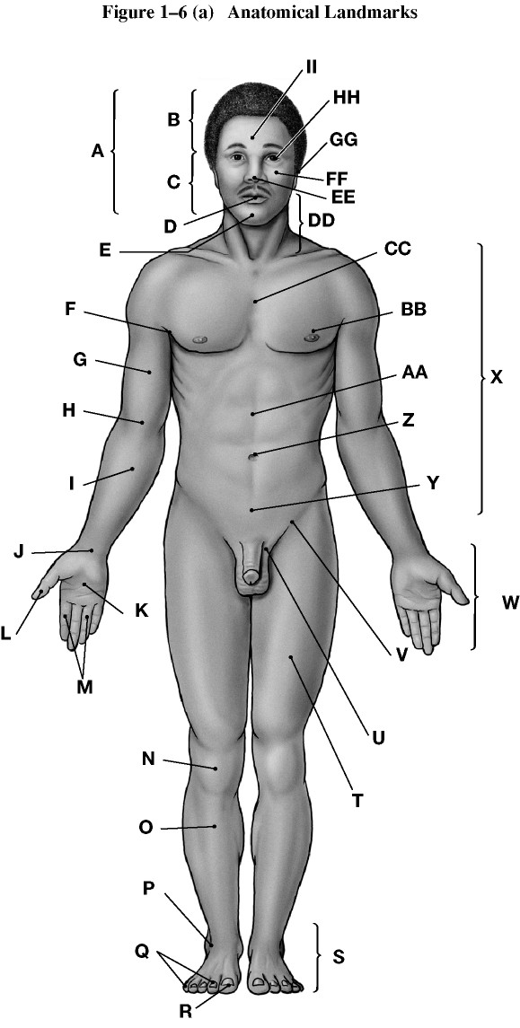
Using the figure above, identify the labeled part.

1)

Label A: ________

Answer:

Cephalon or head (cephalic)

2)

Label B: ________

Answer:

Cranium or skull (cranial)

3)

Label C: ________

Answer:

Facies or face (facial)

4)

Label D: ________

Answer:

Oris or mouth (oral)

5)

Label E: ________

Answer:

Mentis or chin (mental)

6)

Label F: ________

Answer:

Axilla or armpit (axillary)

7)

Label G: ________

Answer:

Brachium or arm (brachial)

8)

Label H: ________

Answer:

Antecubitis or front of elbow (antecubital)

9)

Label I: ________

Answer:

Antebrachium or forearm (antebrachial)

10)

Label J: ________

Answer:

Carpus or wrist (carpal)

11)

Label K: ________

Answer:

Palma or palm (palmar)

12)

Label L: ________

Answer:

Pollex or thumb

13)

Label M: ________

Answer:

Digits (phalanges) or fingers (digital or phalangeal)

14)

Label N: ________

Answer:

Patella or kneecap (patellar)

15)

Label O: ________

Answer:

Crus or leg (crural)

16)

Label P: ________

Answer:

Tarsus or ankle (tarsal)

17)

Label Q: ________

Answer:

Digits (phalanges) or toes (digital or phalangeal)

18)

Label R: ________

Answer:

Hallux or great toe

19)

Label S: ________

Answer:

Pes or foot (pedal)

20)

Label T: ________

Answer:

Femur or thigh (femoral)

21)

Label U: ________

Answer:

Pubis (pubic)

22)

Label V: ________

Answer:

Inguen or groin (inguinal)

23)

Label W: ________

Answer:

Manus or hand (manual)

24)

Label X: ________

Answer:

Trunk

25)

Label Y: ________

Answer:

Pelvis (pelvic)

26)

Label Z: ________

Answer:

Umbilicus or navel (umbilical)

27)

Label AA: ________

Answer:

Abdomen (abdominal)

28)

Label BB: ________

Answer:

Mamma or breast (mammary)

29)

Label CC: ________

Answer:

Thoracis or thorax, chest (thoracic)

30)

Label DD: ________

Answer:

Cervicis or neck (cervical)

31)

Label EE: ________

Answer:

Nasus or nose (nasal)

32)

Label FF: ________

Answer:

Bucca or cheek (buccal)

33)

Label GG: ________

Answer:

Auris or ear (otic)

34)

Label HH: ________

Answer:

Oculus or eye (orbital or ocular)

35)

Label II: ________

Answer:

Frons or forehead (frontal)

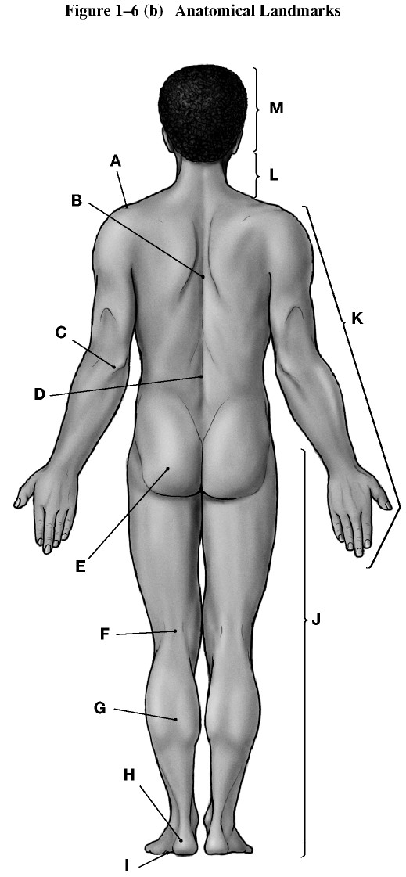

Using the figure above, identify the labeled part.

36)

Label A: ________

Answer:

Shoulder (acromial)

37)

Label B: ________

Answer:

Dorsum or back (dorsal)

38)

Label C: ________

Answer:

Olecranon or back of elbow (olecranal)

39)

Label D: ________

Answer:

Lumbus or loin (lumbar)

40)

Label E: ________

Answer:

Gluteus or buttock (gluteal)

41)

Label F: ________

Answer:

Popliteus or back of knee (popliteal)

42)

Label G: ________

Answer:

Sura or calf (sural)

43)

Label H: ________

Answer:

Calcaneus or heel of foot (calcaneal)

44)

Label I: ________

Answer:

Planta or sole of foot (plantar)

45)

Label J: ________

Answer:

Lower limb

46)

Label K: ________

Answer:

Upper limb

47)

Label L: ________

Answer:

Cervicis or neck (cervical)

48)

Label M: ________

Answer:

Cephalon or head (cephalic)

