Essentials of Anatomy & Physiology, 6e (Martini/Bartholomew)
Chapter 1 An Introduction to Anatomy and Physiology

Multiple-Choice Questions

1) Characteristics of most living organisms include the ability to
A) repair and completely restore itself during any type of injury.
B) respond and adapt to their environment.
C) control the external environment.
D) form positive feedback loops.
E) create a protective covering over themselves.
Answer: B
Learning Outcome: 1-1
Bloom's Taxonomy: Knowledge

2) The waste products of metabolism are eliminated through the process of
A) assimilation.
B) absorption.
C) excretion.
D) digestion.
E) resorption.
Answer: C
Learning Outcome: 1-1
Bloom's Taxonomy: Knowledge

3) All of the chemical operations underway in the body refer to
A) systemic physiology.
B) special physiology.
C) cell physiology.
D) metabolism.
E) physiological chemistry.
Answer: D
Learning Outcome: 1-1
Bloom's Taxonomy: Knowledge

4) Which of the following is an accurate characteristic of humans?
A) Nutrients are absorbed directly from the environment.
B) Excretion involves movement across exposed surfaces.
C) Body cells must travel to one part of the body for nutrients and to another for waste product removal.
D) Excretion is a simpler process than it is in smaller organisms.
E) Respiration is more complicated than it is in very small organisms.
Answer: E
Learning Outcome: 1-1
Bloom's Taxonomy: Comprehension
5) Surface anatomy is a topic in the study of
A) systemic physiology.
B) cytology.
C) histology.
D) cell physiology.
E) macroscopic anatomy.
Answer: E
Learning Outcome: 1-2
Bloom's Taxonomy: Knowledge

6) Studying all the superficial and internal features in one specific area of the body is called
A) gross anatomy.
B) surface anatomy.
C) systemic anatomy.
D) regional anatomy.
E) surgical anatomy.
Answer: D
Learning Outcome: 1-2
Bloom's Taxonomy: Knowledge

7) The study of function is to ________ as the study of form is to anatomy.
A) physiology
B) histology
C) microscopic anatomy
D) systemic anatomy
E) cytology
Answer: A
Learning Outcome: 1-2
Bloom's Taxonomy: Knowledge

8) The study of cells and cellular structures is called
A) gross anatomy.
B) cytology.
C) histology.
D) organology.
E) microbiology.
Answer: B
Learning Outcome: 1-2
Bloom's Taxonomy: Knowledge
9) Which of the following involves the study of events focused at the molecular level?
A) pathological physiology
B) systemic physiology
C) cytology
D) histology
E) cell physiology
Answer: E
Learning Outcome: 1-2
Bloom's Taxonomy: Knowledge

10) The study of body structure is called ________.
A) physiology
B) homeostasis
C) anatomy
D) positive feedback
E) negative feedback
Answer: C
Learning Outcome: 1-2
Bloom's Taxonomy: Knowledge

11) The branch of biological science that deals with how the kidney functions is called ________.
A) endocrine physiology
B) histology
C) adrenal anatomy
D) cytology
E) renal physiology
Answer: E
Learning Outcome: 1-2
Bloom's Taxonomy: Knowledge

12) Which division of anatomy focuses on the form and structure of the heart, blood, and blood vessels?
A) regional anatomy
B) surface anatomy
C) cytology
D) histology
E) systemic anatomy
Answer: E
Learning Outcome: 1-2
Bloom's Taxonomy: Comprehension
13) In dealing with physiology, function is related to
A) form.
B) location.
C) size.
D) cavity.
E) system.
Answer: A
Learning Outcome: 1-2
Bloom's Taxonomy: Comprehension

14) A cardiologist studies the human body mainly with an approach resembling
A) gross anatomy.
B) surface anatomy.
C) microscopic anatomy.
D) systemic anatomy.
E) regional anatomy.
Answer: D
Learning Outcome: 1-2
Bloom's Taxonomy: Comprehension

15) Which of the following is an organ?
A) blood
B) heart
C) peritoneum
D) connective tissue
E) mitochondrion
Answer: B
Learning Outcome: 1-3
Bloom's Taxonomy: Knowledge

16) A collection of cells that work together designates a(n)
A) chemical.
B) organ.
C) tissue.
D) organ system.
E) molecule.
Answer: C
Learning Outcome: 1-3
Bloom's Taxonomy: Knowledge
17) Which of the following is the simplest level of organization?
A) cellular
B) chemical
C) organ
D) system
E) tissue
Answer: B
Learning Outcome: 1-3
Bloom's Taxonomy: Knowledge

18) The heart, blood, and blood vessels combine to form which of the following?
A) a group of cells
B) an organ system
C) the smallest level of organization
D) an organ
E) an individual living entity
Answer: B
Learning Outcome: 1-3
Bloom's Taxonomy: Knowledge

19) Contractile protein fibers of the heart are considered to belong to which level of organization?
A) tissue
B) organism
C) cellular
D) chemical
E) organ
Answer: D
Learning Outcome: 1-3
Bloom's Taxonomy: Comprehension

20) Which of the following is an accurate description of the cellular level of organization?
A) Cells consist of two or more different tissues working together to perform specific functions.
B) Cells are considered to be the largest living units in the body.
C) Cells are comprised of different molecules that interact to form larger structures, each type of which has a specific function.
D) Cells combine to form molecules with complex shapes, which determine their function(s).
E) Cardiac muscle is an example of the cellular level of organization.
Answer: C
Learning Outcome: 1-3
Bloom's Taxonomy: Comprehension
21) The fact that a single defective protein causes cystic fibrosis, a multisystemic illness, proves that
A) all organisms are composed of cells.
B) all levels of organization within an organism are interdependent.
C) chemical molecules make up cells.
D) all cells are independent of each other.
E) congenital defects can be life threatening.
Answer: B
Learning Outcome: 1-3
Bloom's Taxonomy: Application

22) The production of another human organism is the function of which of the following systems?
A) skeletal
B) reproductive
C) respiratory
D) lymphoid
E) cardiovascular
Answer: B
Learning Outcome: 1-4
Bloom's Taxonomy: Knowledge

23) Coordinating the activities of other organ systems in order to direct immediate responses to stimuli is characteristic of the
A) integumentary system.
B) endocrine system.
C) nervous system.
D) cardiovascular system.
E) None of these is correct.
Answer: C
Learning Outcome: 1-4
Bloom's Taxonomy: Knowledge

24) The trachea and lungs are components of the
A) endocrine system.
B) digestive system.
C) respiratory system.
D) urinary system.
E) lymphoid system.
Answer: C
Learning Outcome: 1-4
Bloom's Taxonomy: Knowledge
25) The pituitary and thyroid glands are components of the
A) endocrine system.
B) cardiovascular system.
C) respiratory system.
D) lymphoid system.
E) digestive system.
Answer: A
Learning Outcome: 1-4
Bloom's Taxonomy: Knowledge

26) Gas exchange is a function of the
A) cardiovascular system.
B) lymphoid system.
C) respiratory system.
D) urinary system.
E) endocrine system.
Answer: C
Learning Outcome: 1-4
Bloom's Taxonomy: Knowledge

27) Which structure(s) is/are a component of the digestive system?
A) pituitary gland
B) ligaments
C) urethra
D) arteries
E) liver
Answer: E
Learning Outcome: 1-4
Bloom's Taxonomy: Knowledge

28) Covering, protection, and thermoregulation are functions of which organ system of the human body?
A) integumentary
B) muscular
C) skeletal
D) nervous
E) endocrine
Answer: A
Learning Outcome: 1-4
Bloom's Taxonomy: Comprehension
29) The thymus is associated with which organ system?
A) nervous
B) lymphatic
C) digestive
D) urinary
E) endocrine
Answer: E
Learning Outcome: 1-4
Bloom's Taxonomy: Comprehension

30) Which of the following is characteristic of the endocrine system?
A) It releases chemical messengers called neurotransmitters.
B) It produces a more rapid response to body changes than the nervous system.
C) It can produce effects that last for days or longer.
D) It can produce an effect that involves only one tissue at a time.
E) It is an important thermoregulatory system.
Answer: C
Learning Outcome: 1-4
Bloom's Taxonomy: Comprehension

31) What is/are the primary function(s) of the skeletal system?
A) protection from environment
B) internal transport of materials
C) support, protection, and mineral storage
D) delivery of air for gas exchange
E) locomotion and heat production
Answer: C
Learning Outcome: 1-4
Bloom's Taxonomy: Comprehension
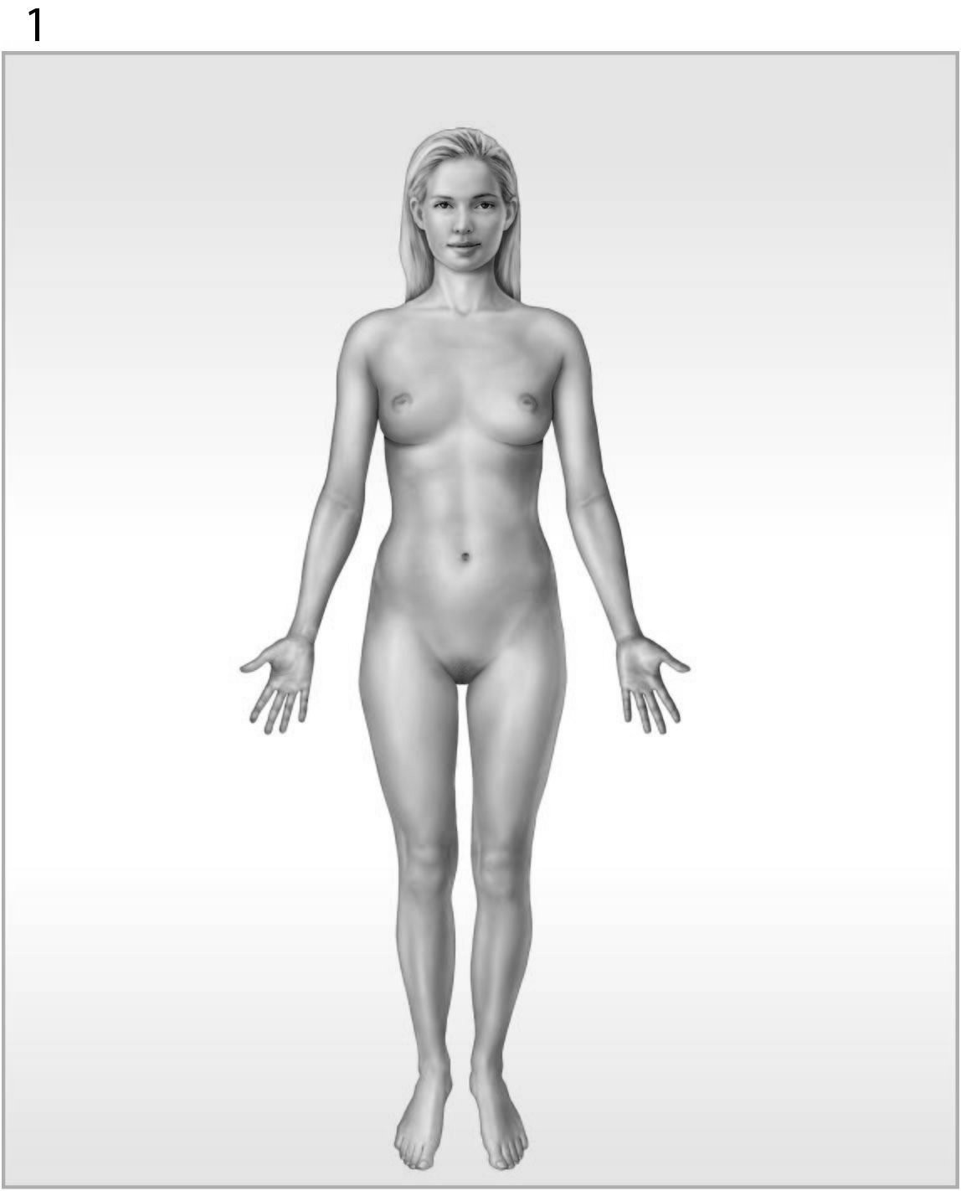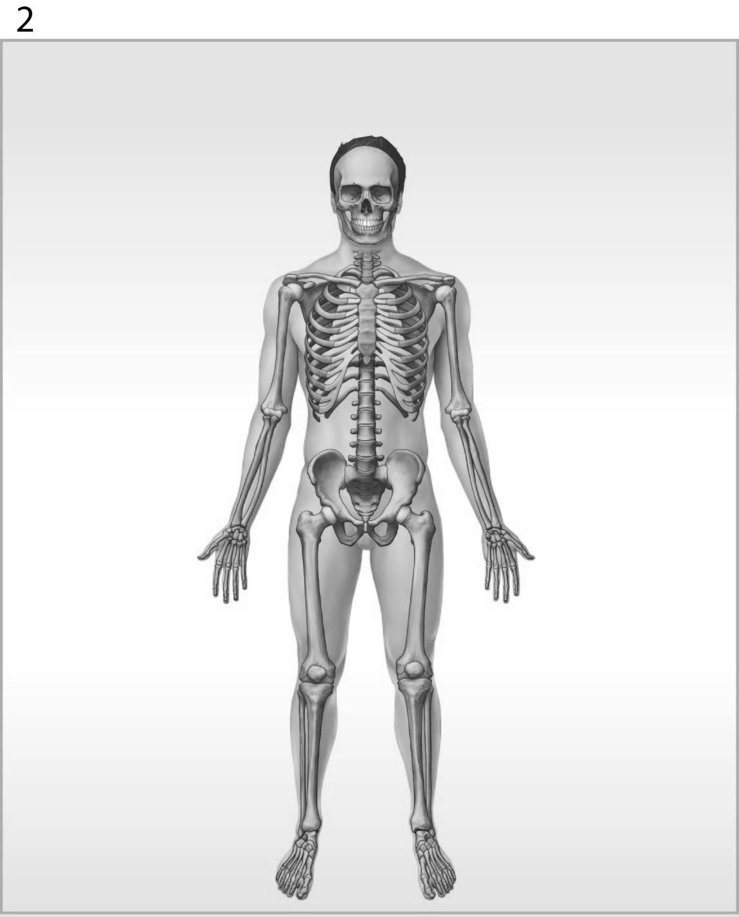
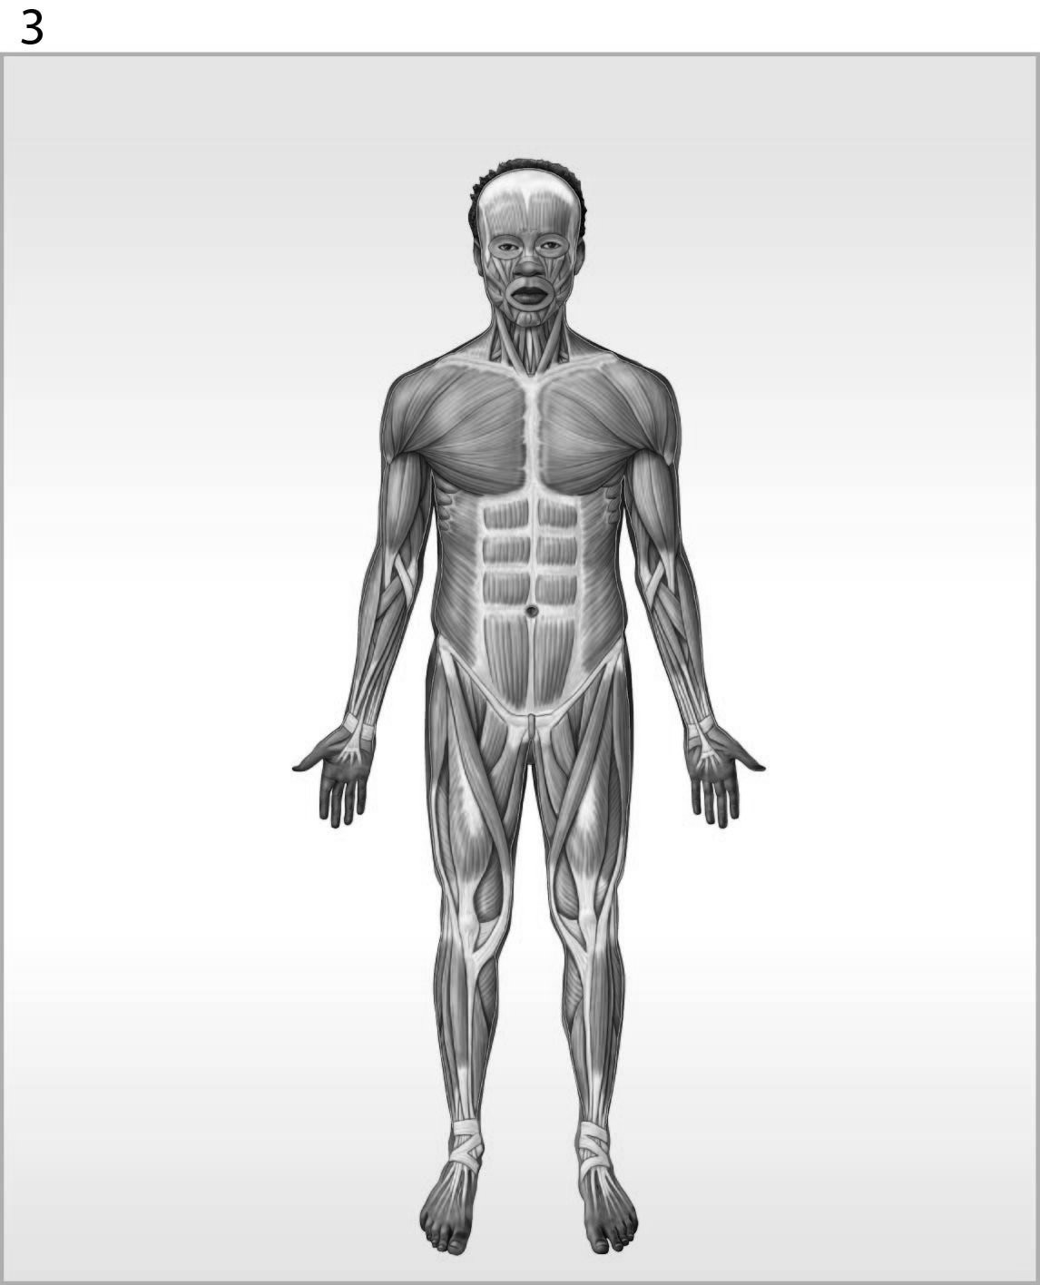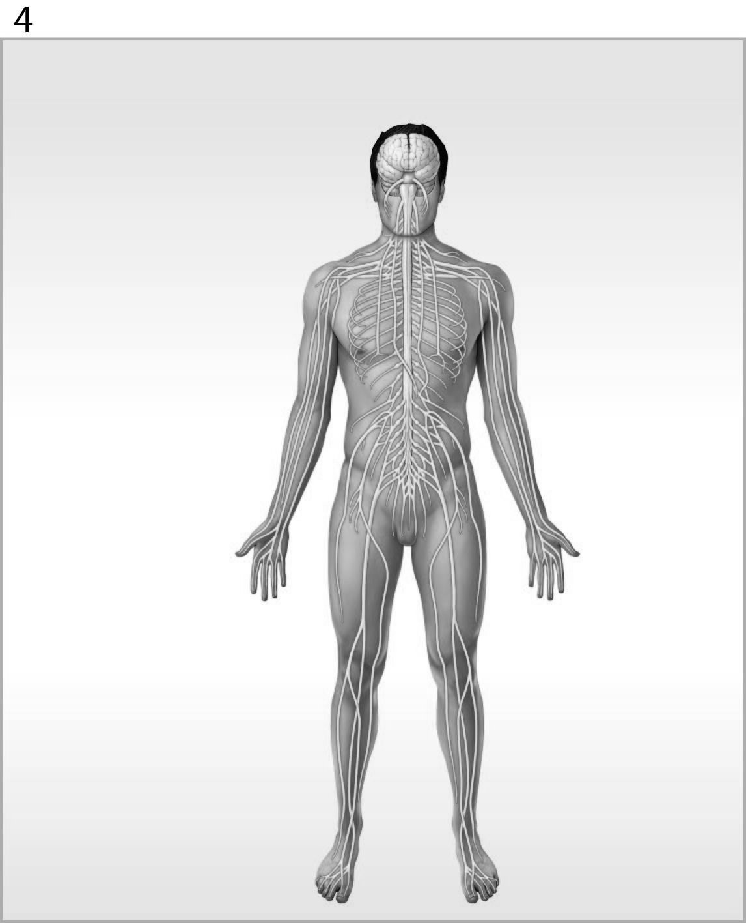

Figure 1-1 The Organ Systems of the Human Body

Use Figure 1-1 to answer the following question(s):

32) Which organ system is labeled #1?
A) nervous system
B) reproductive system
C) integumentary system
D) lymphatic system
E) muscular system
Answer: C
Learning Outcome: 1-4
Bloom's Taxonomy: Knowledge
33) What is(are) the function(s) of the organ system labeled #3?
A) help control body temperature
B) provides support; produces heat
C) provides support; protects tissues; stores minerals
D) directs immediate responses to stimuli
E) defends against infection and disease
Answer: B
Learning Outcome: 1-4
Bloom's Taxonomy: Comprehension

34) Lungs are to the respiratory system as the spleen is to the
A) lymphatic system.
B) urinary system.
C) digestive system.
D) cardiovascular system.
E) muscular system.
Answer: A
Learning Outcome: 1-4
Bloom's Taxonomy: Application

35) A structure that senses change is called a(n) ________.
A) stimulus
B) receptor
C) effector
D) integration center
E) control center
Answer: B
Learning Outcome: 1-5
Bloom's Taxonomy: Knowledge

36) The tendency for physiological systems to stabilize internal conditions with respect to the external environment is called ________.
A) integration
B) internal regulation
C) responsiveness
D) homeostasis
E) external regulation
Answer: D
Learning Outcome: 1-5
Bloom's Taxonomy: Knowledge
37) Which component of a homeostatic regulation is characterized by activity that opposes or enhances the stimulus?
A) balance
B) control center
C) integration center
D) positive feedback loop
E) effector
Answer: E
Learning Outcome: 1-5
Bloom's Taxonomy: Application

38) It's the middle of winter and a typically healthy person starts to exit a building without a coat, but re-enters the building to retrieve her coat. This regulation mechanism is an example of
A) negative feedback.
B) positive feedback.
C) homeostatic regulation.
D) diagnostic regulation.
E) a behavioral change and is not related to the internal environment.
Answer: E
Learning Outcome: 1-5
Bloom's Taxonomy: Application

39) The prevention of change, by ignoring minor variations and maintaining a normal range rather than a fixed value, is characteristic of
A) positive feedback.
B) stimulus reinforcement.
C) negative feedback.
D) effector control.
E) both positive and negative feedback loops.
Answer: C
Learning Outcome: 1-6
Bloom's Taxonomy: Comprehension

40) The increasingly forceful labor contractions that lead to childbirth are an example of which type of mechanism?
A) receptor activation
B) effector shutdown
C) negative feedback
D) positive feedback
E) thermoregulation
Answer: D
Learning Outcome: 1-6
Bloom's Taxonomy: Comprehension
41) An initial stimulus produces a response that reinforces the stimulus in ________.
A) positive feedback
B) homeostasis
C) negative feedback
D) regulation
E) integration
Answer: A
Learning Outcome: 1-6
Bloom's Taxonomy: Comprehension

42) Which of the following describes a mechanism that brings the internal environment back to normal?
A) integration
B) regulation
C) positive feedback
D) negative feedback
E) homeostasis
Answer: D
Learning Outcome: 1-6
Bloom's Taxonomy: Comprehension

43) Which of the following is an example of negative feedback?
A) An increase in normal body temperature triggers heat loss through enhanced blood flow to the skin and increased sweating.
B) An increase in ambient room temperature triggers the thermostat to turn on the heater.
C) A severe cut triggers accelerated blood clotting until the bleeding stops.
D) Increased blood sugar stimulates the release of a hormone from the pancreas that stimulates the liver to release blood sugar.
E) An increase in body temperature triggers a neural response that initiates physiological changes to increase body temperature.
Answer: A
Learning Outcome: 1-6
Bloom's Taxonomy: Application

44) Regarding components of negative feedback in thermoregulation, what is the correlative of the skeletal muscles?
A) effector
B) control center
C) receptor
D) integrator
E) stimulus
Answer: A
Learning Outcome: 1-6
Bloom's Taxonomy: Analysis
45) A person who is lying on his or her stomach is said to be in the
A) supine position.
B) prone position.
C) transverse position.
D) frontal position.
E) sagittal position.
Answer: B
Learning Outcome: 1-7
Bloom's Taxonomy: Knowledge

46) Which directional term indicates the back of the body?
A) lateral
B) proximal
C) dorsal
D) ventral
E) medial
Answer: C
Learning Outcome: 1-7
Bloom's Taxonomy: Knowledge

47) Which of the following anatomical landmarks corresponds to the groin?
A) inguinal
B) cephalon
C) gluteus
D) lumbus
E) thoracis
Answer: A
Learning Outcome: 1-7
Bloom's Taxonomy: Knowledge

48) Which of the following regions corresponds to the foot?
A) cervicis
B) brachium
C) antebrachium
D) femur
E) pes
Answer: E
Learning Outcome: 1-7
Bloom's Taxonomy: Knowledge
49) A person lying face up in the anatomical position is said to be in the ________ position.
A) coronal
B) supine
C) prone
D) sagittal
E) lateral
Answer: B
Learning Outcome: 1-7
Bloom's Taxonomy: Knowledge

50) The forearm is called the ________.
A) acromial
B) olecranon
C) antebrachium
D) lumbus
E) brachium
Answer: C
Learning Outcome: 1-7
Bloom's Taxonomy: Knowledge

51) Which term refers to the posterior of the knee?
A) popliteus
B) patella
C) antecubitis
D) inguinal
E) lumbus
Answer: A
Learning Outcome: 1-7
Bloom's Taxonomy: Knowledge

52) The term ________ refers to the wrist.
A) pes
B) tarsus
C) manus
D) palmar
E) carpus
Answer: E
Learning Outcome: 1-7
Bloom's Taxonomy: Knowledge
53) Describe the regional term "antecubitis."
A) back of knee
B) midline of back
C) eye
D) front of elbow
E) forearm
Answer: D
Learning Outcome: 1-7
Bloom's Taxonomy: Knowledge

54) A cut parallel to the long axis of the body would produce a(n) ________ section.
A) coronal
B) sagittal
C) frontal
D) transverse
E) horizontal
Answer: B
Learning Outcome: 1-7
Bloom's Taxonomy: Comprehension

55) Using anatomical terms of direction, supply the word that would make the sentence correct.
The stomach is ________ to the lungs.
A) ventral
B) dorsal
C) superior
D) inferior
E) deep
Answer: D
Learning Outcome: 1-7
Bloom's Taxonomy: Comprehension

56) Which of the following is medial to the breast?
A) sternum
B) shoulder
C) elbow
D) digits
E) knee
Answer: A
Learning Outcome: 1-7
Bloom's Taxonomy: Comprehension
57) The wrist is ________ to the elbow.
A) proximal
B) distal
C) lateral
D) medial
E) deep
Answer: B
Learning Outcome: 1-7
Bloom's Taxonomy: Comprehension

58) The navel is ________ to the chin.
A) anterior
B) superior
C) posterior
D) inferior
E) medial
Answer: D
Learning Outcome: 1-7
Bloom's Taxonomy: Comprehension

59) In the terminology of planes and sections, which example includes two terms with identical meanings?
A) frontal/coronal
B) coronal/horizontal
C) equatorial/coronal
D) sagittal/midsagittal
E) caudal/cranial
Answer: A
Learning Outcome: 1-7
Bloom's Taxonomy: Comprehension

60) Anterior is to ________ as posterior is to dorsal.
A) cranial
B) ventral
C) caudal
D) inferior
E) medial
Answer: B
Learning Outcome: 1-7
Bloom's Taxonomy: Comprehension
61) A cut passing parallel to the long axis of the body that divides it into unequal left and right halves is known as which type of sectional plane?
A) frontal
B) coronal
C) transverse
D) sagittal
E) horizontal
Answer: D
Learning Outcome: 1-7
Bloom's Taxonomy: Comprehension

62) A diagnostic technique that employs a radiopaque dye injected into blood vessels is called a(n)
A) digital subtractive angiography (DSA).
B) radiograph.
C) CT scan.
D) MRI.
E) ultrasound.
Answer: A
Learning Outcome: 1-7
Bloom's Taxonomy: Comprehension
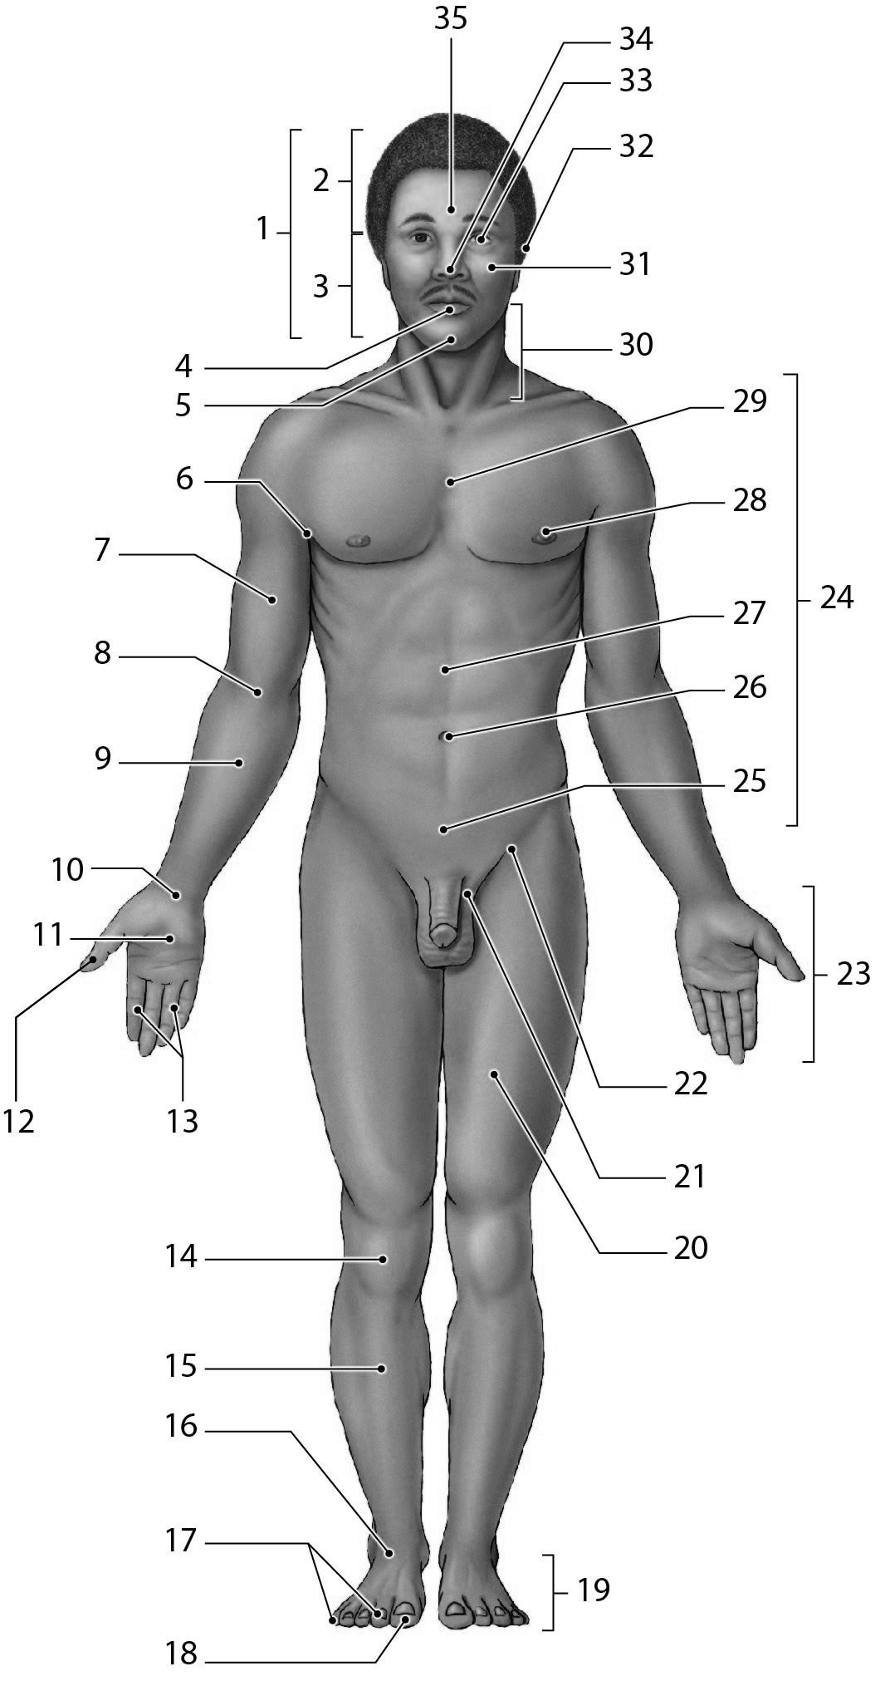

Figure 1-2 Anatomical Landmarks

Use Figure 1-2 to answer the following question(s):

63) Which number identifies the cephalon?
A) 24
B) 30
C) 23
D) 10
E) 1
Answer: E
Learning Outcome: 1-7
Bloom's Taxonomy: Knowledge
64) Which of the following structures is located superior to the nasus?
A) 35
B) 4
C) 32
D) 5
E) 30
Answer: A
Learning Outcome: 1-7
Bloom's Taxonomy: Knowledge

65) Which number identifies the tarsal region?
A) 16
B) 29
C) 10
D) 20
E) 9
Answer: A
Learning Outcome: 1-7
Bloom's Taxonomy: Knowledge

66) The leg region (#15) is also known by its anatomical term, ________.
A) tarsal
B) pedal
C) patellar
D) crural
E) carpal
Answer: D
Learning Outcome: 1-7
Bloom's Taxonomy: Comprehension

67) The pollex is located in which region?
A) 18
B) 23
C) 12
D) 14
E) 16
Answer: C
Learning Outcome: 1-7
Bloom's Taxonomy: Comprehension
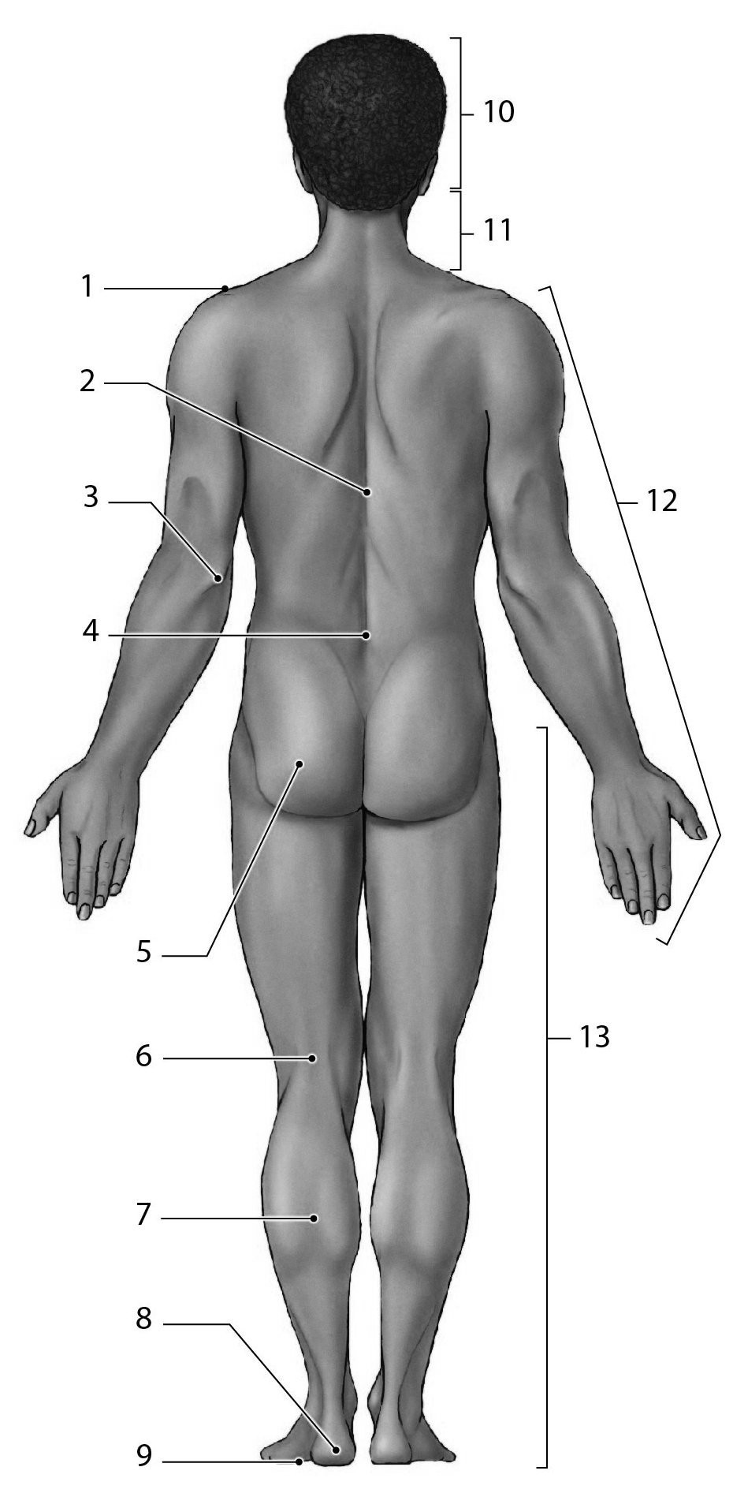

Figure 1-3 Anatomical Landmarks

Use Figure 1-3 to answer the following question(s):

68) Which number identifies the olecranal region of the body?
A) 2
B) 3
C) 4
D) 12
E) 13
Answer: B
Learning Outcome: 1-7
Bloom's Taxonomy: Knowledge
69) Which number identifies the acromial region?
A) 3
B) 13
C) 2
D) 12
E) 1
Answer: E
Learning Outcome: 1-7
Bloom's Taxonomy: Knowledge

70) The kneecap is patellar, whereas the back of the knee is ________.
A) crural
B) pedal
C) manual
D) popliteal
E) pubic
Answer: D
Learning Outcome: 1-7
Bloom's Taxonomy: Knowledge

71) What is the anatomical term for the calf?
A) crural
B) plantar
C) calcaneal
D) sural
E) tarsal
Answer: D
Learning Outcome: 1-7
Bloom's Taxonomy: Comprehension
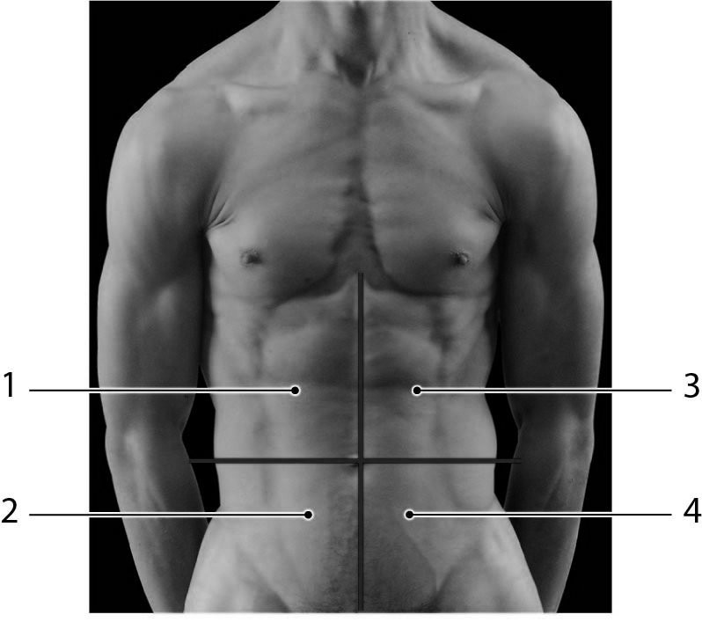
Photo Credit: Custom Medical Stock Photo, Inc.

Figure 1-4 Abdominopelvic Quadrants

Use Figure 1-4 to answer the following question(s):

72) Tenderness in which region(s) may be an indication of gallbladder or liver problems?
A) 2
B) 4
C) 1
D) 3 & 4
E) 3
Answer: C
Learning Outcome: 1-7
Bloom's Taxonomy: Comprehension

73) The appendix is typically located in which region(s)?
A) 2
B) 4
C) 1
D) 3
E) 1 & 3
Answer: A
Learning Outcome: 1-7
Bloom's Taxonomy: Comprehension
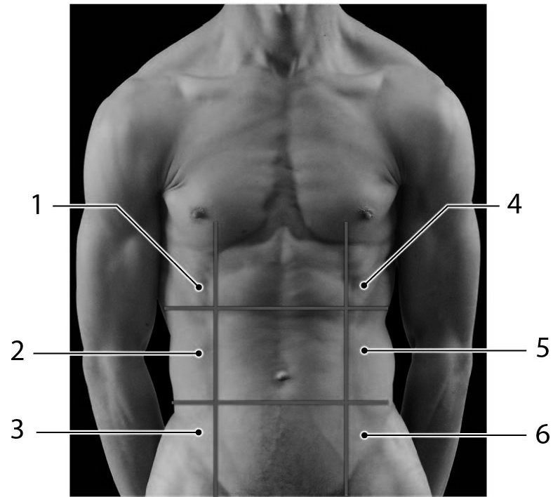
Photo Credit: Custom Medical Stock Photo, Inc.

Figure 1-5 Abdominopelvic Regions

Use Figure 1-5 to answer the following question(s):

74) Which of the following is the hypogastric region?
A) 3
B) 6
C) 9
D) 4
E) 8
Answer: B
Learning Outcome: 1-7
Bloom's Taxonomy: Knowledge

75) The majority of the stomach and the liver, together, are typically located in which region?
A) 5
B) 4
C) 1
D) 7
E) 6
Answer: B
Learning Outcome: 1-7
Bloom's Taxonomy: Analysis
76) The spleen is normally found in which abdominopelvic region?
A) hypogastric
B) left inguinal region
C) right hypochondriac
D) right lumbar region
E) left hypochondriac
Answer: E
Learning Outcome: 1-7
Bloom's Taxonomy: Application

77) Choose the directional term to make the following sentence correct.
The knee is ________ to the foot.
A) lateral
B) medial
C) superficial
D) distal
E) proximal
Answer: E
Learning Outcome: 1-7
Bloom's Taxonomy: Application

78) The arm is to brachium as the cheek is to ________.
A) cranial
B) facial
C) cervical
D) ocular
E) buccal
Answer: E
Learning Outcome: 1-7
Bloom's Taxonomy: Application

79) Mary, who is six months pregnant, goes to her obstetrician for a test to check the development of her fetus. She uses a device that employs sound waves to produce an image of the fetus. This technique is known as
A) an X-ray.
B) a CT scan.
C) an MRI.
D) an ultrasound.
E) radiography.
Answer: D
Learning Outcome: 1-7
Bloom's Taxonomy: Analysis
80) The heart is surrounded by the ________ membrane.
A) pericardial
B) peritoneal
C) visceral
D) serous
E) pleural
Answer: A
Learning Outcome: 1-8
Bloom's Taxonomy: Knowledge

81) The membrane covering the surface of the stomach is named the
A) parietal pleura.
B) visceral pleura.
C) pericardial sac.
D) visceral peritoneum.
E) serous membrane.
Answer: D
Learning Outcome: 1-8
Bloom's Taxonomy: Knowledge

82) The membrane covering the surface of the lung is referred to as the
A) visceral pericardium.
B) parietal peritoneum.
C) visceral pleura.
D) serous membrane.
E) mediastinum.
Answer: C
Learning Outcome: 1-8
Bloom's Taxonomy: Knowledge

83) The heart, lungs, and small intestine would collectively be found in the
A) dorsal body cavity.
B) peritoneal cavity.
C) pleural cavity.
D) ventral body cavity.
E) abdominopelvic cavity.
Answer: D
Learning Outcome: 1-8
Bloom's Taxonomy: Comprehension
84) The diaphragm separates the ________ cavity from the ________ cavity.
A) pleural; mediastinum
B) thoracic; abdominopelvic
C) pericardial; pleural
D) abdominal; pelvic
E) pericardial sac; pericardial
Answer: B
Learning Outcome: 1-8
Bloom's Taxonomy: Comprehension

85) The main function of a serous membrane is to
A) reduce friction.
B) protect organs.
C) allow blood to pass.
D) hold organs together.
E) fill empty spaces.
Answer: A
Learning Outcome: 1-8
Bloom's Taxonomy: Comprehension

86) The peritoneal cavity contains the
A) heart.
B) small intestine.
C) lungs.
D) diaphragm.
E) thymus.
Answer: B
Learning Outcome: 1-8
Bloom's Taxonomy: Comprehension

87) The inner surface of the abdominal body wall is lined by which serous membrane?
A) visceral pleura
B) visceral pericardium
C) visceral peritoneum
D) parietal pleura
E) parietal peritoneum
Answer: E
Learning Outcome: 1-8
Bloom's Taxonomy: Comprehension
88) The mediastinum separates ________ from the ________.
A) the pleural cavity; coelom
B) the thoracic cavity; peritoneal cavity
C) one pleural cavity; other pleural cavity
D) the abdominal cavity; pelvic cavity
E) the pericardial sac; pericardial cavity
Answer: C
Learning Outcome: 1-8
Bloom's Taxonomy: Comprehension

Essay Questions

89) It is a warm day and you feel a little chilled. On checking your temperature, you find that your body temperature is 1.5 degrees below normal. Suggest some possible reasons for this situation.
Answer: There are several reasons why your body temperature may have dropped. Your body may be losing heat faster than it is being produced. This, however, is more likely to occur on a cool day. Various chemical factors, such as hormones, may have caused a decrease in your metabolic rate, and thus your body is not producing as much heat as it normally would. Alternatively, you may be suffering from an infection that has temporarily changed the set point of the body's "thermostat." This would seem to be the most likely explanation considering the circumstances given in the question.
Learning Outcome: 1-5
Bloom's Taxonomy: Analysis

