Economics: Canada in the Global Environment, 7e (Parkin)
Chapter 1 What Is Economics?

1.1 Definition of Economics

1) In a world characterized by scarcity
A) all goods are free.
B) opportunity cost is zero.
C) we are not limited by time.
D) individuals need not work to obtain goods.
E) people must make choices among alternatives.
Answer: E
Diff: 1
Topic: Definition of Economics

2) Which of the following is the best definition of economics?
A) The study of how a provincial government allocates tax dollars.
B) The study of how consumers spend their income.
C) The study of how producers decide what inputs to hire and what outputs to produce.
D) The study of how individuals, businesses, governments, and entire societies make choices as they cope with scarcity and the incentives that influence and reconcile those choices.
E) The study of how consumers and producers meet each other at the market.
Answer: D
Diff: 1
Topic: Definition of Economics

3) Which of the following is a microeconomic topic?
A) the reasons why a consumer buys less honey
B) the reasons why the average price level in a country falls
C) the cause of increasing unemployment
D) the effect of the government budget deficit on inflation
E) the reasons why the labour force in a country decreases
Answer: A
Diff: 1
Topic: Definition of Economics

4) The study of how wages are set for New Brunswick teachers is classified as
A) a macroeconomic topic.
B) a microeconomic topic.
C) economics of social interest.
D) economics of private interest.
E) normative economics.
Answer: B
Diff: 1
Topic: Definition of Economics
5) Which of the following newspaper headlines concerns a macroeconomic issue?
A) Why are people buying more SUVs and fewer minivans?
B) How would a tax on e-commerce affect chapters.indigo.ca?
C) How would an unexpected freeze in Oxford, Nova Scotia change the price of blueberries in the Maritimes?
D) Why is Japan's economy stagnant?
E) Why do grain producers purchase less pesticides?
Answer: D
Diff: 1
Topic: Definition of Economics

6) The branch of economics that studies the choices of individuals and businesses is
A) macroeconomics.
B) microeconomics.
C) positive economics.
D) normative economics.
E) social economics.
Answer: B
Diff: 1
Topic: Definition of Economics
Source: Study Guide

7) Each of the following would be considered a macroeconomic topic except
A) the reasons for a decrease in the unemployment rate.
B) the cause of recessions.
C) the effect of the government budget deficit on inflation.
D) the determination of aggregate income.
E) the selection of production techniques.
Answer: E
Diff: 2
Topic: Definition of Economics

8) Complete the following sentence. Macroeconomics
A) is primarily concerned with the operation of individual markets in the economy.
B) deals mainly with the economic behaviour of households.
C) is the only part of economics to deal with government decisions.
D) is primarily concerned with the behaviour of the stock market.
E) is the study of the national economy and the global economy.
Answer: E
Diff: 2
Topic: Definition of Economics

9) The determination of prices in individual markets is primarily a concern of
A) positive economics.
B) negative economics.
C) macroeconomics.
D) microeconomics.
E) descriptive economics.
Answer: D
Diff: 2
Topic: Definition of Economics
10) Which one of the following topics does macroeconomics study?
A) decisions of individual firms
B) effects of government safety regulations on the price of cars
C) the performance of the global economy
D) prices of individual goods and services
E) effects of taxes on the price of gasoline
Answer: C
Diff: 2
Topic: Definition of Economics

11) Which one of the following topics does microeconomics study?
A) reasons for a fall in the price of orange juice
B) the effect of a rise in the Canadian dollar on Canada's exports
C) effect of interest rates on national economic growth
D) effect of the government budget deficit on employment
E) determination of total production in a country
Answer: A
Diff: 2
Topic: Definition of Economics

12) Complete the following sentence. Microeconomics is
A) not concerned with factors of production.
B) concerned with normative issues only.
C) concerned with the size of the total amount of income earned by all households in an economy.
D) the branch of economics that studies the choices of individuals and businesses.
E) concerned exclusively with the role of the government in the economy.
Answer: D
Diff: 2
Topic: Definition of Economics

13) Which of the following would be considered a microeconomic topic?
A) the severity of a recession
B) the cause of unemployment in the economy
C) the effect of the government budget deficit on inflation
D) the determination of aggregate income
E) the study of how wages are set for mine workers
Answer: E
Diff: 2
Topic: Definition of Economics

14) The branch of economics that studies the national economy and the global economy is
A) macroeconomics.
B) microeconomics.
C) Keynesian economics.
D) positive economics.
E) normative economics.
Answer: A
Diff: 1
Topic: Definition of Economics
15) The fact that human wants cannot be fully satisfied with available resources is called the problem of
A) opportunity cost.
B) scarcity.
C) normative economics.
D) marginal cost.
E) the big tradeoff.
Answer: B
Diff: 1
Topic: Definition of Economics

16) The problem of scarcity exists
A) only in economies that lack incentives.
B) only in economies that have incentives.
C) in all economies.
D) only when people are unemployed.
E) now but will be eliminated with economic growth.
Answer: C
Diff: 2
Topic: Definition of Economics

17) The inescapable economic fact is that
A) there are unlimited wants and limited resources.
B) there are unlimited resources, and we just have to figure out how to allocate them.
C) capitalists are always exploiting the workers.
D) unions are always exploiting firms.
E) capitalists and unions cannot work together.
Answer: A
Diff: 2
Topic: Definition of Economics

1.2 Two Big Economic Questions

1) The two big economic questions
A) involve self-interest only.
B) involve only social interest.
C) involve neither self-interest nor social interest.
D) do not arise from scarcity.
E) involve both self-interest and social interest.
Answer: E
Diff: 1
Topic: Two Big Economic Questions
2) The two big economic questions
A) summarize the scope of economics.
B) are "what goods and services are produced?" and "how are goods and services produced?"
C) have nothing to do with goods and services.
D) do not consider for whom goods and services are produced.
E) have nothing to do with the way goods and services are produced.
Answer: A
Diff: 1
Topic: Two Big Economic Questions

3) The two big economic questions include all of the following except
A) what to produce.
B) why to produce.
C) how to produce.
D) for whom to produce.
E) can choices made in the pursuit of self-interest also promote the social interest.
Answer: B
Diff: 2
Topic: Two Big Economic Questions

4) When a firm decides to produce more hybrid cars and fewer gas guzzlers, it is answering the ________ question.
A) "how"
B) "what"
C) "who"
D) "where"
E) "when"
Answer: B
Diff: 2
Topic: Two Big Economic Questions

5) When a textile firm decides to produce more silk fabric and less cotton fabric, it is answering the ________ question.
A) "who"
B) "how"
C) "what"
D) "where"
E) "when"
Answer: C
Diff: 2
Topic: Two Big Economic Questions
6) When a farmer decides to harvest tomatoes using machines instead of migrant workers, the farmer is answering the ________ question.
A) "what"
B) "how"
C) "who"
D) "where"
E) "when"
Answer: B
Diff: 2
Topic: Two Big Economic Questions

7) Sixty-five years ago, 20 percent of Canadians produced services, 60 percent were employed in mining, construction and manufacturing, and almost 20 percent worked on farms. Today, the percentage in service jobs is
A) close to zero.
B) 25 percent.
C) 20 percent.
D) 50 percent.
E) 75 percent.
Answer: E
Diff: 2
Topic: Two Big Economic Questions

8) Complete the following sentence. Capital is
A) money in the bank.
B) "gifts of nature."
C) tools, instruments, machines, buildings, and other constructions that businesses use to produce goods and services.
D) land.
E) stocks and bonds.
Answer: C
Diff: 1
Topic: Two Big Economic Questions

9) When a firm decides to produce computers using robots instead of people, it is answering the ________ question.
A) "what"
B) "where"
C) "how"
D) "who"
E) "when"
Answer: C
Diff: 2
Topic: Two Big Economic Questions
10) To meet increased demand for its good, a firm decides to hire a few high-skilled workers, rather than hire many low-skilled workers. The firm is answering the ________ question.
A) "when"
B) "what"
C) "who"
D) "where"
E) "how"
Answer: E
Diff: 2
Topic: Two Big Economic Questions

11) An art museum decides to offer tours by having visitors listen to CDs rather than have tour guides. The museum is answering the ________ question.
A) "what"
B) "who"
C) "how"
D) "where"
E) "when"
Answer: C
Diff: 2
Topic: Two Big Economic Questions

12) To earn income, people sell the services of the factors of production they own. Land earns ________; labour earns ________; capital earns ________ and entrepreneurship earns ________.
A) profit; wages; rent; interest
B) wages; interest; profit; rent
C) rent; wages; interest; profit
D) profit; interest; wages; rent
E) interest; profit; rent; wages
Answer: C
Diff: 2
Topic: Two Big Economic Questions

13) The fact that some people can afford to live in beautiful homes while others are homeless is an example of an economy facing the ________ question.
A) "what"
B) "how"
C) "for whom"
D) "where"
E) "when"
Answer: C
Diff: 2
Topic: Two Big Economic Questions
14) The fact that a hockey star earns $3 million a year while a teacher earns $35,000 annually is an example of an economy facing the ________ question.
A) "what"
B) "how"
C) "where"
D) "for whom"
E) "when"
Answer: D
Diff: 2
Topic: Two Big Economic Questions

15) Complete the following sentence. Entrepreneurship is
A) defined as money.
B) traded on the stock market.
C) categorized as capital.
D) the human resource that organizes labour, land and capital.
E) categorized as the factor of production labour.
Answer: D
Diff: 2
Topic: Two Big Economic Questions

16) Sue, who has a law degree, earns $200,000 a year, while Chris, a high-school dropout, earns $5.00 an hour. This is an example of an economy facing the ________ question.
A) "what"
B) "how"
C) "for whom"
D) "where"
E) "when"
Answer: C
Diff: 2
Topic: Two Big Economic Questions

17) A star athlete can afford a garage full of exotic cars while other people can only afford to take a city bus for transportation. This is an example of an economy facing the ________ question.
A) "what"
B) "how"
C) "for whom"
D) "where"
E) "when"
Answer: C
Diff: 2
Topic: Two Big Economic Questions

18) Complete the following sentence. Financial capital is
A) one of the "gifts of nature."
B) the tools and machines that are used to produce goods and services.
C) money, stocks, and bonds.
D) used in the production of goods and services.
E) land.
Answer: C
Diff: 1
Topic: Two Big Economic Questions
19) Which factor of production earns the most income?
A) capital
B) land
C) labour
D) entrepreneurship
E) the stock market
Answer: C
Diff: 2
Topic: Two Big Economic Questions

20) What choices are best for the entire society?
A) self-interest choices
B) minority group choices
C) social interest choices
D) ethnic group choices
E) regional interest choices
Answer: C
Diff: 1
Topic: Two Big Economic Questions

21) Self-interest choices are
A) those choices which are best for the person making them.
B) never in the social interest.
C) always in the social interest.
D) those choices that are best for all residents of a region.
E) choices that are agreed to by majority vote.
Answer: A
Diff: 3
Topic: Two Big Economic Questions

22) The expansion of international trade, borrowing and lending, and investment is
A) the big tradeoff.
B) industrial revolution.
C) corporate revolution.
D) globalization.
E) antiglobalization.
Answer: D
Diff: 3
Topic: Two Big Economic Questions

23) What decades are known as the "Information Revolution"?
A) the 1960s and 1970s
B) the 1970s and 1980s
C) the 1990s and 2000s
D) the 1950s and 1960s
E) the 1930s and 1940s
Answer: C
Diff: 1
Topic: Two Big Economic Questions
24) Which of the following relates factors of production to the sources of income correctly?
A) Land earns interest.
B) Land earns rent.
C) Labour earns rent.
D) Capital earns profit.
E) Entrepreneurship earns rent.
Answer: B
Diff: 1
Topic: Two Big Economic Questions

25) Which statement about incomes earned by factors of production is false?
A) Land earns rent.
B) Natural resources earn rent.
C) Labour earns wages.
D) Capital earns profit.
E) Entrepreneurship earns profit.
Answer: D
Diff: 1
Topic: Two Big Economic Questions

26) A tractor is an example of which of the following factors of production?
A) capital
B) labour
C) land
D) entrepreneurship
E) energy
Answer: A
Diff: 1
Topic: Two Big Economic Questions

27) Which one of the following is an example of capital as a factor of production?
A) money held by Tim Hortons
B) a Bell Canada bond
C) an automobile factory owned by Ford
D) a high school teacher
E) natural gas
Answer: C
Diff: 1
Topic: Two Big Economic Questions

28) Which of the following would an economist classify as capital?
A) natural resources
B) a deposit of silver
C) entrepreneurship
D) a computer
E) land
Answer: D
Diff: 1
Topic: Two Big Economic Questions
29) Which one of the following is labour?
A) money
B) a carpenter's hammer
C) a shoe factory
D) a bread-slicing machine
E) a singer's voice
Answer: E
Diff: 1
Topic: Two Big Economic Questions

30) Which one of the following would economists classify as land?
A) an automotive plant in British Columbia
B) rich agricultural soil in Saskatchewan
C) an oil rig in the Atlantic Ocean
D) an elementary school in Nova Scotia
E) automobiles parked in a parking lot in Manitoba
Answer: B
Diff: 2
Topic: Two Big Economic Questions

31) Which one of the following is an example of land?
A) Bono's singing voice
B) a computer program
C) Lake Erie
D) a road
E) a dam
Answer: C
Diff: 1
Topic: Two Big Economic Questions

32) Which one of the following is an example of a factor of production?
A) an insurance policy
B) a donut
C) the skills of a welder
D) an IBM stock certificate
E) a computer game
Answer: C
Diff: 1
Topic: Two Big Economic Questions

33) Which one of the following is an example of capital?
A) money
B) a carpenter
C) pasture
D) a bread-slicing machine
E) a university professor
Answer: D
Diff: 1
Topic: Two Big Economic Questions
34) The creation of a successful movie illustrates choices made in self-interest that also achieve the social interest if ________.
A) the movie has a higher attendance than any other movie produced that year
B) the movie is produced at the lowest possible cost, and the movie gives the greatest possible benefit
C) the movie addresses a social issue
D) the movie is an Academy award winner because an Academy award winning movie is most popular with the movie-going public
E) the movie is produced in a country where workers typically earn less than workers in North America
Answer: B
Diff: 1
Topic: Two Big Economic Questions
Source: MyEconLab

35) The creation of a successful movie can influence the main questions that economics seeks to answer. Choose the statement that is false.
A) The movie influences the how question because the movie can create new production techniques, which can be used in subsequent films.
B) The movie influences the for whom question because the people who earn higher incomes through the movie production buy more goods and services.
C) The movie influences the when question because movie crews work on many different films and must be available for the entire production.
D) The movie influences the what question because it can lead to spinoff goods or a new movie genre, which can result in the production of similar films.
E) The movie influences the how question because it can use unknown actors or Academy Award winners.
Answer: C
Diff: 1
Topic: Two Big Economic Questions
Source: MyEconLab

1.3 The Economic Way of Thinking

1) Opportunity cost is
A) the value of your favourite activity.
B) your value of leisure.
C) the money you spend on food, shelter, and clothing.
D) the marginal benefit from an activity.
E) the highest-valued alternative that we give up to get something.
Answer: E
Diff: 2
Topic: The Economic Way of Thinking
2) During the next hour John can choose one of the following three activities: playing basketball, watching television, or reading a book. The opportunity cost of reading a book
A) depends on how much the book cost when it was purchased.
B) is the value of playing basketball if John prefers that to watching television.
C) is the value of playing basketball and the value of watching television.
D) depends on how much John enjoys the book.
E) is the value of watching television if John prefers playing basketball to watching television.
Answer: B
Diff: 3
Topic: The Economic Way of Thinking

3) Sally has to decide whether to study for her economics test or her accounting test. If she chooses to study for accounting, her opportunity cost of studying accounting is
A) studying economics.
B) less than the value of studying economics.
C) not comparable to the value of studying economics.
D) equal to the value of studying economics.
E) the future lost wages that will occur if she fails her accounting exam.
Answer: A
Diff: 2
Topic: The Economic Way of Thinking

4) When the government of Alberta chooses to build more roads, the required resources are no longer available to provide better health care facilities. This situation illustrates the concept of
A) marginal benefit.
B) monetary cost.
C) opportunity cost.
D) human capital.
E) entrepreneurship.
Answer: C
Topic: The Economic Way of Thinking

5) The concept of opportunity cost
A) is relevant only for European countries.
B) suggests that individuals can achieve all they want.
C) suggests a major increase in public education spending means a reduced expansion in the public healthcare system.
D) is relevant only for developed countries.
E) is relevant only for developing countries.
Answer: C
Diff: 2
Topic: The Economic Way of Thinking
6) Which one of the following is a necessary consequence of scarcity?
A) no choices required
B) high profits
C) the requirement of making choices
D) all wants are satisfied
E) low profits
Answer: C
Diff: 1
Topic: The Economic Way of Thinking

7) To make choices, people must
A) be able to carry out complex mathematical calculations.
B) have unlimited resources.
C) be free from government constraint.
D) have unlimited access to information at no cost.
E) evaluate the values of alternative actions.
Answer: E
Diff: 2
Topic: The Economic Way of Thinking

8) When the government chooses to use resources to build a dam, those resources are no longer available to build a highway. This illustrates the concept of
A) a market.
B) macroeconomics.
C) opportunity cost.
D) a "how" tradeoff.
E) the big tradeoff.
Answer: C
Diff: 2
Topic: The Economic Way of Thinking
Source: Study Guide

9) What is the definition of marginal benefit?
A) the cost of an increase in an activity
B) the sum of benefit and cost that arises from an increase in an activity
C) the cost of a decrease in an activity
D) the benefit that arises from an increase in an activity
E) the benefit that arises from a decrease in an activity
Answer: D
Diff: 2
Topic: The Economic Way of Thinking
10) When asked in an interview what she missed the most because of the time she spent training for the Olympics, a rower, who lived on her own, answered "a normal social life." She also revealed that she had given up a job that paid $30,000 per year to train fulltime. She received a grant of $8,000 per year from Sport Canada, but this failed to cover all her training expenses. Her food and rent were $5,000 per year and training expenses were $12,000 per year. Aside from the value of a normal social life, what is the annual opportunity cost, expressed in dollars, to this rower of "Going for Gold"?
A) $25,000
B) $4,000
C) $30,000
D) $39,000
E) $34,000
Answer: E
Diff: 3
Topic: The Economic Way of Thinking

11) Saskatchewan had more hospitals than Ontario, despite having one-tenth the population. The Saskatchewan government closed many of these hospitals in spite of widespread local protests. Which one of the following arguments is true?
A) Since hospitals have positive benefits, they should never be closed.
B) If Saskatchewan had more hospitals than Ontario, it must have had too many hospitals.
C) The Saskatchewan government must have thought the marginal benefit from one of these hospitals exceeded its marginal cost.
D) The Saskatchewan government must have thought the marginal benefit from one of these hospitals was less than its marginal cost.
E) The communities where these hospitals existed bore no costs from these decisions, because they did not pay for any of the hospital operating costs.
Answer: D
Diff: 3
Topic: The Economic Way of Thinking

12) "There can be too much of a good thing." This statement suggests that
A) choices made in self-interest cannot be applied to many economic decisions.
B) a good may be produced to the point where its marginal cost exceeds its marginal benefit.
C) certain goods and services such as education and health care are inherently desirable and should be produced regardless of costs and benefits.
D) a good may be produced to the point where its marginal benefit exceeds its marginal cost.
E) a good may be produced to the point where its marginal benefit is equal to its marginal cost.
Answer: B
Diff: 2
Topic: The Economic Way of Thinking
13) Which of the following sayings best describes opportunity cost?
A) "Make hay while the sun shines."
B) "Love of money is the root of all evil."
C) "Boldly go where no one has gone before."
D) "There's no such thing as a free lunch."
E) "Baseball has been very good to me."
Answer: D
Diff: 2
Topic: The Economic Way of Thinking
Source: Study Guide

14) If you take an additional class this term, you can graduate earlier. This is an example of
A) opportunity cost.
B) total cost.
C) the pursuit social interest.
D) marginal benefit.
E) social cost.
Answer: D
Diff: 2
Topic: The Economic Way of Thinking

15) Marginal benefit is the
A) total benefit from an activity.
B) additional benefit from a decrease in an activity.
C) additional benefit from an increase in an activity.
D) opportunity cost of a decrease in an activity.
E) opportunity cost of an increase in an activity.
Answer: C
Diff: 1
Topic: The Economic Way of Thinking
Source: Study Guide

16) Complete the following sentence. Marginal cost is
A) the total cost of an activity.
B) the cost of a decrease in an activity.
C) the cost of an increase in an activity.
D) the opportunity cost of a decrease in an activity.
E) equal to marginal benefit.
Answer: C
Diff: 1
Topic: The Economic Way of Thinking

17) The big tradeoff is the tradeoff between
A) taxes and transfers.
B) equality and efficiency.
C) current consumption and a higher future standard of living.
D) guns and butter.
E) personal security and private property.
Answer: B
Diff: 1
Topic: The Economic Way of Thinking
Source: Study Guide
18) Monika will choose to eat a seventh pizza slice if
A) the marginal benefit from the seventh slice is greater than its marginal cost.
B) the marginal benefit from the seventh slice is less than its marginal cost.
C) the total benefit from all seven slices is greater than their total cost.
D) the total benefit from all seven slices is less than their total cost.
E) she has enough money to pay for it.
Answer: A
Diff: 2
Topic: The Economic Way of Thinking
Source: Study Guide

19) Before starring as Tony Stark in Iron Man, Robert Downey Jr. had played in 45 movies that had average first-weekend box office revenues of a bit less than $5 million. Iron Man grossed $102 million in its first weekend. The success of Iron Man ________ the opportunity cost of hiring Robert Downey Jr.
Movie producers now have ________ incentive to hire Robert Downey Jr.
A) increases; less
B) decreases; less
C) decreases; more
D) increases; more
E) decreases; zero
Answer: D
Diff: 1
Topic: The Economic Way of Thinking
Source: MyEconLab

20) The night before a history test, you decide to go to the movies instead of reviewing your notes. You get 60 percent on your test compared with the 75 percent that you normally score. You ________ a tradeoff ________, and the opportunity cost of your evening at the movies was ________.
A) faced; between a higher test score and an evening at the movies; the 15 percent fall in your grade
B) did not face; because your roommates agreed you should go to the movies and not study; zero
C) did not face; because you made the best choice; zero
D) faced; between a higher test score and an evening at the movies; the mark of 60 percent on your test
E) did not face; most students get 60 percent on history tests; the mark of 60 percent on your test
Answer: A
Diff: 1
Topic: The Economic Way of Thinking
Source: MyEconLab
21) A university decides to change its late night bus service between the campus and student housing from a fare-based service to a free service. This statement means that the incentive to ride the bus ________ and the opportunity cost of a bus ride ________. The university's decision is a ________ decision.
A) changes; decreases; microeconomic
B) changes; decreases; macroeconomic
C) remains the same; remains the same; macroeconomic
D) remains the same; remains the same; microeconomic
E) changes; increases; microeconomic
Answer: A
Diff: 1
Topic: The Economic Way of Thinking
Source: MyEconLab

Use the information below to answer the following question.

Fact 1.1.1 Costs Soar for London Olympics

The regeneration of East London is set to add extra £1.5 billion to taxpayers' bill.
The Times, London, July 6, 2006

22) Refer to Fact 1.1.1. The cost of regenerating East London ________ an opportunity cost of hosting the 2012 Olympic Games ________.
A) is not; because few people attending the 2012 Olympics will spend much time outside Olympic venues
B) is; if the costs of the East London regeneration is equal to a significant percentage of the total amount spent by London taxpayers to host the 2012 Olympics
C) is; if the regeneration of East London would not occur unless London hosted the 2012 Olympics
D) is not; because regenerating East London is an unnecessary expense
E) is; if the property taxes of people living in East London increase
Answer: C
Diff: 1
Topic: The Economic Way of Thinking
Source: MyEconLab

23) The fundamental economic institutions that help societies cope with scarcity are ________.
A) private property protected by a system of laws and markets that enable voluntary exchange
B) banks and the government
C) the objects that people value and produce to satisfy human wants
D) households, firms, and governments
E) foreign exchange markets and stock markets
Answer: A
Diff: 1
Topic: The Economic Way of Thinking
Source: MyEconLab
1.4 Economics as Social Science and Policy Tool

1) Statements about "what ought to be" are called
A) positive statements.
B) normative statements.
C) economic statements.
D) scientific statements.
E) hypotheses.
Answer: B
Diff: 1
Topic: Economics as Social Science and Policy Tool

2) Statements about "what is" are called
A) positive statements.
B) normative statements.
C) economic statements.
D) scientific statements.
E) hypotheses.
Answer: A
Diff: 1
Topic: Economics as Social Science and Policy Tool

3) Which of the following statements is normative?
A) Scientists should not make normative statements.
B) Warts are caused by handling toads.
C) As compact disc prices fall, people buy more of them.
D) If income increases, sales of luxury goods fall.
E) There is more caffeine in a cup of tea than in a cup of coffee.
Answer: A
Diff: 2
Topic: Economics as Social Science and Policy Tool
Source: Study Guide

4) A positive statement is
A) about what ought to be.
B) about what is.
C) always true.
D) capable of evaluation as true or false by observation and measurement.
E) B and D.
Answer: E
Diff: 1
Topic: Economics as Social Science and Policy Tool
Source: Study Guide
5) A positive statement is
A) always true.
B) always false.
C) about what ought to be.
D) what is currently believed about the way the world operates.
E) an opinion that cannot be verified.
Answer: D
Diff: 1
Topic: Economics as Social Science and Policy Tool

6) A normative statement is
A) about what should be.
B) about what is.
C) always true.
D) always false.
E) capable of evaluation, as true or false, by observation and measurement.
Answer: A
Diff: 1
Topic: Economics as Social Science and Policy Tool

7) "The rich should face higher income tax rates than the poor." This is an example of
A) a normative statement.
B) a positive statement.
C) a negative statement.
D) economic reasoning.
E) neither a normative nor a positive statement.
Answer: A
Diff: 2
Topic: Economics as Social Science and Policy Tool

8) Which of the following is an example of a positive statement?
A) Canada should cut back on its use of carbon-based fuels such as coal and oil.
B) Increasing the minimum wage results in more unemployment.
C) Every Canadian should have equal access to health care.
D) The Bank of Canada ought to cut the interest rate.
E) Canada should have lower tax rates for wealthier Canadians.
Answer: B
Diff: 2
Topic: Economics as Social Science and Policy Tool

9) Complete the following sentence. Economic models
A) do not answer questions about the economic world.
B) include most of the details of the economic world.
C) describe some aspect of the economic world, but include only those features needed for the purpose at hand.
D) answer questions that arise from normative statements.
E) were first developed in the 1970s.
Answer: C
Diff: 2
Topic: Economics as Social Science and Policy Tool
10) The scientific purpose of simplifying assumptions in an economic model is to
A) avoid confronting difficult issues.
B) eliminate the need for further testing of the implications of the model.
C) abstract from the complexities of the real world those issues that are not important for the issues under examination.
D) eliminate the possibility of personal bias in the model.
E) add necessary hypotheses to the problem.
Answer: C
Diff: 2
Topic: Economics as Social Science and Policy Tool

11) Model A is superior to model B if
A) it contains more real world detail than model B.
B) it contains fewer unrealistic assumptions than model B.
C) its predictions correspond more closely to the facts than the predictions of model B.
D) it is preferred by a majority of researchers in a public opinion poll.
E) it is scientifically "elegant."
Answer: C
Diff: 2
Topic: Economics as Social Science and Policy Tool

12) In choosing among alternative models, economists generally have the strongest preference for models that
A) have assumptions that are close to exact replicas of reality.
B) are detailed and complex, with every available fact and figure included.
C) have few assumptions and are as simple as possible, even if they cannot predict very well.
D) predict better than any other that is available.
E) have assumptions that are complicated.
Answer: D
Topic: Economics as Social Science and Policy Tool

13) A normative statement is a statement regarding
A) what is usually the case.
B) the assumptions of an economic model.
C) what ought to be.
D) the predictions of an economic model.
E) what is.
Answer: C
Diff: 1
Topic: Economics as Social Science and Policy Tool
Source: Study Guide

14) "The rich face higher income tax rates than the poor" is an example of a
A) a normative statement.
B) a positive statement.
C) a predictive statement.
D) a theoretical statement.
E) an analytical statement.
Answer: B
Diff: 1
Topic: Economics as Social Science and Policy Tool
15) An economic model is tested by
A) examining the realism of its assumptions.
B) comparing its predictions with the facts.
C) comparing its complexity to other models that deal with similar issues.
D) the Testing Committee of the Canadian Economic Association.
E) comparing its descriptions and examining the realism of its assumptions.
Answer: B
Diff: 2
Topic: Economics as Social Science and Policy Tool

16) Which of the following is a positive statement?
A) Low rents restrict the supply of housing.
B) Low rents are better for a city than high rents.
C) Housing costs too much.
D) Owners of apartment buildings ought to be free to charge whatever rent they want.
E) Government should control the rents that apartment owners charge.
Answer: A
Diff: 2
Topic: Economics as Social Science and Policy Tool
Source: Study Guide

17) "The rich face higher income tax rates than the poor, which is not good since it is the rich who provide jobs for the poor." This is an example of
A) a normative statement.
B) a positive statement.
C) a negative statement.
D) a theoretical statement.
E) a descriptive statement.
Answer: A
Diff: 2
Topic: Economics as Social Science and Policy Tool

18) An economic model is
A) tested by examining the realism of its assumptions.
B) useful if it predicts well, even if its assumptions are not realistic.
C) tested by the Testing Committee of the Canadian Economic Association.
D) not useful unless it predicts with 100 percent accuracy.
E) not useful because it simplifies real problems.
Answer: B
Diff: 1
Topic: Economics as Social Science and Policy Tool

19) Select the best statement about economic models.
A) An economic model must always be correct in its predictions or it must be discarded.
B) An economic model is evaluated based on the realism of its assumptions.
C) An economic model should not generate predictions about actual events in the real world, since it discusses only abstract events.
D) An economic model will be discarded if its predictions are often in conflict with the facts.
E) Economic models are all false.
Answer: D
Diff: 2
Topic: Economics as Social Science and Policy Tool
20) To disentangle cause and effect, economists use economic models and use ________ to test the predictions of those models.
A) the what, how, and for whom questions
B) positive statements and normative statements
C) personal economic policy, business economic policy, and government economic policy
D) natural experiments, statistical investigations, and economic experiments
E) marginal benefit and marginal cost
Answer: D
Diff: 2
Topic: Economics as Social Science and Policy Tool
Source: MyEconLab

21) The role of marginal analysis in the use of economics as a policy tool is to ________.
A) find the outcome with the least possible cost
B) evaluate marginal benefit and marginal cost to find the solution that brings the greatest available gain
C) evaluate marginal benefit and marginal cost to find the solution that provides employment to the greatest number of people
D) find the outsome that satisfies the greatest number of people
E) find the outcome that will give a political party the most votes
Answer: B
Diff: 2
Topic: Economics as Social Science and Policy Tool
Source: MyEconLab

22) Which of the following statements are positive?
1. The federal government should increase production of biofuels
2. Air travel has increased since September 11
3. The greatest number of accidents are caused by drunk drivers
4. We ought to have a cure for cancer
A) statements 1 and 4 are positive
B) statements 2 and 3 are positive
C) statements 1 and 2 are positive
D) statements 3 and 4 are positive
E) statements 2 and 4 are positive
Answer: B
Diff: 2
Topic: Economics as Social Science and Policy Tool
Source: MyEconLab
1.5 Appendix: Graphing Data

Use the figure below to answer the following questions.

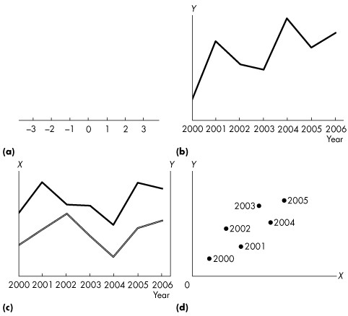

Figure 1A.1.1

1) Refer to Figure 1A.1.1. Which one of the following statements is true?
A) All four graphs indicate ways to represent data.
B) Only graphs like (a) can be used to represent data.
C) Only graphs like (b) and (c) can be used to represent data.
D) Graph (d) cannot be used to represent data because it has dots, not lines.
E) All but graph (a) can be used to represent data.
Answer: A
Diff: 1
Topic: Appendix: Graphing Data

2) Refer to Figure 1A.1.1. Which one of the graphs is a scatter diagram?
A) (a).
B) (b).
C) (c).
D) (d).
E) (b) and (d).
Answer: D
Diff: 1
Topic: Appendix: Graphing Data
3) Refer to Figure 1A.1.1. Which of the diagrams illustrates a time-series graph?
A) (b) and (c).
B) (b).
C) (c).
D) (d).
E) (b), (c), and (d).
Answer: A
Diff: 1
Topic: Appendix: Graphing Data

Use the figure below to answer the following question.

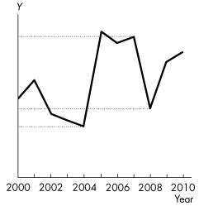

Figure 1A.1.2

4) Refer to Figure 1A.1.2. The solid line represents variable Y. The value of Y
A) increased more rapidly between 2008 and 2009 than in any other period.
B) decreased more rapidly between 2002 and 2003 than between 2001 and 2002.
C) decreased more rapidly between 2005 and 2006 than in any other period.
D) ended the period below its 2004 value.
E) increased more rapidly between 2004 and 2005 than in any other period.
Answer: E
Diff: 2
Topic: Appendix: Graphing Data
Use the figure below to refer to the following question.

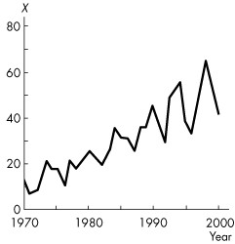

Figure 1A.1.3

5) Refer to Figure 1A.1.3. The behaviour of X over time is best characterized as exhibiting
A) an upward trend.
B) an upward trend sometimes and a downward trend sometimes.
C) a downward trend and increasing variability.
D) no trend.
E) a constant trend.
Answer: A
Diff: 2
Topic: Appendix: Graphing Data

6) The behaviour of a single economic variable over time is best illustrated by a
A) one-variable graph.
B) cross-section graph.
C) time-series graph.
D) scatter diagram.
E) linear graph.
Answer: C
Diff: 2
Topic: Appendix: Graphing Data

7) The general tendency for a variable to move in one direction is called
A) slope.
B) trend.
C) causation.
D) purpose.
E) correlation.
Answer: B
Diff: 1
Topic: Appendix: Graphing Data
8) A cross-section graph shows the values of a variable
A) for different groups or categories at a point in time.
B) for a given group across time.
C) in relationship to other variables.
D) as an absolute rate of change across time.
E) as a percentage of change across time.
Answer: A
Diff: 2
Topic: Appendix: Graphing Data

9) An educator is studying how average grades for economics students vary across classes, based on the time of day of the lecture. The data represent information from one term only. The most effective way of depicting the data is a
A) scatter diagram.
B) time-series graph.
C) trend graph.
D) triple-axis graph.
E) cross-section graph.
Answer: E
Diff: 2
Topic: Appendix: Graphing Data

Use the information below to answer the following question.

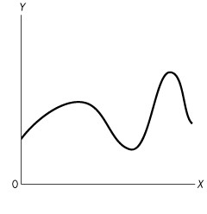
Figure 1A.1.4

10) Figure 1A.1.4 is a time-series graph. The x-axis measures ________ and the y-axis measures ________.
A) time; the variable of interest
B) time; slope
C) the variable of interest in one year; the variable of interest in another year
D) the variable of interest; time
E) slope; time
Answer: A
Diff: 3
Topic: Appendix: Graphing Data
Source: Study Guide
11) Which type of graph can mislead?
A) time-series graphs only
B) cross-section graphs only
C) scatter diagrams only
D) all of the above
E) none of the above.
Answer: D
Diff: 3
Topic: Appendix: Graphing Data

Use the figure below to answer the following questions.

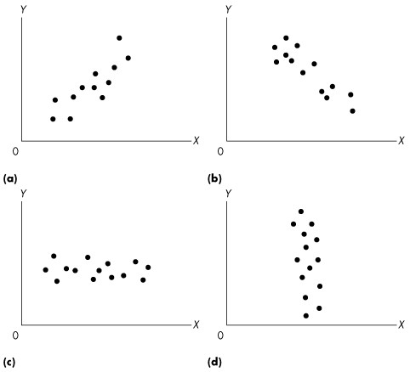

Figure 1A.1.5

12) The graphs in Figure 1A.1.5 are examples of
A) dot graphs.
B) cross-section graphs.
C) dot diagrams.
D) scatter diagrams.
E) none of the above.
Answer: D
Diff: 1
Topic: Appendix: Graphing Data
13) Refer to Figure 1A.1.5. Which graph or graphs indicates a positive relationship between x and y?
A) (a)
B) (b)
C) (c)
D) (d)
E) (a) and (d)
Answer: A
Diff: 2
Topic: Appendix: Graphing Data

14) Refer to Figure 1A.1.5. Which graph or graphs indicates a negative relationship between x and y?
A) (a)
B) (b)
C) (c)
D) (d)
E) (b) and (d)
Answer: B
Diff: 2
Topic: Appendix: Graphing Data

15) Refer to Figure 1A.1.5. Which graph or graphs indicates no relationship between x and y?
A) (a)
B) (b)
C) (c)
D) (c) and (d)
E) (a) and (b)
Answer: D
Diff: 3
Topic: Appendix: Graphing Data

16) Consider graph (a) of Figure 1A.1.5. Which one of the following statements is true?
A) x and y are negatively related.
B) x and y are unrelated.
C) x and y are positively related.
D) x and y move in opposite directions.
E) both A and D are correct.
Answer: C
Diff: 2
Topic: Appendix: Graphing Data

17) Consider graph (b) of Figure 1A.1.5. Which one of the following statements is true?
A) x and y are negatively related.
B) x and y are unrelated.
C) x and y are positively related.
D) x and y move in opposite directions.
E) both A and D are correct.
Answer: E
Diff: 3
Topic: Appendix: Graphing Data
18) Consider graph (d) of Figure 1A.1.5. Which one of the following statements is true?
A) x and y are negatively related.
B) x and y are unrelated.
C) x and y are positively related.
D) x and y move in opposite directions.
E) both A and D.
Answer: B
Diff: 3
Topic: Appendix: Graphing Data

Use the figure below to answer the following questions.

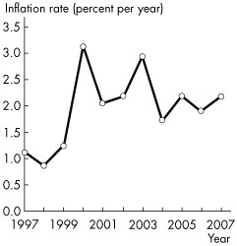

Figure 1A.1.6

19) Refer to Figure 1A.1.6. The graph shows a time-series graph of the inflation rate between 1997 and 2007. The inflation rate is highest in ________ and lowest in ________.
A) 2000; 1998
B) 1999; 1997
C) 2003; 2004
D) 1998; 2000
E) 2007; 1997
Answer: A
Diff: 1
Topic: Appendix: Graphing Data
Source: MyEconLab
20) Refer to Figure 1A.1.6. The graph shows a time-series graph of the inflation rate between 1997 and 2007. The inflation rate ________.
A) shows a downward trend
B) shows an upward trend
C) shows no trend
D) shows that the annual change in inflation is constant
E) has a downward trend followed by an upward trend
Answer: B
Diff: 1
Topic: Appendix: Graphing Data
Source: MyEconLab

Use the figure below to answer the following questions.

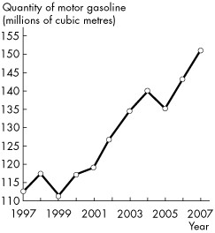

Figure 1A.1.7

21) Refer to Figure 1A.1.7. The graph shows a time-series graph of motor gasoline produced between 1997 and 2007. The quantity of motor gasoline
A) shows an upward trend only between 2001 and 2004.
B) shows an upward trend between 1997 and 2007.
C) has no trend because some years the quantity increases and other years the quantity decreases.
D) shows a downward trend.
E) increases in every year.
Answer: B
Diff: 1
Topic: Appendix: Graphing Data
Source: MyEconLab
22) Refer to Figure 1A.1.7. The graph shows a time-series graph of motor gasoline produced between 1997 and 2007. The quantity of motor gasoline is lowest in
A) 2004.
B) 2001.
C) 2005.
D) 1997.
E) 1999.
Answer: E
Diff: 1
Topic: Appendix: Graphing Data
Source: MyEconLab

1.6 Appendix: Graphs Used in Economic Models

1) If variables x and y move up and down together, they are
A) positively related.
B) negatively related.
C) conversely related.
D) unrelated.
E) trendy.
Answer: A
Diff: 2
Topic: Appendix: Graphs Used in Economic Models
Source: Study Guide

2) Two variables are positively related if
A) increases in one are associated with decreases in the other.
B) increases in one are associated with increases in the other.
C) decreases in one are associated with increases in the other.
D) any change in one causes an increase in the other.
E) any change in one causes a decrease in the other.
Answer: B
Diff: 2
Topic: Appendix: Graphs Used in Economic Models

3) Two variables are negatively related if
A) increases in one are associated with decreases in the other.
B) increases in one are associated with increases in the other.
C) both variables are less than zero.
D) any change in one causes an increase in the other.
E) any change in one causes a decrease in the other.
Answer: A
Diff: 2
Topic: Appendix: Graphs Used in Economic Models
4) The relationship between two variables that are positively related is shown graphically by a line that
A) slopes upward to the right.
B) is horizontal.
C) slopes downward to the right.
D) is vertical.
E) is above the x-axis and to the right of the y-axis.
Answer: A
Diff: 2
Topic: Appendix: Graphs Used in Economic Models

5) The relationship between two variables that are negatively related is shown graphically by a line that
A) slopes upward to the right.
B) is horizontal.
C) slopes downward to the right.
D) is vertical.
E) is below the x-axis and to the left of the y-axis.
Answer: C
Diff: 2
Topic: Appendix: Graphs Used in Economic Models

Use the figure below to answer the following question.

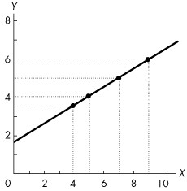

Figure 1A.2.1

6) Refer to Figure 1A.2.1. The variables x and y
A) are negatively related.
B) have a nonlinear relationship.
C) have a negative linear relationship.
D) are unrelated.
E) are positively related.
Answer: E
Diff: 2
Topic: Appendix: Graphs Used in Economic Models
7) In Figure 1A.2.1, the value of y is 5 when x is
A) 4.
B) 5.
C) 6.
D) 7.
E) 8.
Answer: D
Diff: 1
Topic: Appendix: Graphs Used in Economic Models

8) Refer to Figure 1A.2.1. If x decreases from 5 to 4, y
A) decreases from 4 to 3.
B) decreases from 4 to 3 1/2.
C) decreases from 4 to 2.
D) increases from 4 to 5.
E) increases from 3 1/2 to 4.
Answer: B
Diff: 1
Topic: Appendix: Graphs Used in Economic Models

9) Refer to Figure 1A.2.1. When y increases from 5 to 6, x
A) increases from 5 to 6.
B) increases from 7 to 8.
C) increases from 7 to 9.
D) decreases from 9 to 7.
E) increases from 7 to 7 1/2.
Answer: C
Diff: 1
Topic: Appendix: Graphs Used in Economic Models
Use the figure below to answer the following question.

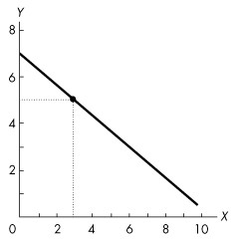

Figure 1A.2.2

10) In Figure 1A.2.2, the variables x and y
A) move in the same direction.
B) are negatively related.
C) are time-series variables.
D) are unrelated
E) are positively related.
Answer: B
Diff: 1
Topic: Appendix: Graphs Used in Economic Models

11) The relationship between two variables that move in opposite directions is shown graphically by a line that is
A) positively sloped.
B) relatively steep.
C) relatively flat.
D) negatively sloped.
E) curved.
Answer: D
Diff: 1
Topic: Appendix: Graphs Used in Economic Models
Source: Study Guide
Use the figure below to answer the following questions.

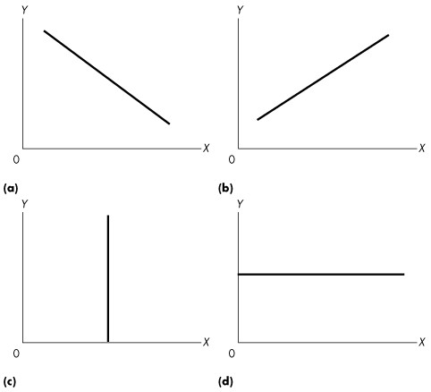

Figure 1A.2.3

12) Refer to Figure 1A.2.3. If you were told that economic theory predicts that higher levels of the rate of interest (x) lead to lower levels of sales of houses (y), which graph would you pick to represent this economic relationship?
A) (a) or (d)
B) (d)
C) (b)
D) (c)
E) (a)
Answer: E
Diff: 2
Topic: Appendix: Graphs Used in Economic Models
13) Refer to Figure 1A.2.3. If your theory predicted that a rise in the wage rate (x) leads to a rise in the amount of labour supplied in the economy (y), which graph would you use to represent this relationship?
A) (a) or (c)
B) (d)
C) (c)
D) (b)
E) (a)
Answer: D
Diff: 2
Topic: Appendix: Graphs Used in Economic Models

14) Refer to Figure 1A.2.3. Which of the graphs shows a positive relationship between x and y?
A) (a)
B) (b)
C) (c)
D) (d)
E) both (b) and (d)
Answer: B
Diff: 1
Topic: Appendix: Graphs Used in Economic Models

15) Refer to Figure 1A.2.3. Which one of the graphs shows a negative relationship between x and y?
A) (a)
B) (b)
C) (c)
D) (d)
E) both (a) and (d)
Answer: A
Diff: 1
Topic: Appendix: Graphs Used in Economic Models

16) Refer to Figure 1A.2.3. Suppose our theory predicted that for low levels of quantity produced (x) a firm's profits (y) were low, for medium levels of output their profits were high, and for high levels of output their profits were low again. Which one of the graphs would represent this relationship?
A) (a)
B) (b)
C) (c)
D) (d)
E) none of the graphs
Answer: E
Diff: 2
Topic: Appendix: Graphs Used in Economic Models
Use the figure below to answer the following questions.

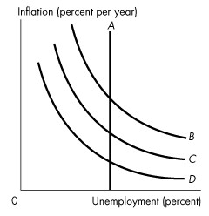
Figure 1A.2.4

17) Which curve or curves in Figure 1A.2.4 shows a positive relationship between unemployment and inflation?
A) A
B) A and B
C) B, C, and D
D) A and B
E) none of the curves.
Answer: E
Diff: 1
Topic: Appendix: Graphs Used in Economic Models

18) Which curve or curves in Figure 1A.2.4 shows no relationship between unemployment and inflation?
A) A
B) A and B
C) B, C, and D
D) A and C
E) B and D
Answer: A
Diff: 1
Topic: Appendix: Graphs Used in Economic Models

19) Which curve or curves in Figure 1A.2.4 shows a negative relationship between unemployment and inflation?
A) A
B) A and B
C) B, C, and D
D) A and D
E) B and C
Answer: C
Diff: 1
Topic: Appendix: Graphs Used in Economic Models
Use the table below to answer the following question.

Table 1A.2.1

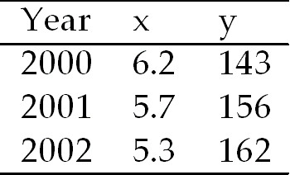

20) The data in Table 1A.2.1 shows that
A) x and y have a negative relationship.
B) x and y have a positive relationship.
C) there is no relationship between x and y.
D) there is first a negative and then a positive relationship between x and y.
E) there is first a positive and then a negative relationship between x and y.
Answer: A
Diff: 2
Topic: Appendix: Graphs Used in Economic Models
Source: Study Guide

Use the figure below to answer the following questions.

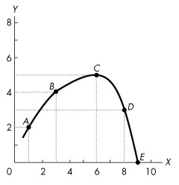

Figure 1A.2.5

21) Refer to Figure 1A.2.5. Which one of the following statements is true?
A) x and y are positively related at all points between A and D.
B) x and y are negatively related at all points between points B and D.
C) y reaches a maximum at point C.
D) y reaches a minimum at point C.
E) x and y are unrelated.
Answer: C
Diff: 1
Topic: Appendix: Graphs Used in Economic Models
Use the table below to answer the following question.

Table 1A.2.2

y | 4 | 6 | 8 | 10 | 12
z | 1 | 2 | 3 | 4 | 5

22) Refer to Table 1A.2.2. What type of relationship exists between y and z?
A) negative
B) positive
C) inverse
D) No consistent relationship exists.
E) first a positive relationship, then a negative one
Answer: B
Diff: 2
Topic: Appendix: Graphs Used in Economic Models

Use the table below to answer the following questions.

Table 1A.2.3

w | 2 | 4 | 6 | 8 | 10
u | 15 | 12 | 9 | 6 | 3

23) Refer to Table 1A.2.3. What type of relationship exists between w and u?
A) positive
B) negative
C) direct
D) No consistent relationship exists.
E) first a positive relationship, then a negative one
Answer: B
Diff: 2
Topic: Appendix: Graphs Used in Economic Models
Use the figure below to answer the following question.

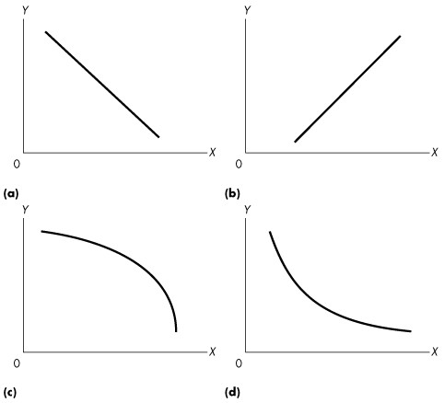

Figure 1A.2.6

24) Refer to Figure 1A.2.6. Consider the values for x and y given in the following table:

x | 2 | 4 | 6 | 8 | 10
y | 12 | 8 | 5 | 3 | 2

Which one of the graphs in Figure A1.13 represents the relationship between x and y?
A) (a)
B) (b)
C) (c)
D) (d)
E) (a) and (b)
Answer: D
Diff: 1
Topic: Appendix: Graphs Used in Economic Models
1.7 Appendix: The Slope of a Relationship

1) The change in the value of the variable measured on the y- axis divided by the change in the value of the variable measures on the x-axis is
A) increasing.
B) slope.
C) decreasing.
D) constant.
E) a maximum or minimum.
Answer: B
Diff: 1
Topic: Appendix: The Slope of a Relationship

2) The slope of a horizontal line is
A) positive.
B) negative.
C) zero.
D) infinite.
E) initially positive and then negative.
Answer: C
Diff: 1
Topic: Appendix: The Slope of a Relationship

3) The slope of a straight line
A) is the same at every point.
B) increases as the variable on the x-axis increases if the slope is positive.
C) decreases as the variable on the x-axis increases if the slope is negative.
D) is the same at every point only if the line is horizontal.
E) depends on where you measure the slope.
Answer: A
Diff: 1
Topic: Appendix: The Slope of a Relationship
Use the figure below to answer the following questions.

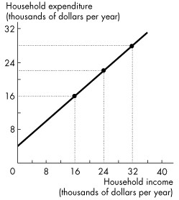

Figure 1A.3.1

4) In Figure 1A.3.1, if household income increases by $1 000, household expenditure will
A) increase by $1 333.
B) decrease by $1 333.
C) remain unchanged.
D) increase by $1 000.
E) increase by $750.
Answer: E
Diff: 2
Topic: Appendix: The Slope of a Relationship
Source: Study Guide

5) The slope of the line in Figure 1A.3.1 is
A) 0.50.
B) 0.75.
C) 1.00
D) 1.25.
E) 1.50.
Answer: B
Diff: 2
Topic: Appendix: The Slope of a Relationship
Use the figure below to answer the following question.

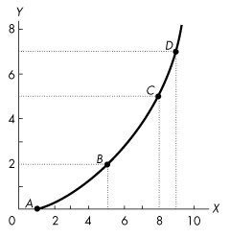

Figure 1A.3.2

6) Refer to Figure 1A.3.2. The slope across the arc between A and B is
A) 1/2.
B) 2/3.
C) 1.
D) 2.
E) 3.
Answer: A
Diff: 2
Topic: Appendix: The Slope of a Relationship
Use the figure below to answer the following questions.

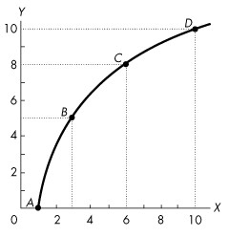

Figure 1A.3.3

7) Figure 1A.3.3 illustrates two variables, x and y, which are
A) negatively related, with a decreasing slope as x increases.
B) negatively related, with an increasing slope as x increases.
C) positively related, with a decreasing slope as x increases.
D) positively related, with an increasing slope as x increases.
E) positively related, with slope first increasing then decreasing.
Answer: C
Diff: 2
Topic: Appendix: The Slope of a Relationship

8) In Figure 1A.3.3, the slope across arc AB is
A) 1/2.
B) 1.
C) 3/2.
D) 5/2.
E) 5/3.
Answer: D
Diff: 2
Topic: Appendix: The Slope of a Relationship

9) In Figure 1A.3.3 the relationship between x and y as x increases is
A) positive with decreasing slope.
B) negative with decreasing slope .
C) negative with increasing slope .
D) positive with increasing slope .
E) positive with slope first increasing then decreasing.
Answer: A
Diff: 3
Topic: Appendix: The Slope of a Relationship
Source: Study Guide
10) What is the slope across the arc between B and C in Figure 1A.3.3?
A) 1/2.
B) 2/3
C) 1
D) 2
E) 3
Answer: C
Diff: 2
Topic: Appendix: The Slope of a Relationship
Source: Study Guide

Use the figure below to answer the following questions.

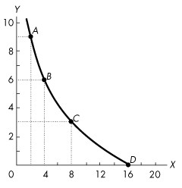

Figure 1A.3.4

11) Figure 1A.3.4 illustrates two variables, x and y, which are
A) negatively related, with slope becoming closer to 0 as x increases from 2 to 16.
B) negatively related, with slope becoming farther from 0 as x increases from 2 to 16.
C) positively related, with slope becoming closer to 0 as x increases from 2 to 16.
D) positively related, with slope becoming farther from 0 as x increases from 2 to 16.
E) positively related, with the slope unchanging as x increases from 2 to 16.
Answer: A
Diff: 2
Topic: Appendix: The Slope of a Relationship

12) In Figure 1A.3.4, the slope across arc AB is
A) 2/3.
B) -1.
C) -3/2.
D) -3.
E) -9/4.
Answer: C
Diff: 2
Topic: Appendix: The Slope of a Relationship
13) In Figure 1A.3.4, the slope across arc BC is
A) -2/3.
B) -3/2.
C) -2.
D) -4/3.
E) -3/4.
Answer: E
Diff: 2
Topic: Appendix: The Slope of a Relationship

14) Refer to Figure 1A.3.4. In Figure 1A.3.4, the slope at point B
A) lies between -2/3 and -1.
B) lies between -3/4 and -3/2.
C) lies between -2/3 and -4/3.
D) lies between 1 and 3/2.
E) is greater than 3/2.
Answer: B
Diff: 2
Topic: Appendix: The Slope of a Relationship

Use the figure below to answer the following questions.

Figure 1A.3.5

15) Refer to Figure 1A.3.5. Which one of the following statements is true?
A) The slope is less between points A and B than between points B and C.
B) The slope is greater between points B and C than between points A and B.
C) The slope at C is 0.
D) The slope at C is 1.
E) The slope at C is negative.
Answer: C
Diff: 2
Topic: Appendix: The Slope of a Relationship
16) Refer to Figure 1A.3.5. In Figure 1A.3.5, the slope across arc BC is
A) 1/3.
B) 1/2.
C) 1.
D) 2.
E) 5/6.
Answer: A
Diff: 2
Topic: Appendix: The Slope of a Relationship

17) Refer to Figure 1A.3.5. In Figure 1A.3.5, the slope across arc CD is
A) 1/2.
B) 1.
C) -1/2.
D) -1.
E) -5/8.
Answer: D
Diff: 2
Topic: Appendix: The Slope of a Relationship

Use the table below to answer the following question.

Table 1A.3.1

y | 4 | 6 | 8 | 10 | 12
z | 1 | 2 | 3 | 4 | 5

18) Refer to Table 1A.3.1. Assuming y is plotted on the vertical axis, the slope of the line is
A) constant at -2.
B) -2 when x is between 1 and 3.
C) -2 when x is between 1 and 3, and then +2 when x is between 4 and 5.
D) -2 when x is between 4 and 5.
E) constant at +2.
Answer: E
Diff: 2
Topic: Appendix: The Slope of a Relationship
Use the table below to answer the following questions.

Table 1A.3.2

w | 2 | 4 | 6 | 8 | 10
u | 15 | 12 | 9 | 6 | 3

19) In Table 1A.3.2, suppose that w is measured along the x-axis. The slope of the line relating w and u is
A) positive with a decreasing slope.
B) negative with a decreasing slope.
C) positive with an increasing slope.
D) negative with a constant slope.
E) positive with a constant slope.
Answer: D
Diff: 2
Topic: Appendix: The Slope of a Relationship
Source: Study Guide

20) Refer to Table 1A.3.2. Suppose that w is measured along the x-axis. The slope of the line relating w and u is
A) +3.
B) -3.
C) -2/3.
D) +3/2.
E) -3/2.
Answer: E
Diff: 2
Topic: Appendix: The Slope of a Relationship
Source: Study Guide

Use the table below to answer the following questions.

Table 1A.3.3

x | 0 | 1 | 2 | 3 | 4 | 5 | 6 | 7 | 9 | 9
y | 10 | 8 | 6 | 4 | 2 | 0 | 2 | 4 | 6 | 8

21) Refer to Table 1A.3.3. If we were to draw a graph of this relationship, when would the slope be positive?
A) never
B) only if x is less than 5
C) only if x equals 5
D) only if x is greater than 5
E) We do not have enough information to tell.
Answer: D
Diff: 3
Topic: Appendix: The Slope of a Relationship
22) Refer to Table 1A.3.3. When x equals 5, the slope is
A) 5.
B) -2.
C) +2.
D) 0.
E) infinite.
Answer: D
Diff: 3
Topic: Appendix: The Slope of a Relationship

23) Refer to Table 1A.3.3. When x equals 5,
A) y is at a maximum.
B) y is at a minimum.
C) the slope is positive.
D) the slope is negative.
E) the slope is first positive and then becomes negative.
Answer: B
Diff: 2
Topic: Appendix: The Slope of a Relationship

24) At all points along a straight line, slope is
A) positive.
B) negative.
C) constant.
D) zero.
E) infinity.
Answer: C
Diff: 1
Topic: Appendix: The Slope of a Relationship
Source: Study Guide
Use the figure below to answer the following question.

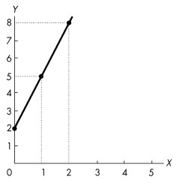

Figure 1A.3.6

25) What is the slope of the line in Figure A1.3.6?
A) 2
B) 1/2.
C) 3
D) 1/3
E) -3
Answer: C
Diff: 1
Topic: Appendix: The Slope of a Relationship
Source: Study Guide
Use the figure below to answer the following question.

Figure 1A.3.7

26) The slope of the line in Figure 1A.3.7 is
A) 1.
B) -1.
C) 1/2.
D) 2.
E) dependent on where you measure it.
Answer: C
Diff: 1
Topic: Appendix: The Slope of a Relationship
Use the figure below to answer the following question.

Figure 1A.3.8

27) The slope of the line in Figure 1A.3.8 is
A) 3/2.
B) 2/3.
C) -3/2.
D) -2/3.
E) none of the above.
Answer: D
Diff: 1
Topic: Appendix: The Slope of a Relationship
Use the figure below to answer the following questions.

Figure 1A.3.9

28) Refer to Figure 1A.3.9. Which one of the graphs shows a line with a zero slope?
A) (a)
B) (b)
C) (c)
D) (d)
E) (a), (b), and (c)
Answer: D
Diff: 1
Topic: Appendix: The Slope of a Relationship

29) Refer to Figure 1A.3.9. Which one of the graphs shows a line with an infinite slope?
A) (a)
B) (b)
C) (c)
D) (d)
E) (b) and (c)
Answer: C
Diff: 1
Topic: Appendix: The Slope of a Relationship
Use the figure below to answer the following questions.

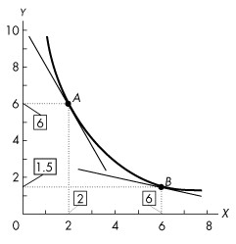

Figure 1A.3.10

30) Refer to Figure 1A.3.10. The figure shows a relationship between two variables, x and y. The slope at point A is
A) 2
B) -2
C) 0.25
D) -0.25
E) -4
Answer: B
Diff: 1
Topic: Appendix: The Slope of a Relationship
Source: MyEconLab

31) Refer to Figure 1A.3.10. The figure shows a relationship between two variables, x and y. The slope at point B is
A) 2
B) -2
C) 0.25
D) -0.25
E) 0.5
Answer: D
Diff: 1
Topic: Appendix: The Slope of a Relationship
Source: MyEconLab
Use the figure below to answer the following question.

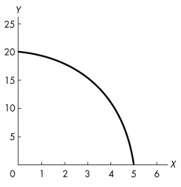

Figure 1A.3.11

32) Refer to Figure 1A.3.11. The graph shows a ________ relationship. The absolute value of the slope of the relationship ________ as the value of x increases.
A) positive; increases
B) positive; decreases
C) negative; decreases
D) negative; increases
E) negative; does not change
Answer: D
Diff: 1
Topic: Appendix: The Slope of a Relationship
Source: MyEconLab

1.8 Appendix: Graphing Relationships Among More Than Two Variables

1) To graph a relationship among three variables we
A) hold two variables constant to graph the third variable.
B) hold one variable constant and graph the relationship between the other two variables.
C) graph each of the three variables using a separate time-series graph.
D) must be able to draw in three dimensions.
E) must be able to allow all three variables to vary simultaneously in one graph.
Answer: B
Diff: 2
Topic: Appendix: Graphing Relationships Among More Than Two Variables
Use the table below to answer the following questions.

Table 1A.4.1

x | 120 | 100 | 80 | 140 | 120 | 100 | 160 | 140 | 120
y | 10 | 12 | 14 | 10 | 12 | 14 | 10 | 12 | 14
z | 4 | 4 | 4 | 5 | 5 | 5 | 6 | 6 | 6

2) Given the data in Table 1A.4.1, holding z constant, the graph of x and y
A) is a negatively sloped line.
B) is a positively sloped line.
C) reaches a maximum.
D) reaches a minimum.
E) does not have a constant slope.
Answer: A
Diff: 3
Topic: Appendix: Graphing Relationships Among More Than Two Variables

3) Given the data in Table 1A.4.1, holding y constant, the graph of x and z
A) is a negatively sloped line.
B) is a positively sloped line.
C) reaches a maximum.
D) reaches a minimum.
E) shows that x and z are not related.
Answer: B
Diff: 3
Topic: Appendix: Graphing Relationships Among More Than Two Variables

4) Consider the data in Table 1A.4.1. Suppose z increases from 4 to 5. What will happen to the graph of the relationship between x and y?
A) It will shift to the right.
B) It will shift to the left.
C) It will become positively sloped.
D) both A and C
E) both B and C
Answer: A
Diff: 3
Topic: Appendix: Graphing Relationships Among More Than Two Variables
Use the figure below to answer the following question.

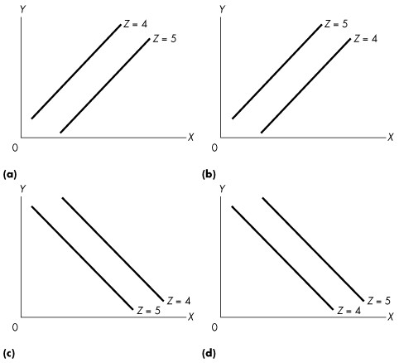

Figure 1A.4.1

5) Given the data in the following table, which one of the graphs in Figure 1A.4.1 correctly represents the relationship among x, y, and z?

x | 120 | 100 | 80 | 140 | 120 | 100 | 160 | 140 | 120
y | 10 | 12 | 14 | 10 | 12 | 14 | 10 | 12 | 14
z | 4 | 4 | 4 | 5 | 5 | 5 | 6 | 6 | 6

A) (a)
B) (b)
C) (c)
D) (d)
E) (b) and (c)
Answer: D
Diff: 3
Topic: Appendix: Graphing Relationships Among More Than Two Variables
Use the figure below to answer the following question.

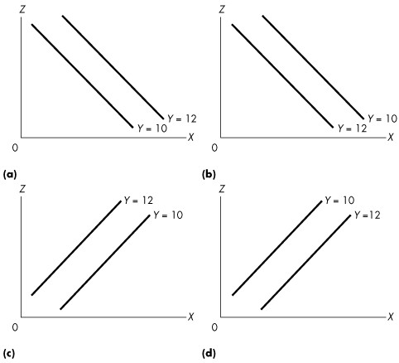

Figure 1A.4.2

6) Given the data in the following table, which one of the graphs in Figure 1A.4.2 correctly represents the relationship among x, y, and z?

x | 120 | 100 | 80 | 140 | 120 | 100 | 160 | 140 | 120
y | 10 | 12 | 14 | 10 | 12 | 14 | 10 | 12 | 14
z | 4 | 4 | 4 | 5 | 5 | 5 | 6 | 6 | 6

A) (a)
B) (b)
C) (c)
D) (d)
E) (a) and (d)
Answer: C
Diff: 3
Topic: Appendix: Graphing Relationships Among More Than Two Variables
Use the table below to answer the following questions.

Table 1A.4.2

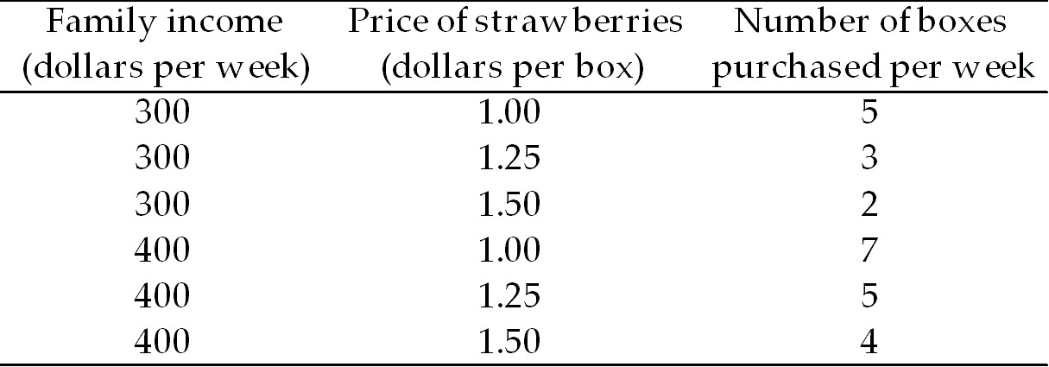

7) Table 1A.4.2 shows that,
A) the number of boxes of strawberries purchased is negatively related to the price of strawberries, holding income constant.
B) the number of boxes of strawberries purchased is negatively related to income, holding the price of strawberries constant.
C) the price of strawberries is negatively related to family income, holding purchases of strawberries constant.
D) B and C.
E) A and B.
Answer: A
Diff: 3
Topic: Appendix: Graphing Relationships Among More Than Two Variables

8) Given the data in Table 1A.4.2, holding income constant, the graph relating the price of strawberries, measured on the y-axis and the purchases of strawberries, measured on the x-axis
A) is a vertical line.
B) is a horizontal line.
C) is a positively sloped line.
D) is a negatively sloped line.
E) reaches a minimum.
Answer: D
Diff: 3
Topic: Appendix: Graphing Relationships Among More Than Two Variables
Source: Study Guide

9) Given the data in Table 1A.4.2, suppose family income decreases from $400 to $300 per week. Then the graph relating the price of strawberries, measured on the y-axis and the number of boxes of strawberries purchased, measured on the x-axis will
A) become negatively sloped.
B) become positively sloped.
C) shift rightward.
D) shift leftward.
E) no longer exist.
Answer: D
Diff: 3
Topic: Appendix: Graphing Relationships Among More Than Two Variables
Source: Study Guide
10) Given the data in Table 1A.4.2, holding price constant, the graph of the purchases of strawberries , measured on the x-axis and family income, measured on the y-axis is a
A) vertical line.
B) horizontal line.
C) positively sloped line.
D) negatively sloped line.
E) positively or negatively sloped line, depending on the price that is held constant.
Answer: C
Diff: 3
Topic: Appendix: Graphing Relationships Among More Than Two Variables
Source: Study Guide

Use the figure below to answer the following question.

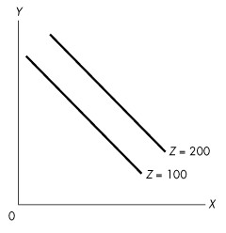
Figure 1A.4.3

11) In Figure 1A.4.3, x is
A) positively related to y and negatively related to z.
B) positively related to both y and z.
C) negatively related to y and positively related to z.
D) negatively related to both y and z.
E) greater than z.
Answer: C
Diff: 3
Topic: Appendix: Graphing Relationships Among More Than Two Variables
Source: Study Guide

12) In Figure 1A.4.3, a decrease in the value of z results in, ceteris paribus,
A) a decrease in the value of x.
B) an increase in the value of x.
C) an increase in the value of y.
D) no change in the value of y.
E) no change in the value of x.
Answer: A
Diff: 3
Topic: Appendix: Graphing Relationships Among More Than Two Variables
Source: Study Guide
Use the figure below to answer the following question.

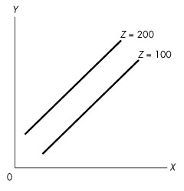
Figure 1A.4.4

13) Complete the following sentence. In Figure 1A.4.4, z is
A) positively related to x and negatively related to y.
B) negatively related to x and positively related to y.
C) positively related to both x and y.
D) negatively related to both x and y.
E) related to y but not related to x.
Answer: B
Diff: 3
Topic: Appendix: Graphing Relationships Among More Than Two Variables

14) To graph a relationship among more than two variables, what assumption is necessary?
A) normative
B) positive
C) linear
D) independence of variables
E) ceteris paribus
Answer: E
Diff: 1
Topic: Appendix: Graphing Relationships Among More Than Two Variables
Source: Study Guide
15) Consider the following information on cola sales by number of cases for a typical university residence floor:

Temp. Price (dollars per case)
(°C) 10.00 12.50 15.00 17.50
15 50 40 30 20
20 60 50 40 30
25 70 60 50 40
30 80 70 60 50
35 90 80 70 60
Cola sales and cola prices are
A) inversely related.
B) positively related.
C) not affected by the temperature.
D) unrelated.
E) negatively related at low temperatures, but positively related at high temperatures.
Answer: A
Diff: 2
Topic: Appendix: Graphing Relationships Among More Than Two Variables

16) Consider the following information on cola sales by number of cases for a typical university residence floor:

Temp. Price (dollars per case)
(°C) 10.00 12.50 15.00 17.50
15 50 40 30 20
20 60 50 40 30
25 70 60 50 40
30 80 70 60 50
35 90 80 70 60
Cola sales and temperature are
A) inversely related.
B) positively related.
C) not affected by the price.
D) unrelated.
E) negatively related at low prices, but positively related at high prices.
Answer: B
Diff: 2
Topic: Appendix: Graphing Relationships Among More Than Two Variables
Use the figure below to answer the following questions.

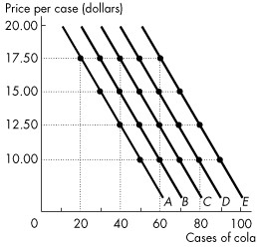

Figure 1A.4.5

17) Consider the following information on cola sales by number of cases for a typical university residence floor:

Temp. Price (dollars per case)
(°C) 10.00 12.50 15.00 17.50
15 50 40 30 20
20 60 50 40 30
25 70 60 50 40
30 80 70 60 50
35 90 80 70 60

Refer to Figure 1A.4.5. Which line shows the relationship of cola sales and its price when the temperature is 30°C?
A) A
B) B
C) C
D) D
E) E
Answer: D
Diff: 2
Topic: Appendix: Graphing Relationships Among More Than Two Variables
18) Consider the following information on cola sales by number of cases for a typical university residence floor:

Temp. Price (dollars per case)
(°C) 10.00 12.50 15.00 17.50
15 50 40 30 20
20 60 50 40 30
25 70 60 50 40
30 80 70 60 50
35 90 80 70 60

Refer to Figure 1A.4.5. Which line shows the relationship of cola sales and the temperature when the price of a case is $15.00?
A) A
B) B
C) C
D) D
E) none of the above.
Answer: E
Diff: 3
Topic: Appendix: Graphing Relationships Among More Than Two Variables

19) Consider the following information on cola sales by number of cases for a typical university residence floor:

Temp. Price (dollars per case)
(°C) 10.00 12.50 15.00 17.50
15 50 40 30 20
20 60 50 40 30
25 70 60 50 40
30 80 70 60 50
35 90 80 70 60

Refer to Figure 1A.4.5. Which one of the following represents what happens when the temperature rises from 20°C to 25°C?
A) The curve shifts from A to B.
B) The curve shifts from C to B.
C) The curve shifts from B to C.
D) The curve shifts along line B.
E) The curve shifts along line C.
Answer: C
Diff: 3
Topic: Appendix: Graphing Relationships Among More Than Two Variables
20) The Latin term ceteris paribus means
A) "Innocent until proven guilty."
B) "Fallacies are composed."
C) "Compositions are fallacious."
D) "The whole is not the sum of the parts."
E) "If all other relevant things remain the same."
Answer: E
Diff: 1
Topic: Appendix: Graphing Relationships Among More Than Two Variables
Source: Study Guide

Use the table below to answer the following question.

Table 1A.4.3

Ice cream consumption
(litres per day)
Price  (dollars per scoop) | 0  degrees | 10  degrees | 20  degrees | 30  degrees
0.50  1.00  1.50  2.00  2.50 | 12  10  7  5  3 | 18  12  10  7  5 | 25  18  13  10  7 | 50  37  27  20  14

21) Refer to Table 1A.4.3. The table shows some data on the quantity of ice cream consumed at different prices and in different weather conditions. To draw a graph of the relationship between the quantity of the ice cream consumed and the price of ice cream, we must ________.
A) decrease the temperature as the price rises
B) pick the temperature that prevailed when the price was $1.00.
C) increase the temperature as the price rises
D) hold the temperature constant at any of the four levels shown
E) hold the price constant at any of the five levels shown
Answer: D
Diff: 3
Topic: Appendix: Graphing Relationships Among More Than Two Variables
Source: MyEconLab
1.9 Appendix: Mathematical Note

Use the figure below to answer the following question.

Figure 1A.5.1

1) The equation of the line in Figure 1A.5.1 is
A) y = 1.5 - 0.5x.
B) y =1.5 + 2x.
C) y = 1.5 + 0.5x.
D) y = -3 + 2x.
E) dependent on where you measure it.
Answer: C
Diff: 1
Topic: Appendix: Mathematical Note
Use the figure below to answer the following question.

Figure 1A.5.2

2) If the line in Figure 1A.5.2 were to continue down to the x-axis, what would the value of x be when y is zero?
A) 0
B) 2
C) 2/3
D) -2/3
E) -3/2.
Answer: D
Diff: 2
Topic: Appendix: Mathematical Note
Source: Study Guide

3) If the equation of a straight line is y = 6 + 3x, then the slope is
A) -3 and the y-intercept is 6.
B) -3 and the y-intercept is -2.
C) 3 and the y-intercept is 6.
D) 3 and the y-intercept is -2.
E) 3 and the y-intercept is -6.
Answer: C
Diff: 1
Topic: Appendix: Mathematical Note
Source: Study Guide

4) If the equation of a straight line is y = 8 - 2x, then the slope is
A) -2 and the x-intercept is -4.
B) -2 and the x-intercept is 4.
C) -2 and the x-intercept is 8.
D) 2 and the x-intercept is -4.
E) 2 and the x-intercept is 4.
Answer: B
Diff: 1
Topic: Appendix: Mathematical Note
Source: Study Guide
5) The equation of a line is y = 4 + 2x. What is the y-intercept of this line?
A) 4
B) -2
C) -1/2.
D) 1/4
E) 0
Answer: A
Diff: 1
Topic: Appendix: Mathematical Note

6) The equation of a line is y = 4 + 2x. What is the x-intercept of this line?
A) 4
B) -2
C) -1/2.
D) 1/4
E) 0
Answer: B
Diff: 2
Topic: Appendix: Mathematical Note

7) The equation of a line is y = 4 + 2x. What is the slope of this line?
A) 4
B) 2
C) 1/2.
D) 1/4
E) 0
Answer: B
Diff: 1
Topic: Appendix: Mathematical Note
Use the figure below to answer the following questions.

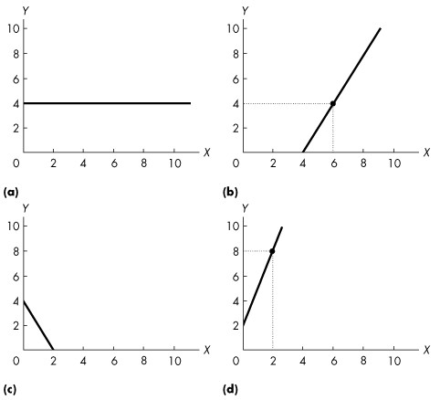

Figure 1A.5.3

8) The equation of a line is y = 4 + 2x. Which one of the graphs in Figure 1A.5.3 represents this line?
A) (a).
B) (b).
C) (c).
D) (d).
E) none of the graphs
Answer: E
Diff: 2
Topic: Appendix: Mathematical Note
Use the figure below to answer the following question.

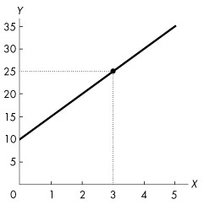
Figure 1A.5.4

9) Refer to Figure 1A.5.4. The graph shows the relationship between two variables, x and y. This relationship is described by the equation ________.
A) y = 5x2 + 10
B) y = 10x + 5
C) y = -5x + 10
D) y = 5x + 10
E) x = 10 + 5y
Answer: D
Diff: 2
Topic: Appendix: Mathematical Note
Source: MyEconLab
Use the figure below to answer the following question.

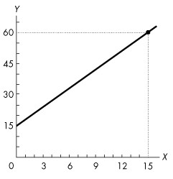
Figure 1A.5.5

10) Refer to Figure 1A.5.5. The graph shows the relationship between two variables, x and y. Which of the following equations describes this relationship?
A) y = 3x + 15
B) y = -3x + 15
C) y = -3x2 + 15
D) y = 15x + 3
E) x = 15y + 3
Answer: A
Diff: 2
Topic: Appendix: Mathematical Note
Source: MyEconLab

11) Which of the following equations describes a straight line with a y-intercept of -2 and a slope of -5?
A) y = -5 - 2x
B) y = -2
C) y = -2 - 5x
D) y = -5x
E) x = -2 - 5y
Answer: C
Diff: 2
Topic: Appendix: Mathematical Note
Source: MyEconLab

