Chapter 1 An Introduction to Microeconomics
Solutions

1.1 The first two steps would be taken in the realm of positive analysis: determining the qualitative and quantitative effects of the proposed policy. The third step would involve normative analysis: making a value judgment as to whether or not the policy was desirable.

1.2 Answers can vary, especially this early in the course. Greater competition between suppliers in the wake of deregulation likely explains the decline in the relative price of interstate telephone calls. For medical care, students may suggest things like the population is getting older, so there is more use of hospitals, or increased government spending on health care programs such as Medicaid and Medicare.

1.3 The nominal price of a good, by itself, doesn’t tell us very much. The value of a dollar changes so prices measured in dollars change too. The real price measures the price of a good in terms of what must be given up to get it. Real prices offer a more stable standard.

1.4 Answer in text.

1.5 The opportunity cost of land is great in every major city, but probably much higher in Tokyo than New York because of the relative greater scarcity of land in Japan. Vending machines take up less space than newsstands, groceries, or liquor stores, and economize on the scarce land.

1.6 Answer in text.

1.7 A draft would lower the accounting cost of maintaining an army but would not lower and probably increase economic cost. The economic cost of the draft is the reduced output elsewhere in the economy when people serve in the army instead of doing other jobs. With a volunteer army, the wages paid to the soldiers equals the opportunity cost since the soldiers would not join unless their opportunity costs were covered. (This analysis could be complicated further by considering training benefits in the service as well). With a draft, the lower wages would often be less than the opportunity cost of the soldiers so the accounting costs would not reflect the economic costs. Further, some people would be drafted who would not have served under a volunteer army because their opportunities outside the military were better than the wage the army paid. Hence, the economic costs would be greater under a draft than a volunteer army. (Note that the accounting costs could also be higher if the costs of administering the draft were substantial.)

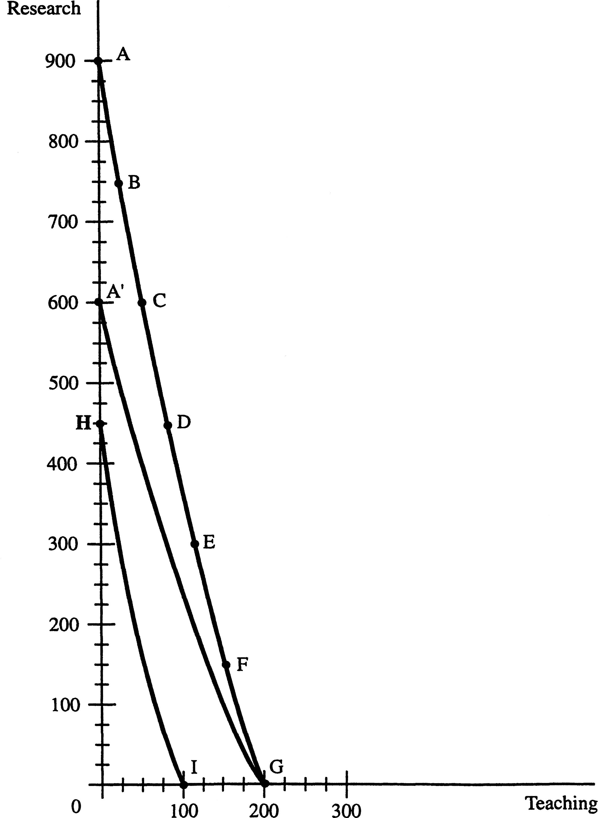

1.8 a. Research production exhibits decreasing opportunity costs.

b. See the figure below. Infeasible production points lie above the PPF. Points on the PPF make the most effective use of the university’s resources. Points below the PPF indicate points where there are unemployed resources.

c. The opportunity cost of going from B to C is 6 units of research per unit of teaching.

d. The opportunity cost of going from C to B is 1/6 unit of teaching per unit of research.

e. In the figure below, the new PPF is A'G.

f. The new PPF is HI in the figure below. (Assuming AG is the original PPF).

g. No, the president is wrong. Every point on the PPF is efficient.

1.9 False. The $5 billion sunk by Motorola into Iridium is a sunk cost and should not be taken into account when making the decision of what should be done with the venture from here on in.

1.10 In real terms, President Lincoln earned $475,000 in 1863 [ (171/9)$25,000 ] and thus more than the current holder of that same office.

1.11 The more productive a populace, the higher is the opportunity cost associated with government-sponsored killing of that populace and thus the less we should observe such killing.

1.12 Downward...given that some net economic benefits presumably can be generated by cellular phone callers while stuck in traffic.

1.13 The opportunity cost of traditional shopping has increased as the growth of two-wage-earner families has increased. Online shopping has a lower opportunity cost relative to traditional shopping, all else equal, thus we would predict and increase in the rate of substitution to the lower opportunity cost activity as two-wage-earner families increases.

