Biological Science, 5e (Freeman)
Chapter 2 Water and Carbon: The Chemical Basis of Life

1) About twenty-five of the ninety-two natural elements are known to be essential to life. Which four of these twenty-five elements make up approximately 96 percent of living matter?
A) carbon, sodium, hydrogen, nitrogen
B) carbon, oxygen, phosphorus, hydrogen
C) oxygen, hydrogen, calcium, nitrogen
D) carbon, hydrogen, nitrogen, oxygen
E) carbon, oxygen, nitrogen, calcium
Answer: D
Bloom's Taxonomy: Knowledge/Comprehension
Section: 2.1

2) Why is each element unique with respect to its chemical properties? Each element has a distinctive _____.
A) atomic mass
B) number of electrons
C) number of protons
D) number of neutrons
E) radioactive property
Answer: C
Bloom's Taxonomy: Knowledge/Comprehension
Section: 2.1

3) Knowing the atomic mass of an element allows inferences about which of the following?
A) the number of electrons in the element
B) the number of protons in the element
C) the number of neutrons in the element
D) the number of protons plus neutrons in the element
E) the number of protons plus electrons in the element
Answer: D
Bloom's Taxonomy: Application/Analysis
Section: 2.1

4) Carbon-12 is the most common isotope of carbon and has a mass number of 12. However, the average atomic mass of carbon found on a periodic table is slightly more than 12 daltons. Why?
A) The atomic mass does not include the mass of electrons.
B) Some carbon atoms in nature have an extra proton.
C) Some carbon atoms in nature have more neutrons.
D) Some carbon atoms in nature have a different valence electron distribution.
E) Some carbon atoms in nature have undergone radioactive decay.
Answer: C
Bloom's Taxonomy: Application/Analysis
Section: 2.1

5) From its atomic number of 15, it is possible to predict that the phosphorus atom has _____.
A) 5 neutrons, 5 protons, and 5 electrons
B) 30 neutrons
C) 15 neutrons and 15 protons
D) 8 electrons in its outermost electron shell
E) 15 protons and 15 electrons
Answer: E
Bloom's Taxonomy: Knowledge/Comprehension
Section: 2.1

6) A covalent chemical bond is one in which _____.
A) electrons are removed from one atom and transferred to another atom so that the two atoms become oppositely charged
B) protons and neutrons are shared by two atoms so as to satisfy the requirements of both atoms
C) outer-shell electrons of two atoms are shared so as to satisfactorily fill their respective orbitals
D) outer-shell electrons of one atom are transferred to fill the inner electron shell of another atom
E) electrons from the same atom, but opposite spins, are paired
Answer: C
Bloom's Taxonomy: Knowledge/Comprehension
Section: 2.1

7) Nitrogen (N) is more electronegative than hydrogen (H). Which of the following is a correct statement about the atoms in ammonia (NH3)?
A) Each hydrogen atom has a partial positive charge; the nitrogen atom has a partial negative charge.
B) Ammonia has an overall positive charge.
C) Ammonia has an overall negative charge.
D) The nitrogen atom has a partial positive charge; each hydrogen atom has a partial negative charge.
E) There are covalent bonds between the hydrogen atoms and polar bonds between each hydrogen atom and the nitrogen atom.
Answer: A
Bloom's Taxonomy: Knowledge/Comprehension
Section: 2.1

8) Bonds between two atoms that are equally electronegative are _____.
A) hydrogen bonds
B) van der Waals interactions
C) polar covalent bonds
D) nonpolar covalent bonds
E) ionic bonds
Answer: D
Bloom's Taxonomy: Knowledge/Comprehension
Section: 2.1

9) A covalent bond is likely to be polar when _____.
A) one of the atoms sharing electrons is more electronegative than the other atom
B) the two atoms sharing electrons are equally electronegative
C) carbon is one of the two atoms sharing electrons
D) one of the atoms has absorbed more energy than the other atom
E) the two atoms sharing electrons are the same elements
Answer: A
Bloom's Taxonomy: Knowledge/Comprehension
Section: 2.1

10) What is the difference between covalent bonds and ionic bonds?
A) Covalent bonds require carbon while ionic bonds do not.
B) Covalent bonds involve the sharing of pairs of electrons between atoms; ionic bonds involve the sharing of single electrons between atoms.
C) Covalent bonds involve the sharing of electrons between atoms; ionic bonds involve the electrical attraction between charged atoms.
D) Covalent bonds involve the sharing of electrons between atoms; ionic bonds involve the sharing of protons between charged atoms.
E) Covalent bonds involve the transfer of electrons between charged atoms; ionic bonds involve the sharing of electrons between atoms.
Answer: C
Bloom's Taxonomy: Knowledge/Comprehension
Section: 2.1

Refer to the following figure to answer the questions below.

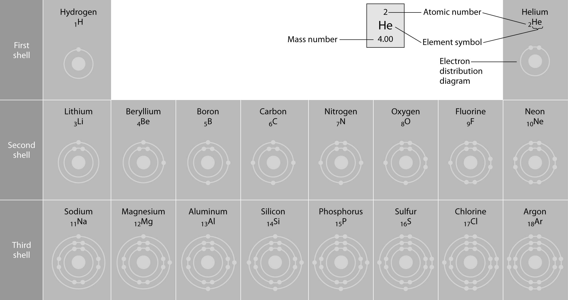

11) Refer to the figure above (first three rows of the periodic table). What element has properties most similar tocarbon?
A) boron
B) silicon
C) nitrogen
D) aluminum
E) phosphorus
Answer: B
Bloom's Taxonomy: Synthesis/Evaluation
Section: 2.1

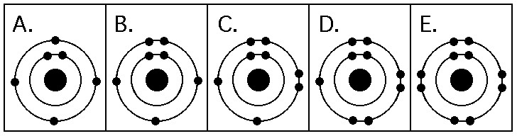

12) Which drawing in the figure above depicts the electron configuration of an element with chemical properties most similar to helium (2He)?
A) A
B) B
C) C
D) D
E) E
Answer: E
Bloom's Taxonomy: Application/Analysis
Section: 2.1

13) Which drawing in the figure above depicts an atom with six valence electrons?
A) A
B) B
C) C
D) D
E) E
Answer: C
Bloom's Taxonomy: Knowledge/Comprehension
Section: 2.1

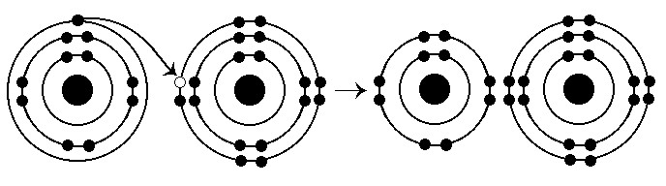

14) What results from the chemical reaction illustrated above? The reactants have no charge.
A) a cation with a net charge of +1 and an anion with a net charge of +1
B) a cation with a net charge of -1 and an anion with a net charge of -1
C) a cation with a net charge of -1 and an anion with a net charge of +1
D) a cation with a net charge of +1 and an anion with a net charge of -1
Answer: D
Bloom's Taxonomy: Knowledge/Comprehension
Section: 2.1

15) Which one of the following pairs of neutral atoms would be most likely to form ions and thus an ionic bond?
A)
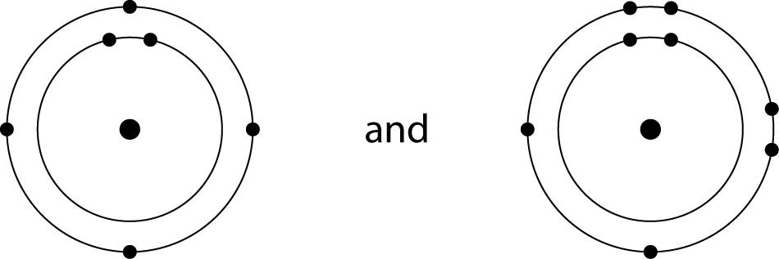
B)
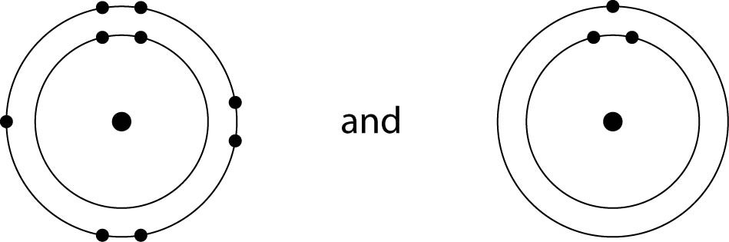
C)
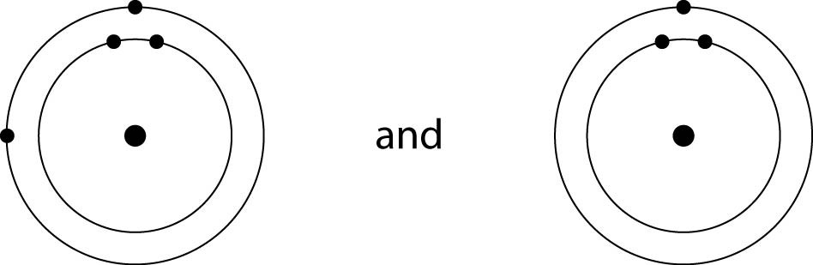
D)
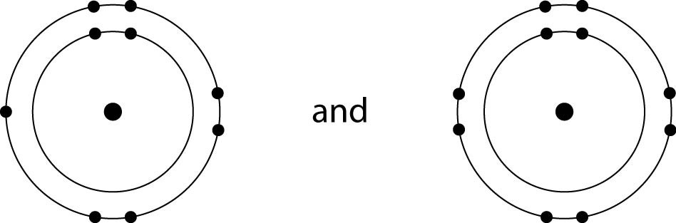
E)
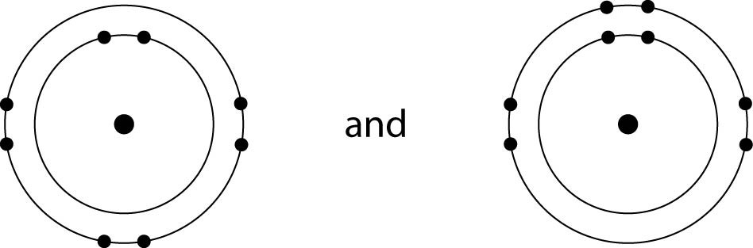
Answer: B
Bloom's Taxonomy: Application/Analysis
Section: 2.1

16) How many electrons are involved in a single covalent bond?
A) one
B) two
C) three
D) four
Answer: B
Bloom's Taxonomy: Knowledge/Comprehension
Section: 2.1

17) Elements found on the left side of the periodic table contain outer shells that are _____; these elements tend to form _____ in solution.
A) almost empty; cations
B) almost empty; anions
C) almost full; cations
D) almost full; anions
Answer: A
Bloom's Taxonomy: Application/Analysis
Section: 2.1

18) An atom has four electrons in its valence shell. What types of covalent bonds is it capable of forming?
A) single, double, or triple
B) single and double only
C) single bonds only
D) double bonds only
Answer: A
Bloom's Taxonomy: Application/Analysis
Section: 2.1

19) When the atoms involved in a covalent bond have the same electronegativity, what type of bond results?
A) an ionic bond
B) a hydrogen bond
C) a nonpolar covalent bond
D) a polar covalent bond
Answer: C
Bloom's Taxonomy: Knowledge/Comprehension
Section: 2.1

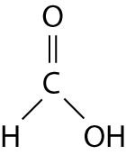

20) The illustration above shows a representation of formic acid. A formic acid molecule _____.
A) will form hydrogen bonds with water molecules
B) has a tetrahedral configuration of hybrid electron orbitals for the carbon atom
C) consists of largely nonpolar covalent bonds
D) is held together by hydrogen bonds
E) has a pyramidal shape and will form hydrogen bonds with water molecules
Answer: A
Bloom's Taxonomy: Synthesis/Evaluation
Section: 2.2

21) You need to write down information about a molecule, but need to indicate only the type and number of atoms it contains. Which representation would work best?
A) molecular formula
B) structural formula
C) ball-and-stick model
D) space-filling model
Answer: A
Bloom's Taxonomy: Knowledge/Comprehension
Section: 2.2

22) You need to represent a molecule to best illustrate the relative sizes of the atoms involved and their interrelationships. Which representation would work best?
A) molecular formula
B) structural formula
C) ball-and-stick model
D) space-filling model
Answer: D
Bloom's Taxonomy: Knowledge/Comprehension
Section: 2.2

23) Water has a high specific heat because of the _____.
A) polar covalent bond formed between the oxygen and a hydrogen of a single water molecule
B) ionic bonds formed between the hydrogen of one water molecule and the oxygen of another water molecule
C) hydrogen bond formed between the hydrogen of one water molecule and the oxygen of another water molecule
D) covalent bond formed between the hydrogen of one water molecule and the oxygen of another water molecule
Answer: C
Bloom's Taxonomy: Knowledge/Comprehension
Section: 2.2

24) Which of the following is a property of liquid water? Liquid water _____.
A) is less dense than ice
B) has a specific heat that is lower than that for most other substances
C) has a heat of vaporization that is higher than that for most other substances
D) is nonpolar
Answer: C
Bloom's Taxonomy: Knowledge/Comprehension
Section: 2.2

25) To act as an effective coolant in a car's radiator, a substance has to have the capacity to absorb a great deal of heat. You have a reference book with tables listing the physical properties of many liquids. In choosing a coolant for your car, which table would you check first?
A) pH
B) density at room temperature
C) heat of vaporization
D) specific heat
Answer: D
Bloom's Taxonomy: Application/Analysis
Section: 2.2

26) A solution with a pH of 5 has how many more protons in it than a solution with a pH of 7?
A) 5 times
B) 10 times
C) 100 times
D) 1000 times
Answer: C
Bloom's Taxonomy: Application/Analysis
Section: 2.2

27) In a single molecule of water, two hydrogen atoms are bonded to a single oxygen atom by _____.
A) hydrogen bonds
B) nonpolar covalent bonds
C) polar covalent bonds
D) ionic bonds
E) van der Waals interactions
Answer: C
Bloom's Taxonomy: Knowledge/Comprehension
Section: 2.2

28) The partial negative charge at one end of a water molecule is attracted to the partial positive charge of another water molecule. What is this attraction called?
A) a covalent bond
B) a hydrogen bond
C) an ionic bond
D) a hydrophilic bond
E) a van der Waals interaction
Answer: B
Bloom's Taxonomy: Knowledge/Comprehension
Section: 2.2

29) The partial negative charge in a molecule of water occurs because _____.
A) the oxygen atom donates an electron to each of the hydrogen atoms
B) the electrons shared between the oxygen and hydrogen atoms spend more time around the oxygen atom nucleus than around the hydrogen atom nucleus
C) the oxygen atom has two pairs of electrons in its valence shell that are not neutralized by hydrogen atoms
D) the oxygen atom forms hybrid orbitals that distribute electrons unequally around the oxygen nucleus
E) one of the hydrogen atoms donates an electron to the oxygen atom
Answer: B
Bloom's Taxonomy: Knowledge/Comprehension
Section: 2.2

30) Which of the following effects can occur because of the high surface tension of water?
A) Lakes cannot freeze solid in winter, despite low temperatures.
B) A raft spider can walk across the surface of a small pond.
C) Organisms can resist temperature changes, although they give off heat due to chemical reactions.
D) Sweat can evaporate from the skin, helping to keep people from overheating.
E) Water can flow upward from roots to the leaves in plants.
Answer: B
Bloom's Taxonomy: Application/Analysis
Section: 2.2

31) Which of the following takes place as an ice cube cools a drink?
A) Molecular collisions in the drink increase.
B) Kinetic energy in the liquid water decreases.
C) A calorie of heat energy is transferred from the ice to the water of the drink.
D) The specific heat of the water in the drink decreases.
E) Evaporation of the water in the drink increases.
Answer: B
Bloom's Taxonomy: Application/Analysis
Section: 2.2

32) Which type of bond must be broken for water to vaporize?
A) ionic bonds
B) both hydrogen bonds and ionic bonds
C) polar covalent bonds
D) hydrogen bonds
E) both polar covalent bonds and hydrogen bonds
Answer: D
Bloom's Taxonomy: Knowledge/Comprehension
Section: 2.2

33) Why does ice float in liquid water?
A) The high surface tension of liquid water keeps the ice on top.
B) The ionic bonds between the molecules in ice prevent the ice from sinking.
C) Ice always has air bubbles that keep it afloat.
D) Stable hydrogen bonds keep water molecules of ice farther apart than water molecules of liquid water.
E) The crystalline lattice of ice causes it to be denser than liquid water.
Answer: D
Bloom's Taxonomy: Knowledge/Comprehension
Section: 2.2

34) A strong acid like HCl _____.
A) dissociates completely in an aqueous solution
B) increases the pH when added to an aqueous solution
C) reacts with strong bases to create a buffered solution
D) is a strong buffer at low pH
E) dissociates completely in aqueous solutions and is a strong buffer at low pH
Answer: A
Bloom's Taxonomy: Application/Analysis
Section: 2.2

35) A solution contains 0.0000001 (10-7) moles of hydroxyl ions [OH-] per liter. Which of the following best describes this solution?
A) acidic: H+ acceptor
B) basic: H+ acceptor
C) acidic: H+ donor
D) basic: H+ donor
E) neutral
Answer: E
Bloom's Taxonomy: Application/Analysis
Section: 2.2

36) What is the pH of a solution with a hydroxyl ion (OH-) concentration of 10-12 M?
A) pH 2
B) pH 4
C) pH 10
D) pH 12
E) pH 14
Answer: A
Bloom's Taxonomy: Application/Analysis
Section: 2.2

37) One of the buffers that contribute to pH stability in human blood is carbonic acid (H2CO3). Carbonic acid is a weak acid that, when placed in an aqueous solution, dissociates into a bicarbonate ion (HCO3-) and a hydrogen ion (H+), as noted below.

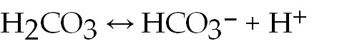

If the pH of blood increases, one would expect _____.
A) a decrease in the concentration of H2CO3 and an increase in the concentration of HCO3-
B) an increase in the concentration of H2CO3 and a decrease in the concentration of HCO3-
C) a decrease in the concentration of HCO3- and an increase in the concentration of H+
D) an increase in the concentration of HCO3- and a decrease in the concentration of OH-
E) a decrease in the concentration of HCO3- and an increase in the concentration of H2CO3 and H+
Answer: A
Bloom's Taxonomy: Application/Analysis
Section: 2.2

38) Based on your knowledge of the polarity of water molecules, the solute molecule depicted here is most likely _____.
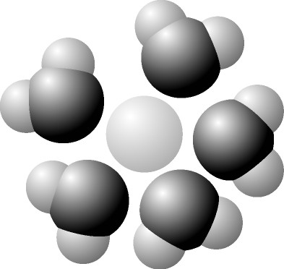

A) positively charged
B) negatively charged
C) without charge
D) hydrophobic
E) nonpolar
Answer: A
Bloom's Taxonomy: Application/Analysis
Section: 2.2

39) You have two beakers. One contains pure water, the other contains pure methanol (wood alcohol). The covalent bonds of methanol molecules are nonpolar, so there are no hydrogen bonds among methanol molecules. You pour crystals of table salt (NaCl) into each beaker. Predict what will happen.
A) Equal amounts of NaCl crystals will dissolve in both water and methanol.
B) NaCl crystals will not dissolve in either water or methanol.
C) NaCl crystals will dissolve readily in water but will not dissolve in methanol.
D) NaCl crystals will dissolve readily in methanol but will not dissolve in water.
E) When the first crystals of NaCl are added to water or to methanol, they will not dissolve; but as more crystals are added, the crystals will begin to dissolve faster and faster.
Answer: C
Bloom's Taxonomy: Application/Analysis
Section: 2.2

40) Why are hydrocarbons insoluble in water?
A) The majority of their bonds are polar covalent carbon-to-hydrogen linkages.
B) The majority of their bonds are nonpolar covalent carbon-to-hydrogen linkages.
C) They are hydrophilic.
D) They exhibit considerable molecular complexity and diversity.
E) They are less dense than water.
Answer: B
Bloom's Taxonomy: Knowledge/Comprehension
Section: 2.2

41) Which of the following is true for this reaction?

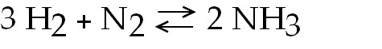

A) The reaction is nonreversible.
B) Hydrogen and nitrogen are the reactants of the reverse reaction.
C) Hydrogen and nitrogen are the products of the forward reaction.
D) Ammonia is being formed and decomposed simultaneously.
E) Only the forward or reverse reactions can occur at one time.
Answer: D
Bloom's Taxonomy: Knowledge/Comprehension
Section: 2.3

42) Which of the following correctly describes all chemical equilibrium?
A) Forward and reverse reactions continue with no net effect on the concentrations of the reactants and products.
B) Concentrations of products are higher than the concentrations of the reactants.
C) There are equal concentrations of products and reactants while forward and reverse reactions continue.
D) Reactions stop only when all reactants have been converted to products.
E) There are equal concentrations of reactants and products, and the reactions have stopped.
Answer: A
Bloom's Taxonomy: Knowledge/Comprehension
Section: 2.3

43) Which of the following correctly describes a reaction that has reached chemical equilibrium?
A) The concentration of the reactants equals the concentration of the products.
B) The rate of the forward reaction is equal to the rate of the reverse reaction.
C) All of the reactants have been converted to the products of the reaction.
D) All of the products have been converted to the reactants of the reaction.
E) Both the forward and the reverse reactions have stopped, with no net effect on the concentration of the reactants and the products.
Answer: B
Bloom's Taxonomy: Knowledge/Comprehension
Section: 2.3

44) Consider the following reaction at equilibrium: 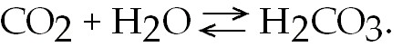What would be the effect of adding additional H2CO3?
A) It would drive the equilibrium dynamics to the right.
B) It would drive the equilibrium dynamics to the left.
C) Nothing would happen, because the reactants and products are in equilibrium.
D) The amounts of CO2 and H2O would decrease.
Answer: B
Bloom's Taxonomy: Application/Analysis
Section: 2.3

45) Which of the following is the most spontaneous reaction? A reaction that is _____.
A) slightly exothermic and leads to a slight increase in entropy
B) slightly endothermic and leads to a huge decrease in entropy
C) highly exothermic and leads to a huge decrease in entropy
D) slightly exothermic and leads to a huge increase in entropy
Answer: D
Bloom's Taxonomy: Knowledge/Comprehension
Section: 2.3

46) Why are some reactions exothermic?
A) The products have lower potential energy than the reactants.
B) They are spontaneous.
C) They are not spontaneous.
D) The products have higher entropy than the reactants.
Answer: A
Bloom's Taxonomy: Knowledge/Comprehension
Section: 2.3

47) Ice melts spontaneously at room temperature, even though the process is endothermic. How is this possible?
A) ΔH is small, so melting still obeys the second law of thermodynamics.
B) The Gibbs free-energy relationship does not apply to phase changes such as melting.
C) Water has a very high specific heat.
D) There is a large increase in entropy.
Answer: D
Bloom's Taxonomy: Application/Analysis
Section: 2.3

48) What does it mean to say a system has a ∆G equal to zero?
A) The system does not release or absorb heat.
B) The system is perfectly ordered (no entropy).
C) The total amount of potential energy in the system is zero.
D) The system is at equilibrium.
Answer: D
Bloom's Taxonomy: Knowledge/Comprehension
Section: 2.3

49) In the Gibbs free-energy relationship, why is the T term necessary?
A) The free-energy change caused by a change in entropy is a function of temperature.
B) The free-energy change caused by a change in potential energy is a function of temperature.
C) The free-energy change caused by a change in electrical charge is a function of temperature.
Answer: A
Bloom's Taxonomy: Knowledge/Comprehension
Section: 2.3

50) Why do chemical reactions tend to speed up when the concentration of the reactants is increased?
A) The reactants move faster.
B) The reactants collide more often.
C) The reactants have greater energy.
D) All of the listed responses are correct.
Answer: B
Bloom's Taxonomy: Knowledge/Comprehension
Section: 2.3

51) Which of the following always tends to make chemical reactions spontaneous?
A) The reactants have lower potential energy than the products.
B) The reactants are more ordered than the products.
C) The temperature is low.
D) The pressure is low.
Answer: B
Bloom's Taxonomy: Knowledge/Comprehension
Section: 2.3

52) _____ atoms give organic molecules their overall shape; _____ atoms determine the overall chemical behavior of organic molecules.
A) Carbon; H, N, and O
B) Hydrogen; C, N, and O
C) Carbon; H2O
D) H, N, and O; carbon
Answer: A
Bloom's Taxonomy: Knowledge/Comprehension
Section: 2.3

53) Which of the following is true of carbon?
A) It forms only polar molecules.
B) It can form a maximum of three covalent bonds with other elements.
C) It is highly electronegative.
D) It can form both polar and nonpolar bonds.
Answer: D
Bloom's Taxonomy: Knowledge/Comprehension
Section: 2.4

54) During chemical evolution, which of the following occurred in the molecules involved?
A) Entropy decreased while potential energy increased.
B) Entropy increased while potential energy increased.
C) Entropy stayed constant while potential energy increased.
Answer: A
Bloom's Taxonomy: Application/Analysis
Section: 2.4

55) The first chemicals that provided potential energy on Earth may have been formaldehyde and hydrogen cyanide. While these were produced by sunlight-driven reactions, they also occurred around deep-sea vents. If the first organisms on Earth evolved around these vents, the first life on Earth was _____.
A) photosynthetic, obtaining energy from the Sun
B) chemosynthetic, obtaining energy from chemicals
C) herbivorous, obtaining energy from plants
D) carnivorous, obtaining energy from animals
Answer: B
Bloom's Taxonomy: Application/Analysis
Section: 2.4

56) Stanley Miller's 1953 experiments supported the hypothesis that _____.
A) life on Earth arose from simple inorganic molecules
B) organic molecules can be synthesized abiotically under conditions that may have existed on early Earth
C) life on Earth arose from simple organic molecules, with energy from lightning and volcanoes
D) the conditions on early Earth were conducive to the origin of life
E) the conditions on early Earth were conducive to the abiotic synthesis of organic molecules
Answer: B
Bloom's Taxonomy: Synthesis/Evaluation
Section: 2.4

57) Which of the functional groups below acts most like an acid in water?
A) amino
B) carbonyl
C) carboxyl
D) hydroxyl
Answer: C
Bloom's Taxonomy: Knowledge/Comprehension
Section: 2.5

58) Why is carbon so important in biology?
A) It is a common element on Earth.
B) It has very little electronegativity, making it a good electron donor.
C) It bonds to only a few other elements.
D) It can form a variety of carbon skeletons and host functional groups.
Answer: D
Bloom's Taxonomy: Knowledge/Comprehension
Section: 2.5

59) The complexity and variety of organic molecules is due to _____.
A) the chemical versatility of carbon atoms
B) the variety of rare elements in organic molecules
C) the diverse bonding patterns of nitrogen
D) their interaction with water
E) their tremendously large sizes
Answer: A
Bloom's Taxonomy: Knowledge/Comprehension
Section: 2.5

60) A carbon atom is most likely to form what kind of bond(s) with other atoms?
A) ionic
B) hydrogen
C) covalent
D) covalent bonds and hydrogen bonds
E) ionic bonds, covalent bonds, and hydrogen bonds
Answer: C
Bloom's Taxonomy: Knowledge/Comprehension
Section: 2.5

