Earth: An Introduction to Physical Geology, 10e (Tarbuck/Lutgens/Tasa)
Chapter 1 An Introduction to Geology

1.1 Multiple-Choice Questions

1) What are the basic differences between the disciplines of physical and historical geology?
A) Physical geology is the study of fossils and sequences of rock strata; historical geology is the study of how rocks and minerals were used in the past.
B) Historical geology involves the study of rock strata, fossils, and geologic events, utilizing the geologic time scale as a reference; physical geology includes the study of how rocks form and of how erosion shapes the land surface.
C) Physical geology involves the study of rock strata, fossils, and deposition in relation to plate movements in the geologic past; historical geology charts how and where the plates were moving in the past.
D) None of the abovephysical geology and historical geology are essentially the same.
Answer: B
Diff: 1

2) ________ was the highly influential, ancient Greek philosopher noted for his writings and teachings on natural philosophy and on the workings of Earth.
A) Nero
B) Odysseus
C) Aristotle
D) Pappagapolis
Answer: C
Diff: 1

3) Compared to the age of Earth accepted as correct today, how did 17th and 18th century proponents of catastrophism envision the Earth's age?
A) They believed Earth to be much older than current estimates.
B) They believed it to be about the same as current estimates, give or take a few million years.
C) They believed Earth to be much younger than current estimates.
D) None of the above  they didn't really address the age of Earth.
Answer: C
Diff: 1

4) ________ was an important 18th-century English geologist and proponent of uniformitarianism.
A) Charles Lyell
B) Isaac Newton
C) James Hutton
D) James Ussher
Answer: C
Diff: 1
5) The currently accepted age of Earth is ________ years.
A) 4.6 thousand
B) 6.4 trillion
C) 4.6 billion
D) 6.4 million
Answer: C
Diff: 1

6) Which of the following best describes the fundamental concept of superposition?
A) Strata with fossils are generally deposited on strata with no fossils.
B) Older strata generally are deposited on younger strata without intervening, intermediate age strata.
C) Older fossils in younger strata indicate a locally inverted geologic time scale.
D) Any sedimentary deposit accumulates on top of older rock or sediment layers.
Answer: D
Diff: 1

7) The ________ division of the geologic time scale is an era of the Phanerozoic eon.
A) Paleocene
B) Paleozoic
C) Permian
D) Proterozoic
Answer: B
Diff: 1

8) The ________ forms the relatively cool, brittle plates of plate tectonics.
A) asthenosphere
B) lithosphere
C) astrosphere
D) eosphere
Answer: B
Diff: 1

9) A ________ is a well-tested and widely accepted view that best explains certain scientific observations.
A) hypothesis
B) generalization
C) law
D) theory
Answer: D
Diff: 1

10) All of the following are possible steps of scientific investigation except for ________.
A) the collection of scientific facts through observation and measurement
B) assumption of conclusions without prior experimentation or observation
C) the development of one or more working hypotheses or models to explain facts
D) development of observations and experiments to test the hypotheses
Answer: B
Diff: 1
11) ________ rocks form by crystallization and consolidation of molten magma.
A) Sedimentary
B) Indigenous
C) Primary
D) Igneous
Answer: D
Diff: 1

12) ________ rocks always originate at the surface of the solid Earth.
A) Secondary
B) Igneous
C) Metamorphic
D) Sedimentary
Answer: D
Diff: 1

13) In correct order from the center outward, Earth includes which units?
A) core, inner mantle, outer mantle, crust
B) inner core, outer core, mantle, crust
C) inner core, crust, mantle, hydrosphere
D) core, crust, mantle, hydrosphere
Answer: B
Diff: 1

14) The ________ refers to the sum total of all life on Earth.
A) hydrosphere
B) atmosphere
C) biosphere
D) asthenosphere
Answer: C
Diff: 1

15) A ________ system is one in which energy moves freely in and out, but no matter enters or leaves the system.
A) closed
B) open
C) feedback
D) equilibrated
Answer: A
Diff: 1
16) ________ is often paraphrased as "the present is the key to the past."
A) Biblical prophecy
B) Uniformitarianism
C) Aristotelian logic
D) Catastrophism
Answer: B
Diff: 1
17) ________, a popular natural philosophy of the 17th and early 18th centuries, was based on a firm belief in a very short geologic history for Earth.
A) Ecospherism
B) Exoschism
C) Uniformitarianism
D) Catastrophism
Answer: D
Diff: 1

18) The ________ proposes that the bodies of our solar system formed at essentially the same time from a rotating cloud of gases and dust.
A) Big Bang theory
B) Plate Tectonics theory
C) Nebular hypothesis
D) Heliocentric theory
Answer: C
Diff: 1

19) The ________ is not a part of the Earth's physical environment.
A) solid Earth
B) astrosphere
C) hydrosphere
D) atmosphere
Answer: B
Diff: 1

20) ________ is the process by which rocks breakdown in place to produce soils and sediments.
A) Weathering
B) Lithification
C) Subduction
D) Metamorphism
Answer: A
Diff: 1

21) Which one of the following statements is not correct?
A) Metamorphic rocks may melt to magma.
B) Sedimentary rocks may weather to igneous rocks.
C) Magmas crystallize to form igneous rocks.
D) Igneous rocks can undergo metamorphism.
Answer: B
Diff: 1

22) The composition of the core of Earth is thought to be ________.
A) basalt
B) granite
C) peridotite
D) solid iron-nickel alloy
Answer: D
Diff: 1
23) The asthenosphere is actually a part of the ________ of the Earth.
A) outer core
B) crust
C) inner core
D) mantle
Answer: D
Diff: 1

24) The ________ is thought to be a liquid, metallic region in the Earth's interior.
A) inner core
B) lithosphere
C) mantle
D) outer core
Answer: D
Diff: 1

25) The ________ is the thinnest layer of the Earth.
A) crust
B) outer core
C) mantle
D) inner core
Answer: A
Diff: 1

26) All of the following provide evidence or clues to the composition of Earth's interior except for ________.
A) diamond-bearing rocks
B) slivers of crustal and mantle rocks now exposed at Earth's surface
C) comets
D) meteorites
Answer: C
Diff: 1
27) The relatively stable interior portion of a continent is known as a ________.
A) craton
B) shield
C) platform
D) belt
Answer: A
Diff: 1

28) Active mountain belts are most likely to be found ________.
A) along the margins of continents
B) in the interior regions of continents
C) scattered throughout continents
D) along only the eastern margins of continents
Answer: A
Diff: 1
29) The continental shelf is located ________.
A) between the continental slope and continental rise
B) between the continental rise and the abyssal plains
C) seaward of the continental slope
D) landward of the continental slope
Answer: D
Diff: 1

30) The most prominent features on the ocean floor are the ________.
A) deep-ocean trenches
B) oceanic ridges
C) seamounts
D) lava plateaus
Answer: B
Diff: 1

31) In sedimentary rocks, lithification includes ________.
A) compaction and cementation
B) cementation and weathering
C) compaction and transportation
D) crystallization and cooling
Answer: A
Diff: 1

1.2 Word Analysis Questions

Examine the words and/or phrases for each question below and determine the relationship among the majority of words/phrases. Choose the option which does not fit the pattern.

1) A) hypothesis
B) theory
C) fact
D) observation
Answer: fact
Diff: 1

2) A) hydrosphere
B) biosphere
C) atmosphere
D) solid earth
Answer: biosphere
Diff: 1

3) A) protosun
B) oort cloud
C) protoplanets
D) meteorites
Answer: oort cloud
Diff: 2
4) A) crust
B) mantle
C) lithosphere
D) core
Answer: lithosphere
Diff: 1

5) A) mountain belt
B) shield
C) craton
D) stable platform
Answer: mountain belt
Diff: 1

6) A) abyssal plain
B) seamouont
C) oceanic ridge
D) continental slope
Answer: continental slope
Diff: 1

7) A) pressure
B) foliation
C) hydrothermal fluids
D) melting
Answer: melting
Diff: 1

1.3 True/False Questions

1) Aristotle and other prominent Greek philosophers were the first ones to promote the doctrine of uniformitarianism.
Answer: FALSE
Diff: 1

2) Internally, the Earth consists of spherical shells with different compositions and densities.
Answer: TRUE
Diff: 1

3) The asthenosphere is a relatively cool and rigid shell that overlies the lithosphere.
Answer: FALSE
Diff: 1

4) The doctrine of uniformitarianism implies that the current forces and processes shaping the Earth have been operating for a very long time.
Answer: TRUE
Diff: 1

5) The law of superposition applies primarily to sedimentary rocks and lava flows.
Answer: TRUE
Diff: 1
6) The currently accepted age of Earth is approximately 4.5 million years.
Answer: FALSE
Diff: 1

7) A scientific theory is a tentative or untested explanation that is proposed to explain scientific observations.
Answer: FALSE
Diff: 1

8) Oceans cover slightly less than half of the Earth's surface.
Answer: FALSE
Diff: 1

9) In an open system both energy and matter flow into and out of the system.
Answer: TRUE
Diff: 1

10) According to the nebular hypothesis, all of the bodies in the universe evolved from a rotating cloud of gases and dust about 5 billion years ago.
Answer: FALSE
Diff: 1

11) The lithosphere and asthenosphere are both layers of Earth defined by their composition.
Answer: TRUE
Diff: 1

12) Much of our modeling of Earth's interior comes from the study of seismic or earthquake waves.
Answer: TRUE
Diff: 2

13) Continental shields and stable platforms are part of the interior region known as a craton.
Answer: TRUE
Diff: 1

14) According to the rock cycle, any type of rock (igneous, sedimentary, or metamorphic) may be transformed into another type of rock, given enough time.
Answer: TRUE
Diff: 1

15) Igneous rocks are produced largely by the deposition and consolidation of surface materials like sand and mud.
Answer: FALSE
Diff: 1

1.4 Short Answer Questions

1) List the two, broad, traditional subject areas of geologic study.
Answer: physical and historical geology
Diff: 1
2) The statement "the present is the key to the past," describes what basic geologic concept or doctrine?
Answer: uniformitarianism
Diff: 1

3) The ________ states that fossil organisms succeed one another in a definite and determinable order.
Answer: principle of fossil succession
Diff: 1

4) In natural systems, mechanisms that drive or enhance change are called ________.
Answer: positive feedback mechanisms
Diff: 1

5) The thin, outer layer of Earth, from 7 to 40 km in thickness, is called the ________.
Answer: crust
Diff: 1

6) The ________ is the relatively rigid zone above the asthenosphere that includes the crust and upper mantle.
Answer: lithosphere
Diff: 1

7) The ________ is the solid, rocky shell between the crust and outer core.
Answer: mantle
Diff: 1

8) The convective flow of liquid, metallic iron in the ________ is thought to generate Earth's magnetic field.
Answer: outer core
Diff: 1

9) Moving from the shoreline towards the deep-ocean basin, the continental margin may include the ________, ________, and the ________.
Answer: continental shelf, continental slope, continental rise
Diff: 1

10) What type of rock comprises most of the exposed surface of Earth (roughly 75%)?
Answer: sedimentary
Diff: 1

1.5 Critical Thinking Questions

Use complete sentences, correct spelling, and the information presented in Chapter 1 to answer the question(s) below.

1) Aside from near oceanic trenches, most earthquakes originate at depths of 100 kilometers or less. Considering the physical properties of Earth's interior, what type of mechanical behavior (in rocks) must be necessary for earthquakes to occur? Explain.
Diff: 2
2) Catastrophism obviously influenced seventeenth and eighteenth century thought by implying that Earth only needed to be a few thousand years old to explain landscapes and geologic features. However, catastrophic and often sudden changes are at least a part of the rock record that geologist's attempt to interpret. List three geologic catastrophes that would most likely affect landscapes or features on Earth and be recorded in rocks. How might these events be explained in the rock record using only uniformitarianism (or the implication of slow, gradual change)?
Diff: 3

3) Earth's physical environment is traditionally divided in the hydrosphere, atmosphere, and the solid Earth. Remembering the scientific method, why do you think that scientists tend to categorize and classify various features, phenomena, and characteristics of the natural world into groups or subdivisions? Also, are there potential pitfalls or problems if we only consider the natural world as individual groups or categories rather than as a whole?
Diff: 3

1.6 Visualization Questions

1) Label the layers of Earth's interior on the diagram below.

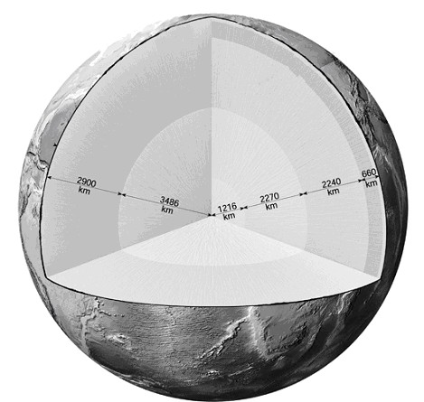

Answer: See figure 1.16 in chapter 1 of Earth, 10e
Diff: 1
2) On the seafloor profile below, fill in the blanks with the correct name of the feature that is labeled.

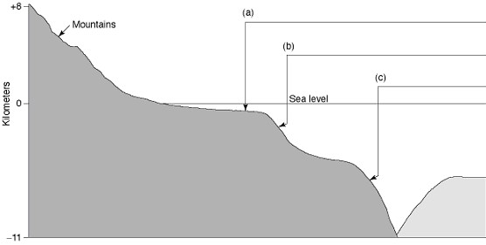

Answer: a) continental shelf b) continental slope c) oceanic trench
Diff: 1

3) Fill in the blanks with the correct name of the feature that is labeled.

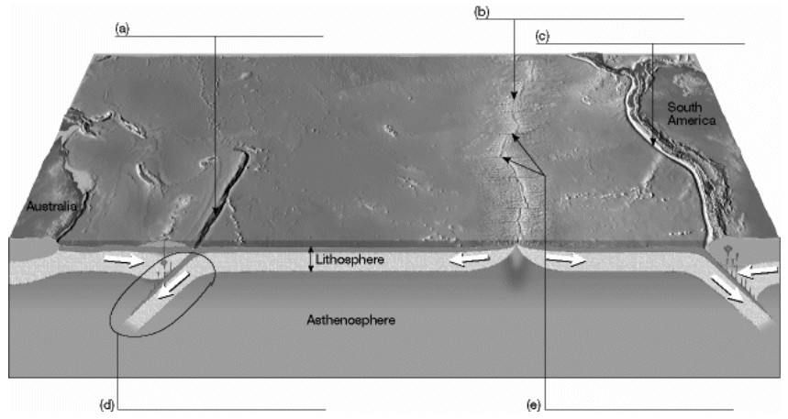

Answer: a) oceanic trench b) oceanic ridge c) oceanic trench d) subduction zone
e) transform faults
Diff: 1
4) In the spaces provided, describe what happens during the rock cycle.

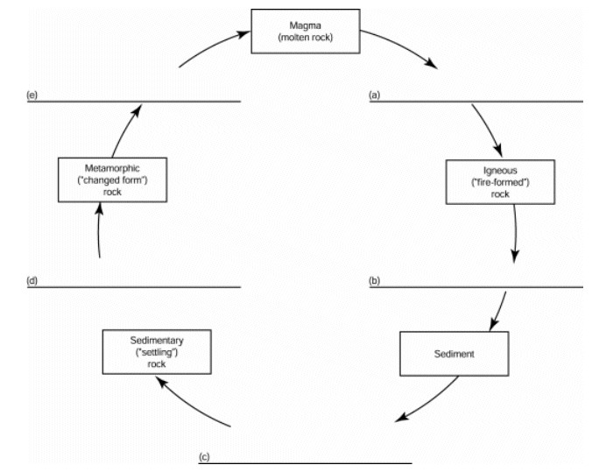

Answer: a) cooling and crystallization b) weathering, transportation, and deposition
c) compaction and cementation d) heat and pressure e) melting
Diff: 2

