Solutions Manual

to accompany

Australasian Business Statistics
3rd Edition

Prepared by
Miriam Krakovska



© John Wiley & Sons Australia, Ltd 2012

Chapter 2 - Charts and Graphs

SOLUTIONS TO PROBLEMS IN CHAPTER 2

2.1 (a) $\text{Class} \text{width}=\frac{\text{Maximum} \text{value}−\text{Minimum} \text{value}}{\text{No}\text{.} \text{of} \text{classes}}=\frac{\text{234}\text{.}1−3\text{.}3}{5}=\text{46}\text{.}\text{16}≈\text{50}$

Class | Frequency
(0,50] | 81
(50,100] | 41
(100, 150] | 8
(150,200] | 2
(200,250] | 1

(b)
$\text{Class} \text{width}=\frac{\text{Maximum} \text{value}−\text{Minimum} \text{value}}{\text{No}\text{.} \text{of} \text{classes}}=\frac{\text{234}\text{.}1−3\text{.}3}{\text{10}}=\text{23}\text{.}\text{08}≈\text{25}$

Class | Frequency
(0,25] | 33
(25,50] | 48
(50, 75] | 28
(75,100] | 13
(100,125] | 4
(125,150] | 4
(150, 175] | 0
(175,200] | 2
(200,225] | 0
(225,250] | 1

(c) The frequency distribution table in part a) reveals that the national debt of countries ranges from 0% to 250% of their GDP. About 60% of the countries have a national dept that represents up to 50% of their GDP. The national debt of approximately 31% of counties represents between 50% and 100% of their GDP. Approximately 8% of the counties have a national dept that exceeds 100% of their GDP.

The table in part b) shows the frequency distribution in more details. In particular, it shows that about 25% of the countries have a national debt that represents 25% or less of their GDP and that there is at least one country with a national debt representing between 225% and 250% of its GDP.

2.2 One possible frequency distribution is the one below with 12 classes and class widths of 2.

Class Interval Frequency
(38,40] 2
(40,42] 1
(42,44] 5
(44,46] 10
(46,48] 18
(48,50] 13
(50,52] 15
(52, 54] 15
(54, 56] 7
(56, 58] 9
(58, 60] 4
(60, 62] 1

Almost 80% of the sample comes within 5 raisins of attaining the intended figure. Three per cent, on the other hand, fall short or exceed the intended figure by 10 raisins or more.

2.3
Class Class Relative Cumulative
Interval Frequency Midpoint Frequency Frequency
(0,5] 6 2.5 6/86 = .0698 6
(5,10] 8 7.5 .0930 14
(10,15] 17 12.5 .1977 31
(15,20] 23 17.5 .2674 54
(20,25] 18 22.5 .2093 72
(25,30] 10 27.5 .1163 82
(30,35] 4 32.5 .0465 86
TOTAL 86 1.0000

The relative frequency tells us that it is most probable that a customer is in the 15–20 category (.2674). Over two-thirds (.6744) of the customers are between 10 and 25 years of age.

2.4
Class Class Relative Cumulative
Interval Frequency Midpoint Frequency Frequency
(0,2] 218 1 .436 218
(2,4] 207 3 .414 425
(4,6] 56 5 .112 481
(6,8] 11 7 .022 492
(8,10] 8 9 .016 500
TOTAL 500 1.0000

Assuming that the absenteeism is expressed in days, in the past year, 85% of the employees were absent for 4 days or less and all of the employees were absent for 10 days or less.

2.5 Some examples of cumulative frequencies in business:
- sales for the fiscal year,
- costs for the fiscal year,
- spending for the fiscal year,
- inventory build-up,
- accumulation of workers during a hiring buildup,
- production output over a time period.

2.6 Histogram
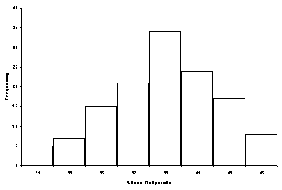

Frequency Polygon
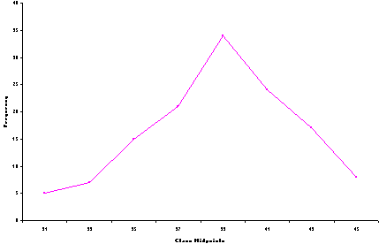

2.7 Histogram
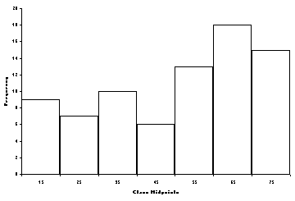

Frequency Polygon

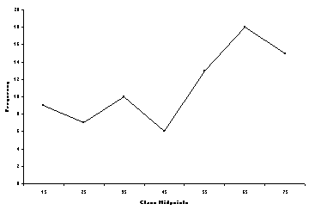

2.8 Ogive

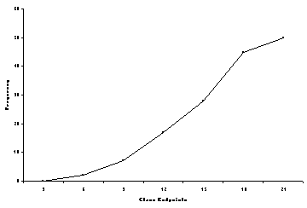

2.9 STEM LEAF

21 2889
22 012466799
23 0045889999
24 0036999
25 034557789
26 01123356
27 01

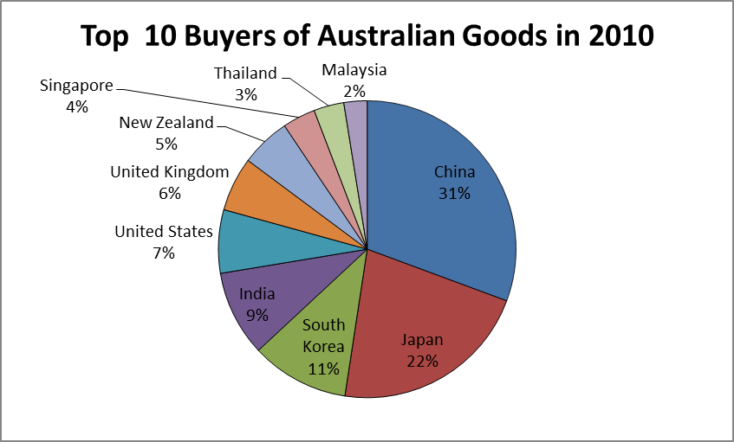
2.10

This pie chart is effective if the researcher is interested in only the top 10 buyers of Australian goods in 2010. However, if they are interested in all buyers of Australian goods in 2010, then a category representing ‘other’ buyers should also be included.

2. 11
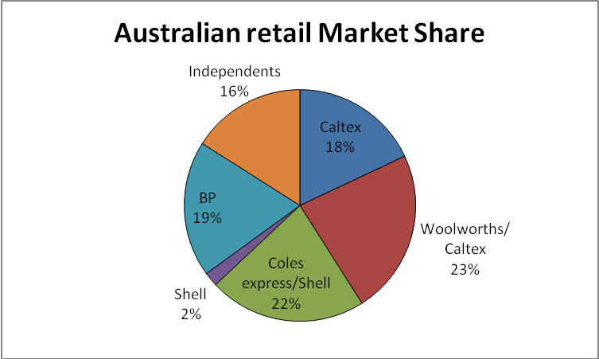

2.12
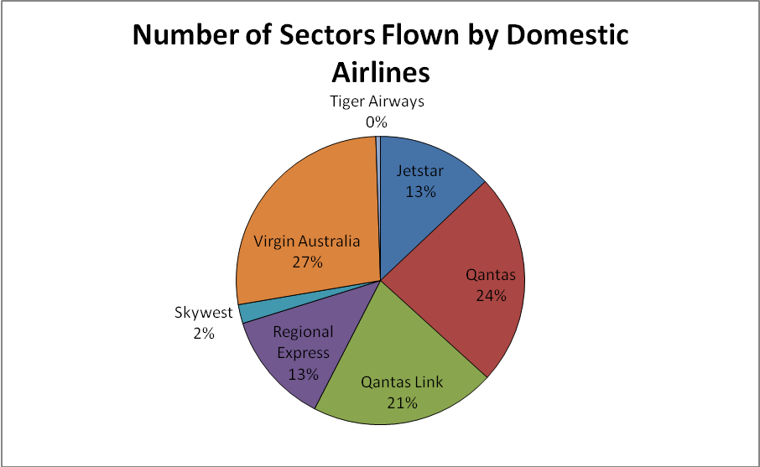

The Australian domestic airlines with the largest number of sectors flown in August 2011 were Virgin Australia (27%), Qantas (24%) and Qantas link (21%).

2.13 Stem Leaf

137 | 56
138 | 455555555577999999
139 | 3355559999999999999999999
140 |
141 |
142 | 9
143 | 9
144 |
145 |
146 |
147 | 9
148 |
149 | 9
150 |
151 | 9

The stem and leaf plot shows that petrol prices were mostly between 138.5 cents and 139.9 cents per litre. Most of the prices are less than 140 cents with only five between 142 cents and 152 cents.

2.14
Complaint Number % of Total

Busy Signal 420 56.5
Too long a Wait 184 24.7
Could not get through 85 11.4
Get Disconnected 37 4.0
Transferred to the Wrong Person 10 1.3
Poor Connection 8 1.1
Total 744 100.0

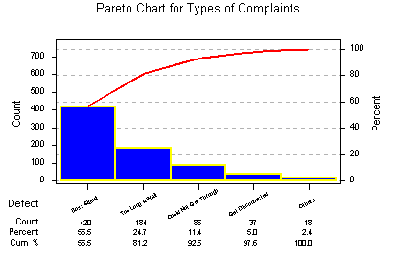

2.15

There are two outliers in the data, one corresponding to China (mainland), for which the number of visitors is low although the number of students is high and the other corresponding to Singapore, for which the number of visitors is high but the number of students is low. If we ignore these outliers, then the scatter plot indicates a strong positive relationship between the number of visitors and the number of international students. However, the data is sparse at the high end of visitors containing only two points, so it is not clear if the relationship is actually as strong as it seems.

2.16
There seems to be a positive relationship between Sales and Advertising

2.17 Class Interval Frequencies

(16, 23] 8
(23, 30] 7
(30, 37] 4
(37, 44] 4
(44, 51] 5
(51, 58] 2
TOTAL 30

2.18 Class Interval Frequency Midpoint Rel. Freq. Cum. Freq.

(20, 25] 17 22.5 .207 .207
(25, 30] 20 27.5 .244 .451
(30, 35] 16 32.5 .195 .646
(35, 40] 15 37.5 .183 .829
(40, 45] 8 42.5 .098 .927
(45, 50] 6 47.5 .073 1.000

2.19 Label Value Proportion Degrees

A 55 .180 65
B 121 .397 143
C 83 .272 98
D 46 .151 54
TOTAL 305 1.000 360

Pie Chart
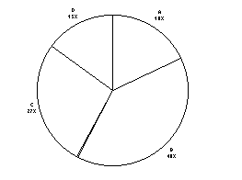

2.20 STEM LEAF

28 4, 6, 9
29 0, 4, 8
30 1, 6, 8, 9
31 1, 2, 4, 6, 7, 7
32 4, 4, 6
33 5

2.21 Problem Frequency Percent of Total
1 673 26.96
2 29 1.16
3 108 4.33
4 379 15.18
5 73 2.92
6 564 22.60
7 12 0.48
8 402 16.11
9 54 2.16
10 202 8.09
2496

Pareto Chart:
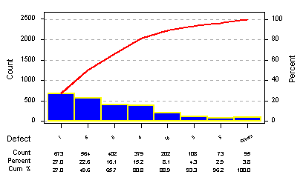

2.22

2.23
Class Class Class Relative Cumulative
Interval Frequency Midpoint Frequency Frequency
(20, 25] 8 22.5 8/53 = .1509 8
(25, 30] 6 27.5 .1132 14
(30, 35] 5 32.5 .0943 19
(35, 40] 12 37.5 .2264 31
(40, 45] 15 42.5 .2830 46
(45, 50] 7 47.5 .1321 53
TOTAL 53 .9999

2.24 Class Interval Frequency
(0.9, 1.1] 2
(1.1, 1.3] 12
(1.3, 1.4] 8
(1.4, 1.5] 10
(1.5, 1.6] 10
(1.6, 1.7] 5
(1.7, 1.8] 2
(1.8, 2.0] 1

The frequency distribution shows that most of the rings have weight in the range 1.1 kg to 1.5 kg. Two rings are in the range 0.9 to 1.1 kg, and three are more than 1.7 kg.

2.25 Cumulative
Asking Price ($000) Frequency Frequency

(120,130] 21 21
(130,140] 27 48
(140,150] 18 66
(150,160] 11 77
(160,170] 6 83
(170,180] 3 86
(180,190] 4 90
90

Histogram

Frequency Polygon

Ogive

2.26
Expense | Percentage
Technical support | 11
Project management | 5
Administrative support | 3
Other overhead | 2
Development | 17
Research | 62
Pie Chart

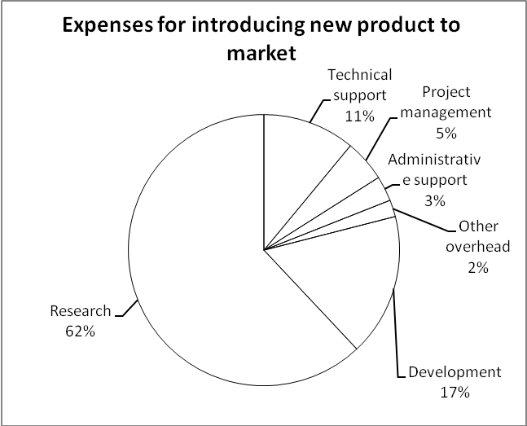

Pareto Chart

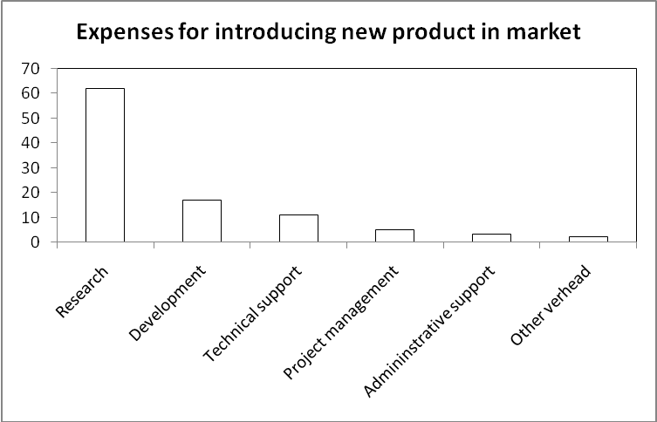

The two plots show that the major expense in introducing a new product into the market is research at 62%, followed by development at 17%. Technical support is a close third at 11%, and all the other costs are 5% or less. Such information should be used as a guide by corporations who are interested in developing and introducing new products.

2.27
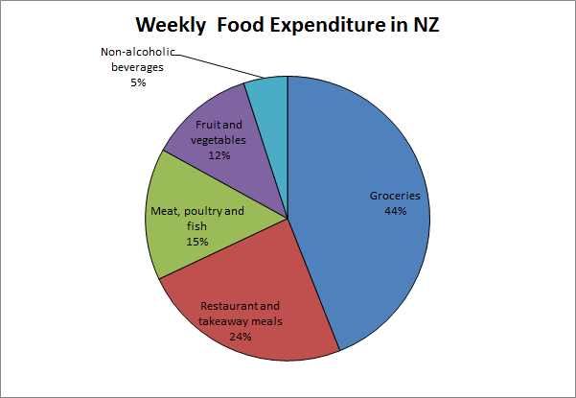

2.28

2.29 The fewest number of audits is 12 and the most is 42. More companies (8) performed 27 audits than any other number. Thirty-five companies performed between 12 and 19 audits. Only 7 companies performed 40 or more audits.

2.30 There were relatively constant sales from January through August. Toy sales at this company dramatically increased at the end-of-year period between November and December

