Essentials of Geology, 10e (Lutgens/Tarbuck/Tasa)

Chapter 1

An Introduction to Geology

1)

What are the basic differences between the disciplines of physical and historical geology?

A)

physical geology is the study of fossils and sequences of rock strata; historical geology is the study of how rocks and minerals were used in the past

B)

historical geology involves the study of rock strata, fossils, and geologic events, utilizing the geologic time scale as a reference; physical geology includes the study of how rocks form and of how erosion shapes the land surface

C)

physical geology involves the study of rock strata, fossils, and deposition in relation to plate movements in the geologic past; historical geology charts how and where the plates were moving in the past

D)

none of the above – physical geology and historical geology are essentially the same

Answer:

B

Diff: 1

2)

________ was the highly influential, ancient Greek philosopher noted for his writings and teachings on natural philosophy and on the workings of Earth.

A)

Nero

B)

Odysseus

C)

Aristotle

D)

Pappagapolis

Answer:

C

Diff: 1

3)

Compared to the age of Earth accepted as correct today, how did 17th and 18th century proponents of catastrophism envision the Earth's age?

A)

They believed Earth to be much older than current estimates

B)

They believed it to be about the same as current estimates, give or take a few million years.

C)

They believed Earth to be much younger than current estimates

D)

None of the above — they didn't really address the age of Earth

Answer:

C

Diff: 1

4)

Which one of the following observations and inferences is consistent with the idea of uniformitarianism?

A)

sand rolling along a stream bottom shows that sediment is moving downstream

B)

erupting volcanoes overlie burning, subterranean, coal beds

C)

lava flows on the seafloor precipitated from seawater

D)

all of the above

Answer:

A

Diff: 1

5)

________ was an important 18th century English geologist and proponent of uniformitarianism.

A)

Charles Lyell

B)

Isaac Newton

C)

James Hutton

D)

James Ussher

Answer:

C

Diff: 1

6)

The currently accepted age of Earth is ________ years.

A)

4.6 thousand

B)

6.4 trillion

C)

4.6 billion

D)

6.4 million

Answer:

C

Diff: 1

7)

Which of the following best describes the fundamental concept of superposition?

A)

strata with fossils are generally deposited on strata with no fossils

B)

older strata generally are deposited on younger strata without intervening, intermediate age strata

C)

older fossils in younger strata indicate a locally inverted geologic time scale

D)

any sedimentary deposit accumulates on older rock or sediment layers

Answer:

D

Diff: 1

8)

The ________ division of the geologic time scale is an era of the Phanerozoic eon.

A)

Paleocene

B)

Paleozoic

C)

Permian

D)

Proterozoic

Answer:

B

Diff: 1

9)

The ________ forms the relatively cool, brittle plates of plate tectonics.

A)

asthenosphere

B)

lithosphere

C)

astrosphere

D)

eosphere

Answer:

B

Diff: 1

10)

A ________ is a well-tested and widely accepted view that best explains certain scientific observations.

A)

hypothesis

B)

generalization

C)

law

D)

theory

Answer:

D

Diff: 1

11)

All of the following are possible steps of scientific investigation except for ________.

A)

the collection of scientific facts through observation and measurement

B)

assumption of conclusions without prior experimentation or observation

C)

the development of one or more working hypotheses or models to explain facts

D)

development of observations and experiments to test the hypotheses

Answer:

B

Diff: 1

12)

________ rocks form by crystallization and consolidation of molten magma.

A)

Sedimentary

B)

Indigenous

C)

Primary

D)

Igneous

Answer:

D

Diff: 1

13)

________ rocks always originate at the surface of the solid Earth.

A)

Secondary

B)

Igneous

C)

Metamorphic

D)

Sedimentary

Answer:

D

Diff: 1

14)

During the late nineteenth and early twentieth centuries, direct observations showed that a glacier in Switzerland flowed forward in the downhill direction while its snout (terminus) was retreating higher up the valley? Which of the following explains these observations in a rational, scientific way?

A)

cooler temperatures meant slower forward glacier flow resulting in snout retreat

B)

the glacial hypothesis was finally accepted as a scientific theory

C)

rocky debris in the valley downhill from the snout was deposited by Noah's flood

D)

the melting rate of ice in the glacier exceeded the rate at which new snow and ice were added to the glacier

Answer:

D

Diff: 2

15)

In correct order from the center outward, Earth includes which units?

A)

core, inner mantle, outer mantle, crust

B)

inner core, outer core, mantle, crust

C)

inner core, crust, mantle, hydrosphere

D)

core, crust, mantle, hydrosphere

Answer:

B

Diff: 1

16)

The ________ refers to the sum total of all life on Earth.

A)

hydrosphere

B)

atmosphere

C)

biosphere

D)

asthenosphere

Answer:

C

Diff: 1

17)

A ________ system is one in which energy moves freely in and out, but no matter enters or leaves the system.

A)

closed

B)

open

C)

feedback

D)

equilibrated

Answer:

A

Diff: 1

18)

________ is often paraphrased as "the present is the key to the past."

A)

Biblical prophecy

B)

Uniformitarianism

C)

Aristotelian logic

D)

Catastrophism

Answer:

B

Diff: 1

19)

________, a popular natural philosophy of the 17th and early 18th centuries, was based on a firm belief in a very short geologic history for Earth.

A)

Ecospherism

B)

Exoschism

C)

Uniformitarianism

D)

Catastrophism

Answer:

D

Diff: 1

20)

The ________ proposes that the bodies of our solar system formed at essentially the same time from a rotating cloud of gases and dust.

A)

Big Band theory

B)

Plate Tectonics theory

C)

Nebular hypothesis

D)

Heliocentric theory

Answer:

C

Diff: 1

21)

The ________ is not a part of the Earth's physical environment.

A)

solid Earth

B)

astrosphere

C)

hydrosphere

D)

atmosphere

Answer:

B

Diff: 1

22)

________ is the process by which rocks breakdown in place to produce soils and sediments.

A)

Weathering

B)

Lithification

C)

Subduction

D)

Metamorphism

Answer:

A

Diff: 1

23)

Which one of the following statements is not correct?

A)

metamorphic rocks may melt to magma

B)

sedimentary rocks may weather to igneous rocks

C)

magmas crystallize to form igneous rocks

D)

igneous rocks can undergo metamorphism

Answer:

A

Diff: 1

24)

The composition of the core of Earth is thought to be ________.

A)

basalt

B)

granite

C)

peridotite

D)

solid iron-nickel alloy

Answer:

D

Diff: 1

25)

The asthenosphere is actually a part of the ________ of the Earth.

A)

outer core

B)

crust

C)

inner core

D)

mantle

Answer:

D

Diff: 1

26)

The ________ is thought to be a liquid, metallic region in the Earth's interior.

A)

inner core

B)

lithosphere

C)

mantle

D)

outer core

Answer:

D

Diff: 1

27)

The ________ is the thinnest layer of the Earth.

A)

crust

B)

outer core

C)

mantle

D)

inner core

Answer:

A

Diff: 1

28)

All of the following provide evidence or clues to the composition of Earth's interior except for ________.

A)

diamond-bearing rocks

B)

slivers of crustal and mantle rocks now exposed at Earth's surface

C)

comets

D)

meteorites

Answer:

C

Diff: 1

29)

The relatively stable interior portion of a continent is known as a ________.

A)

craton

B)

shield

C)

platform

D)

belt

Answer:

A

Diff: 1

30)

Active mountain belts are most likely to be found ________.

A)

along the margins of continents

B)

in the interior regions of continents

C)

scattered throughout continents

D)

along only the eastern margins of continents

Answer:

A

Diff: 1

31)

The continental shelf is located ________.

A)

between the continental slope and continental rise

B)

between the continental rise and the abyssal plains

C)

seaward of the continental slope

D)

landward of the continental slope

Answer:

D

Diff: 1

32)

The most prominent feature on the ocean floor are the ________.

A)

deep-ocean trenches

B)

oceanic ridges

C)

seamounts

D)

lava plateaus

Answer:

B

Diff: 1

33)

In sedimentary rocks, lithification includes ________.

A)

compaction and cementation

B)

cementation and weathering

C)

compaction and transportation

D)

crystallization and cooling

Answer:

A

Diff: 1

Word Analysis. Examine the words and/or phrases for each question below and determine the relationship among the majority of words/phrases. Choose the option which does not fit the pattern.

34)

a. hypothesis b. theory c. fact d. observation

Answer:

C

Diff: 1

35)

a. hydrosphere b. biosphere c. atmosphere d. solid Earth

Answer:

B

Diff: 1

36)

a. protosun b. Oort cloud c. protoplanets d. meteorites

Answer:

B

Diff: 2

37)

a. crust b. mantle c. lithosphere d. core

Answer:

C

Diff: 1

38)

a. mountain belt b. shield c. craton d. stable platform

Answer:

A

Diff: 1

39)

a. abyssal plain b. seamount c. oceanic ridge d. continental slope

Answer:

D

Diff: 1

40)

a. pressure b. foliation c. hydrothermal fluids d. melting

Answer:

D

Diff: 1

41)

Aristotle and other prominent Greek philosophers were the first ones to promote the doctrine of uniformitarianism.

Answer:

FALSE

Diff: 1

42)

Internally, the Earth consists of spherical shells with different compositions and densities.

Answer:

TRUE

Diff: 1

43)

The asthenosphere is a relatively cool and rigid shell that overlies the lithosphere.

Answer:

FALSE

Diff: 1

44)

The doctrine of uniformitarianism implies that the current forces and processes shaping the Earth have been operating for a very long time.

Answer:

TRUE

Diff: 1

45)

The law of superposition applies primarily to sedimentary rocks and lava flows.

Answer:

TRUE

Diff: 1

46)

The currently accepted age of Earth is approximately 4.5 million years.

Answer:

FALSE

Diff: 1

47)

A scientific theory is a tentative or untested explanation that is proposed to explain scientific observations.

Answer:

FALSE

Diff: 1

48)

Oceans cover slightly less than half of the Earth's surface.

Answer:

FALSE

Diff: 1

49)

In an open system both energy and matter flow into and out of the system.

Answer:

TRUE

Diff: 1

50)

According to the nebular hypothesis, all of the bodies in the universe evolved from a rotating cloud of gases and dust about 5 billion years ago.

Answer:

FALSE

Diff: 1

51)

The lithosphere, asthenosphere, and mesosphere are all layers of Earth defined by their composition.

Answer:

FALSE

Diff: 1

52)

Much of our modeling of Earth's interior comes from the study of seismic or earthquake waves.

Answer:

TRUE

Diff: 2

53)

Continental shields and stable platforms are part of the interior region known as a craton.

Answer:

TRUE

Diff: 1

54)

According to the rock cycle, any type of rock (igneous, sedimentary, or metamorphic) may be transformed into another type of rock, given enough time.

Answer:

TRUE

Diff: 1

55)

Igneous rocks are produced largely by the deposition and consolidation of surface materials like sand and mud.

Answer:

FALSE

Diff: 1

56)

List the two, broad, traditional subject areas of geologic study.

Answer:

physical and historical geology

Diff: 1

57)

The statement "the present is the key to the past," describes what basic geologic concept or doctrine?

Answer:

uniformitarianism

Diff: 1

58)

The ________ states that fossil organisms succeed one another in a definite and determinable order.

Answer:

principle of fossil succession

Diff: 1

59)

In natural systems, mechanisms that drive or enhance change are called ________.

Answer:

positive feedback mechanisms

Diff: 1

60)

The thin, outer layer of Earth, from 7 to 40 km in thickness, is called the ________.

Answer:

crust

Diff: 1

61)

The ________ is the relatively rigid zone above the asthenosphere that includes the crust and upper mantle.

Answer:

lithosphere

Diff: 1

62)

The ________ is the solid, rocky shell between the crust and outer core.

Answer:

mantle

Diff: 1

63)

The convective flow of liquid, metallic iron in the ________ is thought to generate Earth's magnetic field.

Answer:

outer core

Diff: 1

64)

Moving from the shoreline towards the deep-ocean basin, the continental margin may include the ________, ________, and the ________.

Answer:

continental shelf, continental slope, continental rise

Diff: 1

65)

What type of rock comprises most of the exposed surface of Earth (roughly 75%)?

Answer:

sedimentary

Diff: 1

Critical thinking and discussion questions. Use complete sentences, correct spelling, and the information presented in Chapter 1 to answer the questions below.

66)

Aside from near oceanic trenches, most earthquakes originate at depths of 100 kilometers or less. Considering the physical properties of Earth's interior, what type of mechanical behavior (in rocks) must be necessary for earthquakes to occur? Explain.

Diff: 2

67)

Catastrophism obviously influenced seventeenth and eighteenth century thought by implying that Earth only needed to be a few thousand years old to explain landscapes and geologic features. However, catastrophic and often sudden changes are at least a part of the rock record that geologist's attempt to interpret. List three geologic catastrophes that would most likely affect landscapes or features on Earth and be recorded in rocks. How might these events be explained in the rock record using only uniformitarianism (or the implication of slow, gradual change)?

Diff: 3

68)

Earth's physical environment is traditionally divided in the hydrosphere, atmosphere, and the solid Earth. Remembering the scientific method, why do you think that scientists tend to categorize and classify various features, phenomena, and characteristics of the natural world into groups or subdivisions? Also, are there potential pitfalls or problems if we only consider the natural world as individual groups or categories rather than as a whole?

Diff: 3

69)

Label the layers of Earth's interior on the diagram below.

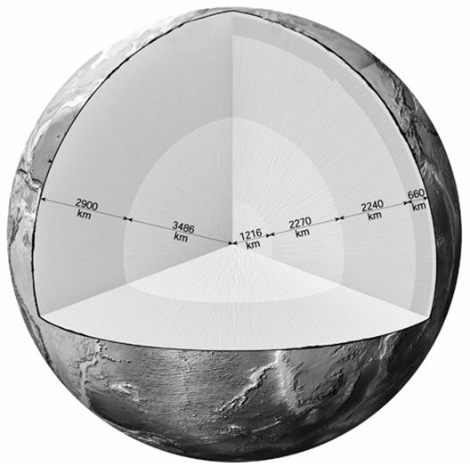

Answer:

See Figure 1.13 in chapter 1 of the Essentials of Geology, 10e textbook

Diff: 1

70)

On the seafloor profile below, fill in the blanks with the correct name of the feature that is labeled.

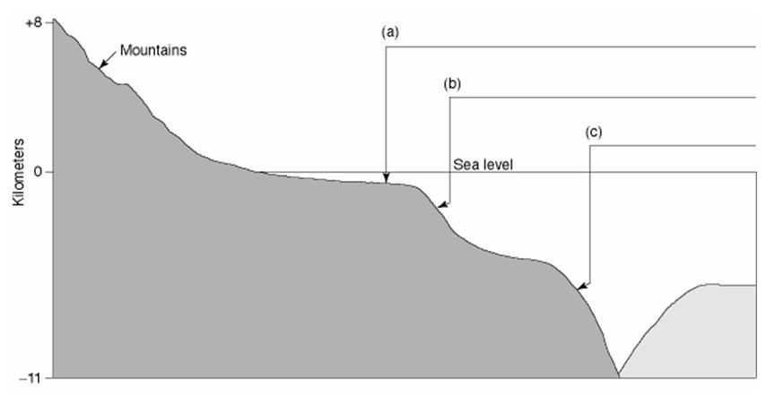

Answer:

(a) continental shelf (b) continental slope (c) oceanic trench

Diff: 1

71)

Fill in the blanks with the correct name of the feature that is labeled.

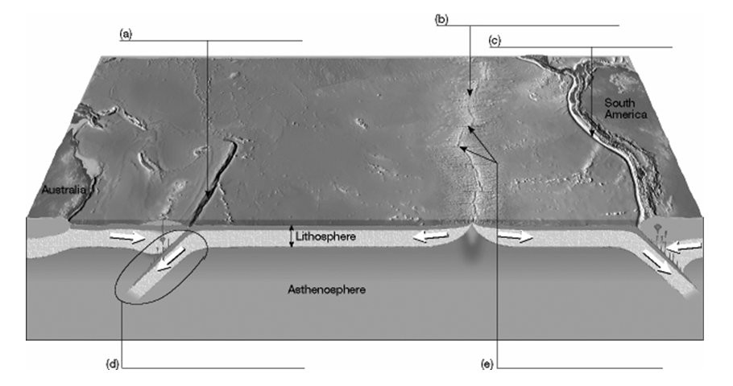

Answer:

(a) oceanic trench (b) oceanic ridge (c) oceanic trench (d) subduction zone (e) transform faults

Diff: 1

