Earth Science, 13e (Tarbuck)
Chapter 1 Introduction to Earth Science

1) What are the basic differences between the disciplines of physical and historical geology?
A) Physical geology is the study of fossils and sequences of rock strata; historical geology is the study of how rocks and minerals were used in the past.
B) Historical geology involves the study of rock strata, fossils, and geologic events, utilizing the geologic time scale as a reference; physical geology includes the study of how rocks form and of how erosion shapes the land surface.
C) Physical geology involves the study of rock strata, fossils, and deposition in relation to plate movements in the geologic past; historical geology charts how and where the plates were moving in the past.
D) none of the above – physical geology and historical geology are essentially the same.
Answer: B
Diff: 1
Topic: 1.1 What Is Earth Science?
Bloom's: Analyzing

2) The study of Earth's atmosphere is known as ________.
A) astronomy
B) oceanography
C) meteorology
D) cosmology
Answer: C
Diff: 1
Topic: 1.1 What Is Earth Science?
Bloom's: Remembering

3) A ________ is a well-tested and widely accepted view that best explains certain scientific observations.
A) hypothesis
B) generalization
C) law
D) theory
Answer: D
Diff: 1
Topic: 1.3 The Nature of Scientific Inquiry
Bloom's: Remembering

4) All of the following are possible steps of scientific investigation except for ________.
A) the collection of scientific facts through observation and measurement
B) assumption of conclusions without prior experimentation or observation
C) the development of one or more working hypotheses or models to explain facts
D) development of observations and experiments to test the hypotheses
Answer: B
Diff: 1
Topic: 1.3 The Nature of Scientific Inquiry
Bloom's: Analyzing
5) The ________ explains how our solar system probably formed from a giant cloud of gases and dispersed solid particles.
A) protogalactic theory
B) nebular theory
C) extrastellar solar hypothesis
D) planetary compression theory
Answer: B
Diff: 1
Topic: 1.5 Early Evolution of Earth
Bloom's: Remembering

6) The ________ refers to the sum total of all life on Earth.
A) hydrosphere
B) atmosphere
C) biosphere
D) asthenosphere
Answer: C
Diff: 1
Topic: 1.6 Earth's Spheres
Bloom's: Remembering

7) In correct order from the center outward, Earth includes which units?
A) core, inner mantle, outer mantle, crust
B) inner core, outer core, mantle, crust
C) inner core, crust, mantle, hydrosphere
D) core, crust, mantle, hydrosphere
Answer: B
Diff: 1
Topic: 1.7 A Closer Look at the Geosphere
Bloom's: Remembering

8) The composition of the Earth's inner core is thought to be ________.
A) basalt
B) granite
C) peridotite
D) solid iron-nickel alloy
Answer: D
Diff: 1
Topic: 1.7 A Closer Look at the Geosphere
Bloom's: Remembering

9) The asthenosphere is actually a part of the ________ of the Earth.
A) outer core
B) crust
C) inner core
D) mantle
Answer: D
Diff: 1
Topic: 1.7 A Closer Look at the Geosphere
Bloom's: Remembering
10) The ________ is thought to be a liquid, metallic region in the Earth's interior.
A) inner core
B) lithosphere
C) mantle
D) outer core
Answer: D
Diff: 1
Topic: 1.7 A Closer Look at the Geosphere
Bloom's: Remembering

11) The ________ is the thinnest layer of the Earth.
A) crust
B) outer core
C) mantle
D) inner core
Answer: A
Diff: 1
Topic: 1.7 A Closer Look at the Geosphere
Bloom's: Remembering

12) The ________ forms the relatively cool, brittle tectonic plates.
A) asthenosphere
B) lithosphere
C) astrosphere
D) eosphere
Answer: B
Diff: 1
Topic: 1.7 A Closer Look at the Geosphere
Bloom's: Remembering

13) Which of the following energy sources is thought to drive the lateral motions of Earth's lithospheric plates?
A) gravitational attractive forces of the Sun and Moon
B) electrical and magnetic fields localized in the inner core
C) export of heat from deep in the mantle to the top of the asthenosphere
D) swirling movements of the molten iron particles in the outer core
Answer: C
Diff: 1
Topic: 1.7 A Closer Look at the Geosphere
Bloom's: Remembering
14) Flat, expansive regions on a continent, composed of deformed crystalline (igneous intrusive and metamorphic) rock, are known as ________.
A) cratons
B) shields
C) platforms
D) belts
Answer: B
Diff: 1
Topic: 1.8 The Face of Earth
Bloom's: Remembering

15) Active mountain belts are most likely to be found ________.
A) along the margins of continents
B) in the interior regions of continents
C) scattered throughout continents
D) along only the eastern margins of continents
Answer: A
Diff: 1
Topic: 1.8 The Face of Earth
Bloom's: Remembering

16) The continental shelf is located ________.
A) between the continental slope and continental rise
B) between the continental rise and the abyssal plains
C) seaward of the continental slope
D) landward of the continental slope
Answer: D
Diff: 1
Topic: 1.8 The Face of Earth
Bloom's: Remembering

17) The most prominent feature on the ocean floor are the ________.
A) deep-ocean trenches
B) oceanic ridges
C) seamounts
D) lava plateaus
Answer: B
Diff: 1
Topic: 1.8 The Face of Earth
Bloom's: Remembering
18) A(n) ________ system is one in which energy moves freely in and out, but no matter enters or leaves the system.
A) closed
B) open
C) feedback
D) equilibrated
Answer: A
Diff: 1
Topic: 1.9 Earth as a System
Bloom's: Remembering

19) Mechanisms that enhance or drive change are known as ________.
A) negative feedback mechanisms
B) positive feedback mechanisms
C) closed feedback mechanisms
D) open feedback mechanisms
Answer: B
Diff: 1
Topic: 1.9 Earth as a System
Bloom's: Remembering

20) What is the source of the energy that powers the Earth system?
A) the Sun
B) heat from Earth's interior
C) both A and B
D) none of the above
Answer: C
Diff: 1
Topic: 1.9 Earth as a System
Bloom's: Remembering

Word Analysis. Examine the words and/or phrases for each question below and determine the
relationship among the majority of words/phrases. Choose the option which does not fit the pattern.

21) hypothesis theory fact observation
Answer: fact
Diff: 1
Topic: 1.3 The Nature of Scientific Inquiry
Bloom's: Analyzing

22) hydrosphere biosphere atmosphere solid Earth
Answer: biosphere
Diff: 1
Topic: 1.6 Earth's Spheres
Bloom's: Analyzing
23) protosun Oort cloud planetesimals meteorites
Answer: Oort cloud
Diff: 2
Topic: 1.5 Early Evolution of Earth
Bloom's: Analyzing

24) crust mantle lithosphere core
Answer: lithosphere
Diff: 1
Topic: 1.7 A Closer Look at the Geosphere
Bloom's: Analyzing

25) mountain belt shield continental interior stable platform
Answer: mountain belt
Diff: 1
Topic: 1.8 The Face of Earth
Bloom's: Analyzing

26) abyssal plain seamount oceanic ridge continental crust
Answer: continental crust
Diff: 1
Topic: 1.8 The Face of Earth
Bloom's: Analyzing

27) Internally, the Earth consists of spherical shells with different compositions and densities.
Answer: TRUE
Diff: 1
Topic: 1.7 A Closer Look at the Geosphere
Bloom's: Understanding

28) The asthenosphere is a relatively cool and rigid shell that overlies the lithosphere.
Answer: TRUE
Diff: 1
Topic: 1.8 The Face of Earth
Bloom's: Remembering

29) The formation of the solar system from a huge cloud of gases and dispersed particles is known as the solar galactic hypothesis.
Answer: FALSE
Diff: 1
Topic: 1.5 Early Evolution of Earth
Bloom's: Remembering

30) A scientific theory is a tentative or untested explanation that is proposed to explain scientific observations.
Answer: FALSE
Diff: 1
Topic: 1.3 The Nature of Scientific Inquiry
Bloom's: Remembering
31) Oceans cover slightly less than half of the Earth's surface.
Answer: FALSE
Diff: 1
Topic: 1.6 Earth's Spheres
Bloom's: Remembering

32) In an open system both energy and matter flow into and out of the system.
Answer: TRUE
Diff: 1
Topic: 1.9 Earth as a System
Bloom's: Remembering

33) According to the nebular theory, all of the bodies in the universe evolved from a rotating cloud of gases and dust about five billion years ago.
Answer: TRUE
Diff: 1
Topic: 1.5 Early Evolution of Earth
Bloom's: Remembering

34) The lithosphere and asthenosphere are layers of Earth defined by their composition.
Answer: TRUE
Diff: 1
Topic: 1.6 Earth's Spheres
Bloom's: Remembering

35) Shields and stable platforms are typically found in the interior regions of a continent.
Answer: TRUE
Diff: 1
Topic: 1.8 The Face of Earth
Bloom's: Remembering

36) The currently accepted age of Earth is approximately 4.5 million years.
Answer: TRUE
Diff: 1
Topic: 1.8 The Face of Earth
Bloom's: Remembering

37) List the two broad, traditional subject areas of geologic study.
Answer: physical geology and historical geology
Diff: 1
Topic: 1.1 What Is Earth Science?
Bloom's: Remembering

38) Hazardous Earth processes such as volcanoes, tsunami, floods, earthquakes, and hurricanes are all ________ processes.
Answer: natural
Diff: 1
Topic: 1.2 Earth Science, People, and the Environment
Bloom's: Remembering
39) The ________ was developed by Earth scientists and divides the 4.6-billion-year history of Earth into many different units.
Answer: geologic time scale
Diff: 1
Topic: 1.4 Scales of Space and Time in Earth Science
Bloom's: Remembering

40) In natural systems, mechanisms that drive or enhance change are called ________.
Answer: positive feedback mechanisms
Diff: 1
Topic: 1.9 Earth as a System
Bloom's: Remembering

41) The thin, outer layer of Earth, from 7 to 40 km in thickness, is called the ________.
Answer: crust
Diff: 1
Topic: 1.6 Earth's Spheres
Bloom's: Remembering

42) The ________ is the relatively rigid zone above the asthenosphere that includes the crust and upper mantle.
Answer: lithosphere
Diff: 1
Topic: 1.7 A Closer Look at the Geosphere
Bloom's: Remembering

43) The ________ is the solid, rocky shell between the crust and outer core.
Answer: mantle
Diff: 1
Topic: 1.7 A Closer Look at the Geosphere
Bloom's: Remembering

44) The convective flow of liquid, metallic iron in the ________ is thought to generate Earth's magnetic field.
Answer: outer core
Diff: 1
Topic: 1.7 A Closer Look at the Geosphere
Bloom's: Remembering

45) Moving from the shoreline towards the deep-ocean basin, the continental margin includes the ________.
Answer: continental shelf, continental slope, continental rise
Diff: 1
Topic: 1.8 The Face of Earth
Bloom's: Remembering

46) The ________ is the most prominent feature on the ocean floor.
Answer: oceanic or mid-ocean ridge
Diff: 1
Topic: 1.8 The Face of Earth
Bloom's: Remembering
47) When a hypothesis has survived extensive scrutiny and when competing ones have been eliminated, a hypothesis may be elevated to the status of a ________.
Answer: scientific theory
Diff: 1
Topic: 1.3 The Nature of Scientific Inquiry
Bloom's: Remembering

Critical Thinking and Discussion. Use complete sentences, correct spelling, and the information presented in Chapter 1 to answer the questions below.

48) A good scientific theory is one that has survived extensive scrutiny by the scientific community and also best explains observable facts. What are some observations regarding our solar system that are explained by the nebular hypothesis? Are there any observations that are not easily explained by the nebular hypothesis?
Diff: 2
Topic: 1.3 The Nature of Scientific Inquiry and 1.5 Early Evolution of Earth
Bloom's: Analyzing and Applying

49) Earth's physical environment is traditionally divided in the hydrosphere, atmosphere, and the solid Earth. Remembering the scientific method, why do you think that scientists tend to categorize and classify various features, phenomena, and characteristics of the natural world into groups or subdivisions? Also, are there potential pitfalls or problems if we only consider the natural world as individual groups or categories rather than as a whole?
Diff: 3
Topic: 1.6 Earth's Spheres
Bloom's: Evaluating and Analyzing

50) What is the relationship of the dense oceanic crust that is produced at a divergent plate boundary to the convergence or collision of an oceanic plate and a continental plate, such as the western margin of South America in the diagram below?

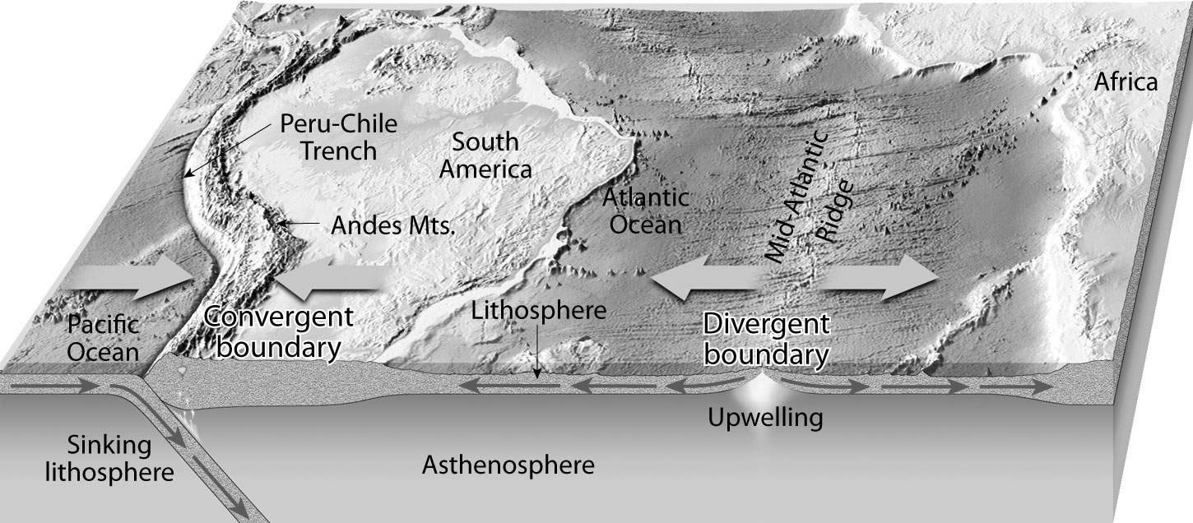
Answer: The dense oceanic crust sinks underneath the more buoyant continental crust at this type of convergent plate boundary.
Diff: 1
Topic: 1.7 A Closer Look at the Geosphere
Bloom's: Applying

