Foundations of Earth Science, 6e (Lutgens)
Chapter 1 Minerals: Building Blocks of Rocks

1) Which of the following best defines a mineral and a rock?
A) A rock has an orderly, repetitive, geometrical, internal arrangement of minerals; a mineral is a lithified or consolidated aggregate of rocks.
B) A mineral consists of its constituent atoms arranged in a geometrically repetitive structure; in a rock, the atoms are randomly bonded without any geometric pattern.
C) In a mineral the constituent atoms are bonded in a regular, repetitive, internal structure; a rock is a lithified or consolidated aggregate of different mineral grains.
D) A rock consists of atoms bonded in a regular, geometrically predictable arrangement; a mineral is a consolidated aggregate of different rock particles.
Answer: C
Diff: 1

2) Which of the following is not a fundamental particle found in atoms?
A) neutron
B) selectron
C) electron
D) proton
Answer: B
Diff: 1

3) Atoms of the same element, zinc for example, have the same number of ________.
A) electrons in the nucleus
B) protons in the nucleus
C) neutrons in the outer nuclear shell
D) electrons in the valence bond level
Answer: B
Diff: 1

4) Atoms that have an electrical charge due to a gain or loss of electrons are called ________.
A) isotopes
B) ions
C) isochrons
D) periodic elements
Answer: B
Diff: 1

5) Which of the following is correct for isotopes of the same element?
A) the atoms have different numbers of protons and the same number of neutrons
B) the atoms have the same number of electrons and different numbers of protons
C) the atoms have different numbers of neutrons and the same number of protons
D) the atoms have different numbers of electrons but the same number of neutrons
Answer: C
Diff: 1
6) What mineral is the hardest known substance in nature?
A) silicate
B) native gold
C) diamond
D) muscovite
Answer: C
Diff: 1

7) Which carbonate mineral reacts readily with cool, dilute hydrochloric acid to produce visible bubbles of carbon dioxide gas?
A) calcite
B) quartz
C) gypsum
D) plagioclase
Answer: A
Diff: 1

8) Which common mineral is composed entirely of silicon and oxygen?
A) calcite
B) diamond
C) olivine
D) quartz
Answer: D
Diff: 1

9) Which of the following minerals is a silicate?
A) hematite
B) feldspar
C) calcite
D) halite
Answer: B
Diff: 1

10) Which one of the following mineral groups exhibits a sheet-like silicate structure?
A) carbonates
B) pyroxenes
C) micas
D) feldspars
Answer: C
Diff: 1

11) The ion at the center of a silicon-oxygen tetrahedron is surrounded by ________.
A) 4 oxygen ions
B) 6 oxygen ions
C) 4 sodium ions
D) 6 sodium ions
Answer: A
Diff: 1
12) The resistance of a mineral to abrasion is known as ________.
A) luster
B) cleavage
C) streak
D) hardness
Answer: D
Diff: 1

13) All silicate minerals contain which two elements?
A) iron, silicon
B) silicon, sodium
C) oxygen, carbon
D) silicon, oxygen
Answer: D
Diff: 1

14) Which mineral is easily soluble in water at room temperature?
A) diamond
B) talc
C) halite
D) olivine
Answer: C
Diff: 1

15) What element is the most abundant in the Earth's crust by weight?
A) carbon
B) chlorine
C) oxygen
D) sodium
Answer: C
Diff: 1

16) The strong tendency of certain minerals to break along smooth, parallel planes is known as ________.
A) streak
B) cleavage
C) cracking luster
D) crystal form
Answer: B
Diff: 1

17) An atom's mass number is 13 and its atomic number is 6. How many neutrons are in its nucleus?
A) 19
B) 7
C) 13
D) 6
Answer: B
Diff: 1
18) Which one of the following is NOT true for minerals?
A) They have a specific, internal, crystalline structure.
B) They can be a liquid, solid, or glass.
C) They have a specific, predictable chemical composition.
D) They can be identified by characteristic physical properties.
Answer: B
Diff: 1

19) Which group of minerals are the most abundant in the Earth's crust?
A) sulfides
B) carbonates
C) silicates
D) halides
Answer: C
Diff: 1

20) Which the following denotes the positively charged particles in an atom's nucleus?
A) protons
B) electrons
C) isotrons
D) neutrons
Answer: A
Diff: 1

21) Which of the following has the highest specific gravity?
A) wood
B) water
C) gold
D) quartz
Answer: C
Diff: 1

22) The most unreliable (variable) diagnostic property of minerals such as quartz is ________.
A) hardness
B) crystal form
C) specific gravity
D) color
Answer: D
Diff: 1

23) Which of the following is NOT one of the eight most common elements in Earth's crust?
A) carbon
B) potassium
C) aluminum
D) calcium
Answer: A
Diff: 1
Examine the words and/or phrases for each question below and determine the relationship among the majority of words/phrases. Choose the option which does not fit the pattern.

24) a. electron b. atom c. proton d. neutron
Answer: b
Diff: 1
Type: Word Analysis Questions

25) a. oxygen b. sulfur c. aluminum d. iron
Answer: b
Diff: 1
Type: Word Analysis Questions

26) All minerals exhibit cleavage.
Answer: FALSE
Diff: 1

27) Rocks are aggregates of one or more minerals.
Answer: TRUE
Diff: 1

28) Mineral luster is broadly classified as either being metallic or opaque.
Answer: FALSE
Diff: 1

29) Electrically neutral atoms have equal numbers of electrons and protons.
Answer: TRUE
Diff: 1

30) Most minerals have a higher specific gravity than water.
Answer: TRUE
Diff: 1

31) In the silicon-oxygen tetrahedron there are more silicon atoms than oxygen atoms.
Answer: FALSE
Diff: 1

32) All atoms of the same element have the same atomic number.
Answer: TRUE
Diff: 1

33) A mineral can be composed entirely of one element.
Answer: TRUE
Diff: 1

34) Diamond and quartz are both minerals composed of a single element.
Answer: FALSE
Diff: 1
35) The micas, biotite and muscovite, both exhibit one direction of cleavage.
Answer: TRUE
Diff: 1

36) Nonmetallic minerals like halite and gypsum have no industrial uses.
Answer: FALSE
Diff: 1

37) More than 4,000 minerals have been named.
Answer: TRUE
Diff: 1

38) Isotopes of the same element have the same mass number.
Answer: FALSE
Diff: 1

39) What physical property denotes the color of a powdered mineral?
Answer: streak
Diff: 1
40) The physical property denoting a mineral's tendency to crack along parallel, planar surfaces is known as ________.
Answer: cleavage
Diff: 1

41) What is the hardest mineral known?
Answer: diamond
Diff: 1

42) A compound is a stable chemical substance composed of two or more ________.
Answer: elements
Diff: 1

43) Most glasses and some minerals exhibit a type of fracture characterized by nested and curved, crack surfaces. What term describes this property?
Answer: conchoidal
Diff: 1

44) What is the smallest particle of matter that exhibits and defines the distinctive chemical characteristics of the individual elements?
Answer: atom
Diff: 1

45) An aggregate of one or more minerals is called a ________.
Answer: rock
Diff: 1
46) The central region of an atom is called the ________.
Answer: nucleus
Diff: 1

47) The two most abundant elements found in Earth's crust are ________ and ________.
Answer: oxygen; silicon
Diff: 1

Use complete sentences, correct spelling, and the information presented in Chapter 1 to answer the question below.

48) Why are most rock-forming minerals silicates? Also, considering the composition of Earth's crust, do all of the nonsilicate mineral groups make sense chemically? Why or why not?
Answer: The elements silicon and oxygen are the two most common elements in Earth’s crust. Yes, it follows that there are fewer non-silicate minerals in the crust because the quantities of their constituent elements within the crust are much lower.
Diff: 2
Type: Critical Thinking and Discussion Questions

49) Label the various parts of an atom in the diagram below.

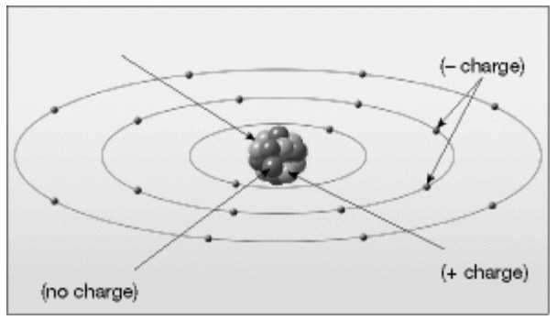

Answer: See figure 1.5 A in chapter 1 of Foundations of Earth Science, 6e.
Diff: 1
Type: Visualization Questions
50) What molecule is illustrated in the diagram below?

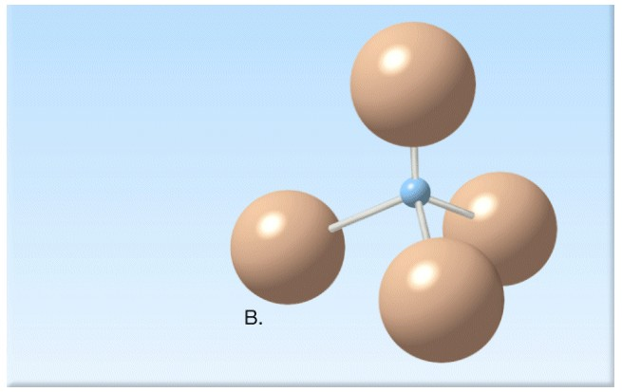
Answer: silicon-oxygen tetrahedron
Diff: 1
Type: Visualization Questions

51) Examine the periodic table of the elements. Observe the positions of the atoms. How are the elements within a vertical column related? How are the adjacent elements in a horizontal row associated? Hint, the atoms in one group are associated by atomic weight, the other, more by electron configurations. Which group, columns or rows, would behave similarly in a chemical reaction?
Answer: Within each column they are related by their electron configurations, their chemical properties, how they behave in a chemical reaction as they form compounds. The adjacent elements are related by atomic number and mass, increasing from left to right.
Diff: 3

52) Examine the list of the eight most common elements in Earth's crust? Does this list help you understand why silicates make up the vast majority of the minerals in the crust? Feldspars are the most common mineral group in the crust. Why?
Answer: It would follow that the most common elements in the crust would be the constituents of the most common minerals. An excellent example is the Si and O pair which are the building blocks for the largest mineral group, the silicate.
Diff: 2

53) Examine the list of the eight most common elements in Earth's crust again. The specific gravity of quartz is 2.65, and feldspars range from 2.56 to 2.76. But the average specific gravity of the whole planet is 5.5! What elements must occur in abundance below the crust?
Answer: Of the eight most common elements, the heavier Fe, Mg, and Ca are abundant below the crust, within the mantle and core(s).
Diff: 2
54) Why are the first four planets in our solar system (Mercury, Venus, Earth, and Mars) primarily composed of silicates and metals, while the next four (Jupiter, Saturn, Uranus, and Neptune) are all gas and ice?
Answer: Silicates and metals melt (and crystallize) at very high temperatures, generally over 1000 degrees C. They make up the material that condensed closest to the Sun during the formation of the solar system. The temperatures at which the gas and ice of which the outer planets are composed were much lower and only found at great distance from the Sun.
Diff: 4

55) The carbon atom is the "element of life" because it has the ability to combine with other elements to form extremely complex chains of organic compoundsamino acids, proteins, and hormones. Examine the silicate tetrahedron carefully. What property does the silicate tetrahedron share with the carbon atom that allows it to form so many complex and varied silicate minerals? Give examples.
Diff: 3

56) Why does a radioactive element lose weight after a period of time? Hint: Einstein had the answer!
Diff: 2

57) What is the atomic number of gold? What is its atomic weight? How many electrons would a gold atom normally contain? What is it about gold's structure that it almost never is found combined with another element? Is that true of sodium? Calcium?
Diff: 3

